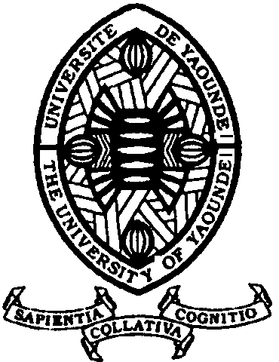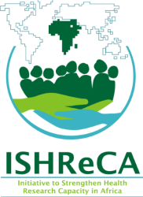

15th – 17th July 2015

**VENUE: UNIVERSITY OF YAOUNDE I**

Opened for Newly recruited lecturers and researchers in

Life, Medical, Environmental & Social Sciences