Health Heredity and Environment Research Group
Profile:
The research group is domiciled in the Department of Medicine, College of Medicine, University of Nigeria located in the University of Nigeria Teaching Hospital, Ituku-Ozalla, Enugu, Nigeria. It has since inception in 2005 evolved into a formidable Research Group. The group has seasoned and dedicated researchers drawn from various departments in the College of Medicine.

Organization:
The PI is a Professor of Medicine and a nephrologist. She is a Fellow of the West African College of Physicians and she also has Masters in Clinical Research of the University of Liverpool, UK and PGD in Sociology. She is currently enrolling to complete Masters in Sociology & Anthropology – Medical Sociology.

Core members include:
6 nephrologists
2 cardiologists
1 pharmaco-epidemiologist
1 neurologist
1 gastroenterologist
1 endocrinologist
2 nurse research coordinators
6 nurses
6 interviewers
2 lab scientists
2 social scientists
1 data manager
Most of the investigators are members of the Association of Good Clinical Practice in Nigeria (AGCPN) and are GCP compliant
The group has the capability to do electronic data capture as the NOAAH trial involved both print and electronic CRFs.

Research Space:
The research office is located in the Renal Unit of the University of Nigeria Teaching Hospital. It has ample space, a research side lab and a seminar room. They also have access to -80⁰ freezers. The group also has an arm in Federal Teaching Hospital, Abakaliki were they recruit subjects from.

Research Experience:

Ongoing Project
- H3 Africa kidney Disease Network (2013 till date) – multicentre, multinational study on influence of genes in kidney disease. Sponsored by NIH, USA and Wellcome Trust. H3 Africa Kidney Disease Network is one of the projects in the H3 Africa Consortium.

Apart from the main project, there are two supplementary studies about to commence:
- MYH9/APOL1 renal risk variants in patients with HIVAN,
- Epidemiologic and Clinicopathologic Studies of Hepatitis B and C in sub-Saharan Africa

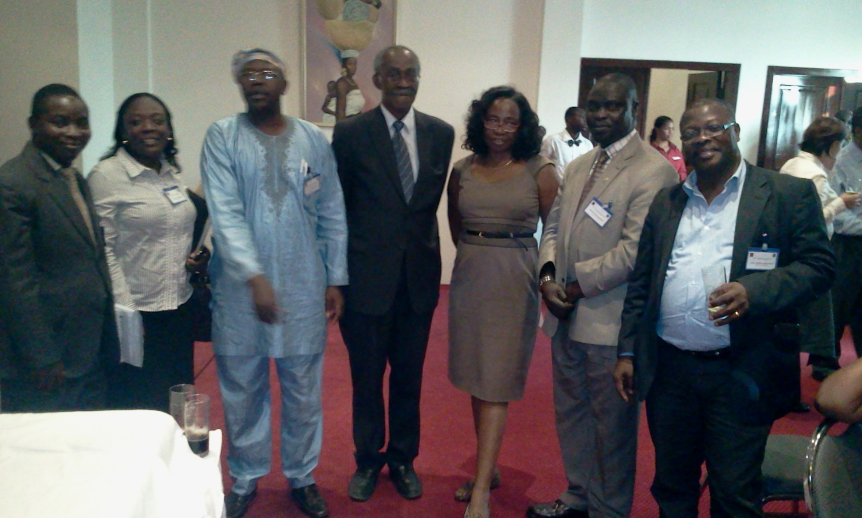
Investigators of H3 Africa Kidney Disease Network at meeting in Accra, Ghana

Completed Research Support

- ExonMobil (2005)
The proposal titled “Provision and Sustainability of Renal Dialysis Services at UNTH, Enugu, South East Nigeria” for augmentation of facilities in Renal Unit. This resulted in the company sponsoring an ultrasound machine for assessment of kidney sizes and augmenting renal biopsies

- International Society of Nephrology (2006 – 2007)
The International Society of Nephrology (ISN) through it programme - COMGAN non-communicable chronic disease prevention programmes in developing countries – KHDC (program for detection and management of chronic kidney disease, hypertension, diabetes and cardiovascular disease) funded our project entitled “Towards prevention of chronic kidney disease in South-East, Nigeria”. Aspects of the project have been published in various journals.

The Research Group put a proposal which won the first prize of the ISN grant in October 2006. They conducted the first investigator led community based research to evaluate risk factors for chronic kidney and cardiovascular diseases. The generated data which is part of the ISN data base and they duly submitted a project report to the funders. The Research group was invited to present the findings at the ISN meeting during the American Society of Nephrology Conference in Denver, USA 2010 and also at the ISN Satellite meeting in Vancouver, Canada 2011. The projected resulted in several publications.

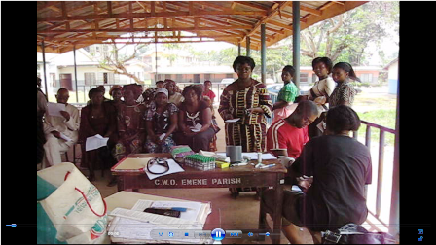
Clinical evaluation and collection of samples at a screening centre – St Joseph’s Church, Emene, Nike, Enugu, Nigeria.

- Genetic Studies in Kidney Diseases (2010 to 2011)
A study project titled “APOL1 as kidney disease risk genetic locus in South-east, Nigerian Patients.” The project looked at the APOL1-MYH9 genomes in patients with chronic kidney disease. The study was done in collaboration with two centres – The Rappaport Family Institute for Research in the Medical Sciences, Technion-Israel Institute of Technology _ Prof Skorecki and Walter Wasser; and Dr Macaulay Onuigbo – Midelfort Clinic, Mayo Health System, Eau Claire WI, USA & College of Medicine, Mayo Clinic, Rochester, MN, USA. This projected resulted in a publication and has since been referenced by other genomic studies in Africa.

- NOAAH Study – multicentre study (2010 to 2012)
A trial of antihypertensives in a multicentre clinical trial in Africa [Newer vs Older Antihypertensive Agents in African Hypertensive Patients (NOAAH) Trial]; a study that involved various countries in Africa. This study was coordinated by Prof Jan Staessen’s Hypertension Lab, the Studies Coordinating Centre, Division of Hypertension and Cardiovascular Rehabilitation, Department of Cardiovascular Diseases, University of Leuven, Leuven, Belgium. Sponsor was the University of Kinshasa, Democratic Republic of Congo and Study Coordination Centre, Leuven, Belgium.

This was a phase trial registered with ClinicalTrials.gov (ClinicalTrials.gov Identifier: NCT01030458). There are several publications emanating from that project. This trial was novel in Africa in that electronic and print CRFs were used. Blood pressures were recorded directly on computers and all the data were bullzipped and emailed to the Study Coordinating Centre in Leuven, Belgium.
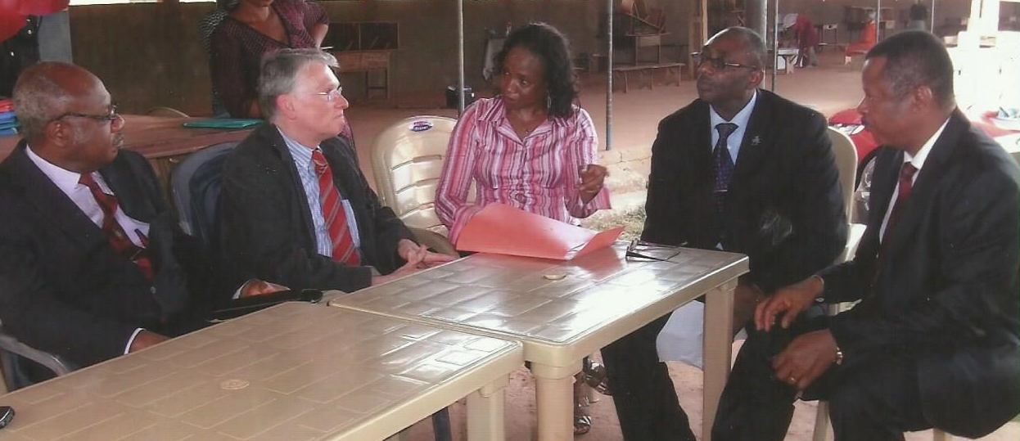
Prof Staessen with members HHE Research Group during his visit to our site.

Some Publications:

- Ifeoma I Ulasi, Chinwuba K Ijoma, Obinna O Onodugo.
A community-based study of hypertension and cardio-metabolic syndrome in semi-urban and rural communities in Nigeria. BMC Health Services Research, 10: 71; 2010. Available at http://www.biomedcentral.com/1472-6963/10/71.

- Ifeoma I Ulasi, Chinwuba K Ijoma.
The enormity of chronic kidney disease in Nigeria: the situation in a
teaching hospital in South-east Nigeria. Journal of Tropical Medicine
doi:10.1155/2010/501957; 2010.

- Chinwuba K Ijoma, Ifeoma I Ulasi, Uchenna N Ijoma
Efficacy and Safety of Telmisartan Monotherapy in the Black Hypertensive Patient. Journal of College of Medicine. In Press accepted in 2010.

- Ulasi II, Ijoma Ck, Onwubere BJ, Arodiwe E, Obinna O, Okafor C. High prevalence and low awareness of hypertension in a market population in Enugu, Nigeria. Int J Hypertens. 2011:869675; 2011.

- Odili AN, Richart T, Thijs L, Kingue S, Boombhi HJ, Lemogoum D, Kaptue J, Kamdem MK, Mipinda JB, Omotoso BA, Kolo PM, Aderibigbe A, Ulasi II, Anisiuba BC, Ijoma CK, Ba SA, Ndiaye MB, Staessen JA, M'buyamba-Kabangu JR; On behalf of the NOAAH Investigators. Rationale and design of the Newer Versus Older Antihypertensive Agents in African Hypertensive Patients (NOAAH) trial. Blood Press. 2011 Apr 15.

- Ulasi II, Anisiuba BC, Ijoma CK. Blood pressure variability and its implication in people of African descent. Hypertens Res. 2011 Oct; 34(10):1076-7. doi: 10.1038/hr.2011.138.

- Birinius Ezeala-Adikaibe, Yan-Ping Liu, Daniel Lemogoum, Benedict C Anisiuba, Marius K Kamdem, Joseph Kaptue, Chinwuba K Ijoma, Lutgarde Thijs, Augustine N Odili, Kei Asayama, Jan A Staessen, Jean Rene M’buyamba Kabangu, Ifeoma Ulasi; On behalf of the NOAAH Investigators. Central haemodyanics reveal significant potential for prevention in black hypertensive patients born and living in sub-Saharan Africa. Artery Research (2012), doi:10.1016/j.artres.2011.11.002.

- Ezeala-Adikaibe AB, Ekenze OS, Onwuekwe IO, Ulasi II. Frequency and Pattern of headache among medical students at Enugu, South-east Nigeria. Nigerian Journal of Medicine 2012; 21 (2): 205 -208.

- Odili AN, Ezeala-Adikaibe B, Ndiaye MB, Anisiuba BC, Kamdem MM, Ijoma CK, Kaptue J, Boombhi HJ, Kolo PM, Shu EN, Thijs L, Staessen JA, Omotoso BA, Kingue S, Ba SA, Lemogoum D, M'buyamba-Kabangu JR, Ulasi II. Progress report on the first sub-Saharan Africa trial of newer versus older antihypertensive drugs in native black patients. Trials. 2012 May 17;13:59. doi: 10.1186/1745-6215-13-59.

- Ifeoma I Ulasi, Shay Tzur, Walter G Wasser, Revital Shemer, Etty Kruzel, Elena Feigin, Chinwuba K Ijoma, Obinna D Onodugo, Julius U Okoye, Ejikeme B Arodiwe, Ngozi A Ifebunandu, Chinwe J Chukwuka, Cajetan C Onyedum, Uchenna N Ijoma, Emmaunuel Nna, Macaulay Onuigbo, Saharon Rosset, Karl Skorecki. High population frequencies of APOL1 risk variants are associated with increased prevalence of non-diabetic chronic kidney disease in the Igbo people from south-eastern Nigeria. Nephron Clin Pract 2013; 123: 123- 128 doi: 10.1159/000353223

- Ifeoma I Ulasi, Chinwuba K. Ijoma, Obinna D. Onodugo, Ejikeme B Arodiwe, Ngozi A Ifebunandu, Julius U Okoye. Towards prevention of chronic kidney disease in Nigeria: a community based study in Southeast Nigeria. Kidney Int suppl 2013; 3: 195 – 201.

- JR M’Buyamba-Kabangu, BC Anisiuba, MB Ndiaye, D Lemogoum, L Jacobs, CK Ijoma, L Thjis, HJ Boombhi, J Kaptue, PM Kolo, JB Mpinda, CE Osakwe, B Ezeala-Adikaibe, S Kingue, BA Omotoso, SA Ba, II Ulasi, JA Staessen; On behalf of the NOAAH Investigators. Efficacy of newer versus older antihypertensive drugs in black patients living in sub-Saharan Africa. Journal of Human Hypertension 27 June 2013; doi:10.1038/jhh.2013.56.

- Osakwe CE, Jacobs L, Anisiuba BC, Ndiaye MB, Lemogoum D, Ijoma CK, Kamdem MM, Thijs L, Boombhi HJ, Kaptue J, Kolo PM, Mipinda JB, Odili AN, Ezeala-Adikaibe B, Kingue S, Omotoso BA, Ba SA, Ulasi II, M’buyamba-Kabangu JR, Staessen JA; On behalf of the Newer versus Older Antihypertensive Agents in African Hypertensive Patients trial (NOAAH). Heart rate variability on antihypertensive drugs in black patients living in sub-Saharan Africa. Blood Press 2013 Sep 25.

- Ejim EC, Onwubere BJ, Okafor CI, Ulasi II, Emehel A, Onyia U, Akabueze J, Mendis S. Cardiovascular risk factors in middle-aged and elderly residents in South-east Nigeria: the influence of urbanization. Niger J Med 2013; 22 (4): 286 -291.

- H3 Africa Consortium. Enabling genomic revolution in Africa. Science 2014; 344 (6190): 1346 – 1348.

