**TEMBISA CLINICAL RESEARCH SITE BEFORE CONSTRUCTION OF THE NEW SITE BEGAN IN 2011:**

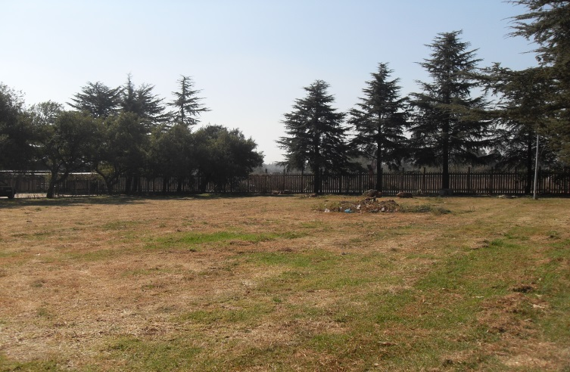

**Figure 1:** Vacant land on which the new site has been built within the grounds of The Tembisa Hospital in the Ekurhuleni District of Gauteng South Africa. Construction began in 2011.

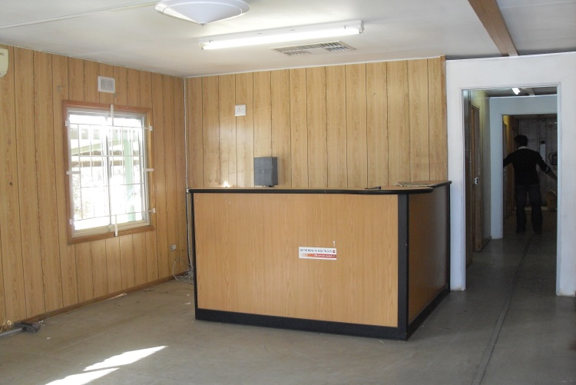

**Figure 2:** Reception area of the old site which was located in a single container within the grounds of the Tembisa Hospital in the Ekurhuleni District of Gauteng South Africa.

**Figure 3:** Passage way leading from the reception area to adjacent clinic rooms, kitchenette, small laboratory and pharmacy.

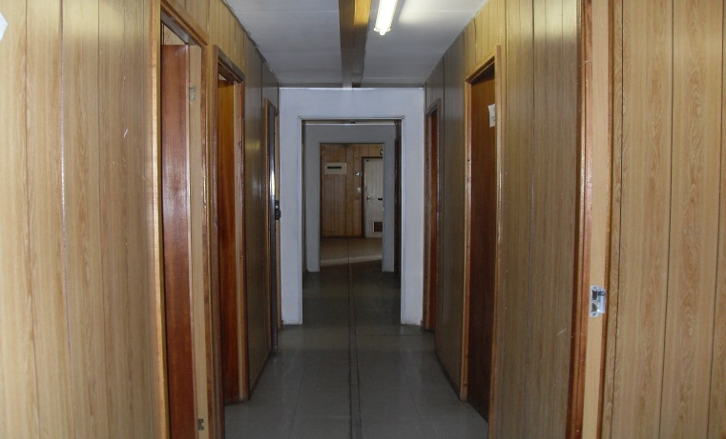

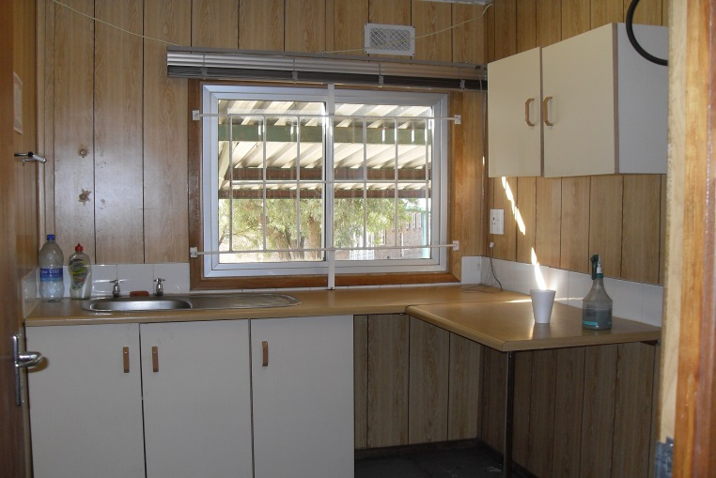

**Figure 4:** Kitchen used by staff to prepare tea coffee and refreshments for participants.

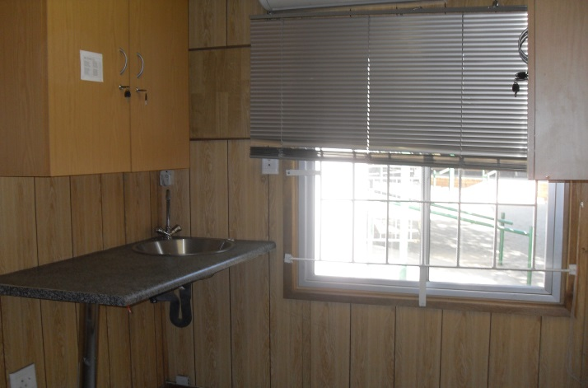

**Figure 5:** Layout of the pharmacy and laboratory.

**TEMBISA CLINICAL RESEARCH SITE AFTER CONSTRUCTION OF THE NEW SITE BEGAN IN 2011:**

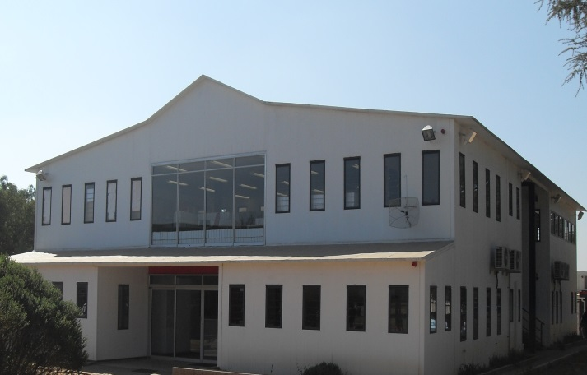

**Figure 6:** Double story unit of the new Tembisa clinical Research Site...

**Downstairs:**

Reception, Reimbursement, Quality Control and Quality Assurance.

**Upstairs:**

Data Management, Project Management, Boardroom, Waiting Area and Kitchen.

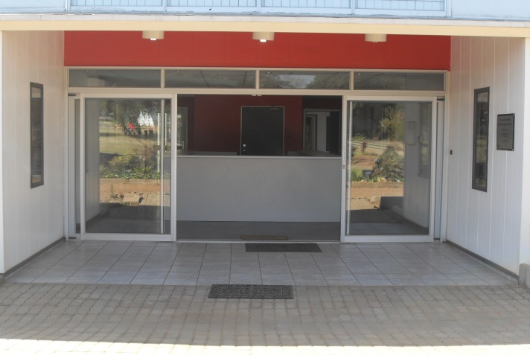

**Figure 7:** Entrance to reception.

Participants enter reception through the entrance shown alongside. This is the first point of contact all participants have with the research staff.

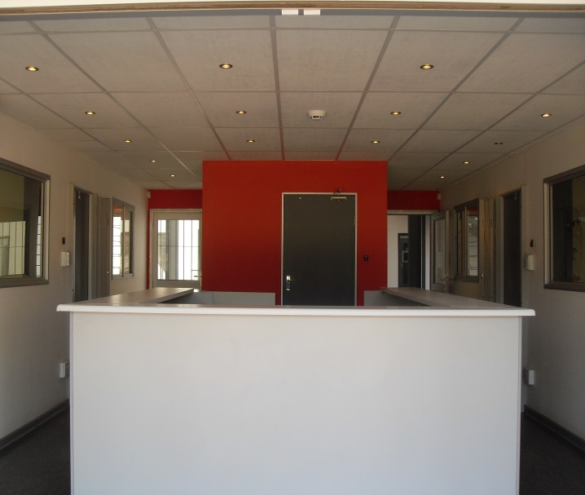

**Figure 8:** Reception.

Participants are directed either to the left or right doors shown in the e picture alongside.

The split ensures that TB positive participants are kept separate from TB negative participants.

It is explained to participants that are directed based upon they study into which they have been enrolled and not according to their TB or HIV status. Confidentiality is maintained throughout each participant visit.

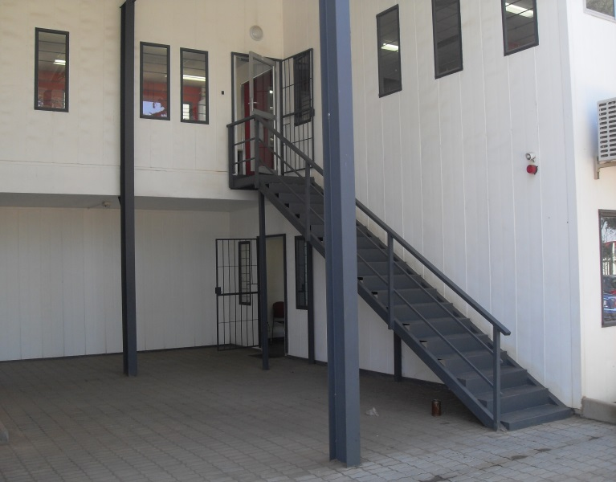

**Figure 9: Double Story Unit**

Participants exit the reception area and are directed to the pharmacy entrance located beneath the stairs. Adherence to study product is evaluated by the pharmacist in microbicide and TB treatment trials. Participants enrolled in Vaccine studies are directed to the Clinical Waiting area shown in figure 15, below.

**Upstairs:**

Data Management, Project Management, Boardroom, Waiting Area and Kitchen.

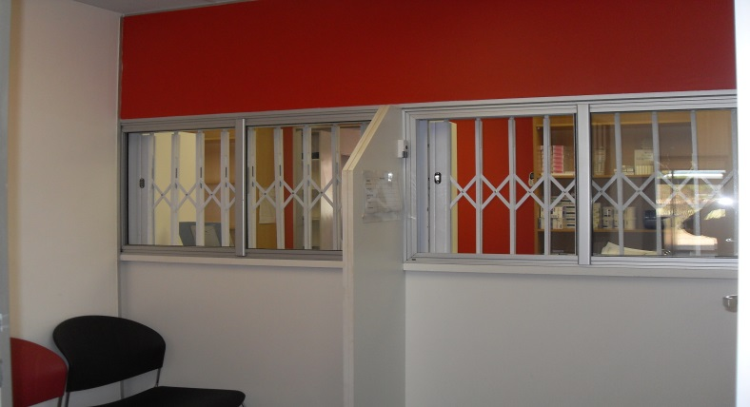

**Figure 10: Pharmacy**

Study Product Returns and Dispensary

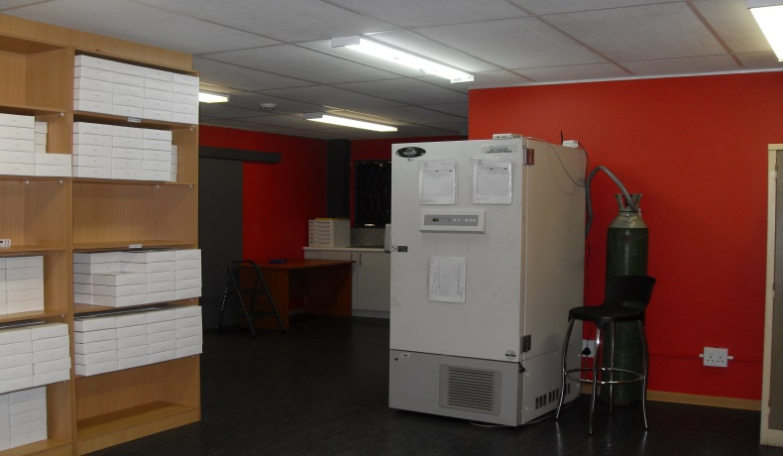

**Figure 11: Pharmacy**

-80°C Freezer, with back-up CO2 cylinder

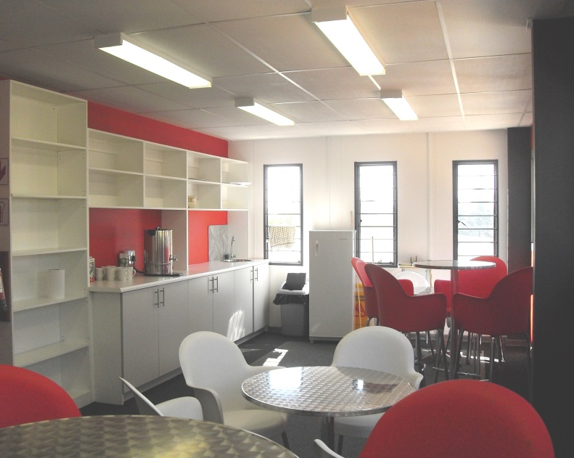

**Figure 12: Boardroom waiting area and kitchen**

After climbing the staircase shown in figure 9, the boardroom, boardroom waiting area and project management offices are entered

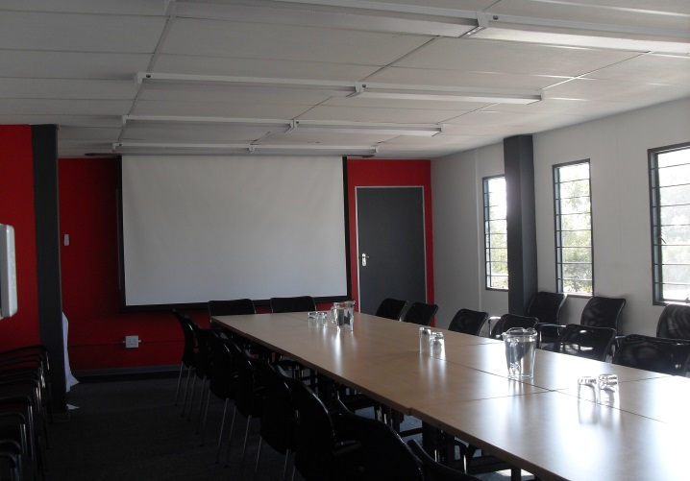

**Figure 13:** Boardroom

**Figure 14: One of the Project** Management offices.

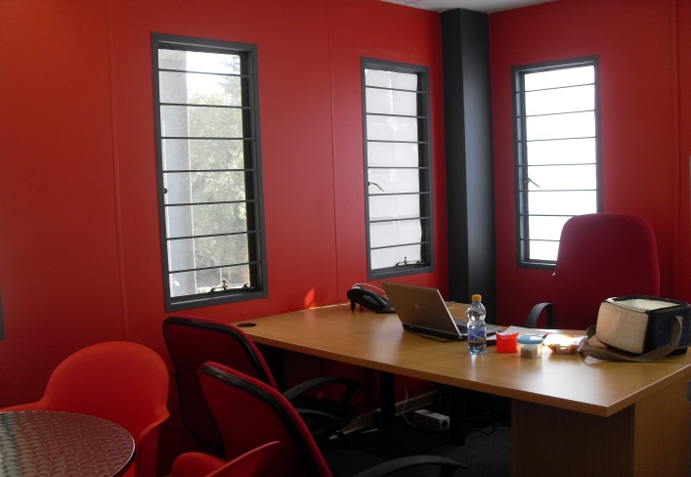

**Figure 15: Clinic waiting area for participants**

After all pre-examination pharmacy procedures have been completed, participants are directed along the side of the building as shown in figure 9, above to the clinic. The site consists of 4 large clinical sections located one behind the other. In each section, the waiting area is surrounded by clinic rooms.

The participant waiting areas are equipped with energy-efficient heating systems, ceiling fans which draw fresh up towards the ceiling and UV-infection control lights

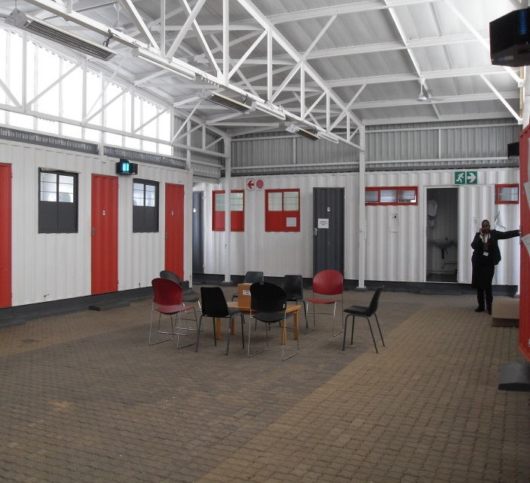

**Figure 16:** Investigator and examination room

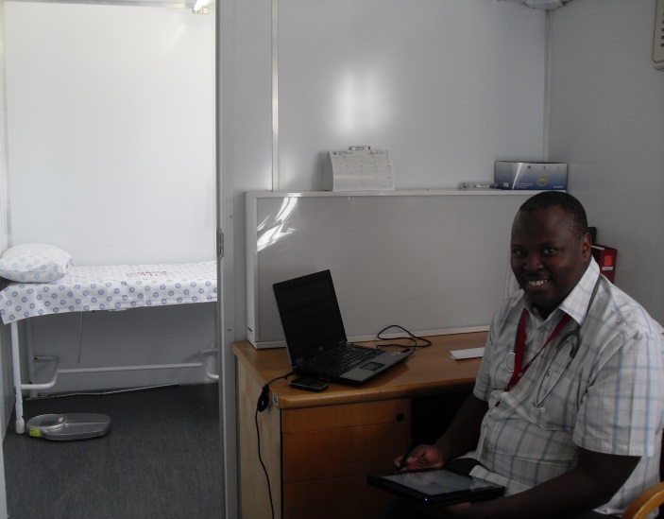

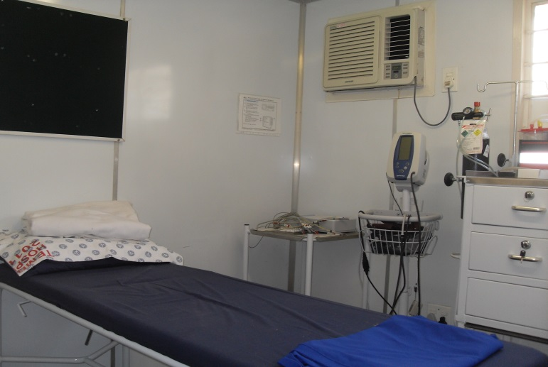

**Figure 17:** Vaccine administration and emergency room

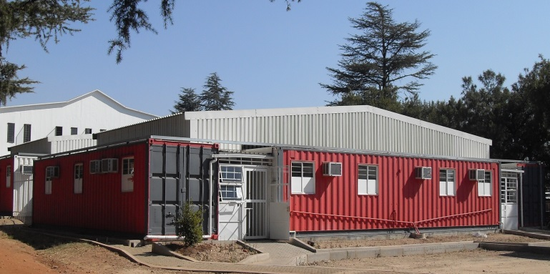

**Figure 18:** Outside of one of the four clinic sections located behind the double story unit. The site consists of 4 clinic sections arranged one behind each other.

In between clinic areas 2 and 3, lies the on-site laboratory shown in figure 19 below.

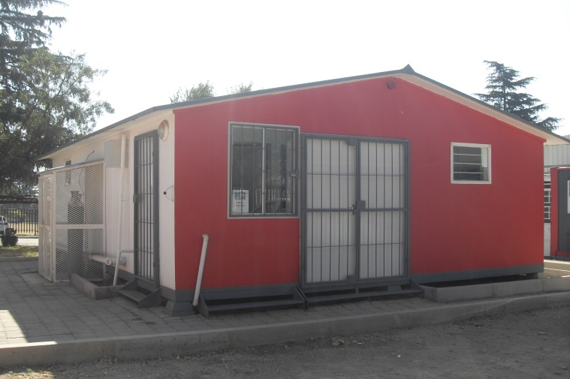

**Figure 19:** Outside the on-site laboratory. The CO2 back-up cylinder is visible.

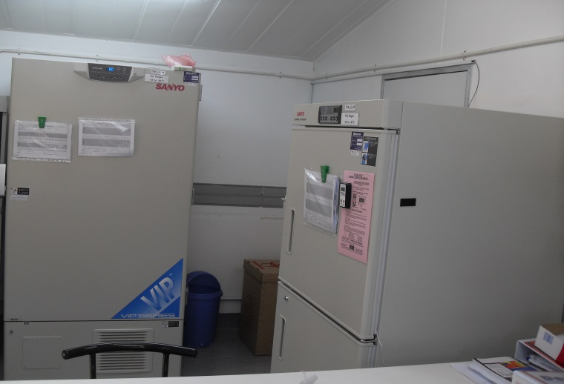

**Figure 20:** Freezers housed within the on-site laboratory

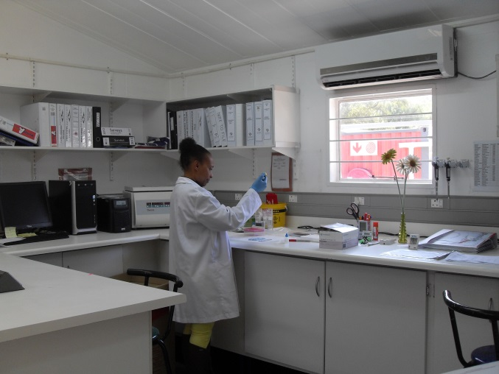

**Figure 21:** laboratory workspace, computer and centrifuge