**Malawi Infrastructure:**

Summary

* 1. Malawi CRS Resources

The Malawi CRS is a part of the larger UNC Project Malawi. UNC Project Malawi resources are available to the Malawi CRS.

* + 1. UNC Project Buildings and Facilities

Refer to Component 10C for the main discussion of facilities/infrastructure of the Malawi CRS.

The following buildings/facilities are directly owned and operated by the CRS and are available for CRS activities at all times. Their location relative to each other is featured in the map below. The Tidziwe Centre is 4km from the Bwaila Building and 5km from the Area 18 George Joaki center.

Figure : Map of Lilongwe City demonstrating relative location of Malawi CRS facilities

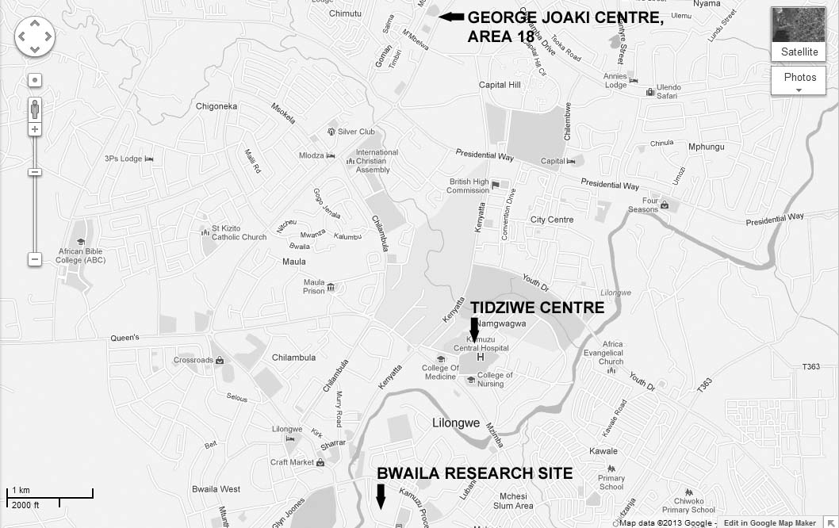

Tidziwe Centre

Tidziwe Centre, headquarters of the UNC Project, is located on the campus of Kamuzu Central Hospital. The Centre is a 20,000 ft2, two-story building. Clinic facilities at Tidziwe, located on the ground floor, include **twenty-two examination and counseling rooms** furnished with sinks, exam tables with exam lights, clinical supply carts and all other infrastructure required to conduct informed consent, individual, couples and group counseling, screening, enrollment, specimen collection, clinical evaluations including colposcopy for cervical cancer screening, family planning services and treatment. Additionally, one room has emergency resuscitation equipment. There is a sheltered participant registration and waiting area that seats 300 persons. Radiology support exists in an adjoining building at Kamuzu Central Hospital, including digital x-ray equipment. To support clinical activities, Tidziwe Centre houses an **840 ft2 climate controlled investigational pharmacy**, a climate controlled pharmacy dispensary, **UNC Project Laboratory** Central Receiving, Core, Microbiology/Parasitology Departments, Hematology, Chemistry and Serology departments, a 200 ft2 community activity and participant retention office, and two data management offices, including 250 ft2 of secured file storage space. The upper floor of Tidziwe Centre houses 16 administrative offices for senior management, investigators, and administrative support staff, as well as the IRB, Communications, ICT, and Data/Quality Management offices. Teaching, training, and learning facilities include a **medical library** with UNC supported satellite internet access for reference searches. There is a **140-seat lecture hall** and a **30-seat conference room**, both with teleconferencing capacity for participation in conference calls with the 4 other CRS leaders and the CTU leadership as well as the NIH clinical networks committee conference calls. The Tidziwe Centre hosts all adult and pediatric therapeutics studies, as well as microbicide and combined prevention clinical studies. An adjacent 2,250 ft2 **secure warehouse** on the campus of Kamuzu Central Hospital, 200 yards from Tidziwe Centre has separate bays for pharmacy, laboratory consumables, data archive, and general storage. Each bay is accessed through a secured steel door, has a fire alarm system, fire extinguishers, and is treated for rodent and insect control on a regular basis. Entry is access controlled by UNC Project security guards on duty 24-hours a day.

Since the initial construction, several additions and renovations have been added to accommodate the research unit’s expanding research profile. These include a detached staff break room and outdoor lunch facility. We added 200 ft2 data management offices, 400 ft2 of data storage, guardhouse, driver overnight sleeping quarters, transport office, community educators office, trainee/student offices, Laboratory storage, and general office supply storage.

Figure : Floor plans (Upper and Lower levels) of Tidziwe Centre

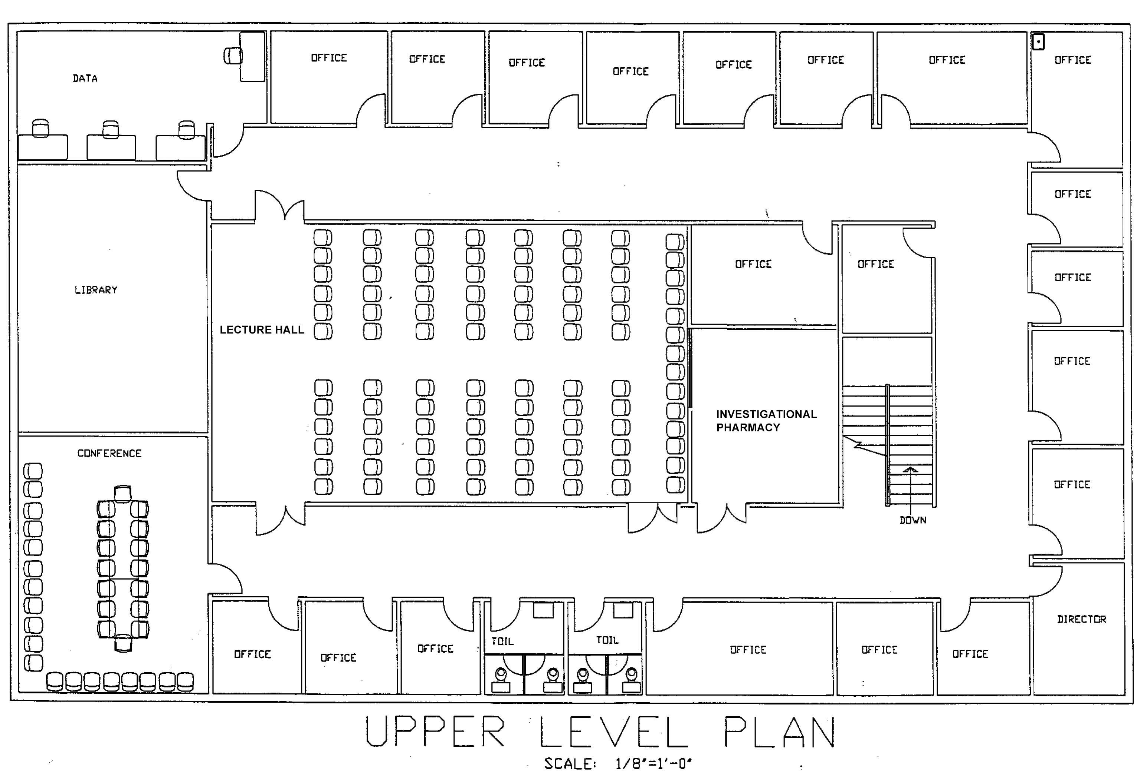

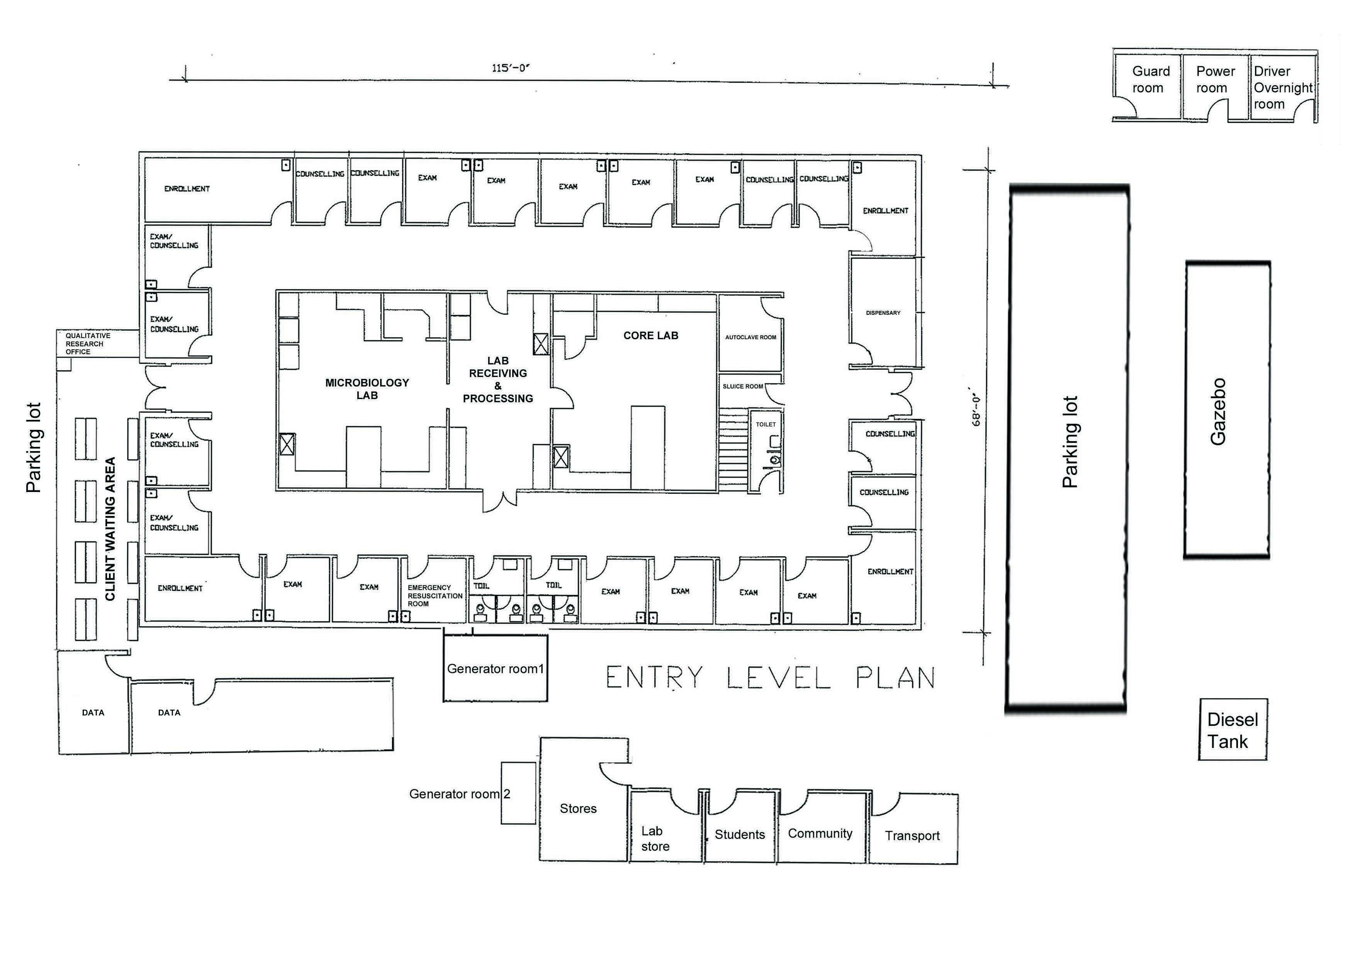KCH STD Clinic

For studies involving STD patients and for identifying female and male subjects at extreme high risk of HIV infection and for subjects with acute HIV, the UNC Project operates the 7500 patient per year KCH STD Clinic. Located on the Kamuzu Central Hospital campus 100 yards from Tidziwe Centre, the facility includes 2000 sq ft of clinical and research space comprising 13 exam/counseling rooms, patient waiting and group counseling area with seating for 100, a data management office, and a secure file storage room. The Clinic has high-speed internet connectivity, and is connected to the Tidziwe Centre main servers. The clinic is managed with an electronic clinical data base that is utilized for recruitment and to analyze HIV/STD trends. Current research activities conducted at the KCH STD clinic include studies requiring the identification of acute HIV infected subjects and serves as a primary HIV testing facility to refer clients to appropriate clinical trials. Here, find the relative locations of the described clinics on the KCH campus.

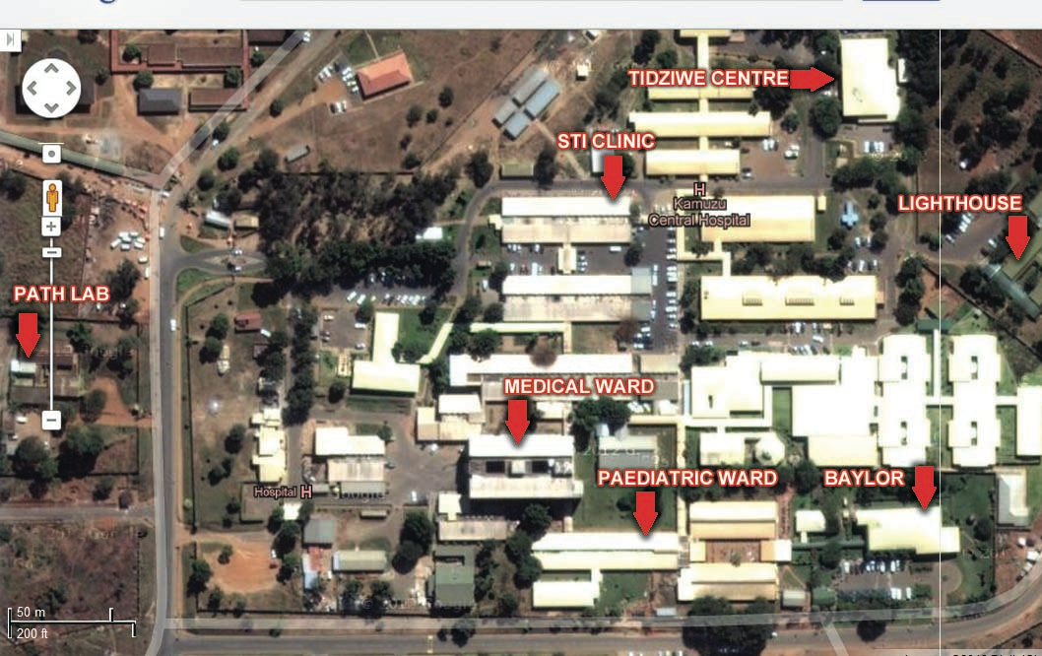

Figure 9: Aerial view of Kamuzu Central Hospital with relative clinic locations

Bwaila Research Building and Bwaila Data Center

For antenatal and PMTCT research, the UNC Project operates from Bwaila Hospital, the District Hospital for Lilongwe District, which is located 5 km from Tidziwe Centre. In order to conduct the BAN study, UNC project built this 5000 ft2 free-standing clinical research center adjacent to the maternity hospital that includes 10 exam/counseling rooms, meeting room, auxiliary laboratory, pharmacy dispensary, office space, and staff break room. An additional 1500 ft2 free- standing data center includes 2 secure data storage rooms and data stations for 10 data officers. The Research Building and Data Centers have high-speed internet connectivity, and are connected to the Tidziwe Centre main servers. The IMPAACT PROMISE study and previously the BAN study used these facilities to enroll over 3200 mother-infant pairs in PMTCT trials in the past 8 years.

Figure : Floor plan of Bwaila research building

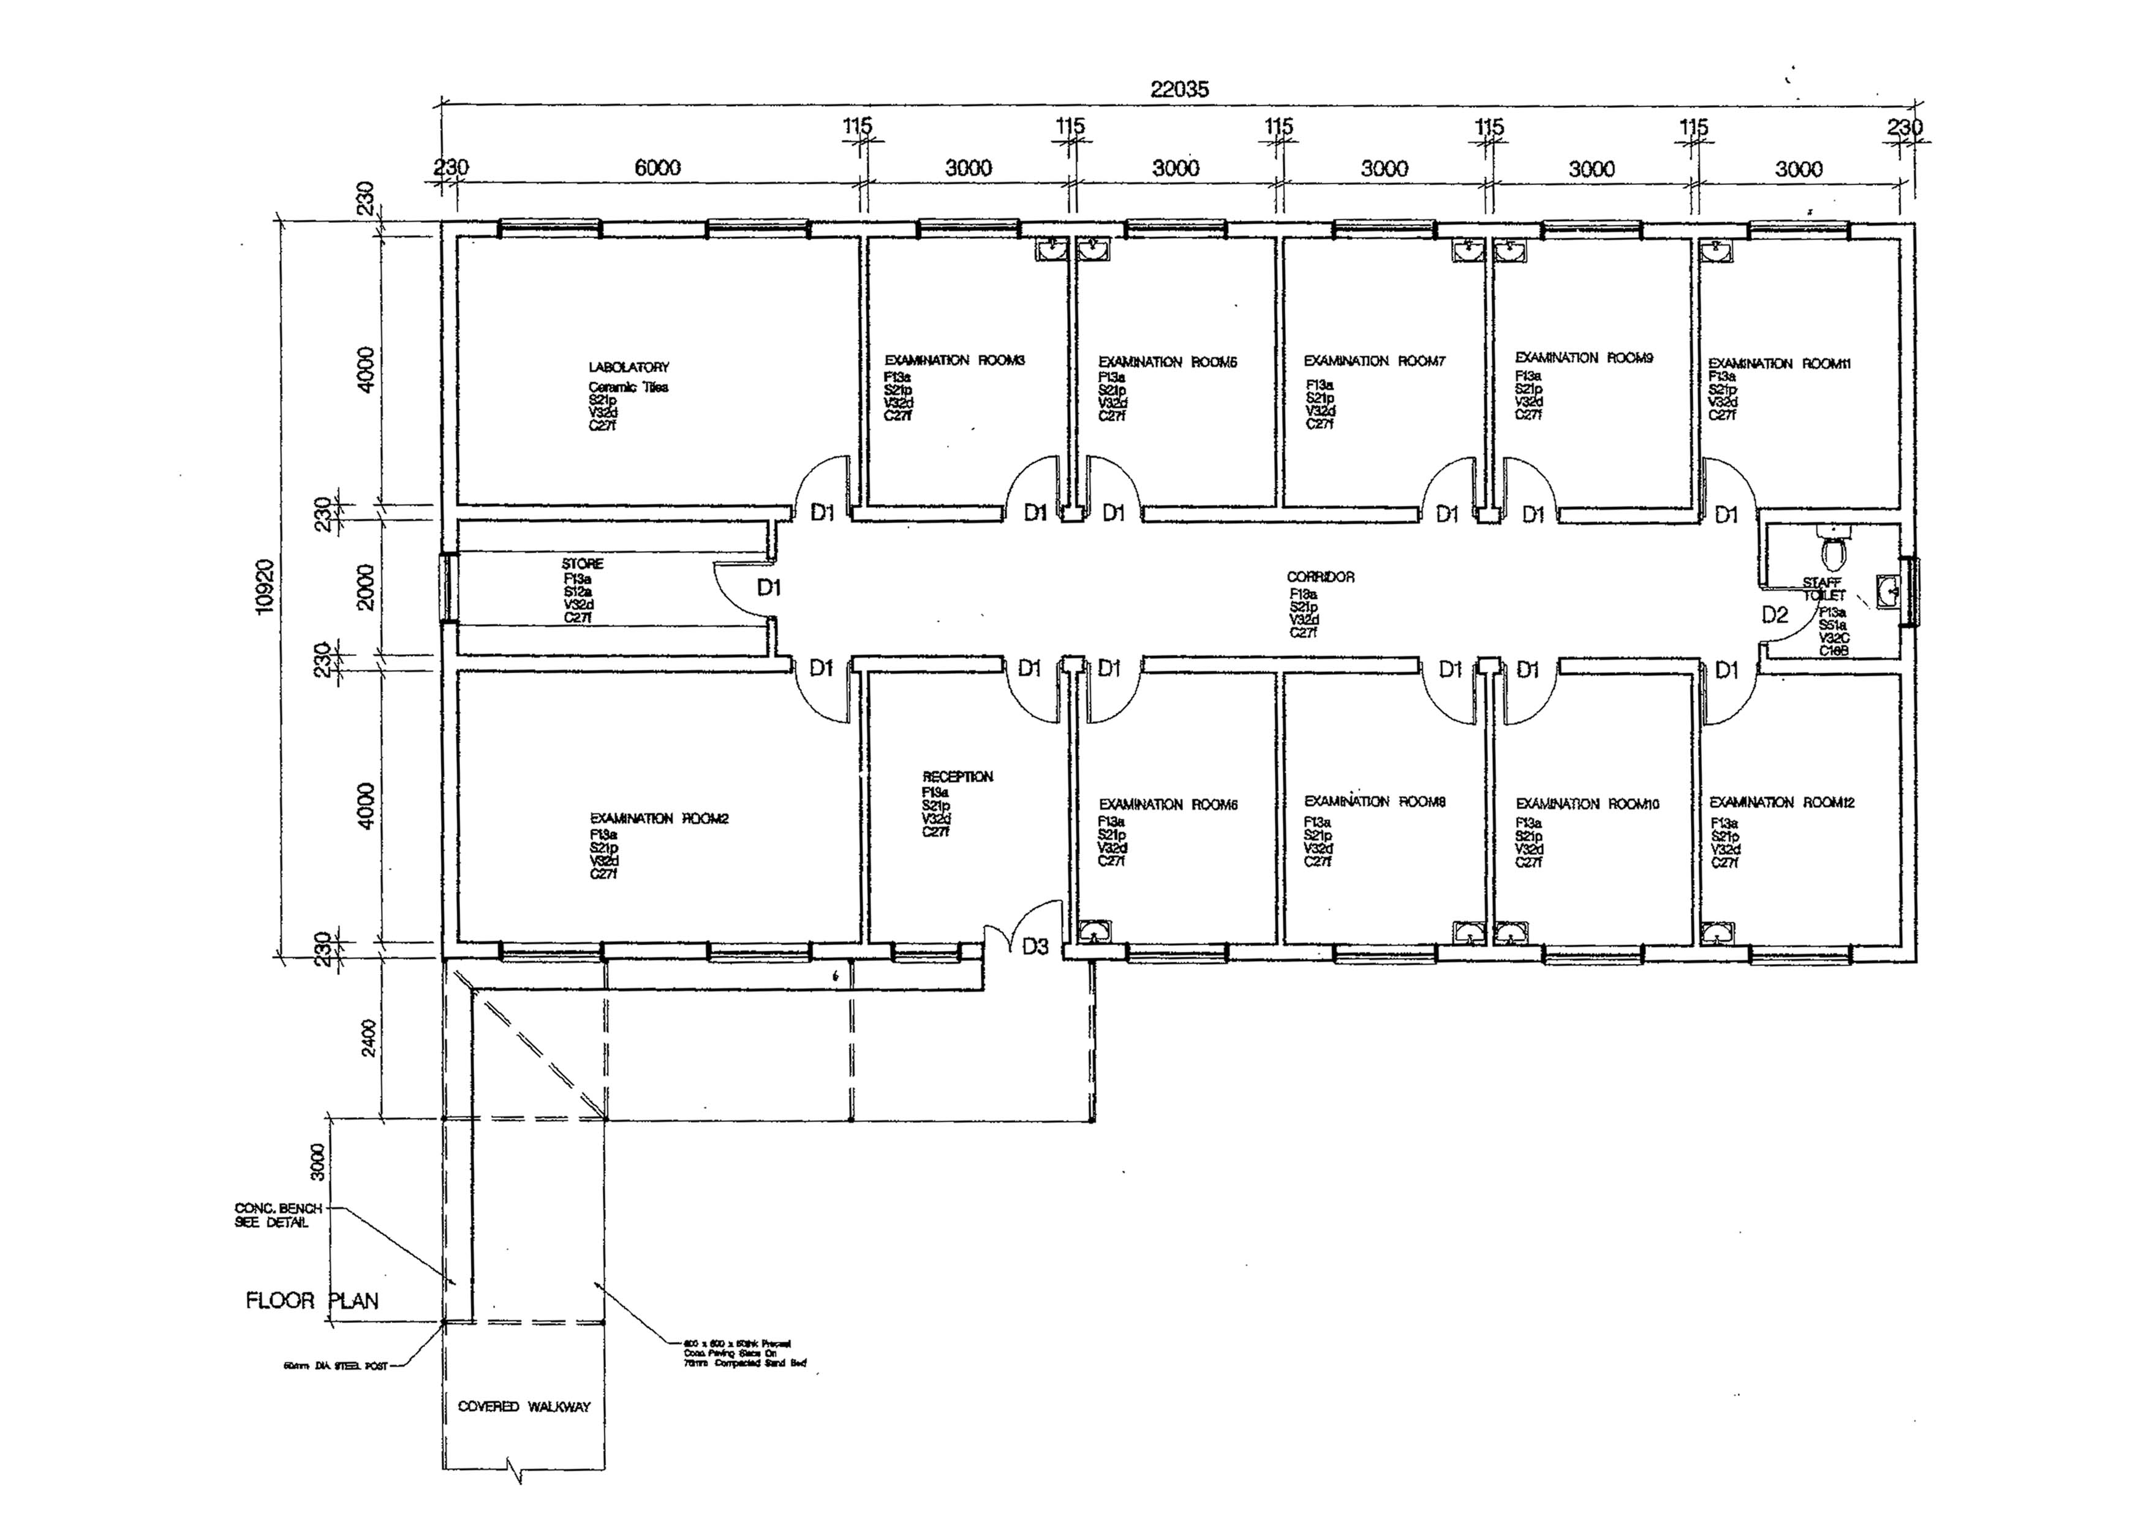

Figure : Aerial view of Bwaila District Hospital campus with relative location of key facilities

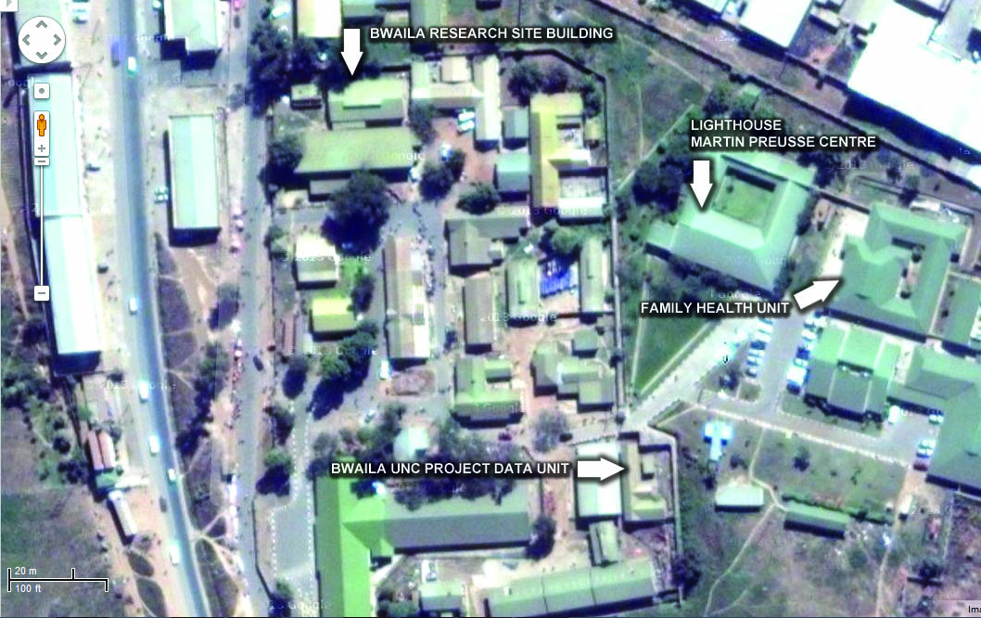

George Joaki Centre

Located at the Area 18 Health Centre, a 10-minute drive from Tidziwe Centre, George Joaki Centre, is a newly constructed, 5,200 ft2, two-story facility which currently houses the Project’s vaccine related and community –based research activities. The clinical facilities include 10 exam and counseling rooms, observation room, on-call room, and participant reception and waiting area with a capacity of 300. Clinical activities at the site are supported by an auxiliary laboratory, pharmacy dispensary, 800 ft2 data management office with secure file storage and 8 data stations, secure data archive room, staff office space, 20-seat conference room, and staff break room. The second floor houses the UNC Project Laboratory PCR Department and offices. The Centre has internet connectivity, remote data-entry capacity, and is connected to the Tidziwe Centre main servers. Situated in the middle of residential townships, we have household level geographic (GIS), demographic and health information for the catchment areas (~75,000 people) surrounding this center to facilitate community based investigations, i.e., vaccine efficacy.

Figure 12: Floor Plan of the Lower Level of the George Joaki Centre

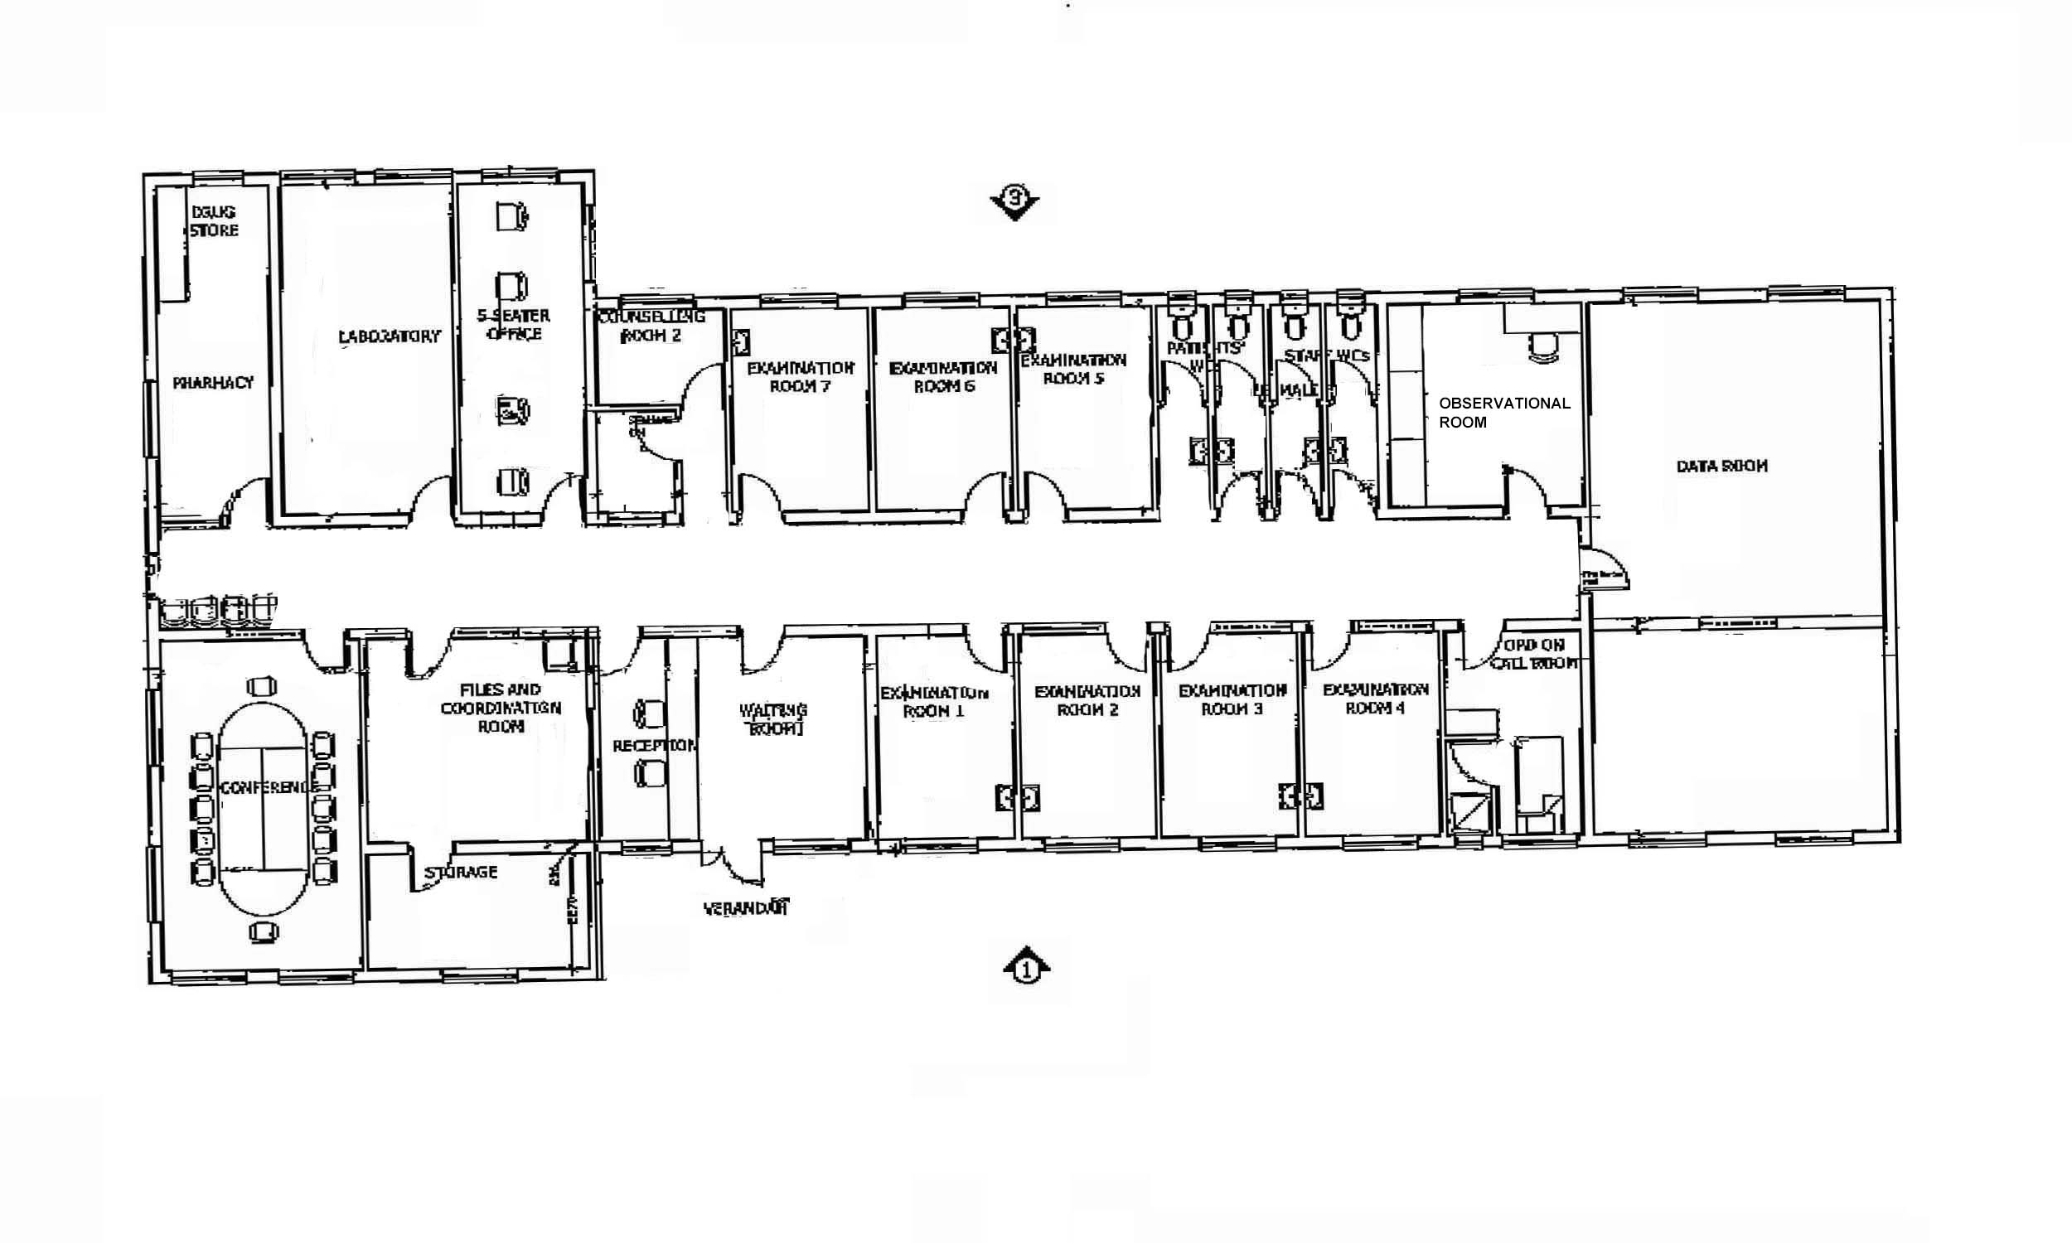

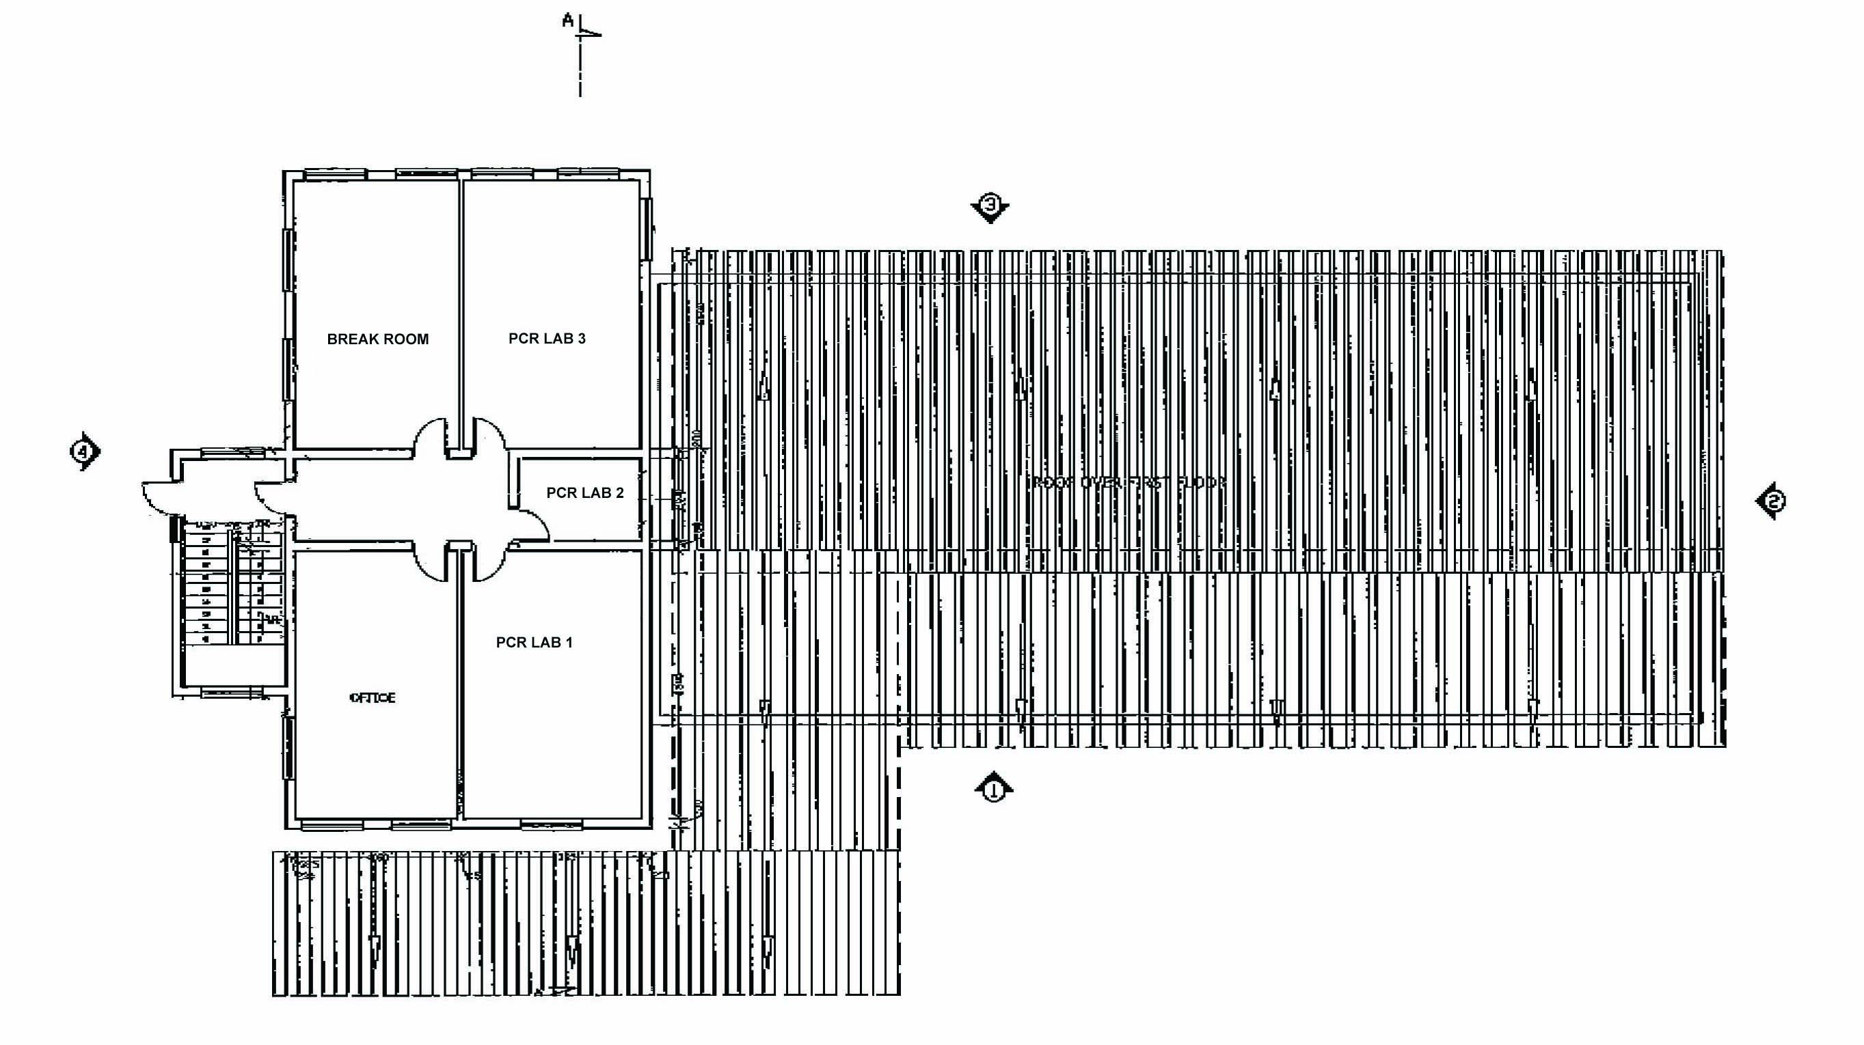UNC Project Guest House

Figure 13: Floor Plan of the Upper level of the George Joaki Center

Built in 2007, the UNC Project Guest House accommodates up to 16 visiting faculty and scholars in 2 four bedroom apartments. The guesthouse is approximately a 5 minute walk from Tidziwe Centre and includes internet access through the UNC project.

* + 1. Laboratory

Refer to Component 8 (Laboratory) and Component 10 (Clinical Research Sites) for the main discussion of laboratory capacity of the Malawi CRS.

UNC Project Laboratory consists of 7 departments. The 1600 sq-ft Core Department, located at Tidziwe Centre, houses the central receiving area where specimen reception, processing, storage, shipping, and test resulting take place. The Core Department also houses the laboratory’s hematology, chemistry, and serology services. The 1000 sq-ft Microbiology Department is located adjacent to the Core Department. The department provides general parasitology and microbiology testing, TB diagnostic services . It includes a separate media preparation room and TB isolation room. The PCR Department, located a 10 minute drive from the Core Department, occupies a new purpose-built 1100 sq-ft PCR facility. It consists of four rooms, including clean room, sample preparation room, and amplification/detection room. The 1400 sq-ft, three room Cell Processing Department, located 5 minutes from Core Department, serves as a processing facility for PBMCs, urine, breast milk, vaginal secretions, and semen, and as an ultra-low freezer and liquid nitrogen storage repository. Infrastructure includes a Cryomech LNP-40 Liquid Nitrogen Plant and 5 liquid nitrogen specimen storage tanks and 5 ultra-low freezers. The 1000 sq-ft Pathology Department is located adjacent to the Cell Processing Department. Offering histopathology and cytology sample processing, it features a specimen receiving room, grossing room, and processing/reading room, Additionally, there are two small satellite laboratory departments at Bwaila Research Building(800 ft2) and George Joaki Centre (650 ft2), which provide specimen processing and forwarding services to other departments, hematology, microscopy, and point-of-care testing for CRS activities in these locations.

Biohazardous waste disposal resources: The CRS employs a full time biohazardous waste disposal technician, has 1 large autoclave and autoclave room dedicated to waste disposal, and full time access to the incinerator at Kamuzu Central Hospital.

Table : Major equipment available in the laboratory departments

| Department | Floor space | Key Equipment/Systems |
| --- | --- | --- |
| Tidziwe - Central Processing | 1,600 ft2 | Laboratory Information Management System (LAB DAQ LIS, Antek Healthware). All laboratory departments are connected real time to this central server. |
|  |  | LDMS (Frontier Sciences) Lab #305 |
|  |  | 2 ultra-low freezers |
|  |  | 3 centrifuges (1 refrigerated) |
|  |  | 3 computers |
| Tidziwe - Core |  | 2 Beckman Coulter AcT5 Diff CP hematology analyzers |
|  |  | 3 BD FACSCOUNT CD4/CD8 analyzers |
|  |  | 1 EPICS MXCL 4 color flow cytometer |
|  |  | Beckman Coulter CX5 PRO chemistry analyzer |
|  |  | Roche Cobas C311 chemistry analyzer |
|  |  | 2 Pacific Hemostasis Thromboscreen 200 coagulation analyzers |
|  |  | Purite water purification system |
|  |  | 2 plate readers, 1 plate washer, 1 autoblot washer |
|  |  | 4 refrigerators |
|  |  | 1 -20oC freezer |
|  |  | 6 computers |
| Tidziwe- Microbiology/TB/Parasitology | 1000 ft2 | 3 Olympus CX series microscopes, 1 Olympus teaching microscope, 1 LED fluorescent microscope |
|  |  | Manual MGIT Reader |
|  |  | 5 incubators, including 1 CO2 |
|  |  | 3 class II biological safety cabinets |
|  |  | 4 centrifuges |
|  |  | 2 autoclaves (1 media prep, 1 dedicated for waste) |
|  |  | Media Prep Room |
|  |  | TB isolation room (negative pressure, HEPA-filtered room exhaust) |
|  |  | 1 refrigerator |
|  |  | 2 computers |
| PCR Department | 1100 ft2 | 3rooms, including separate processing and amplification rooms |
|  |  | Abbott m2000sp sample automated sample preparation machine |
|  |  | Abbott m2000 rt Real Time PCR cycler |
|  |  | 2 GeneAmp 9700 thermal cyclers |
|  |  | 2 plate readers, 1 plate washer |
|  |  | Ultralow freezer |
|  |  | 3 centrifuges |
|  |  | 1 incubator |
|  |  | 2 class II biological safety cabinets |
|  |  | ProbeTech SDA GC/CT detection system |
|  |  | LDMS (Frontier Sciences) Lab #291 |
|  |  | Hain Twincubator |
|  |  | 1 refrigerator |
|  |  | 2 computers |
| Cell Processing Department | 1400 ft2 | 5 ultra-low freezers |
|  |  | Cryomech LNP-40 Liquid Nitrogen Plant |
|  |  | 1 refrigerator |
|  |  | 5 liquid nitrogen storage tanks |
|  |  | 4 centrifuges (3 refrigerated) |
|  |  | 2 class II biological safety cabinets |
|  |  | 2 Olympus CX series microscopes |
|  |  | LDMS (Frontier Sciences) Lab #245 |
|  |  | 2 computers |
| Pathology Department | 1000 ft2 | Automated tissue processor |
|  |  | Automated tissue stainer |
|  |  | Embedding equipment |
|  |  | Microtome |
|  |  | Ultra-low freezer |
|  |  | Teaching microscope with camera |
|  |  | Aperio automated slide scanner |
|  |  | 2 computers |
| Bwaila Research Building and George Joaki Centre | 800 and 650 ft2 | 1 Beckman Coulter AcT5 Diff CP hematology analyzer |
|  |  | 3 Olympus CX series microscopes |
|  |  | 4 centrifuges |
|  |  | 2 refrigerator/freezers |
|  |  | 3 computers |

* + 1. Clinical

Refer to Component 7 (Pharmacy) Component 10 (Clinical Research Sites) for the main discussion of clinic and pharmacy capacity of the Malawi CRS.

Affiliated Facilities

Malawi CRS collaborates closely with and conducts research activities at the facilities listed below.

1. Kamuzu Central Hospital (KCH) is the only tertiary hospital for the Central Region of Malawi, operated by the Malawi Ministry of Health and consisting of 625-beds. KCH’s campus serves as the home for the Malawi UNC Project, and all central medical, surgical, pediatric, and OB-GYN care and research activities. UNC Project clinical staff work in the hospital on the various services. Trainees, both pre and post doctoral have the opportunity to both experience clinical inpatient and outpatient rotations as well as to conduct IRB approved clinical research in the hospital facilities. They also host UNC Project’s Pathology and Cell Processing Laboratory Departments.
2. Lighthouse Clinic and Lighthouse Clinic at Bwaila Hospital: The Lighthouse has a free-standing HIV Clinic and day ward on the campus of KCH and a second facility at Bwaila Hospital. The Lighthouse provides care for over 20,000 patients on antiretroviral therapy. The Lighthouse receives support from the Malawi MOH, the Global Fund, the German Government and community organizations. Many UNC staff devote time to clinical care and training at the Lighthouse and the clinic is an important source of participants for DAIDS-sponsored studies. The Lighthouse clinics maintain an electronic database of all patient visits and contributes to the NIH IeDEA database.
3. Bwaila Hospital is the District Hospital for Lilongwe District. There are 20,000 deliveries at Bwaila Hospital and it is home of Malawi’s largest Option B+ (Universal ART for pregnant women) PMTCT location, over 15,000 women are tested for HIV annually, of whom 14% are HIV positive. The Bwaila location has a fully integrated TB/HIV program, the largest in the country. Over 4000 patients are assessed in the chronic cough clinic each year and approximately 150 new TB cases (10% children) are registered monthly at this location. The prevalence of HIV among TB patients is 70%, and among patients initiating ART, the incidence of TB case detection is 3/100py, providing a strong basis for TB focused research including trials such as A5274 and A5279.
4. University of Malawi College of Medicine was founded in 1991, as a fifth, and youngest, constituent college of the University of Malawi. The College of Medicine began qualifying doctors in July 1992. The school currently offers a five-year MBBS program which is followed by an eighteen month internship. The main campus in in Blantyre. The College has recently completed construction of a campus adjacent to Kamuzu Central Hospital, including offices, classrooms, laboratories, and student dormitories. Third year students are based at this campus with clinical rotations at Kamuzu Central Hospital. UNC staff teach at the College.
5. Baylor Center of Excellencewas founded in 2006 to provide excellence in pediatric HIV treatment. Currently, over 3000 pediatric HIV infected patients are currently in care and actively refer clients to the Malawi CRS.

Pharmacy

Refer to Component 7 (Pharmacy) and Component 10 (Clinical Research Sites) for the main discussion of laboratory capacity of the Malawi CRS.

The UNC Project Pharmacy consists of a single central investigational pharmacy located at Tidziwe Centre on the second floor. There are 3 pharmacy dispensaries, one located at Bwaila hospital, currently serving IMPAACT’s PROMISE study, one at Tidziwe serving HPTN, MTN, ACTG, and IMPAACT (non-PROMISE) studies, and one at Area 18 George Joaki Center serving vaccine activities. All dispensaries are within the respective clinical research buildings.

The Tidziwe Investigational pharmacy is 322 ft2, the Tidziwe dispensary is 129 ft2, the Bwaila dispensary is 258 ft2, and the Area 18 dispensary is 226 ft2, for a total of 935 ft2. The pharmacy and all dispensaries are temperature controlled with air conditioning to maintain a temperature between 15°C– 25°C. The Investigational pharmacy and the dispensaries have a backup generator that comes on after 30 seconds of an interruption in the main electricity supply The building’s electricity is further supported by a UPS system with a 30-minute battery life. Both of these back-up power systems have routine maintenance agreements with agents for regular maintenance. Table 4 lists major pharmacy equipment.

Table : Major pharmacy equipment

|  |  |  |
| --- | --- | --- |
| Facility | Floor space | Equipment |
| Tidziwe Investigational Pharmacy | 322 ft2 | Computer |
|  |  | Refrigerator/Freezer |
|  |  | Vaccine Refrigerators (3) |
| Tidziwe Dispensary | 129 ft2 | Refrigerator/Freezer |
|  |  | Computer |
| Bwaila Dispensary | 258 ft2 | Refrigerator/Freezer |
|  |  | Computer |
| Area 18 Dispensary | 226 ft2 | Vaccine Refrigerator |
|  |  | Refrigerator/Freezer |
|  |  | Computer |
| Bwaila Labour Ward | Not applicable | Pharmacy Isolator |
| Kamuzu Central Hospital Pharmacy | Not applicable | Chemotherapy Isolator |

* + 1. Animal

Not applicable

* + 1. Office

Refer to Component 9 (Other Clinical Research Activities) for the main discussion of Data and IT capacity for the Malawi CRS.

The Malawi CRS has adequate human resources and the equipment to support data entry, storage or transmission through both datafax and E-Data. These resources are described in detail in component 9. UNC Project has a fiber-based primary internet connection with satellite as back-up to assure we have both fast and reliable internet connectivity. All satellite facilities of our project are connected by point-to-point wireless connections to Tidziwe Centre allowing the same quality internet connection. All IT equipment is located inside lockable, non-public access rooms. The edge of the network is protected by a firewall and an internet traffic filter. All data is backed up daily to an external server at UNC Chapel Hill. Table 5 summarizes Data/IT equipment in Malawi CRS Data/IT Offices.

Table : Major data/IT office resources

|  |  |  |
| --- | --- | --- |
| Facility | Floor space | Equipment |
| Tidziwe Centre Data and IT Offices | 800 ft2 | 4 stand alone Servers |
|  |  | 2 Virtual servers |
|  |  | 2 Network attached back up storage devices |
|  |  | Redundant internet links |
|  |  | Network firewall |
|  |  | 16 Computers |
|  |  | 3 Datafax machines |
|  |  | 1 heavy duty photocopier |
|  |  | 3 heavy duty printers |
| KCH STD Clinic Data Office | 125 ft2 | 3 computers |
|  |  | 1 printer |
| BWAILA DATA CENTRE | 1500 ft2 | 1 heavy duty printer |
|  |  | 1 laptop |
|  |  | 10 computers |
| George Joaki Centre Data Office | 800 ft2 | 1 heavy duty printer |
|  |  | 1 Dell laptop |
|  |  | 6 computers with remote data entry (RDE) capacity |

An additional 42 computers are available in the library/resource centre, clinic rooms, and staff offices.

* + 1. Other

Refer to Component 9 (Other Clinical Research Activities) for the main discussion of Other Research related capacity for the Malawi CRS.

Transportation

UNC Project maintains a transport department staffed by 15 drivers operating 18 vehicles (predominantly twin-cab, 4x4 vehicles), and 3 motorcycles and supervised by a transport supervisor. The transport department supports participant recruitment, tracing study participants who have missed visits, patient transport if patients are delayed for pharmacokinetic studies or who complete visits after hours, transport for sick study participants requiring hospitalization, community outreach and education activities, specimen transportation and procurement logistics. Dedicated specimen transportation vehicles are based at Bwaila Hospital and George Joaki Centre, which transport specimens to the UNC Project Laboratory Central Receiving and Cell Processing Departments according to defined transport schedules. All vehicles are monitored through a GPS-based fleet tracking system, and Project drivers are trained in protection of patient confidentiality, infection prevention, and specimen transportation.

Back-up systems

All UNC Project facilities are covered by back-up diesel –powered generators (listed in Table 4 below). The Tidziwe laboratory facility key specimen storage freezers and Tidziwe Investigational Pharmacy are also covered by a second back-up generator in case of failure of the main Tidziwe Centre back-up generator. UNC Project maintains an on-site diesel fuel sub-depot with 7,000 liter storage tank to ensure availability of fuel for generators and the transport fleet in case of national fuel shortages. All sites have large water storage tanks to carry the facilities through any cuts in supply from the city water system. The site has pre-qualified suppliers for electrical, climate-control, plumbing, structural, refrigeration, liquid nitrogen and dry ice, and ICT maintenance services, who provide routine maintenance according to defined schedules and are on 24-hour call for maintenance emergencies.

Table : UNC Project generators

| Genset | Facility Served | kVA | Fuel type | Start mechanism |
| --- | --- | --- | --- | --- |
| Tidziwe Genset 1 | Tidziwe Center | 83 | Diesel | Autostart |
| Tidziwe Genset 2 | Back-up for Tidziwe key lab freezers and for Tidziwe Investigational Pharmacy in case of failure of Tidziwe Genset 1 | 10 | Diesel | Manual start |
| KCH Genset 1 | KCH STD Clinic | 6 | Petrol | Manual start |
| KCH Genset 2 | Cell processing and pathology lab departments | 45 | Diesel | Autostart |
| Bwaila Genset | Bwaila Research Building | 20 | Diesel | Autostart |
| George Joaki Centre Genset | George Joaki Centre | 50 | Diesel | Autostart |

Training Resources

UNC Project Training Programs

**AIDS International Training and Research Program (AITRP):** This long term Fogarty International Center funded program (in its 13th year) provides short, medium and long term training opportunities for Malawians. Training opportunities range from short courses taught in country, distance degree programs to pursuit of Master’s and Doctoral degrees at UNC-Chapel Hill, the London School of Hygiene & Tropical Medicine and several partner institutions in South Africa.

**Fogarty International Clinical Research Scholars (FICRS/F), Doris Duke Fellows, and Fulbright Scholar Programs:** Each year UNC Project Malawi hosts 2 Doris Duke Fellows, one FICRS Scholar and one Fulbright-Fogarty Scholar. These 4 students are pre MD or PhD students who work in Lilongwe for one year learning research techniques and conducting research under close supervision of local faculty. We also host 1-4 post MD or PhD trainees funded by FIRCF or the UNC Dept of Surgery to carry out research projects.

**Gilead:** The Gilead Foundation provided funding for 3 trainees to pursue clinical and research training in South Africa at either Wits or University of Cape Town (UCT) since 2008. The trainees return to Lilongwe for 1 month per year to work on one of the research projects at UNC Project and Kamuzu Central Hospital. This model helps the trainee remain integrated with the research and care units in Lilongwe.

**Surgery Residency Program:** Established in 2010 and certified by the College of Surgeons of East, Central and Southern Africa (COSECSA), this program provides surgery residency for 3-5 residents per year in a 5 year program.

Public Service Programs

**Lilongwe Medical Relief Fund Trust:** Lilongwe Medical Relief Fund Trust (LMRFT), was developed to work with the UNC Project in a service capacity. The LMRFT in collaboration with the Lilongwe District Health Office (DHO) has been implementing a PMTCT program integrated within the Maternal and Child Health (MCH) service delivery since 2002. The program started providing services in urban facilities but later expanded to include all rural facilities and CHAM facilities in Lilongwe District. Since its inception, the program has managed to counsel and test over 260,000 pregnant women with 23,000 testing HIV positive. In 2010, the program counseled and tested over 70,000 pregnant women in both urban and rural areas of Lilongwe District with over 4,000 pregnant women testing HIV positive. The program recently started implementing USAID funded **SAFEGUARD THE FAMILY PROJECT,** which is the expansion of the PMTCT Program to include the Central West Zone and Dowa targeting a total of 5 districts and 130 facilities. This three-year, $8.2 million initiative is a public-private partnership with USAID contributing $4.1 million and 10 other partner organizations including the UNC Project, UNC at Chapel Hill, the Elizabeth Glaser Pediatric AIDs Foundation (EGPAF), Proctor and Gamble, NorthWestern and Emory Universities, the Burnet Institute, PharmAccess and Therapy Edge contributing a marching amount in cash and in-kind. The main purpose of the program is to integrate PMTCT interventions into a package of care that also incorporates antiretroviral therapy (ART) and general health care including family planning, care of under-five children and tuberculosis (TB) management. The project expects to reach out to 153,000 pregnant women and their families with these services every year.

* + 1. Scientific Environment

All key investigators have offices at the Tidziwe Centre and therefore are able to meet easily on a regular basis. Key partners and advisors (College of Medicine, Lighthouse, Baylor, and KCH) are all located on the KCH campus that allows frequent iterations. Journal clubs, grand rounds, meetings and educational activities are attended by investigators to create a collegial and academic environment. Daily teleconferences are available through the KCH telemedicine centre to allow continuing professional education and training opportunities.

Laboratories:

* + 1. Malawi CRS - UNC Project Laboratory

**Organization:** Supporting research activities at UNC Project, UNC Project Laboratory is directed by **Robert Krysiak MS** and **Gerald Tegha MSc**. Robert Krysiak is a clinical microbiologist and recognized expert in building and maintaining laboratory systems in resource-limited settings. Gerald Tegha is a laboratory scientist with 10 years’ experience in implementation of DAIDS-sponsored clinical trials, and a member of the HIV/AIDS Network Coordination HANC Malaria Working Group and ACTG/IMPAACT Laboratory Technologists Committee. The laboratory employs 23 laboratory professionals, including 2 full-time laboratory quality assurance staff and a microbiologist. Ten laboratory support staff assist with specimen receiving and processing, specimen storage, shipping, data management, archiving, and stock control functions.

**Experience**: Over the past 7 years, the laboratory has successfully supported the FDA-regulated trials HPTN 035, HPTN 052, and IPM 015, and non-FDA regulated trials MTN 015, 13 ACTG protocols, 4 IMPAACT protocols, and CHAVI 001.

**Testing, equipment, and facilities:** UNC Project Laboratory consists of 7 departments.

1. The 1600 ft2 **Core Department**, located at Tidziwe Centre, houses the **central receiving area** where specimen reception, processing, storage, shipping, and test resulting take place. These processes are supported by an electronic Laboratory Information System, FSTRF LDMS Lab 305, 2 ultra-low freezers, and 3 centrifuges. The Core Department also houses the laboratory’s **hematology** (CBC with 5 part AutoDiff, Manual Differentials, CD4/CD8 count and percentage, PT, aPTT, INR), **chemistry** (electrolytes, LFTs, RFTs, lipid profile, glucose, lactate, total protein), and **serology** (HIV Rapid, ELISA and WB, HSV-2 ELISA, HepBsAg ELISA, RPR, TP-PA) services. Equipment supporting these services includes 2 Beckman Coulter AcT5Diff CP Analyzers, 3 BD FACSCOUNT analyzers, 1 EPICS MCXL four-color flow cytometer, 1 Beckman Coulter CX5Pro chemistry analyzer, 1 Roche Cobas C311 chemistry analyzer, and 2 Pacific Hemostasis Thromboscreen 200s.
2. The **Microbiology Department** (1000 ft2) is located adjacent to the Core Department. The department provides **general parasitology and microbiology** testing, including blood, urine, stool, and CSF microscopy; blood and body fluid culture, APIs, and sensitivities; and **TB diagnostic services** (AFB smear by fluorescent microscopy, MGIT liquid culture system, LJ solid culture, SIRE testing, and GeneXpert testing). These functions are supported by 3 Olympus CX series microscopes, 1 PrimoStar iLED microscope, 2 BacTec 9050 blood culture incubators, 4 standard incubators, 1 CO2 incubator, media preparation room, TB isolation room, manual MGIT Reader, a four – module GeneXpert , and 3 class II biological safety cabinets.
3. The **PCR Department**, occupies a new purpose-built 1100 ft2 PCR facility. Tests include Roche and Abbott HIV viral load assays, Roche HIV DNA PCR, HPV PCR, BD ProbeTec for chlamydia and gonorrhea diagnostics, and Hain Line Probe assay for TB speciation and drug resistance. Infrastructure in this facility includes a three room PCR suite, ProbeTech GC/CT SDA system, Abbott m2000 sample prep, Abbott m2000rt thermal cycler, 2 GeneAmp 9700 thermal cyclers, 2 class II biological safety cabinets, 2 plate readers, plate washer, ultralow freezer, Hain Twincubator, and LDMS Lab 291.
4. The **Cell Processing Department**, with 3 rooms and 1400 ft2, serves as a **processing facility** for PBMCs, urine, breast milk, vaginal secretions, and semen, and as **an ultra-low freezer and liquid nitrogen storage repository**. Infrastructure includes a Cryomech LNP-40 Liquid Nitrogen Plant, 5 liquid nitrogen specimen storage tanks, 5 ultra-low freezers, 4 centrifuges, 2 class II biological safety cabinets, and LDMS Lab 245.
5. The **Pathology Department** (1000 ft2) offers histopathology and cytology sample processing, and has a specimen receiving room, grossing room, processing/reading room, automated tissue processor, automated tissue stainer, embedding equipment, microtome, ultra-low freezer, a dual-head teaching microscope, and an Aperio automated slide scanner.
6. Additionally, there are two small satellite laboratory departments at (6) Bwaila Hospital (800 ft2) and (7) Area 18 Health Centre (650 ft2), which provide specimen processing and forwarding services to other departments and point-of-care testing for CRS activities in these locations.

**Specimen management:** Specimen collection is done by trained nurses according to the Specimen Management SOP. Specimens are transported to the receiving lab by trained transport personnel according to defined transport schedules. At the receiving lab, specimens are accessioned in the Laboratory Information System (LabDaq, Antek Healthware), then processed for testing and/or storage as required. The site has extensive experience in international shipping of clinical trial specimens using World Courier, and maintains 3 IATA certified shipping staff. Dry ice is reliably supplied by World Courier, South Africa. Specimen export from Malawi is straightforward, requiring only a Material Transfer Agreement between the site and the local IRB. Key temperature controlled systems are monitored 24 hours a day, year-round by a Sensaphone dial-out temperature monitoring system. All departments are supported by back-up diesel-powered generators in case of loss of mains supply. Service contracts are maintained on all analyzers and major support equipment. UNC Project Laboratory has developed strong systems to ensure supply chain continuity in the face of long delivery timelines and customs bureaucracy. These challenges are addressed by (1) maintenance of a minimum stock level of three months’ supply as a hedge against unexpected delivery delays, and (2) use of standing orders ensure a continuous supply chain. To ensure continuous available of all assays, UNC Project laboratory maintains on site back-up instrumentation for hematology, chemistry, CD4/CD8 enumeration, serology, and HIV DNA PCR. UNC Project Laboratory will use CIDRZ Laboratory, Zambia CRS, as our primary lab back-up, with COM-JHU CRS Laboratory, Malawi, as our secondary back-up based on current and historic arrangements.

**Quality management:** SOPs are written by senior lab staff, approved for use by the Lab Directors, and reviewed annually. New staff complete training in safety, the laboratory’s quality management system, GCP, GCLP and specific assays using a system of training checklists under the supervision of senior technicians and must be certified as competent before testing independently. Staff are tested for competency annually. Malawi Bureau of Standards has recently adopted the ISO 15189 standard for medical laboratories. UNC Project laboratory has harmonized all its SOPs and practices with this standard. The laboratory has a fully implemented Quality Management System and employs 2 full time QA professionals. Key elements of our Quality Management System are a highly developed training and competency testing program, Corrective Action and Preventative Action program, rigorous monitoring of internal quality assurance, and participation in EQA programs for all testing done in the laboratory through CAP, UKNEQAS, Duke PBMC IQA program, and VQA. The lab currently holds testing certification certificates from HPTN, IMPAACT, ACTG, and MTN. Laboratory operations are audited annually by DAIDS contractors and GSK-GCLP division, Belgium. Laboratory staff are registered with the local professional regulatory body, Medical Council of Malawi

**Regulatory Matters:**

At the Malawi CRS, the National Health Sciences Research Committee (NHSRC) in Lilongwe, Malawi reviews all studies (OHRP: IRB00003905). There are additional regulatory requirements for clinical trials with investigational drugs. These need to be approved by the in-country regulatory authority, the Pharmacy, Medicines, and Poisons Board (PMPB), which performs a similar function to the US FDA. Documented approvals by the UNC IRB, NHSRC, and the PMPB are needed prior to protocol implementation. The NHSRC meets once every two months, with submission to the NHSRC approximately one month before the meeting date. CTU staff prepare and provide the initial consent form drafts and supporting documents to the local CRS staff six weeks prior to the IRB meeting date to ensure time for translation and preparation of documents. After initial submission to NHSRC, final approval is obtained approximately 6 months after submission.

The PMPB meets once per quarter but may have ad hoc meetings if there are several protocols requiring review. Documents are submitted to the PMPB simultaneously with NHSRC, but final approval from the PMPB will only be granted once NHSRC approval is provided. Approval is typically obtained approximately 3 months after the board review.

At the **Malawi CRS**, the addition of the PMPB review in the last two years has added to the timeline to obtain approval.  However, recent administrative changes within the Ministry of Health and the clarification of the requirement of purchasing No Fault Clinical Trials insurance for HIV prevention trials has now reduced the time to approvals to an acceptable 3-5 months. (These recent changes led to the immediate NHSRC and PMPB approvals of MTN 020).  To further streamline this time to approval we have requested with the new Minister of Health that the PMPB approval process could be conducted simultaneously with the NHSRC approval process. Francis Martinson, the Malawi CRS leader leads these efforts on the CTU’s behalf.

In order to facilitate quality and effectiveness, and further collaboration with partner IRBs, we have developed strategies for increased communication and education across the IRBs. Ms. Caravella visits each of the two international ethics committees annually in order to foster communication, discuss training needs, and discuss how the CTU and IRB at the parent institution may assist the in-country review boards. Further support is provided by the UNC Center for AIDS Research (CFAR) International Core. The goal of the International Core is to facilitate the development and continued success of international collaborations in HIV/AIDS research. This core supports research and training on ethical issues and technology transfer, working with investigators and ethics board members in partner countries, including Zambia and Malawi. UNC IRB provides additional support to in-country review boards. Members are available for discussion during study review, and members of the UNC IRB and NHSRC have participated in collaborative training workshops.

Quality Assurance:

**Malawi CRS**

**Nkhafwire Mkandawire, M.P.H**, has served as the Quality Assurance and Data Manager of the CRS since March 2008, and has worked with the project since 2002. He reports to the CRS Leader, Francis Martinson and CRS Coordinator, Deborah Kamwendo. The Data Manager is responsible for department output and quality and oversees a department of 20 data officers, 6 data associates, and 4 data assistants who are responsible for data entry, data export to end-users, data archiving, and also play an important role in data quality assurance (described below). Data staff are trained on and assigned to specific protocols, with the number of assignments determined by the requirements of the study. The department has approximately 800 ft2 of floor space in two large offices in Tidziwe Centre, and large satellite facilities at Area 18 Health Centre and Bwaila Hospital. The site has adequate human resources and the equipment to support data entry, storage or transmission through both DataFax and e-Data. The Malawi CRS has devoted significant resources to develop data and IT capacity comparable to that in a developed country. The site employs an IT Specialist and 2 IT officers who are supported by an IT consultant based at UNC-Chapel Hill, Michael Owino (See BUDGET JUSTIFICATION and COMPONENTS 2) who spent 2 years on-site in Malawi. The Malawi CRS has a fiber-based primary internet connection with satellite back-up to assure both fast and reliable internet connectivity. All satellite facilities are connected by secure point-to-point wireless connections to the administrative hub, Tidziwe Centre, allowing the same quality internet connection. System security is designed to control who and what types of devices are allowed on the network and how far into the network they can reach. All IT equipment is located inside lockable, non-public access rooms. The network is protected by a firewall and an internet traffic filter. Security implementation for the local domain gives different password-protected access levels to different user types for the site’s various servers and individual computers. All hardware to be connected to the network must be registered, inspected and installed on the network by the IT department, including laptops, tablets, and phones. USB portable memory devices are not allowed on the network to decrease virus introduction. The network also runs Symantec Antivirus Software. All data are backed up daily to an external server at the CTU at UNC-Chapel Hill.

**Nkhafwire Mkandawire,** under supervision of the CRS Leader and CRS Coordinator, is responsible for the quality management program at the Malawi CRS. The QA/Data Manager is responsible for the implementation of the clinical quality management plan. QA/QC officers, data officers and QA/QC nurses (all assigned to specific studies, based on study size) are responsible for day-to-day QC activities, with support from the Mr. Mkandawire and Study Coordinators.

**On-going daily self quality control is performed as follows:** (1) Both data staff and QA nurses complete self QC and review 100% of both case report forms and source documentation to ensure that data is complete, source documentation is adequate, and data is attributable, accurate and legible. The chart review tool is utilized when reviewing study participant charts. The tool is inclusive of all key indicators for QA review. The following categories of CRFs receive expedited review: (a) New staff: 100% of all visits completed by a new staff will receive real-time review until competency is determined, (b) New protocols: The first 5 records for a new protocol receive immediate review, (c) Complex protocols: Based on recommendations of the Principal Investigator (PI) or designee, protocols may be targeted for an expedited or more thorough review. (2) The Data Manager and the QA/QC Officer review Quality Control reports from SDMCs. (3) Communication reports and case report form validation e-mails from data management centers are used to monitor and track case report forms in order to make sure that data has successfully entered the DMC databases. The Data Manager together with the responsible data officer is responsible to review all communication reports from different DMCs, (4) the CRS Coordinator reviews Quarterly DAIDS monitoring reports.

All errors identified through these processes are entered into the Malawi CRS QA/QC database, which tracks error type, visit date, action required, responsible staff, and completion date. Correction by the responsible staff is required within 2 business days in the case of internal and DMC findings, 2 weeks in the case of DAIDS quarterly monitoring reports. All errors generated through the site database are discussed at the weekly study team meetings. Staff members who have recurring errors require immediate re-training and follow-up monitoring in liaison with the Study Coordinator.

Malawi CRS:

1. 10C MALAWI CLINICAL RESEARCH SITE

CRS highlights

* Access to HIV positive, negative and acutely infected men, women, and children, serodiscordant couples, and HIV infected pregnant women in a high prevalence area
* Experienced clinical research and administrative team, consistently among top network enrolling sites
* Strong and successful collaborations with Malawi Ministry of Health, Malawi College of Medicine, Johns Hopkins Blantyre CTU, and other local partners

Proposed areas of research

* Adult HIV therapeutic strategies, including:
  + TB co-infection
  + HIV-related malignancies
  + 2nd and 3rd line therapy in low-resource settings
* HIV strategies in maternal and pediatric populations
* HIV prevention strategies
  + Integrated approaches, including identification
* and treatment of acute infection
  + Microbicides
  + Vaccines

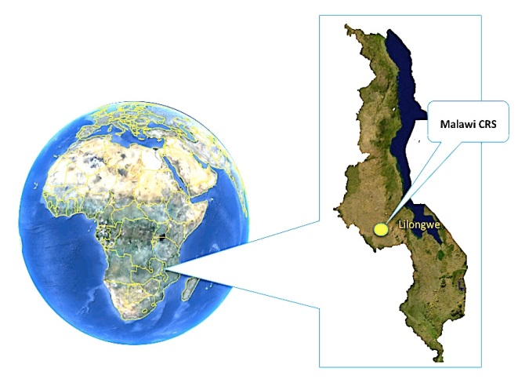

* 1. 10C.1 Introduction

**Malawi,** located in Southern Africa, is a small land-locked country with a population of approximately 15 million, 80% living in rural communities. Malawi borders on Zambia to the east and Lilongwe is 385 miles from Lusaka and the Lusaka CRS. Lilongwe, the nation’s capital, is the country’s largest city with a population of 700,000. The HIV/AIDS prevalence among adults aged 15-49 is 11%, with the majority of infections occurring in women (60%). Of the nearly 1 million infected individuals in Malawi, approximately 10% are children. Health indicators have improved in recent years but remain poor compared to other countries in the region with a maternal mortality rate of 675/100,000 births, under-5 mortality rate of 112/1000 births, total fertility rate of 5.7, and average life expectancy of 52 years.

The **Malawi CRS** is based in Lilongwe and has been active in NIAID network research since 2001. This research site is among the largest, most productive, and most comprehensive HIV clinical research sites in the world. Our site investigators, led by **Mina Hosseinipour** and **Francis Martinson**, have been highly active in the scientific leadership of the networks. We have recruited large numbers of HIV-infected men, women, and children into 19 network protocols. We have invested heavily in the necessary research infrastructure to identify HIV serodiscordant couples and adults with acute HIV infection, two critical populations for HIV research. We have demonstrated our capacity to enroll these special populations into complex clinical trials of innovative prevention and treatment strategies. Our commitment for the next grant cycle is to continue to enroll and retain large numbers of patients on a broad array of studies in each of the five NIAID networks (Adult HIV Therapeutic Strategies Network, Maternal-Pediatric Network, Integrated Prevention, Microbicides, and Vaccines), to continue training the next generation of US and Malawian investigators, and to build additional capacity for the benefit of the Malawian people.

The Malawi CRS is housed within the **UNC Project Malawi**, a 20-year collaboration between the University of North Carolina at Chapel Hill and the Malawi Ministry of Health. The mission of the Project is to identify innovative, culturally acceptable, and affordable methods to improve the health of the people of Malawi through research, health service strengthening, prevention, training, and care. The project is based at our 20,000 ft2, state-of-the-art Tidziwe Centre, on the campus of the Malawi central region referral center, Kamuzu Central Hospital (KCH), with additional free-standing project buildings at Bwaila District Hospital and Area 18 Health Centre. All facilities are within a few kilometers of each other in Lilongwe. In total, the project maintains 45,000 ft2 of space and employs 320 staff. Numerous faculty from UNC-Chapel Hill Institute for Global Health & Infectious Diseases, Cancer Center, Departments of Surgery and Ob-Gyn, and the School of Public Health either live full time in Lilongwe or frequently travel here. Our primary local partner is the Ministry of Health, which oversees the operation of all UNC Project facilities. We also cooperate closely with the University of Malawi College of Medicine, our primary academic partner, which has a campus next to our research facility where our faculty are integrally involved in medical student education. Long-standing training activities at our site include the Fogarty AIDS International Training and Research Program (in its 13th year), the Fogarty Global Fellows Program (in its 1st year), the Fogarty International Clinical Fellows and Scholars Program (3 years supported), the Doris Duke International Scholars Program (in its 5th year), and the Medical Education Partnership initiative (MEPI), funded by the NIH and PEPFAR (in its 3rd year). All programs work to increase the number of Malawians qualified to assume scientific leadership positions in our organization.

* 1. 10C.2 CRS Performance and Experience

The Malawi CRS currently participates in four NIAID networks: ACTG, HPTN, IMPAACT, and MTN. Our track record demonstrates capacity to enroll key target populations, including (1) HIV-positive, HIV-negative and acutely infected adults, (2) HIV serodiscordant couples, (3) HIV-infected, HIV-exposed and HIV uninfected children, (4) HIV-infected pregnant women, and (5) Adults and children co-infected with TB. Our site is consistently among the top enrolling sites into network protocols, highlighting the strengths of community engagement, recruitment process and our local reputation. Our large non-network portfolio allows us to leverage different research opportunities and create economies of scale. For example, we have participated in NIH research including the Center for HIV/AIDS Vaccine Immunology (CHAVI) and the National Cancer Institute (NCI) AIDS Malignancy Consortium, as well as the International Partnership for Microbicides and the Malaria Vaccine Initiative. We have also conducted large, single site clinical trials, including the CDC-funded BAN study 171,192,203-206,325-327,365,391,393,439-442 and operational research activities funded by USAID, WHO, Doris Duke Charitable Foundation and the Malawi National AIDS commission. In the past 7 years, the UNC Project Malawi has enrolled nearly 9000 patients in clinical trials (Table 10C.1).

Table 10C.1: Summary of UNC Project and Malawi CRS study participation and performance

| Study | Population, Brief Study description | | Enrolled | | Retention | | Comment | | |
| --- | --- | --- | --- | --- | --- | --- | --- | --- | --- |
| Microbicides | | | | | | | | | | | |
| HPTN 035231,267 | | HIV uninfected women comparing condoms, Placebo gel, PRO 2000 or Buffer Gel | | 600 | | 95% | | Top enrolling site | | |
| MTN 015 | | Sero-converters during microbicide trial | | 14 | | 100% | | Substudy of HPTN 035 | | |
| IPM 015 | | Phase 1 HIV uninfected women using Dapivarine Ring | | 16 | | 94% | | Closure prior to target | | |
| MTN 020 | | Phase 3 HIV uninfected women using Dapivarine Ring | | - | | - | | Opening Q1 2013 | | |
| HIV Prevention | | | | | | | | | | |
| HPTN 0522 | | HIV discordant couples: Comparison of Early versus Delayed ART on prevention and clinical outcomes | | 251 couples | | 90% | | Top enrolling site | | |
| HPTN 062 | Behavior intervention for acute HIV | | 24 | | 100% | | Single network site | | |
| MP3 | ART and behavioral intervention for acute HIV | | 10 | | - | | Enrolling 3/month | | |
| Adult Therapeutics | | | | | | | | | |
| ACTG 517535,438 | HIV infected ART naïve individuals with CD<300 | | 110 | | 92% | | Top 10 enrolling site | | |
| ACTG 519977,83 | Neurological Sub-study of 5175 | | 78 | | 97% | | Top enrolling site | | |
| ACTG 5185 | Genital Secretion Sub-study of 5175 | | 88 | | 92% | | Top enrolling site | | |
| ACTG 522136 | HIV infected TB patients with CD4< 250 | | 83 | | 96% | | Top enrolling site | | |
| ACTG 520837-39,46,85 | HIV infected women with/without sd-NVP exposure | | 68 | | 92% | | Top 5 enrolling site | | |
| ACTG 523034 | HIV infected patients failing first line therapy: Treated with Lopinavir/ritonavir monotherapy | | 40 | | 100% | | Top enrolling site | | |
| ACTG 5253 | HIV infected subjects: Screening for TB | | 23 | | 100% | | Closure prior to target | | |
| ACTG 5271 | HIV negative adults for neuro-cognitive values | | 241 | | 93% | | First to complete study | | |
| ACTG 5273 | HIV infected patient failing first line therapy | | 51 | | - | | 2nd in enrollment | | |
| ACTG 5274 | Empiric TB therapy in HIV patients (CD4< 50) | | 34 | | - | | 8 new patients/month | | |
| ACTG 5279 | Therapy shortening for Latent TB in HIV patients | | - | | - | | Pending | | |
| ACTG 5264 | HIV infected KS Patients with limited disease | | 13 | | - | | Top enrolling site | | |
| ACTG 5263 | HIV infected KS Patients with advanced disease | | - | | - | | Opening Q1 2013 | | |
| ACTG 5282 | Test and Treat for Cervical Cancer Screening | | - | | - | | Opening Q1 2012 | | |
| ACTG 5288 | HIV infected subjects failing second line therapy | | - | | - | | Opening Q1 2013 | | |
| ACTG 5297 | HIV/Malaria: Evaluation of Lopinavir/r to treat asymptomatic parasitemia | | - | | - | | Opening Q1 2013 | | |
| Maternal Child Prevention and Therapeutics | | | | | | | | |
| IMPAACT 1077 | HIV infected pregnant women with CD4 > 350 cells and their infants | | 360 | | - | | Top enrolling site | | |
| Ban Study203 | HIV infected pregnant women with CD4 > 250 cells and their infants | | 2369 | | 90% | | Single site study | | |
| IMPAACT 1060306,433 | HIV infected children with/without sd-NVP exposure | | 38 | | 93% | | Site added to complete enrollment | | |
| IMPAACT 1068 | Malaria sub-study for IMPAACT 1060 | | 31 | | 100% | | Top 2 enrolling site | | |
| IMPAACT 1079 | HIV infected children on ART with Malaria | | 4 | | - | | Recruiting. | | |
| Vaccine | | | | | | | | |
| Malaria Vaccine302,443 | Healthy Infants, RTSS Phase III, 3 years f/u | | 1600 | | 93% | | Top 5 enrolling site | | |
| CHAVI 001 | Acutely infected HIV infected subjects | | 97 | | 90% | | Top enrolling site | | |

**Adult Therapeutics**: From 2006 to 2012, our site was the 8th highest enrolling international site overall for ACTG, with a total of 829 adults recruited into treatment protocols (Table 10C.1); in 2012, we ranked 5th among international sites in recruitment. Consistently, we are among the top 10 sites for enrollment (eight studies), and are the lead site for four protocols. To date, we have contributed masthead authorship on five ACTG studies, resulting in 12 publications.34-39,46,77,83-85,438 The Malawi CRS has met ACTG all network metrics for data management, monitoring, regulatory and CAB engagement. Due to the network delay in the opening of several international study protocols, our accrual rate of new patients on intervention trials fell below network standards in 2011. Since the studies opened, our site rapidly increased enrollment above network standards with 97 subjects enrolled in ACTG studies for this evaluation year. We are currently enrolling into 4 trials including A5264 (limited stage KS) and A5274 (empiric TB therapy for mortality reduction in patients with CD4< 50 cells) for which Dr. Hosseinipour serves as Protocol Chair. An additional 5 trials (A5288, A5263, A5297, A5282, A5279) are slated to open in Quarter 1 of 2013. We also have one of the shortest average times to regulatory approval among ACTG sites.

**Maternal Adolescent and Child Health**: From 2006 to 2012, our site was the 6th highest enrolling international site for IMPAACT, with 1022 mothers and infants participating in network protocols. We have participated in four studies to date, including P1060 (ART outcomes of children with/without single dose NVP exposed),306,433 P1068 (malaria sub-study of P1060), and P1079 (malaria-antiretroviral PK study). Our team is also the highest enrolling site worldwide for the 1077 PROMISE protocol (n=360), an accomplishment made possible by strategic, forward-thinking investments by our group to recruit and retain HIV-infected pregnant women and their infants. We have met network standards in data management, regulatory process, and CAB engagement. Our external performance monitoring was noted to be sub-optimal during the most recent evaluation year, prompting a review and revision of our quality management policies and standard operating procedures. Our team has introduced additional safeguards to ensure data quality and subsequent monitoring reports have demonstrated consistent trends of improvement.

**Integrated HIV Prevention Strategies**: We were the highest accruing site in the landmark HPTN 052 study2,268, enrolling 251 discordant couples and maintaining 90% retention of the index cases after up to 5 years of follow-up. Irving Hoffman and Dr. Hosseinipour were critical 052 team members and participated in the development of the protocol, the ongoing analyses and are members of the 052 publication committee. For the single-site HPTN 062 protocol, which studied adults acutely infected with HIV, we successfully enrolled 24 acutely infected subjects with 96% retention over an intense follow-up schedule. Currently, we are continuing our efforts in HIV prevention among acute HIV infection cases in our MP3 study, a clinical trial comparing a novel ART intervention and behavioral intervention for HIV prevention.

**Microbicides**: Our MTN efforts include the HPTN 035 study (completed 2008) where we were the top enrolling site231,267. We also enrolled 14 subjects into the ongoing companion sero-converter protocol (MTN 015). Our retention rate for HPTN 035 was 95% and our data management met network standards. We were not able to participate in the VOICE trial due to new Malawi regulatory requirements for clinical trial insurance. This is an important policy to ensure patient safety; however, we were unable to work out the logistical issues – which were new in Malawi at the time – within the network’s required timeframe. We have since worked closely with the National Health Sciences Research Committee and the Pharmacy Medicine and Poison’s Board (Malawi’s equivalent to the US FDA) to identify an appropriate insurance provider to allow subsequent submissions to proceed more smoothly. These efforts resulted in our recent approval for MTN 020 (ASPIRE), a randomized trial of the dapivirine vaginal ring for HIV prevention among HIV-uninfected women. We had previously completed a phase 1 trial of the dapivirine ring as part of the International Partnership for Microbicides (IPM 015 protocol) and are invested in the development of this promising intervention.

**Vaccine Efforts**: Our site has not yet participated in any HVTN activities. However, we have been nominated as an international site for future participation and have in place the required infrastructure to participate if chosen as a network site. Specifically, we have existing infrastructure to collect and ship laboratory specimens for vaccine related research including proficiency in storing PBMCs. The CHAVI study identified acutely HIV infected individuals and collected specimens on a regular basis to establish a repository for basic science research. The BAN study collected breast milk, PBMCs and other specimens. Our site maintains a liquid nitrogen production plant and has systems for shipping specimens on either liquid nitrogen or dry ice according to international requirements. In order to implement the GSK funded Phase 3 malaria vaccine (RTS,S/AS01) efficacy study 302, our site developed additional procedures to conduct FDA NDA vaccine research, established a vaccine pharmacy and GIS-backed community-based subject monitoring.

* 1. 10C.3 Proposed Research Areas

In the coming grant cycle, the Malawi CRS will align with five NIAID networks: adult therapeutics, integrated HIV prevention strategies, maternal/adolescent/child therapeutics, microbicides and vaccines. Based on our experience with CHAVI444 and our phase III RTS,S/AS01 malaria vaccine trial302, we are prepared to join the network for HIV vaccines. We will continue our track record of high performance, both in recruitment and retention, across a broad range of network protocols. We will also continue providing scientific leadership to the adult therapeutics and integrated HIV prevention networks, with focused efforts to bring in young expatriate and Malawian investigators. From the catchment population of 750,000 with an HIV prevalence of 11%, the Malawi CRS will recruit from the following populations:

* HIV-1 infected patients co-infected with or at risk for tuberculosis (40,000 per year) for inclusion in adult therapeutic trials
* HIV-1 infected patients on therapy (> 40,000) to explore the impact of inflammation/activation for those who are successfully treated and to contribute to second and third line therapy studies
* HIV-1 infected individuals with malignancy, especially KS (563 cancer registrations in past 3 years) and cervical cancer (570 in past 3 years) or at risk for cervical cancer (15,0000 women per year)
* HIV-1 infected pregnant women or women of child bearing potential (15,000 per year)
* HIV-1 infected or exposed infants and children (2,000 per year)
* HIV-1 uninfected individuals at high risk of infection for inclusion in studies of microbicides, integrated prevention, PrEP and vaccines. Currently, the STI clinic has nearly 14,000 visits, representing 7000 new patient visits per year, of which 60% are HIV negative and an estimated 1% are acutely infected.
* HIV-1 acutely infected, screened from patients with an STI, at a rate of approximately 20 per year.

Central to our plan to efficiently identify eligible patient populations across our scientific agenda are the extensive HIV counseling and testing services offered by the UNC Project and our partners (Table 10C.2). The HIV prevalence at our testing locations ranges from 9% to 40%. These programs identify HIV-positive individuals for therapeutics trials (inpatient and outpatient), HIV-negative subjects for prevention, and pregnant women for PMTCT activities. Couples counseling and partner testing are promoted at all testing locations enabling us to enroll discordant couples. Importantly, our holistic HIV testing program provides the framework for integrated prevention strategies. Notably, our site has experience in identifying acute HIV infections using HIV RNA pooling methods. This novel group of individuals plays a critical role in understanding early immune processes, critical to vaccine development and cure agendas.

Table 10C.2: 2012 HIV testing service at our Lilongwe clinic and hospital locations

|  |  |  |  |  |
| --- | --- | --- | --- | --- |
| HIV testing location | HIV prevalence | # Tested Annually | % Women | % Couples |
| Sexually Transmitted Clinic at KCH | 40% | 9000 | 60% | 1% |
| Medicine Inpatient Ward at KCH | 40% | 6500 | 50% | N/A |
| Surgical Inpatient Ward at KCH | 12% | 6000 | 32% | N/A |
| Pediatric Inpatient Ward at KCH | 9% | 10,000 | 50% | N/A |
| Antenatal Clinic Bwaila Hospital | 14% | 14,000 | 100% | 10% |
| Lighthouse Counseling and Testing | 50% | 10,000 | 65% | 10% |

**Access to patients on or needing treatment (adult and pediatric):** With respect to therapeutics (adult, adolescent, child), our efforts are complemented by the highly successful Malawi ART program which has initiated over 350,000 HIV infected individuals on ART since the roll-out began in 2004. Our primary recruitment and post-trial ART access sites are the Lighthouse Trust’s comprehensive HIV clinics, where several UNC faculty members directly provide clinical care. The Lighthouse clinic at KCH is immediately adjacent to UNC Tidziwe Centre and the Lighthouse clinic at Bwaila is approximately 100 meters from our Bwaila research building. We have worked with the Lighthouse since its inception in 1999. The Lighthouse director and CRS Advisory Group member, **Sam Phiri PhD**, is a UNC Fogarty AITRP graduate and an adjunct faculty member at UNC-Chapel Hill. The Lighthouse has approximately 20,000 patients on ART, 5000 in pre-ART care, and registers 450 new antiretroviral naïve enrollees per month, of whom 10% are children. Approximately 4% of the cohort is on second line therapy and approximately one-third of the cohort has been on therapy > 4 years, thereby providing a large population for treatment trials for second and third line therapy or trials requiring long-term suppressed patients for evaluation of chronic inflammation and long term consequences of HIV and ART therapy. Comprehensive services provided at both clinics include HIV VCT (10,000 per annum), HIV and ART care (25,000 in care), family planning (300 visits per month), cervical cancer screening (200 women per month), and palliative care. Also, we will engage additional health centers in Lilongwe district for recruitment such that the access to HIV-infected patients exceeds 40,000 individuals. In addition to the Lighthouse, which has over 2,000 children and adolescents in care, we work with the Baylor Centre of Excellence, located on the KCH campus. **Peter Kazembe MD**, long-time scientific advisor for the UNC Project Malawi, serves as the Executive Director. The Baylor group follows a cohort of 3000 HIV-infected children and maintains an HIV-exposed infant cohort. An adolescent club meets once per month.

**Access to TB patients (adult and pediatric):** The Lighthouse Bwaila location has a fully integrated TB/HIV program, the largest in the country. Over 4000 patients are assessed in the clinic each year and approximately 150 new TB cases (10% children) are registered monthly at this location. The prevalence of HIV among TB patients is 70%, and among patients initiating ART, the incidence of TB case detection is 3/100 person-years (p/y), providing a strong basis for TB focused research including trials such as A5274 and A5279.

**Access to HIV infected pregnant women:** The Bwaila location also houses Malawi’s largest PMTCT site for “Option B+” (i.e., lifelong ART for all pregnant women) services.445 Over 15,000 women are tested for HIV annually, of whom 14% are HIV positive. The Bwaila clinic serves as the PMTCT program’s Center of Excellence and provides an excellent infrastructure for patient recruitment into clinical trials and implementation studies. With the Malawi Ministry of Health, UNC Project has implemented a USAID-funded PMTCT program at 130 clinics in 5 districts, further expanding our potential recruitment population.

**Access to high-risk HIV negative subjects:** Our previous microbicide work provides significant guidance as to best strategies for identifying high risk women for participation in female oriented prevention research. In HPTN 035, the incidence of HIV among our recruited population was 1.6/100 p/y. However, sub-group analysis suggests that targeting those < 25 years of age and living in urban centers yields an incidence of 2.5/100 p/y. Targeting this young population aligns with both the Microbicides and the Integrated HIV prevention network’s goal of HIV prevention in young women in Southern Africa. Additionally, our preparatory work for PrEP trials identified bars, bottlestores and resthouses where substantial numbers of men and women engage in commercial sex work as recruitment sites for PrEP and other prevention trials. The KCH and Bwaila STI clinics also provide significant numbers of high-risk women (Table 2). Additionally, we have demonstrated an HIV incidence of 3.7/100 p/y among pregnant women attending the Bwaila Antenatal clinics.366 We can enroll at least 500 high risk patients annually.

**Proposed community engagement plans**: The Malawi CRS and UNC Project have a robust community engagement plan that has functioned well for 12 years. Our Community Advisory Board includes 24 members representing all components of Lilongwe society, and meets bi-monthly to review potential studies. Our community outreach nurses conduct community education, tracing of study participants who have missed appointments, and work with a drama troupe that helps with health education (see Component 6).

* 1. 10C.4 Organizational Structure

Macintosh HD:Users:harmonychi:Documents:PROPOSALS:CTU 2013:Org charts:Malawi CRS.pdfThe Malawi CRS has a central management scheme similar to the other 4 CRS within the UNC Global HIV CTU. Department heads report to the leadership team (See organogram). Within each department, established chains of command exist to ensure organization of the department. Notably, all senior staff have greater than 5 years of experience with the Project. For study implementation teams, departments assign key personnel so each study has designated staff for clinical, laboratory, pharmacy, data/QA, nursing, and community activities. CRS leadership (CRS Leader, CRS coordinator, Network Liaisons, and Department heads) meet monthly to keep all senior staff informed of critical developments, while network teams meet weekly with the respective network liaison in attendance. Staff offices are all in Tidziwe on the same floor, allowing daily communication. All members have computers connected to LAN for easy email communication amongst themselves as well as the CTU leadership and the NIAID staff.

Figure 10C.1: Organizational structure of Malawi CRS

* + 1. 10C.4.1 CRS Leadership

**Francis Martinson MD, PhD,** will serve as the **Malawi CRS Leader**, where he will be responsible for the overall performance of the clinical research site. Dr. Martinson is a Research Associate Professor at the UNC School of Medicine and a trained obstetrician-gynecologist and epidemiologist, who has lived in Malawi since 1999. Dr. Martinson has been highly engaged in many UNC Project Malawi trials in the areas of maternal-child health (HPTN 024, the BAN study, PROMISE), microbicide HIV prevention (HIVNET 016, HIVNET 016A, HPTN 035, MTN 015, IPM 015), and vaccines (Malaria Vaccine Initiative RTSS, CHAVI 001). 171,189,190,192,204,226,230,236,237,267,271,302,327,361,384,385,390-393,396,446-453 As the CRS Leader for the past 12 years, Dr. Martinson is responsible for all aspects of the CRS including supervising budgetary issues, regulatory affairs, data quality, enrollment, relations with the MOH, clinical management, patient safety and adverse event reporting, and study selection to ensure relevance and feasibility. He meets with his leadership team monthly and is accessible daily to department leaders.

**Debbie Kamwendo MS** will serve as the **CRS coordinator**. The roles and responsibilities of the CRS coordinator have previously been described (Component 2). Since 2004, Mrs. Kamwendo has served as the Laboratory Director at UNC Project Malawi, where she successfully oversaw laboratory compliance to external quality standards. She serves as the UNC PI for the CDC-funded Malawi College of Medicine/UNC/Loma Linda Lab Consortium, a program that provides capacity building for public sector laboratories. Through these activities, she is responsible for a multi-site PIMA CD4 implementation project and a DBS HIV RNA validation study, both currently in the field. Given her experience with lab management across networks and implementation research, she will easily translate these skills to overall CRS coordination. In anticipation, she has been working with Dr. Hosseinipour, the current CRS coordinator, to ensure a smooth transition.

* + 1. 10C.4.2 Network Liaisons and Other Investigators

The role of the Network Liaisons is two-fold. First, the liaison works with CTU and CRS leadership to prioritize study selection and recruitment targets, balancing available protocol implementation funds, investigator interest, patient population required, national interests, and network priorities. Second, they drive the leadership group’s scientific agenda by writing concepts for new protocols and serving on network scientific committees. The Liaison attends network meetings and informs the site of protocols in development. Our liaisons for each network include senior, accomplished investigators as outlined in the biosketches and promising junior investigators with clear mentorship plans. Over the course of the grant cycle, we expect Malawian investigators to assume the key leadership roles. Each liaison has experience in managing protocols in their area of expertise as well as contributing to the scientific agenda of their respective leadership groups.

**Adult Therapeutics Network**: **Cecelia Kanyama MD** will serve as the Network Liaison for the Adult Therapeutics Network. From 2002 to 2007, Dr. Kanyama worked as study physician and coordinator for numerous NIAID network trials, both for the ACTG (A5175, A5208, A5199) and for the HPTN (052).38,77,83,85 Through sponsorship from UNC, she completed her Internal Medicine residency in South Africa and returned in November 2012 to assume a leadership role within the Malawi CRS, where she is currently the Investigator of record for A5279. Dr. Kanyama will work hand-in-hand with Dr. Hosseinipour over the first year of the new grant cycle, to ensure a smooth transition into this new Network Liaison role.Key investigators of the Adult Therapeutics team will cover specific topical areas, including HIV-associated malignancies (Agnes Moses), tuberculosis (Cecelia Kanyama), and treatment failure and drug resistance (Mina Hosseinipour). In addition to network experience, this adult therapeutics team has conducted extensive research with partners in the Malawi ART program.117,120,171,225,227,305,328,360,361,363,421,446,452,454-468. In addition, we will draw from the expertise of on-site Ob-Gyn and Oncology faculty (Table 10C.3) as needed.

**Maternal, Adolescent and Pediatric Therapeutics Network: Portia Kamthunzi MBBS MS,** a qualified pediatrician, will serve as Network Liaison for this NIAID network. Dr. Kamthunzi joined UNC Project in 2007 after completing her Master’s degree in Tropical Pediatrics in the UK and working at the Baylor Pediatric Treatment Center of Excellence in Lilongwe. She serves as Investigator of Record for IMPAACT P1060, P1068, and P1079 and as a co-investigator for PROMISE P1077BF and the Malaria Vaccine trial. She is a member of the IMPAACT Malaria working group. She has demonstrated substantial academic productivity with her work with UNC, including publications in pediatric HIV treatment,306,433 malaria vaccines,302,443 and implementation science.362,469 Dr. Kamthunzi will be supported by senior investigators Mina Hosseinipour, Francis Martinson, and Peter Kazembe. This team will be further strengthened in 2014 with the return of **Dumbani Kayira**, a former study physician for the BAN Study171,192,204,205,325-327,391,439,441,442 who is currently completing his Pediatrics specialty training in South Africa. Complementing this strong expertise in pediatric HIV will be the members of the adult therapeutics team, with experience in maternal and adolescent HIV research.34,171,192,203-205,225-227,328,365,366,393,439,448,450,462,470,471

**Integrated HIV Prevention Network**: **Mina Hosseinipour MD MPH** will serve as the Network Liaison for the Integrated HIV Prevention Network. Dr. Hosseinipour’s scientific accomplishments have been discussed at length (See Component 1), in particular her strong leadership – both at the protocol and at the site level – for the HPTN 052 protocol. She will apply lessons learned from these experiences to develop the integrated prevention strategies focused on discordant couples, adolescents and pregnant women. As Chair of the Integrated HIV Prevention Network Science Team, she will also provide strategic direction to our unit’s future work in this important area, including the use of combined strategies to maximize prevention gains.

**Microbicide Network**: **Lameck Chinula MBBS** will serve as the Network Liaison for the Microbicide Prevention Network. Dr. Chinula is a Malawian physician with extensive experience with microbicide trials, having served as medical officer and study coordinator for the HPTN 035 study. He is currently completing his Ob-Gyn training in South Africa – again, sponsored by UNC – and will return to take a leadership role in the Malawi CRS when he returns in 2013. Dr. Chinula will be mentored by Dr. Martinson, the Malawi CRS Leader and an experienced investigator within the NIAID networks.

**Vaccine Network**: **Irving Hoffman PA, MPH** will serve as Network Liaison for the HIV Vaccines Network. He has been a lead investigator for the CHAVI network and the Malaria Vaccine Initiative for our site302 and serves as the International Director for the UNC Project. Over the 20 years that he has worked in the Lilongwe site, he has played a key scientific role and accumulated publications in all research areas that have been developed by the UNC Project.2,171,182,183,188,190,192,195,204,225-227,230,235-237,239,241,265,267,270,271,302,361,362,366,384, 385,390,392,393,396,446-452,460,461,472-475 In addition to scientific leadership, as the International Director, he coordinates CRS finances and communication between UNC Project, UNC-Chapel Hill and the Malawi CRS and provides mentorship across the networks. Professor Hoffman will play a key, strategic role as UNC seeks to become involved in this new area of collaborative science.

Alongside the Network Liaisons, the Malawi CRS has identified a talented pool of Malawi-based investigators who will be available to participate in study leadership in the coming grant cycle. They include:

Table 10C.3: Malawi-based investigators

|  |  |  |  |
| --- | --- | --- | --- |
| Investigator | Position | Research Interests | Network Involvement |
| Satish Gopal | Infectious Diseases Oncologist | KS and HIV related cancer | ACTG 5263, 5264, 5282 |
| George Liomba | Pathologist | KS and HIV related cancer | ACTG 5263, 5264, 5282 |
| Jeff Wilkinson | Obstetrician/Gynecologist | Woman’s Health/Cervical Cancer | IMPAACT/MTN |
| Jennifer Tang | Obstetrician/Gynecologist | Woman’s Health/Cervical Cancer | IMPAACT/MTN/ACTG |
| Agnes Moses | Internal Medicine | HIV related cancer | ACTG 5263, 5264, 5282 |
| Nora Rosenberg | Epidemiologist | HIV Social Networks | HPTN 062 |
| Gloria Hamela | Social Scientist | Qualitative research | HPTN 062 |

* + 1. 10C.4.3 Advisory Group

The Advisory Group is made up of representatives of key partner institutions – the Ministry of Health (**Frank Chimbwandira**), the Lilongwe District Health Management (**Mwawi Mwale**), Kamuzu Central Hospital (**Noor Alide**), Lighthouse Trust (**Sam Phiri**), Baylor College of Medicine Children’s Foundation/Malawi (**Peter Kazembe**), and University of Malawi College of Medicine (**Ken Maleta**) (See Letters of Support or Biosketch). This body will meet with CRS Leadership semi-annually for briefings on CRS research priorities, planned activities, and study progress updates. The group provides scientific and policy guidance and feedback to the CRS on local research priorities and implementation of key research findings.

* + 1. 10C.4.4 Research Operations

The CRS leadership is supported by strong, experienced department heads as detailed below.

**Laboratory Director**: **Gerald Tegha, MSc**, and **Robert Krysiak, MS**, currently serve as Co-Directors for the UNC Project and the Malawi CRS laboratory (See Laboratory: Component 8). Mr. Tegha is a Malawian and holds a diploma in Medical Lab Technology from the Malamulo College of Medical Sciences, a Bachelors of Technology and Master’s degree in Laboratory Sciences from Nelson Mandela Metropolitan University in South Africa, funded by UNC. He has tremendous practical experience in clinical trial implementation both with CDC and NIH sponsored clinical trials192,203,204,206,440. In the 12 years that he has worked at our site, he has served as the laboratory supervisor for the BAN study, the assistant laboratory manager and most recently as the laboratory manager for the UNC Project. He manages a staff of 33 laboratory professionals and support staff, ensures that Good Clinical Laboratory Practice is observed, and optimizes the running of all seven laboratory departments. As we have been active in AACTG, IMPAACT, HPTN and MTN studies, he is familiar with the requirements of all networks and serves on the Joint AACTG/IMPAACT laboratory technologists committee since July 2011. Mr. Tegha is the PI of several laboratory based studies, including the evaluation of rapid diagnostic malaria tests and molecular methods for malaria speciation. He is evaluating the role of monocyte and dendritic cell function as contributing factors to increased malaria severity in infants compared to adults. Robert Krysiak, M.S. Microbiology, has worked with UNC Project and UNC-Chapel Hill for 15 years and is responsible for the construction and planning of all laboratory structures and has developed our Tuberculosis and Pathology laboratories. He is an investigator in our TB diagnostics and resistance studies.189,190,204,385

**Pharmacy Supervisor**: **Dorothy Sichali** serves as the pharmacy supervisor and Pharmacist of Record. Wilberforce Mhango serves as the Back-up Pharmacist of Record. Mrs. Sichali and Mr. Mhango have worked with the project since 2004 and 2005, respectively. (See Pharmacy: Component 7) The Pharmacy Department employs 6 pharmacy technicians and includes a central investigational pharmacy and three dispensaries with over 70m2 of temperature controlled space, access to refrigeration and a newly commissioned chemotherapy hood. The pharmacy consistently meets network standards for monitoring with no major findings in the current grant cycle.

**Community Activities Coordinator**: **Nelecy Chome BS** assumed the community supervisor role in 2010 after serving as the Malaria vaccine community nurse representative and working in the community department since 2006. (See Component 6). The community department includes 6 community educators and 10 field tracing staff. Ms. Chome supervises all community activities including communication and organization of the CAB, community education and study dissemination plans, recruitment and retention strategies, and participant tracing. Our community engagement activities have resulted in our site having the highest recruitment for many network studies, while maintaining greater than 90% long term retention (Table 10C.1). Our community department has developed innovative strategies to ensure consistent recording of the outcomes of tracing visits, piloted the use of cell phones for tracing and communication, and developed incentive programs for consistent study participation. The community team meets monthly as a group. Each team member is assigned to a network, and also attends the weekly study meetings for that network.

**Data Management**: **Nkhafwire Mkandawire MPH** has served as the Data Manager of the project since March, 2008, and has worked with the project since 2002 (Data Management: Component 9). The Data group includes regulatory, data and QA divisions. We maintain 2 regulatory officers, 3 data coordinators, 11 data officers, 6 QA/QC Officers, 6 data associates, and 12 data assistants.  The data department consistently meets network standards for data quality. The Data management team meets monthly as a group and data and QA/QC representative attend weekly meetings of their respective networks.

**Administration: Innocent Mofolo BS, MS** has worked with the project since 2005. Mr. Mofolo has an extensive background in program implementation and operations research and is the Director of the Lilongwe Medical Relief Trust, the service arm of the UNC Project. Its activities include the USAID funded Safeguard the Family program that provides PMTCT technical support to >130 clinics in 5 districts in Malawi, serving 153,000 pregnant women and their families annually. He meets daily with CRS leadership. The administration department includes security, human resources, and secretarial staff.

**Finance**: **Arthur Sungitsa BA** has been the finance manager for the project since 2002. The finance department has 1 accounts supervisor and 6 accounts officers. (Finance, Component 5). The Finance office manages $10 million in grants annually. Since the inception of Annual External Financial audits 3 years ago, there have been no significant findings.

**Information Technology (IT):** Previously, IT was embedded within the Data department but was newly established as an independent department in 2009 to better maintain the critical communication lines required for efficiency of the Project. **James Chirwa** is the IT Specialist and is assisted by **Mike Owino**, IT Consultant, (based in the US), 2 IT officers and 1 IT assistant. (Communication, Component 4). Our site maintains both satellite and fiber connections to ensure continuous access to high speed internet.

* + 1. 10C.4.5 Community Advisory Board (CAB)

Malawi CRS has one Community Advisory Board (CAB) that acts as a liaison between the research site and the communities in its catchment area. It acts as the eyes and ears of the CRS in the community and promptly notifies the CRS leadership of any concerns of the community regarding its research activities and also helps inform better research operational approaches in the communities. The 24 non-CRS members work with CRS Community Educators to form the CAB team. The non-CRS members are nominated by their communities after consultation with chiefs and elders of the communities. The catchment area for the CRS has been divided into 24 operational areas based on population size, ease of access and previous level of participation in research studies conducted at the CRS. The CAB currently meets bi-monthly and is associated with the HPTN, AACTG, IMPAACT and MTN networks and other non-network sponsored studies. All CAB meetings take place at the CRS and non CRS-employees have access to the Community Educators office resources to help them better support their voluntary efforts to help achieve the CRS’s goals, including informing the community.

* 1. 10C.5 CRS Administration

The Malawi CRS maintains efficiency in its operations by following similar procedures for all studies. All department heads are responsible for supervision and coordination across all networks, including allocation of resources and staff depending on accrual expectations. Since the CRS has a well-functioning, cohesive team located in offices next to each other, this type of management system has proved highly effective.

The Malawi CRS has implemented several innovative approaches for optimizing the support of the clinical research networks. These include 1) training research staff to conduct both interventional and prevention trials, facilitating the movement of staff between studies, 2) using a central lab and negotiating low prices with vendors for reagents, 3) using a central pharmacy and transporting drugs as needed to satellite pharmacy dispensary sites, 4) frequent assessment of accrual and patient volumes to optimize staffing, 5) building capacity by training Malawians to take over responsibilities.

After choosing a protocol for site implementation, the following major steps are followed according to written standard operating procedures to ensure that all protocol activities are conducted in accordance with NIAID and other regulatory requirements.

* Prior to implementation, all staff complete training in Good Clinical Practice and Research Ethics training.
* Assignment of core team leaders by CRS leadership (Investigator, Lead Nurse, Study Coordinator, Lab, Pharmacy, Data and Community representative). This team is responsible for the preparatory steps including regulatory submissions, preparing recruitment and retention plans, creating/modifying protocol specific source documents, development of lab processing charts, and pharmacy preparation.
* Regulatory submissions are closely coordinated with the UNC-Chapel Hill regulatory office to facilitate submissions for common protocols implemented across the CTU. Once approvals and preparatory activities are completed, additional study staff are added according to expected recruitment targets.
* Study specific training takes place stressing key elements of the protocol, case report forms, standard operating procedures, and clinic flow. Prior to implementing any study, the team will conduct “dry runs” of enrollment and follow-up visits so as to better inform clinic flow and allow modifications to the study SOPs. Thereafter, “wet runs” that include sample processing take place. Enrollment begins slowly to allow the team to determine any additional problems prior to full implementation of the recruitment plan.
* Clinical Quality Management Plan: all files receive 100% QA by senior quality management staff in the opening stages of the protocol. Investigators review all eligibility checklists, consent forms and perform QC on the screening and enrollment visits to ensure no enrollment or consent violations.
* Each study team holds a weekly meeting where each department provides feedback on the progress of their department related to the study. The study meeting provides an opportunity for ongoing training if required. Proceedings are minuted and circulated to CRS management and department heads.

Monitoring visits provide an additional opportunity for identification of problems. Importantly, any errors are shared across all teams, allowing teams to learn from each other and improve processes across the networks.

* 1. 10C.6 Facilities and Resources

The UNC Project has the facilities, equipment, and infrastructure necessary to conduct high subject volume research in all research priority areas (See Resources, Components 7 (Pharmacy), 8 (Laboratory), and 9 (Other Clinical Research Activities). UNC Project has four sites, all within a 10 minute drive of each other in Central Lilongwe, with the main facility at Tidziwe Centre and satellite centers at KCH STD Clinic, Bwaila Research Site, and George Joaki Centre.

**Tidziwe Centre**: The CRS is based at Tidziwe Centre, headquarters of the UNC Project. Tidziwe Centre, built by UNC in 2003, is located on the campus of KCH, the referral hospital for the Central Region of Malawi and a teaching hospital for the University of Malawi College of Medicine. UNC Project administration and most research studies (adult and pediatric therapeutics, microbicides, and combined prevention) are based at this location. The Centre is a 20,000 ft2, two-story building. Clinic facilities, located on the ground floor, include twenty-two examination and counseling rooms. The sheltered participant registration and waiting area seats 300 persons. Radiology support exists in an adjoining building at KCH, including digital x-ray equipment. Tidziwe Centre houses an 840 ft2 climate controlled investigational pharmacy, a pharmacy dispensary, UNC Project Laboratory Central Receiving Core, Microbiology/Parasitology Departments, Hematology, Chemistry and Serology departments, a 200 ft2 community activity and participant retention office, and two data management offices, including 250 ft2 of secured file storage space. The upper floor of Tidziwe Centre houses 16 administrative offices. Teaching and training facilities include a medical library with UNC supported internet access for reference searches, a 140-seat lecture hall and a 30-seat conference room, and teleconferencing capacity for participation in conference calls with the 4 other CRS leaders, the CTU leadership and the NIH networks committee.

**KCH STD Clinic**: For studies involving STD patients, for identifying female and male subjects at extremely high risk of HIV infection and for subjects with acute HIV, the UNC Project operates the 14000 patient per year KCH STD Clinic. Located on the KCH campus 100 yards from Tidziwe Centre, the facility includes 2000 ft2 of clinical and research space comprising 13 exam/counseling rooms, patient waiting and group counseling area with seating for 100, a data management office, and a secure file storage room. The Clinic has high-speed internet connectivity, and is connected to the Tidziwe Centre main servers. The clinic maintains an electronic clinical data base that is utilized for recruitment and to analyze HIV/STD trends. This site serves as a primary HIV testing facility to refer clients to appropriate clinical trials.

**Bwaila Research Building**: For PMTCT research, the UNC Project operates from Bwaila Hospital, the District Hospital for Lilongwe District, which is located 5 km from Tidziwe Centre. The Bwaila hospital is the location of the Maternity Hospital that includes all maternal and child health services, a psychiatric unit, inpatient tuberculosis hospital and outpatient departments for sexually transmitted diseases and general medicine. UNC project built a 5000 ft2 free-standing clinical research center adjacent to the maternity hospital that includes 10 exam/counseling rooms, meeting room, auxiliary laboratory, pharmacy dispensary, office space, and staff break room. An additional 1500 ft2 free- standing data center includes 2 secure data storage rooms and data stations for 10 data officers. The Clinic and Data Centers have high-speed internet connectivity, and are connected to the Tidziwe Centre main servers. The IMPAACT PROMISE study and previously the BAN study used these facilities to enroll over 3200 mother-infant pairs in PMTCT trials in the past 8 years.

**George Joaki Centre**: Located at the Area 18 Health Centre, a 10-minute drive from Tidziwe Centre, George Joaki Centre, is a newly constructed, 5,200 ft2, two-story facility built by UNC. It currently houses our vaccine related research activities. The facilities include 10 exam and counseling rooms, observation room, on-call room, and participant reception and waiting area with a capacity of 300. Clinical activities at the site are supported by an auxiliary laboratory, pharmacy dispensary, 800 ft2 data management office with secure file storage and 8 data stations, secure data archive room, staff office space, and 20-seat conference room. The second floor houses the Laboratory PCR Department and offices. The Centre has internet connectivity, remote data-entry capacity, and is connected to the Tidziwe Centre main servers. Situated in the middle of residential townships, we have household level geographic (GIS), demographic and health information for the catchment areas (~75,000 people) surrounding this center to facilitate community based investigations.

To support the health facilities and research activities, the UNC Project maintains the following resources.

**Transportation:** UNC Project maintains a transport department staffed by 15 drivers operating 18 vehicles (predominantly twin-cab, 4x4 vehicles), and 3 motorcycles and supervised by a transport supervisor. The transport department supports participant recruitment, tracing study participants who have missed visits, patient transport for after-hours visits (pharmacokinetic studies) or for sick study participants requiring hospitalization, community outreach and education activities, specimen transportation and procurement logistics. Dedicated specimen transportation vehicles are available to transport specimens to the UNC Project Laboratory Central Receiving and Cell Processing Departments according to defined schedules. Project drivers are trained in protection of patient confidentiality, infection prevention, and specimen transportation.

**Storage:** UNC Project maintains a 2,250 ft2 secure warehouse on the campus of KCH, 200 yards from Tidziwe Centre. The warehouse has separate bays for pharmacy, laboratory consumables, data archive, and general storage. Each bay is accessed through a secured steel door, has a fire alarm system, and is treated for rodent and insect control regularly. Entry is access controlled by UNC Project security guards on duty 24-hours a day.

**Data Storage:** Tidziwe Centre, KCH STD Clinic, Bwaila Hospital Clinic, and George Joaki Centre all have on-site secure data storage facilities as described above. Long-term data storage is available through the Warehouse data archive facility. The UNC Project server has secure connections to our UNC-Chapel Hill server. All data on the local server is backed-up daily onto the Chapel Hill server.

**Security:** The Security Department employs 34 security guards who provide round-the-clock security at all UNC Project facilities. Entry to all buildings is controlled by security staff. All facilities are covered by Group 4 Securicor Emergency Response Service and are monitored by closed-circuit television security cameras.

**Back-up systems:** All UNC Project Malawi facilities are covered by back-up generators. The Tidziwe Lab and Investigational Pharmacy are doubly covered by a second back-up generator. We also maintain an on-site diesel fuel sub-depot with 7,000 litre storage tank to ensure availability of fuel for generators and the transport fleet in case of national fuel shortages. All sites have large water storage tanks to carry the facilities through any cuts in supply from the city water system. The site has suppliers for electrical, climate-control, plumbing, structural, refrigeration, liquid nitrogen and dry ice, and ICT maintenance services, who provide scheduled maintenance and are on 24-hour call for maintenance emergencies.

* 1. 10C.7 Opportunities and Challenges

UNC Project and the Malawi CRS leadership continuously examine our processes to determine strategies to improve efficiency and optimize performance in the face of evolving challenges. We regularly solicit feedback from our community advisory board and community department, external advisors, employees, and participants.  Below, we outline examples of how our CRS has and will address challenges.

Malawi has limited medical doctors and scientific leaders. We have added UNC faculty from non-ID disciplines (oncology- Gopal, obstetrics- Wilkinson) to broaden local research expertise. We have also trained Malawian faculty to assume leadership roles within the CTU structure (Moses and Kanyama- Internal Medicine; Chinula- OB/GYN; Kayira and Mvalo- Pediatrics; Oncology- Mwafongo) to address this deficit.

Our standard retention program required field tracing of clients, an expensive strategy that became even more costly with recent fuel shortages. We piloted text messaging and cell phone visit reminders and developed new SOPs for phone tracing as a strategy to reduce overall tracing costs. Through this innovative approach, we were able to maintain retention rates with high satisfaction reported among participants.

Given the challenges of limited internet bandwidth, we introduced additional measures to prioritize data traffic during work hours and allowed a system of oversight to immediately abort high bandwidth activities. We have constructed a network that links all the facilities through a wireless system, plus we have a back-up server at UNC-CH that synchronizes in real time with our server in Lilongwe.

We have consistently recognized the need to expand our facilities and provide adequate space for the required activities as demonstrated by the Tidziwe building, expansions to the KCH STI clinic, and the construction of the Area 18 George Joaki Centre and Bwaila research unit. UNC Project plans to expand its facility at Tidziwe Centre to include new space for a larger data repository, specimen processing and freezer repository facility, clinician offices, administrative offices, and expanded meeting spaces to enhance overall efficiency.

In response to the newly established Pharmacy Medicine and Poisons Board and requirements for clinical trial insurance, we established links between the UNC-CH ethics committee and the Malawi regulatory institutions and engaged in regular meetings with relevant local players to establish guidelines for our institution.  Also, we established a new regulatory team structure involving UNC-CH with regular team calls.

High turnover of trained staff in some departments, particularly laboratory and data, have led to lower data management scores across the networks. As a retention strategy, we have secured funding for one laboratory technician per year to receive a Bachelor’s degree and used our Fogarty AITRP to support master’s degrees. We have developed an in-house training curriculum focused on epidemiology, biostatistics, and scientific writing for staff, with incentives for successful abstract and manuscript submissions.