Macha Research Trust
Annual Report 2011

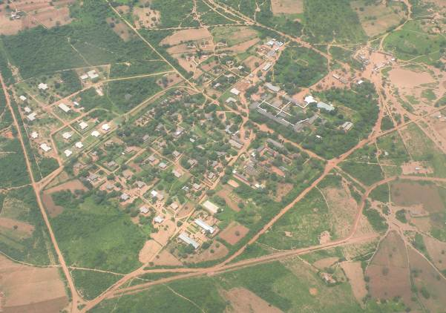

FOREWORD

The Macha Research Trust (MRT) is a unique place -- both in the sense that it is one of the few research institutes in sub-Saharan Africa established in a remote rural area and is in the midst of an area traditionally endemic to malaria, HIV and tuberculosis.

Equipped with molecular biology and clinical research facilities, MRT is a place that can carry out world-class health research for the benefit of humankind, as evidenced by the publications documenting our work over the past years. Our overarching goal is to guide the successful control of malaria, TB, HIV/AIDS, helminthes and other diseases affecting communities in Macha, Zambia and beyond.

This report provides a summary of the various projects that were carried out at MRT during the 2011 calendar year, as well as a brief synopsis of MRT’s on-going capital development efforts, which include the construction of additional staff housing and a new expanded clinical research laboratory facility. The work summarized in this report could not have been accomplished without the dedication of all MRT staff -- from the housekeeping, grounds, maintenance, clerical and technical support staff, to the various scientists involved.

As the designated “malaria field research and education centre” of the Johns Hopkins Malaria Research Institute (JHMRI) at the Johns Hopkins Bloomberg School of Public Health in Baltimore, Maryland, USA, MRT has benefited from core funding, project grants and technical support over the last years.

Additionally, the broadening of the MRT research base to include other relevant diseases such as tuberculosis and HIV/AIDS, has successfully resulted in approved research and program grants, further expanding MRT’s research capacity and international collaborations.

We anticipate that MRT will continue to expand and carry out relevant research programmes to address the issues that affect humanity.

Mr. Mukuwa Kalambo,
Managing Director, MRT

Table of Contents

 | Page
Foreword ………………………………………………………………………. | 2
Table of Contents …………………………………………………………….. | 3
Mission Statement ……………………………………………………….…… | 4
Vision Statement ……………………………………………………………… | 4
Introduction ……………………………………………………………………. | 4
Management Structure ………………………………………………………. | 5
Projects involving Macha Research Trust ………………………………….  Malaria …………………………………………………………………  HIV / AIDS ……………………………………………………………..  Tuberculosis …………………………………………………………..  Other Studies ………………………………………………………….  Other Projects ………………………………………………………… | 6  6  8  10  10  11
Training and Sponsorships …………………………………………………. | 12
Accomplishments ……………………………………………………………. | 15
Publications ………………………………………………………………….. | 16
Presentations………………………………………………………………… | 18
Finance, Facts and Figures ………………………………………………… | 19
Future Plans …………………………………………………………………. | 20
Staff of Macha Research Trust ……………………………………………. | 21

Mission Statement:

“Improving the health and well-being of people.”

Vision Statement:

“To conduct and support quality research, training, and other programmes, addressing relevant health issues affecting Macha, Zambia and beyond.”

Introduction

The Malaria Institute at Macha (MIAM) was established by a Memorandum of Understanding signed by four entities in 2003:
- Ministry of Health, Zambia
- Johns Hopkins Malaria Research Institute (JHMRI)
- Macha Malaria Research Institute (MMRI), a US-based non-profit
- Macha Mission Hospital as part of the Brethren in Christ Church in Zambia.

The initial goal of the Memorandum of Understanding was to develop a quality rural research and training institute situated in the midst of a malaria-endemic area. The evolution of the research institute over the past years, including the construction and equipping of state-of-art molecular biology and clinical research laboratories, has met and exceeded that initial goal – bringing us now to a phase of even greater challenges but potentially greater rewards.

Growth from MIAM to MRT

As planned in the 2003 Memorandum of Understanding, the Malaria Institute at Macha formally transitioned into an independent research entity in 2008, at which time it obtained its own legal registration in Zambia and officially changed its name to Macha Research Trust, reflecting the expanded scope of activities beyond the field of malaria.

The description that follows focuses on the various programmes, projects and activities that were carried out in 2011 as part of the research institute's mission. Acknowledgement is due to the many dedicated MRT staff who worked on the various research programmes and projects described herein. A friendly, welcoming and cooperative community that spans the chiefdoms of Macha, Mapanza, Muchila, Chikanta, and others, has been key to MRT’s ability to have a significant impact on malaria and other public health problems in this region. National support through the Ministry of Health has also been exemplary, leading to great progress and partnership that grows from strength to strength.
Management Structure
Scientific Director Sungano Mharakurwa Kalambo
Laboratory Scientists Molecular Research Lab.
Manager Field Work Harry Hamapumbu
Entomologist/Supevisor Malaria (Mol Biol) Research Laboratory (to be named)
Coordinator Epidemiology Study Harry Hamapumbu
Coordinator GIS projects Aniset Kamanga
Coordinator Entomology Projects Limonty Simubali
Macha Research Trust Board of Trustees dba MIAM
Managing Director Mukuwa Kalambo
Clinical Research Director Janneke van Dijk
Trial Coordinator Rifaquin Study Francis Hamangaba
Coordinator Clinical Research Laboratory (to be named)
Assistant Coordinator CCC Program Pamela Sinywimaanzi
PART Study PI Janneke van Dijk
Coordinator MEET TB Study
Jay Sikalima
Senior Scientific Advisor Phil Thuma
Administrative Director Chris Book
Human Resource Officer Fidelis Chanda
JHMRI Projects Accounts Officer Esther Kamanga
Manager Office Services and Hospitality Marjorie Hamahuwa
Manager Accounting Services
Caroline N. Muchimba
Supervisor Vehicles, Grounds and Maintenance Stembridge Mweetwa

MRT 2011 Organogram
Projects Involving Macha Research Trust in 2011

Malaria
International Centers of Excellence for Malaria Research (ICEMR). This is a seven-year NIH-funded research programme partnering the JHMRI of the Johns Hopkins Bloomberg School of Public Health (JHBSPH, USA), Macha Research Trust (MRT, Zambia), Tropical Disease Research Centre (TDRC, Zambia) and the Biomedical Research and Training Institute (BRTI, Zimbabwe). Directed by Nobel Laureate Professor Peter Agre of the Johns Hopkins Bloomberg School of Public Health, this research programme delves into an in-depth understanding of the epidemiology, entomology and immunology of malaria in order to find ways of strengthening control and eventual elimination of the disease. The programme bases these studies in three epidemiologically contrasting sites (Fig 1).
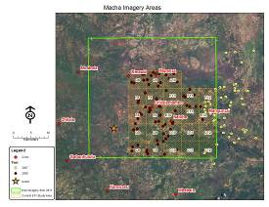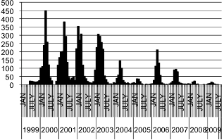
In Macha (part of 2000km² shown on left panel), malaria was dramatically depleted through ACT and ITN interventions.
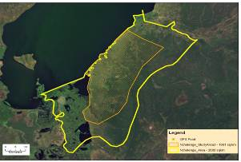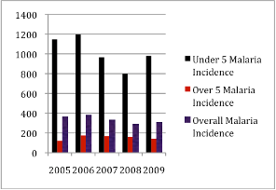
In Nchelenge district, malaria incidence has remained largely unchanged despite control efforts.

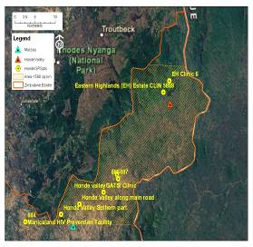
In Mutasa district, malaria incidence has been resurging relentlessly despite control efforts.
These distinct areas are: (i) Macha (Choma district, Zambia), an area of successful malaria control; (ii) Nchelenge District (Zambia), an area where malaria remains high despite control efforts; and (iii) Mutasa district (Zimbabwe), an area where malaria was previously under control but is resurgent despite control efforts.
The Southern Africa ICEMR is one of ten such centers awarded in the world and attempts to draw on research evidence from contrasting sites, as well as the methodology used to control malaria at Macha in order to find ways for decreasing transmission of malaria in southern Africa and beyond. In September 2011, MRT organized and hosted the first of annual global ICEMR meetings, which was held in Livingstone, Zambia with about 120 international attendees. (The 2012 meeting will be held in Goa, India.) Collaboration with other ICEMRs was initiated at this conference, including, for example, parasite genomics studies with The Broad Institute and Harvard School of Public Health.
Malaria Training and Research Capacity Building in Southern Africa. This is a five-year training project funded by the Fogarty Center of NIH to Johns Hopkins School of Public Health to carry out training in Zambia to develop malariologists, and to sponsor individuals for research projects at the Masters or Ph.D. level.
Gates Grand Challenges Exploration Award. This one-year research award to Dr. Mharakurwa was extended to a second year to continue the development of a malaria diagnostic using saliva. The goal is to use the new diagnostic to treat asymptomatic malaria carriers, in an effort to decrease subsequent transmission during the rainy season. Exploratory work was carried out in collaboration with Dr. Dan Malamud of New York University to develop a sensitive, easily operable and affordable point-of-care diagnostic chip that can be used at grass-root level for saliva-based testing and treatment of reservoir malaria infections.
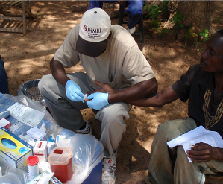
Malaria Epidemiology Study: Headed by Dr. Bill Moss and funded by the JHMRI pilot programme, this project takes longitudinal and cross-sectional approaches to look at malaria transmission with a special emphasis on the gametocyte as a potential target for ultimate malaria elimination. In 2011 it was shown that Category 3 rivers (formed by the merging of two rivers whose tributaries have no further tributaries) were the key hot spots for malaria, opening potential target for depleting malaria transmission. This study has now been incorporated into the ICEMR project.
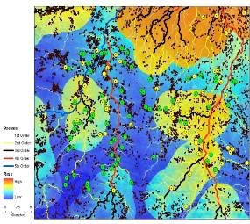
The RDT-positive malaria reservoir was found to cluster along Category 3 Rivers in the Macha catchment, opening a potential target for thwarting transmission of the disease.

Reactive Case Detection, aka Special Project:
Funded by MMRI-USA, this is a non-research program which attempts to trace patients treated for malaria at Macha Hospital. Once former patients are located, a team is sent to screen their household members to determine if any are asymptomatic malaria carriers and— if so—to offer treatment. The program began in late 2009 after obtaining permission from the Choma District Medial Officer to carry this out as part of our local malaria control efforts, and is coordinated by the MRT Field Manager.

In 2011, a total of 30 cases were traced to their homestead. Of the household members screened, 5 of 229 (6.5%) were found to be asymptomatic malaria carriers. All accepted treatment.

HIV/AIDS
Pediatric Anti Retro-viral Treatment (PART) study. This CDC-funded research study of rural African children receiving HIV-care at the Macha ART clinic is now in its fourth year. Sub-Saharan Africa is the epicenter of the HIV-1 pandemic and is home to over 90% of the world’s HIV-1 infected children. Less than 10% of these children receive adequate health care. Little is known of the factors that affect a child’s ability to initiate antiretroviral treatment (ART) and respond favorably in resource-poor settings, particularly outside established or urban HIV research sites. An understanding of the barriers and challenges to care and effective treatment response in rural sub-Saharan Africa is critical to the provision of optimal care to HIV-infected children and the effective use of scarce antiretroviral drugs.

Our cohort study is a prospective evaluation of children in a rural environment who have HIV/AIDS and begin anti-retroviral treatment. The study aims to determine barriers to care and factors that lead to improvement or deterioration. Principal Investigators are Dr. Janneke van Dijk at Macha and Dr. Bill Moss from Johns Hopkins University.
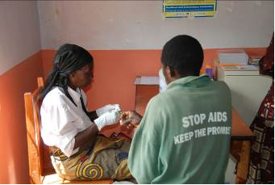
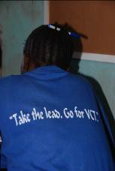
Training staff from Rural Health Posts (Community Health Workers and Traditional Birth Attendants) in HIV Counseling and Testing.
Comprehensive Community Care (Triple-C) program. This CDC-funded non-research program is now in the third of five years. The overall program is designed to “Enhance rural uptake of Prevention of Mother to Child Transmission (PMTCT), Voluntary Counseling and Testing (VCT) and Early Infant Diagnosis (EID) of HIV/AIDS in the Macha Hospital catchment area”. Seven Rural Health Centers (RHCs) and one Hospital Associated Health Center (HAHC) in Choma District refer patients to Macha Hospital on a regular basis. In addition, patients are referred from four RHCs in Kalomo District, and two RHCs in Namwala District. These thirteen RHCs and Macha Hospital’s own HAHC cover the catchment area of the hospital, which is considered to be a 35 - 40 km radius around the hospital with an estimated population of 135,000 people.
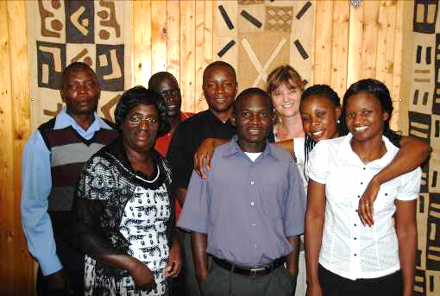

Some of the CCC-staff: Matthias Muleka, Bertha Milimo, Justin Moono, Francis Hamangaba, Lushomo Chikobolo, Janneke van Dijk, Namute Kamata, Pamela Sinywimaanzi.

The Triple-C program aims to provide comprehensive care at the grass roots community level to prevent HIV transmission, with an emphasis on interrupting mother to child transmission of HIV and diagnosing infected infants early so that effective therapy can be started as soon as possible. In doing so, team members work closely together with the health care facilities and community within the Macha Hospital catchment area.
Tuberculosis
International Clinical Trial of Rifapentine and a Quinolone to treat Pulmonary TB (Rifaquin Study). The current treatment of tuberculosis involves taking drugs daily for six months. Although the drugs are free to patients in low-income countries, this still involves a substantial cost, in terms of time and administration, to both the patient and the treatment provider. If the length of treatment could be shortened to four months, or treatment administration simplified by, for example, being given once or twice weekly rather than daily, this will be of great benefit to the patients and the treatment provider. Fewer doses of medication could also reduce side effects from the drugs. This study assessed whether rifapentine (a rifamycin) and moxifloxacin (a quinolone) can achieve these objectives.

This research study, funded by the EDTCP (European-Developing Countries Clinical Trials Program), is an open-label 3-arm drug-trial to compare a standard control regimen with two alternative treatment regimens for the treatment of tuberculosis (TB). The study is carried out at seven other sites in Africa, with Dr. Janneke van Dijk as the local PI for the Macha site. Enrollment was completed in 2011, and data is now being analyzed. The study enabled MRT to establish a TB culture facility, and for several of the MRT lab technologists to learn state-of-art TB culture techniques.

Intensive Tuberculosis screening in HIV-infected persons not yet on Antiretroviral Treatment (MEET TB). This research project is funded by Erasmus University and is under the direction of Dr. Janneke van Dijk at Macha and Dr. Jan Nouwen from the Erasmus University at Rotterdam. Tuberculosis is the most common cause of morbidity and mortality in individuals with HIV-1 infection in sub-Saharan Africa. This study seeks to determine the prevalence and occurrence of Tuberculosis in HIV pre-ART patients in rural Zambia. It uses intensified active case finding, screening pre-ART patients with more sensitive laboratory diagnosis procedures like culture method and Fluorescent Light Emitting Diode (LED) microscopy. Laboratory scientists and technologists from MRT, together with medical students from Erasmus University Rotterdam, the Netherlands, carry out the project. Enrollment for the study will be completed in early 2012.

Other Studies
Risk Factors for Reading Disabilities in Zambian Children in Southern Province (Bala Bbala study). This NIH-funded research project in collaboration with Dr. Elena Grigorenko at Yale University is now in the fourth of five years. The study seeks to determine whether children in rural Africa have learning disorders, and if so, what might be the etiology of these disorders, including the potential role of past severe malaria. Preliminary analysis has already demonstrated children with reading disorders, though determining whether poor reading skills are due to poor teaching or true learning disabilities has proved to be challenging.
A qualitative study of Newborn Care Practices in rural Southern Zambia. This study, in collaboration with PhD candidate Emma Sacks at Johns Hopkins University, started enrollment of participants in July 2011, with data collection to be completed within one year. It is anticipated that this study of newborn care practices at rural clinics and in the home will provide important insight into how to design educational, behavioral and clinical programmes to optimize newborn health in rural sub-Saharan Africa.

Other Projects
Construction of a ‘Clinical Research’ Laboratory. Erasmus University Rotterdam in collaboration with MachaWorks, Netherlands, sponsored the construction of a new research lab at MRT over the past few years. A major cosponsor for this construction project was the pharmaceutical company, Gilead. The Clinical Research Laboratory will house the TB and HIV sections of the MRT lab-based research, including enhanced capability for TB culture and HIV diagnostics and monitoring. The new laboratory building construction was completed in October 2011, and was fully operational by the end of 2011. MRT is currently in the process of seeking Zambian government approval to use the facility to carry out early infant diagnosis of HIV.
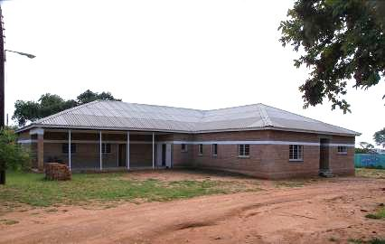
The new clinical research laboratory facility was completed in 2011.

Construction of Office space. Adjacent to the new laboratory, an additional section was built to provide space for two offices, as well as a conference and meeting room.
Construction of additional flats. 2011 saw the completion of the second block of four single-bedroomed flats for MRT professional staff. This project was completed within budget and by late 2011 several staff members had moved into the new flats.
Training and Sponsorship

Training and academic development was made possible through assistance of multiple collaborators and funders:

Auxiliary training
The following MRT staff were given the opportunity to attend trainings organized within the CDC-funded Triple-C program;
- Francis Hamangaba and Bertha Milimo attended the “Management of HIV with Antiretroviral Therapy, advance course” facilitated by the University of Maryland, Institute of Human Virology, from 23-27 May 2011.
- Francis Hamangaba, Justin Moono, and Fortune Ndambo attended the Pediatric Palliative Care Training, given by EGPAF from 27 June – 1 July 2011.
- Pamela Sinywimaanzi attended the Play Therapy Training, facilitated by EGPAF from 6-23 July 2011.
- Namute Kamata and Fortune Ndambo attended the HIV Rapid Test Training, facilitated by MRT from 5-9 September 2011.
- Jeridy Munsanje attended the Computer Introduction course, facilitated by the LinkNet Academy (LITA) from 26-30 September 2011.

Nurse training
MMRI-USA provided sponsorship to three MRT staff members enrolled in nurse training. Shadreck Habbanti hopes to complete his RN training at Livingstone in June 2012. Bertha Sizyongo Muntanga and Cliff Sing’anga are enrolled in the hospital's Zambian Enrolled Nurses Training School and will complete their training in June, 2013.

Masters Degree

Ms. Sandra Chishimba (Laboratory Scientist) continued her Masters Degree study in Infection and Immunity’ at the Erasmus Medical Center Rotterdam, the Netherlands. Her Masters is sponsored by the Erasmus University Rotterdam and she intends to complete her studies in August 2012.

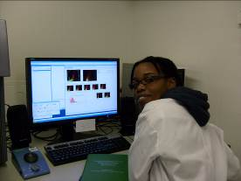

Sandra Chishimba,enrolled for Masters (Infection and Immunity) studies at the Erasmus University Rotterdam, acquiring data using flow cytometry.

In September 2011, Ms. Mwiche Siame (Laboratory Scientist) enrolled in a Masters Degree study in ‘Epidemiology’ at the University of Zambia, School of Community Medicine. Her Masters study is sponsored by NOMA (Norway) and she intends to complete her studies in September 2013.

PhD fellowship
Dr. Janneke van Dijk (Clinical Research Director) continues to work towards her PhD with the Erasmus University Rotterdam, department of Internal Medicine and Medical Microbiology & Infectious Diseases.

Other
The Macha environment has also proven to be conducive for self-studies, enabling people to pursue studies in their field of interest. Mr. Fidelis Chanda (Human Resource Officer) and Ms. Noreen Nzekete (Accounts officer) are pursuing a BA at the University of Zambia by distance learning using their own funds.

Trainings facilitated by MRT

In 2011 the vision of developing MRT into a regional rural health training center became a reality, with several trainings organized and facilitated by MRT and collaborating partners.

 | Time period | Activity | Facilitators | Target group
Jan | 24 Jan - 9 Feb | SQUEAC | Valid | Nutritionist, HCW
Feb | 22 - 25 Feb | Supervision and Mentoring training | EGPAF | MRT PC supervisors
Mar | 14-19 Mar | Basic Community Counseling | MRT | CHW / TBA
 | 21 - 25 Mar | HV Rapid | MRT | CHW / TBA
Apr | 11-Apr | Child Sexual Abuse training | JHU | Community leaders
 | 12-14 Apr | Pediatric Adherence training | EGPAF | PC / HCW
 | 15-Apr | Child Sexual Abuse training | JHU | PC / HCW
 | 19-20 Apr | Play and Say | EGPAF
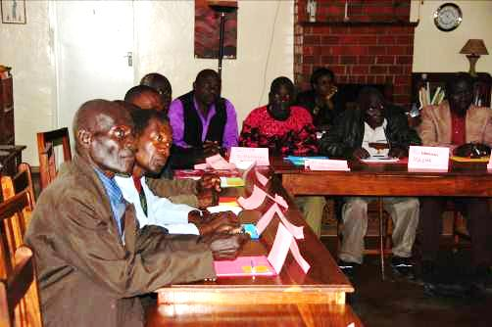

Village headmen and community leaders attending a training on recognition, reporting
and prevention of Child Sexual Abuse (CSA).

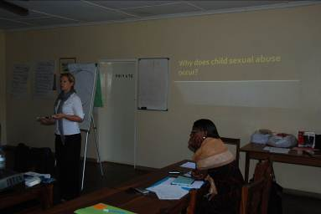
Consultant of JHU department of mental health facilitating a training on recognition, reporting and prevention of CSA.

May | 10 - 14 May | Supervision and Mentoring training | EGPAF | MRT PC supervisors
 | 23 May -27 May | ART training | AIDS Relief | HCW
 | 28-May | Counseling Refresher course | MRT | CHW/TBA
Jun | 27 Jun - 1 Jul | Pediatric Palliative Care training | EGPAF | Multidisciplinary
Aug | 29 Aug - 3 Sep | Basic Community Counseling | MRT | CHW / TBA
 | 5 Sep - 9 Sep | HIV rapid testing | MRT | CHW / TBA
 | 19-Aug | Play and Say training - kids club 1 | MRT | HIV infected children
 |  |  |  | Parents Guardian

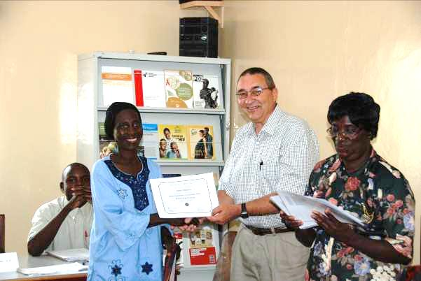
Dr. Phil Thuma issues certificate to Traditional Birth Attendant after completion of training in Basic Community Counseling and HIV testing.

Sep | 26 Sep - 30 Sep | Computer Introduction course | LinkNet | HCW/CHW
 | 27 Sep - 30 Sep | Supervision and Mentoring training | EGPAF | PC supervisors
Dec - May | Monthly - 1/2 day | Journey of Life - group 1 | MRT | HiV infected children
Jun - Sep | Monthly - 1/2 day | Journey of Life - group 2 | MRT | Parents / guardians

In addition to these trainings for national staffs, MRT also housed several international medical and nursing student groups, including a three week residential course for US university students titled “Health Care in the Developing World” as well as a three week course for Dutch university students titled “Tropical Medicine and International Health”. These short-term study courses were primarily facilitated by the sending University’s faculty members with additional inputs from local professionals. This, combined with an exposure to life and work in a different culture, results in a worthwhile experience and often long-lasting impressions for the students.

Accomplishments

As seen by the list below, work carried out at MRT resulted in 19 articles published in peer-reviewed scientific literature in 2011. Names of MRT co-authors are highlighted in bold. Additionally, numerous oral or poster presentations were given at various scientific meetings and presented at several national and international forums.

Both the Scientific Director and the Senior Research Advisor serve on various committees at the national level, including the National Health Research Ethics Committee and the Insecticide Resistance Management Technical Working Group. The Scientific Director is involved in supervision of Masters students for the University of Zambia and other local and international universities.

Publications

- Thuma PE, van Dijk J, Bucala R, Debebe Z, Nekhai S, Kuddo T, Nouraie M, WeissG, Gordeuk VR. Distinct Clinical and Immunologic Profiles in Severe Malarial Anemia and Cerebral Malaria in Zambia. J Inf Dis 2011 203: 211-219. PMID: 21362177

- Sutcliffe CG, van Dijk JH, Munsanje B, Hamangaba F, Sinywimaanzi P, Thuma PE, Moss WJ. Weight and height z-scores improve after initiating ART among HIV-infected children in rural Zambia: a cohort study. BMC Infect Dis. 2011 Mar 1;11:54. PMID: 21362177

- van Dijk JH, Sutcliffe CG, Munsanje B, Sinywimaanzi P, Hamangaba F, Thuma PE, Moss WJ. HIV-infected children in rural Zambia achieve good immunologic and virologic outcomes two years after initiating antiretroviral therapy. PLoS One. 2011 Apr 28;6(4):e19006 PMID: 21552521

- Sutcliffe CG, van Dijk JH, Munsanje B, Hamangaba F, Sinywimaanzi P, Thuma PE, Moss WJ. Risk factors for Pre-Treatment Mortality among HIV-infected Children in Rural Zambia: A Cohort Study. PloS one 6 (12), e29294

- van Dijk JH, Moss WJ, Sutcliffe. Feasibility and Challenges in Providing Antiretroviral Treatment to Children in Sub-Saharan Africa. Current Pediatric Reviews 7 (3), 154-165.

- Cirimotich CM, Dong Y, Clayton AM, Sandiford SL, Souza-Neto JA, Mulenga M, Dimopoulos G. Natural microbe-mediated refractoriness to Plasmodium infection in Anopheles gambiae. Science. 2011 May 13;332(6031):855-8. PMID: 21566196

- Tan M, Reich J, Hart L, Thuma PE, Grigorenko EL. Examining Specific Effects of Context on Adaptive Behavior and Achievement in Rural Africa: Six Case Studies from Southern Province, Zambia. J Autism Dev Disord. 2011 Jun 1. [Epub ahead of print] PMID: 21630097

- Chidi AP, Chishimba S, Kobayashi T, Hamapumbu H, Mharakurwa S, Thuma PE, Moss WJ. Validation of oral fluid samples to monitor serological changes to Plasmodium falciparum: an observational study in southern Zambia. Malar J. 2011 Jun 10;10:162. PMID: 21663660

- Moss WJ, Hamapumbu H, Kobayashi T, Shields T, Kamanga A, Clennon J, Mharakurwa S, Thuma PE, Glass G. Use of remote sensing to identify spatial risk factors for malaria in a region of declining transmission: a cross-sectional and longitudinal community survey. Malar J. 2011 Jun 10;10:163. PMID: 21663661

- Mharakurwa S, Thuma PE, Norris DE, Mulenga M, Chalwe V, Chipeta J, Munyati S, Mutambu S, Mason PR; for the Southern Africa ICEMR Team. Malaria epidemiology and control in Southern Africa. Acta Trop. 2011 Jul 2. [Epub ahead of print] PMID: 21756864

- Shiff C, Thuma P, Sullivan D, Mharakurwa S. Designing a sustainable strategy for malaria control? Malar J. 2011 Aug 3;10:220. PMID: 21812949

- Moss WJ, Norris DE, Mharakurwa S, Scott A, Mulenga M, Mason PR, Chipeta J, Thuma PE; for the Southern Africa ICEMR Team. Challenges and prospects for malaria elimination in the Southern Africa region. Acta Trop. 2011 Aug 19. [Epub ahead of print] PMID: 21871864

- Davis RG, Kamanga A, Castillo-Salgado C, Chime N, Mharakurwa S, Shiff C. Early detection of malaria foci for targeted interventions in endemic southern Zambia. Malar J. 2011 Sep 12;10:260. PMID: 21910855

- Sutcliffe CG, Kobayashi T, Hamapumbu H, Shields T, Kamanga A, Mharakurwa S, Thuma PE, Glass G, Moss WJ. Changing individual-level risk factors for malaria with declining transmission in southern Zambia: a cross-sectional study. Malar J. 2011 Oct 31;10(1):324. [Epub ahead of print] PMID: 22039751

- Mharakurwa S, Kumwenda T, Mkulama MA, Musapa M, Chishimba S, Shiff CJ, Sullivan DJ, Thuma PE, Liu K, Agre P. Malaria antifolate resistance with contrasting Plasmodium falciparum dihydrofolate reductase (DHFR) polymorphisms in humans and Anopheles mosquitoes. Proc Natl Acad Sci U S A. 2011 Nov 15;108(46):18796-801. Epub 2011 Nov 7. PMID: 22065788

- Pooe OJ, Shonhai A and Mharakurwa S (2011) A PCR screen for malaria carrier infections using human saliva samples African Journal of Microbiology Research 5 (28) 5120-5126.

- Norris LC, Norris DE: Insecticide resistance in Culex quinquefasciatus mosquitoes after the introduction of insecticide-treated bed nets in Macha, Zambia. J Vector Ecol 2011, 36(2):411-420.

- Norris LC, Norris DE: Efficacy of long-lasting insecticidal nets in use in Macha, Zambia, against the local Anopheles arabiensis population. Malar J 2011, 10:254.

- Fornadel CM, Norris LC, Franco V, Norris DE. Unexpected anthropophily in the potential secondary malaria vectors Anopheles coustani s.l. and Anopheles squamosus in Macha, Zambia. Vector Borne Zoonotic Dis. 2011 Aug;11(8):1173-9. PMID: 21142969

Presentations

5th International Workshop on HIV treatment, Pathogenesis and Prevention in Resource-poor Settings (INTERST), Tanzania, 10-13 May 2011:

- van Dijk JH., Sutcliffe CG., Hamangaba F., Bositis C., Watson DC., Moss WJ. Effectiveness of EFV-based ART regimens in young children requiring TB/HIV co-treatment: a possible treatment option for resource-limited settings? (Oral presentation)

- van Dijk JH., Hogendoorn W., Bech N., Manyani F., Sikalima J., Nouwen J.: Point-to-care device to measure lactate levels in HIV patients in rural Zambia; association with D4T based regimen but no severe hyperlactatemia found. (Oral presentation)

- van Dijk JH., Sitali S., Sinywimaanzi P., Bakasa G., Spurrier DJ. Working towards universal testing: coverage and acceptance of mobile voluntary counseling and testing in a rural African setting. (Poster presentation)

- Sikalima JFM., vMourik MG., van Dijk JH., Chikobolo LM., Manyani F., Nouwen JL.: Intensive Tuberculosis screening in HIV infected persons not yet on Antiretroviral Treatment, in Macha, rural Zambia. (Poster presentation)

Zambian National Health Research Conference, Lusaka, Zambia, 19-21 October 2011

- Sikalima JFM., van Mourik MG., van Dijk JH., Chikobolo LM., Manyani F., Nouwen JL: Intensive Tuberculosis screening in HIV infected persons not yet on Antiretroviral Treatment, in Macha, rural Zambia. (Oral presentation by Michael Musonda)

- van Dijk JH., Hogendoorn W., Bech N., Manyani F., Sikalima J., Nouwen J: Point-to-care device to measure lactate levels in HIV patients in rural Zambia; association with D4T based regimen but no severe hyperlactatemia found. (Oral presentation)

- van Dijk JH., Sutcliffe CG., Hamangaba F., Bositis C., Watson DC., Moss WJ.: Effectiveness of EFV-based ART regimens in young children requiring TB/HIV co-treatment: a possible treatment option for resource-limited settings? (Oral presentation)

- van Dijk JH., Sitali S., Sinywimaanzi P., Bakasa G., Spurrier DJ.: Working towards universal testing: coverage and acceptance of mobile voluntary counseling and testing in a rural African setting. (Poster presentation by Jay Sikalima)

- Musonda K., Kobayashi T., Kamanga A., Hamapumbu H., Thuma P., Mharakurwa S., and Moss W. Antibodies to Plasmodium falciparum in a region of declining malaria transmission in southern Zambia (Oral presentation)

- Siame M., Hamapumbu H., Kamanga A. and Mharakurwa S. Dry Season Pilot Community based molecular surveillance of Plasmodium falciparum asymptomatic infections in Kalomo, Southern Zambia (Oral presentation)

- Phiri M., Kobayashi T., Hamapumbu H., Mharakurwa S., Thuma P., and Moss W. Age and gender distribution of gametocyte-positive individuals in southern Zambia (Oral presentation by Mwiche Siame)

- Mharakurwa S., Kumwenda T., Mkulama A.P., Musapa M., Chishimba S., Shiff C., Sullivan D., Thuma P., Liu K. and Agre P. Emergence of Plasmodium falciparum drug resistance: the unnoticed role of vector mosquitoes (oral presentation)

American Society of Tropical Medicine & Hygiene 60th Annual Meeting, Philadelphia, Pennsylvania, USA, December 4 - 8, 2011, .

- Mharakurwa S., Siame M. and Thuma P. Adaptive changes in malaria transmission during scaled up interventions in Southern Zambia (Poster presentation)

- Phiri M., Kobayashi T., Hamapumbu H., Mharakurwa S., Thuma P.E. and Moss W.J. Age and sex distribution of gametocyte-positive individuals in Southern Zambia (Poster presentation)

- Musonda K., Kobayashi T., Kamanga A., Hamapumbu H., Mharakurwa S., Thuma P. and Moss W.J. (2011) Antibodies to Plasmodium falciparum in a region of declining malaria transmission in Southern Zambia (Poster presentation)

- Stresman G.H., Kamanga A., Moono P., Mharakurwa S. and Shiff C.J. Reactive case detection in a rural area of Zambia –year 2 of targeting asymptomatic reservoirs of Plasmodium falciparum malaria during the low transmission season (Poster presentation)

Finance, Facts and Figures

The Bar charts below reflects the sources of funding (“Income”) and Expenses at MRTover the year 2011.

Income

EXPENSES

Future Plans

Looking ahead to the next five years, MRT management has set the following goals:

Continue to expand the molecular biology lab and the clinical research lab capacities to provide facilities and capabilities to carry out the various research projects that will accomplish the mission of MRT.

Work with MRT staff to develop clear lines of academic development and promotion, including the necessary training to establish a core group of scientists that can compete internationally for grants to carry out relevant research.

Provide competitive salaries and conditions of service for all MRT employees, such that both morale and output remain high. This will also allow MRT to continue to be a place that attracts talented individuals with the potential to become the scientific leaders of Zambia in the future.

Continue to work with the Government of Zambia to carry out relevant research projects that will provide evidence that can be used for national policy development on health issues in the country.

Staff of Macha Research Trust

During the year 2011, MRT had 70 permanent staff members in employment: 16 General Workers (GW), 32 General Staff (GS), 9 Managerial or Technical Staff (MA) 8 Professional Staff (PS) and 5 Senior Staff (SS).

A total of nine employees were newly hired; three new staff joined the Triple-C program, four the Molecular Lab, one for the maintenance department and one for the hospitality department.

Three employees left for studies and one resigned to join the Civil service. Four employees were dismissed.

Below is the list of MRT Staff members for 2011.
Name of employee | Position
Aniset Kamanga | Lab Scientist / Coordinator GIS
Bertha Milimo | Nurse / Trainer of Trainees
Bertha Sizyongo | Study assistant
Betty Muchindu | House keeper
Bicent Mweetwa | General worker / Grounds
Bornface Munsanje | Study assistant
Bright Mapeke | General worker / Maintenance
Bruce Malembeka | Field Worker
Caroline N. Muchimba | Manager, Accounts
Choolwe Nachibbantu | Lab Assistant
Chris Book | Director, Administrative
Clement Mwaanga | Field Worker
Cliff Sing'anga | Microscopist
Conceptor Chuumbwa | Accounts Assistant
Conceria Munkombwe | Office assistant
Cornelius Choobwe  Baleto Mudenda | Field Worker  Field Worker
Cosmas Muntanga | Security Guard
Credwin Simwinga | Driver
Dester Mwaanga | Office assistant
Edith Mwaanga | Dorm Caretaker
Esther Pandawe | Accounts Officer
Fidelis Chanda | Human Resource Officer
Fines Mwaanga | Microscopic reader
Flora Munachonga | Senior House Keeper
Fortune Ndambo | Study assistant
Francis Hamangaba | Coordinator Rifaquin / CO
Gift Chaambwe | Office assistant
Gift Moono | Office assistant
Gift Mwaanga | Lab Assistant
Godfrey Munsanje | Security Guard
Gordon Vinda | Field Worker
Guide Mweetwa | Senior Maintenance
Harry Hamapumbu | Manager, Field Work
Isaac Mwaalu | General Worker / Grounds
Ivan Muleya | Senior Grounds Keeper
Janneke van Dijk | Director, Clinical Research
Jay Sikalima | Lab Technologist
Jeridy Munsanje | Study assistant
Justin Moono | Program Assistant
Kasapo Musonda | Lab Scientist
Limonty Simubali | Field Worker
Lushomo Chikobolo | Lab Technologist
Luyando Muchindu | Office assistant
Marjorie Hamahuwa | Manager, Office & Housekeeping Services
Masiliso Phiri | Lab Scientist
Mathias Muleka | Field Worker
Michael Musonda | Lab Scientist
Morris Sianyinda | Driver/Mechanic
Mukuwa Kalambo | Director, Managing
Musapa Mulenga | Lab Scientist (unpaid leave)
Mwiche Siame | Lab Scientist
Namute Kamata | Social Worker
Nchimunya Chaavwa | Study assistant
Nervis Moono | General worker / Grounds
Nomore Siachiwena | General worker / Maintenance
Noreen Nzekete | Accounts Assistant
Pamela Sinywimaanzi | Assistant Coordinator, Triple C
Pascalina Chinyanwa | House keeper
Passwell Munachoonga | Study assistant
Patricia Muleya | Office assistant
Perity Sinamweenda | Coordinator Bala Bbala
Philip Thuma | Senior Scientific Advisor
Renox Munachoonga | Security Guard
Rhoda Bakasa | Pyschosocial Counselor
Rodex Hansolo | Study assistant
Sandra Chishimba, | Lab Scientist (study leave)
Shadreck Habbanti | Study assistant (study leave)
Sibajene Hamoombe | Study assistant
Starfred Muchindu | Security Guard
Stembridge Mweetwa | Supervisor, Maintenance
Sungano Mharakurwa | Director, Scientific
Sydney Mweetwa | Study assistant
Sydney Vwalika | IT Support assistant

