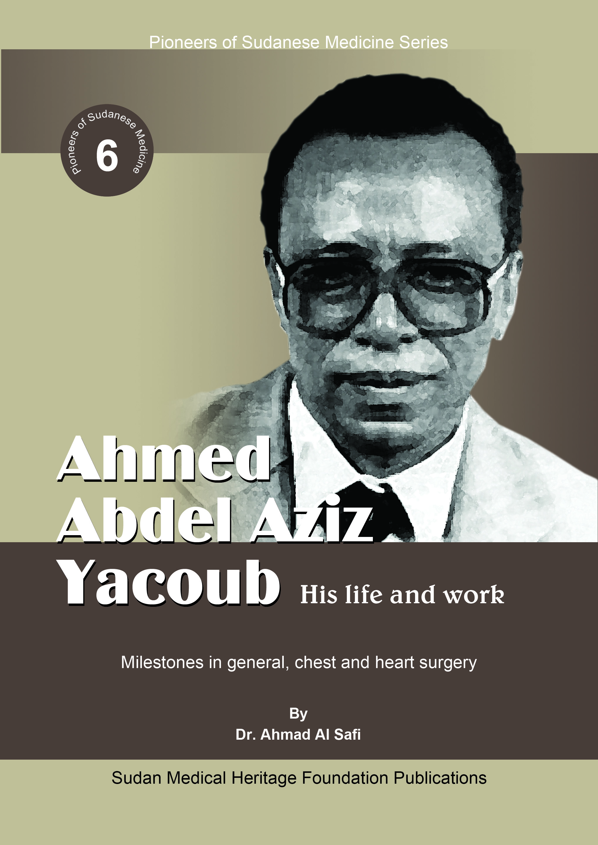Also by
Dr Ahmad Al Safi
- Native Medicine in Sudan, sources, concepts & methods (1970)
- Tigani El Mahi, Selected Essays (1981)
- التجاني الماحي: مقالات مختارة (1984)
- Women’s Medicine: the zar-bori cult in Africa and beyond (co-editor 1991)
- المرشد إلى قواعد وإجراءات الهيئات التداولية (1999)
- Traditional Sudanese Medicine, a primer for health care providers, researchers & students (1999)
- المرشد إلى قواعد وإجراءات التنظيمات الحديثة (2007)
- الزار والطمبرة في السودان (2008)
- Abdel Hamid Ibrahim Suleiman, his life and work (2008)
- Ahmed Mohamed El-Hassan, his life and work (2008)
- Daoud Mostafa Khalid, his life and work (2009)
- El Hadi Ahmed El Sheikh, his life and work (2010)
- Mohamed Hamad Satti, his life and work (2011)
- الحكيم، من أجل أطباء أعمق فهماً لمهنتهم وأكثر وعياً ببيئتهم وأحوال أهلهم (2013)

Author | Ahmad Al Safi
Book Title | Ahmed Abdel Aziz Yacoub, his life & work
First Edition | 2014
Deposit No. | 664/2013
ISBN | 978-99942-69-46-4
Copyright© | Sudan Medical Heritage Foundation
Distribution | Sarra for Information Services Tel +2491221674
Cover design | Ahmed Hussain

Pioneers of Sudanese Medicine Series (6)
Ahmed Abdel Aziz Yacoub
His life and work
Milestones in general, chest and heart surgery
By
Dr. Ahmad Al Safi
Sudan Medical Heritage Foundation Publications

Contents
Acknowledgements 4
Preface 5
Introduction 7
Ahmed Abdel Aziz Yacoub 10
Early life & education 10
Career 11
Initiatives & achievements 13
General surgery 13
Training of surgeons 13
Heart surgery in Sudan 14
History of rheumatic heart disease 14
History of heart disease 15
Thoracic surgery 16
Mastering technique 17
The open heart surgery programme 17
Launching open heart surgery 18
Medical Jurisprudence 20
Recent developments 21
Sudan Heart Foundation 21
Salam Centre for Cardiac Surgery 22
Anaesthesia & Intensive Care 22
Paediatric cardiology & cardiac surgery 22
Predecessors & mentors 24
Donald Ross 24
John Jacques 24
Richard Emanuel 24
Abdel Hamid Bayoumi 25
Ibrahim Mohamed El Moghrabi 26
Julian Taylor 29
Marriot F Nicholls 29
EWT Morris 30
Photo Gallery 31
Biographer’s Profile 38
References and Notes 40

Acknowledgements
I Acknowledge with gratitude the verbal and written contributions of the many friends, schoolmates, associates, coworkers, and students of Mr. Ahmed Abdel Aziz Yacoub. Indeed, I am indebted to Mr. Ahmed himself for sharing with me his documents, and spending lengthy hours documenting his lengthy and rich career few years before his illness.

Preface
This series of monographs aims at providing concise documentation of the lives and work of the men and women who have shaped health care services in Sudan. This volume profiles the life and work of Mr. Ahmed Abdel Aziz Yacoub.
The idea of this series came up after I finished compiling and editing the scattered works of the late Professor Tigani El-Mahi (1911-1970). In two volumes, I collected, collated, edited, and published his Arabic writings in 1981and the English in 1984. The warm reception those two volumes had encouraged me to continue similar work on more pioneers albeit in a different way.
The work on this series started during my expatriate period in Saudi Arabia (1989-2004), and took fresh momentum after I came back. Throughout this period and earlier, I realized that this type of work could have far-reaching value than mere documentation. I realized that allusion to several ancestors of this profession is anecdotal and reflected misinformation and superficial impressions at best. In the face of this dismal situation, readers and researchers are faced with a dearth of reliable sources on the bookshelf. Books are alarmingly few and historical writings notably deficient. Sources rest mainly in grey literature, which is not readily available.
I conducted a limited pilot study on a sample of students and lecturers in Faculty of Medicine, University of Khartoum. The results were alarming. I found out that a significant number of the interviewed know little about the founding members of this profession. They know even less about the nature and extent of the contribution and impact of the lives and work of the few notables they know. For example, none of those interviewed knew Anis Mohamed Ali Al Shami; very few knew Al Baghdadi; the knowledge of those who knew Haseeb was hazy.
I launched a documentary project titled “Sudan Health Trilogy” to be discussed later in this booklet. The biographies that are published to-date including this one are nine. The next book on this list is Abdel Rahim Mohamed Ahmed, his life and work.

Introduction
The individuals featured in this series, including Mr. Ahmed Abdel Aziz Yacoub, fulfilled the criteria I set to identify a pioneer. Pioneers have established new institutions, founded new disciplines, researched the field, consolidated clinical practice, or made new discoveries. They all set new traditions and models of admirable behaviour. They taught and trained, mentored, and more importantly, provided guidance and encouragement to several generations of young and aspiring physicians and scientists. They were, without exception, meticulous clinicians, arduous teachers, imaginative trainers, and hard-working researchers. They maintained unimpeachable professional integrity, upheld strict medical ethics, and consolidated sound medical traditions in a rich service career. They all worked with purpose, with principles, with top line, with culture building, and strengthening people. In each situation they worked in, they looked for better management, efficiency, perfecting techniques, practices, and processes.
Their contribution as scientists or physicians in science and life has been exemplary. They searched for continuous improvement in their lives and in the institutions, they worked in or for. They have been constantly involved in pursuit of fact and truth – about everything in life. That is why they were also notable social workers, sportsmen, poets, musicians, political leaders, writers, and administrators.
Studying the lives of these individuals clearly shows that the path to success and distinction requires hard work and confident persistent toil. Nothing happens arbitrarily through luck, or due to quick fixes. Among these pioneers, Mr. Ahmed Abdel Aziz Yacoub, the subject of this monograph, has been exemplary. He did his job as expected in terms of quality. His performance has been solid, fully competent in all aspects of job content and expectations. That is why he won the admiration and respect of his peers, coworkers, and associates. However admirable his qualities as a man, it is his contributions as scientist that have been our chief concern in this monograph.

Ahmed Abdel Aziz Yacoub
His life and work
Milestones in general, chest and heart surgery

Ahmed Abdel Aziz Yacoub
Mr. Ahmed Abdel Aziz Yacoub is one of Sudan’s most outstanding surgeons and physicians who have served his country in the health sector with distinction and dedication. He has contributed valuable services to the country in clinical surgery, and has put in his fair share in laying its foundations as a scientific discipline.
He has influenced the progress and evolution of general, chest, and heart surgery; he planned, organized, managed, implemented, contributed to, and influenced all major surgery policies, plans, scientific research, and training in this field.

Early life & education
Mr. Ahmed Abdel Aziz Yacoub was born in Gubbat Salim in the Northern Province on 12 January 1931 and died in London on Friday 26 April 2013. He joined the University of Khartoum in 22 July 1950 and graduated in the School of Medicine in 26 April 1956 attaining the Diploma of Kitchener school of Medicine (DKSM)
His outstanding educational career included several university prizes including the University of Khartoum Prize in 1951, the Jackson Prize in Pathology in 1954, the Waterfield Prize in Public Health in 1955, and the Archibald Prize in Community Medicine in 1956.
His academic and professional degrees include:
- In January 1961, he was awarded the Fellowship of the Royal College of Surgeons of Edinburgh, U.K. (F.R.C.S.E).
- In May 1961, he was awarded the Fellowship of the Royal College of Surgeons of England, U.K. (F.R.C.S.).
- In January 1964, he was awarded the Membership of the Royal College of Physicians of Edinburgh, U.K. (M.R.C.P.E) in Cardiology.
- In 1972, he was awarded the Master of Surgery, University of Khartoum.
- In 1972, he was made fellow of the Royal College of Physicians of Edinburgh, U.K. (F.R.C.P.E).
- In 1973, he was awarded PhD in cardiac surgery from University of Khartoum.
- In 1976, he was awarded the Fellowship of the American College of Surgeons.
- In 1986, he acquired Bachelor of Law from Cairo University (Khartoum Branch).
- In 1995, he acquired a Diploma in High Jurisprudence from the University of Khartoum.
- In 1996, he acquired Master of Arts in Sharia, University of Khartoum
- In July 2002, he earned a PhD in Jurisprudence at the School of Oriental and African Studies, University of London.

Career
Mr. Ahmed Abdel Aziz Yacoub career started in the Ministry of Health (MOH), Sudan on graduation in 1956 as house officer, medical officer, and surgeon until he retired in 1983.
- During the period 1964-1984, he was Head Department of chest and heart surgery.
- He was appointed Senior Surgeon in the MOH in 1968. A post he held up to 1984.
- He held the post of Head Department of Surgery, Khartoum Teaching Hospital (1968-1983).
- He was chairperson of the Board of Directors of Khartoum Teaching Hospital from 1976-1984.
- During the period 1984-1988, he was called upon to head the Sudan Medical Corps in the capacity of liwaa.
- In 1990, he established the Department of Surgery in Omdurman Islamic University, and was the first professor of surgery in that institution. He was later awarded the status of Professor Emeritus in Omdurman Islamic University.
- He also held the posts of Dean of Nursing and Minister of Youth and Sports for short periods.
- In the period 1989-1991, Mr. Yacoub held the post of the six president of the Sudan Medical Council. During his tenure, he introduced the specialization directorates to take care of the regulation of the different specialties.

Initiatives & achievements

General surgery

Training of surgeons
Mr. Ahmed Abdel Aziz Yacoub played a leading role in the establishment of most of the surgical departments in the country. He trained, motivated and sent for further specialization and/or training abroad several surgeons. Many notable Sudanese surgeons were trained abroad through his wide international links and contacts, which helped in placing them in prestigious training centres in Ireland, Scotland, and England.
In an obituary note, Professor Mohamed El Makki Ahmed and Professor Elbagir Ali Elfaki identified at least 41 doctors sent for training and specialization in surgery in the UK in the period 1970 to 1990. This group of surgeons specialized in almost all the fields that are practiced today: general surgery, paediatric surgery, orthopaedic, urology, cardiac and chest surgery, neurosurgery, gastroenterology, and ENT. These surgeons occupied leading roles in ministries, hospitals and universities in Sudan and abroad.
Priority in sub-specialization in surgery was given to ENT, Orthopaedics, Chest, Urology, Plastic, Gastroenterology, Paediatric Surgery, and Neurosurgery. Specialization in Anesthesiology was also started.

Heart surgery in Sudan

History of rheumatic heart disease
In Sudan, rheumatic heart disease was diagnosed by the first British doctors who came over during the reign of the Anglo-Egyptian Condominium, and by 1926, the disease was taught and demonstrated in Khartoum Hospital. The first Sudanese patient with mitral stenosis who had a valvotomy was a male aged about 30 who was sent to London in 1953. There were signs of restenosis and atrial fibrillation. The chest radiograph showed calcification of the mitral valve. He returned to London in 1966 and had a second operation, which was a transventricular valvotomy. He died in April 1972 after an attack of congestive cardiac failure and pulmonary oedema.
An increasingly high proportion of mitral stenosis in the Sudan has been apparent to Dr. Abdel Halim Mohamed. In 1937, hundred consecutive cases of heart disease admitted to Khartoum Hospital were analysed: eighty had cardiovascular syphilis, three had mitral stenosis. In a paper read before the Sudan Branch of the British Medical Association, Dr. Dawood Mustafa described in 1945 66 cases of heart disease admitted to Omdurman Hospital in a six-month period. Of these, only nine (14%) were rheumatic. Apart from these two isolated studies, no reliable statistics are available up to the beginning of the present survey in 1957. The general impression is that rheumatic heart disease is increasing.
A paper by Halim and Jaques in 1960 concluded that of a total of 958 patients with cardiac disorders investigated at Khartoum Hospital over a recent three-year period, 243 (25%), were suffering from rheumatic heart disease. Twenty of these patients were operated on. Typical valvular lesions were found. The relative incidence was considerably higher than that reported from other parts of Africa. It appears that there has been a real increase over the last twenty years.

History of heart disease
Mr. Ahmed Abdel Aziz Yacoub rightly deserves the name of the father of chest and heart surgery in Sudan. His interest in this field was early in his surgical career. He performed his first case of mitral valvotomy in December 1959 with the help of Mr. John Jacques.
Mr. Jacques, FRCSE, carried out the first operations of mitral valvotomy in the Sudan in Khartoum Civil Hospital (KCH) in 1959. Twenty-two (22) cases were done during that year. These cases were:
- Mitral valvotomy done in July 1959 for a female patient aged 28 years. Digital fracture of the commissure was used. The patient was well until 1970 when she complained of dyspnoea, cough, and died of haemoptysis on her way to Khartoum.
- Aortic stenosis done in August 1959 in which the valve was split with an aortic valve dilator under hypothermic circulatory arrest. The patient died 18 hours later.
- Mitral incompetence done in September 1959 on a boy of 17 years in whom the purse-string technique was used.
- Some nineteen (19) other cases of mitral stenosis were done. Thirteen (13) of whom were treated with finger dilatation. In the other six, a three-flanged aortic valve dilator was used via the ventricle.
In 1962, Mr. Jacques returned to Britain and no further cardiac surgery was carried out in Sudan until Mr. Ahmed Abdel Aziz started a new series in March 30 1964.
Mr. Ahmed Abdel Aziz reviewed the history of mitral valvotomy and heart disease in Sudan, and documented the cases he operated on and his initiatives in this field. He reported on 102 cases of dominant mitral stenosis, which he operated on in the period March 30 1964 and April 11 1972 in the general surgery unit in Khartoum Civil Hospital, Khartoum, Sudan.
The second case in this series was done with the help of Mr. A. L. d’Abreu who was visiting Khartoum at that time. Those cases were strictly selected. The aim was to operate on those with dominant stenosis only as this procedure was well established at the time in other cardiac centres abroad, and had been shown to give excellent results and low operative mortality. Other workers noted that this procedure is important in establishing a new major surgical technique in a country such as Sudan. Diagnosis was strictly clinical as there was no cardiac catheter laboratory at that time. The anaesthetic technique adopted was that in vogue in that period, plain vanilla technique (thiopentone, suxamethonium, d-tubocurarine, N₂O and Oxygen).

Thoracic surgery
During the period (1964-1972), Ahmed Abdel Aziz performed about 500 cases of thoracic surgery. The chest problems included tuberculosis of the lung, chest injuries, empyema, lung abscesses, carcinoma of the oesophagus, hydatid cysts of the lung, achalasia of the cardia, carcinoma of the lung, hiatus hernia, patent ductus arteriosus, bronchiectasis, constrictive pericarditis, pericardial cysts, cysts of the lung, adenoma of the bronchus, coarctation of the aorta, diverticulum of the oesophagus, and pharyngeal pouch. Over the same period, 200 bronchoscopies and oesophagoscopies were done for diagnosis, removal of foreign bodies, and insertion of Celestin tubes for inoperable cancers of the middle oesophagus.

Mastering technique
Mr. Ahmed has been conscientious enough and lucky to be trained by the surgical notables of Europe of that time, namely Pilcher, d’Abreu, and Logan. He worked with them and mastered thoracotomies and valvotomies following the standard techniques that were rife at that time in the United Kingdom. That opportunity was not possible without the help and support of Mr. Julian Taylor.

The open heart surgery programme
Mr. Ahmed Abdel Aziz was fully aware of the problems that beset the path leading to a full-blown programme of heart surgery. He was positively motivated by the progress that was achieved since Kebs passed his pessimistic remark:
“Let no man who hopes to retain the respect of his medical brethren dare to operate on the human heart.”
Mr. Yacoub was fully aware and informed of the work of early workers in this field particularly that of Saways in 1898 who rightfully said:
“I anticipate that with the progress of cardiac surgery, some of the severest cases of mitral stenosis will be relieved by slightly notching the mitral orifice and trusting to the auricle to continue its defence.”
That is why Mr. Ahmed Abdel Aziz Yacoub dwelled long enough on this procedure while he was laying the foundation for a more ambitious programme.
However, no such ambitious programme would be possible to launch without the establishment of dedicated buildings, provision of state-of-the-art equipment, instruments, consumables, drugs and ensuring that highly trained, motivated personnel are on site.

Launching open heart surgery
Preparation for launching the open-heart surgery programme took over 20 years of animal experimentation, building new premises, laying down infrastructure, and training personnel. In addition, Mr. Yacoub did extensive training in this field in Britain.,He founded the Shaab Hospital Operations Theatre Complex in 1964 to care for heart, chest, and neuro-surgery.
Surgeons (e.g., Muhammad Saied El Fiel, Ibrahim Mustafa ) and physicians (Siddig Ibrahim Khalil) were sent for training in both disciplines. High School nurses (Hayat Bab Allah, Nimat Mohamed Malik) and pump technicians (e.g., Himaidan from the Military Corps) were sent for training in Harefield, UK. Other surgeons, cardiologists, and anaesthetists were attracted to join the programme at different stages of its development. Several surgeons were involved in this venture and assisted Mr. Ahmed Abdel Aziz either in heart or chest surgery. Mr. Mirghani Sanhouri career path continued in general surgery and chest surgery with excellence. Mohammed Saied El Fiel who finished his training in Ireland and came back home in 1982 carried on with chest and heart surgery.
In preparation for launching the open-heart surgery programme on humans, Mr. Ahmed Abdel Aziz Yacoub befriended and invited to Sudan several notables including Ritchard Emanuel and Mr. Donald Ross. He started experimentation on open-heart surgery on animals in 1976 with the help of veterinarian Dr. Salah Umbabi, who gave anaesthesia, and joined by Christopher Lincoln on UCT Ken in February 1977. This small team operated on forty (40) cases (11 goats and 29 sheep) in preparation for launching human open-heart surgery programme.
Mr. Yacoub started open-heart surgery in man in 1978. In collaboration with Mr. Donald Ross, he and his team operated on nine (9) cases. The Sudanese team included Mr. Mirghani Sanhouri and Mr. Kamil El Sadig, and anaesthetists including Drs. Hassan Mohamed Ibrahim and Laila Abdalla.
In January and February 1982, Mr. Ahmed Abdel Aziz team headed by Mr. Ibrahim Mostafa launched the open-heart surgery programme. Sir Mr. Magdi Yacoub and Ritchard Emanuel consolidated this venture by visiting Sudan in 1982 with a full team of surgical anaesthetic registrars, pump technicians, and sisters, and operated on eleven (11) cases.
By the end of the eighties of the twentieth century, and under a grant given by King Fahd, a Saudi Arabian heart surgeon by the name of Hassaan Al Raffa visited Sudan. This surgeon made a lot of ho ha surgery, and worst of all he attracted all the programme team of nurses and technicians to join him in Jeddah in Saudi Arabia. This brought the open-heart surgery programme to a complete halt in 1989.
No fully-fledged open-heart surgery programme would be possible without qualified cardiologists and catheter laboratory. While in UK, Dr. Muhammad Sirag Abbashar, then cardiologist in Harefield, did the first catheter in the newly established Catheter Laboratory in Shaab Hospital in 1978. The catheter work became regular activity in 1980 and continued with excellence. Eight cases were done each week in three sessions. In 1989, activities in this laboratory slowed down and came to a standstill later due to lack of funding, and inability to maintain equipment. Ultrasonography and stress tests started in 1981.

Medical Jurisprudence
After specializing in both medicine and surgery, and starting and maintaining a successful surgical career, Mr. Ahmed Abdel Aziz and other members of the profession, encountered several problems associated with the development and progress of medical science. To understand these problems, he embarked on the study of law as an undergraduate student at Cairo University (Khartoum Branch) and graduated in 1986 and as a postgraduate student at the University of Khartoum, where he acquired a Diploma in High Jurisprudence in 1995, and a Master of Arts in Sharia at University of Khartoum in 1996. He then proceeded to study for a doctoral degree at the School of Oriental and African Studies, University of London, where he earned a PhD in Jurisprudence in July 2002.
His book, the Figh of Medicine, also published in Arabic is based on his doctoral thesis, Responses in Islamic Jurisprudence to Development in Medical Science. In this thesis and book, he examined some of the most burning issues of medical science in the twentieth century. He examined the legal and moral aspects of responsibility and medical liability within the context and scope of the Islamic faith.
In laying down the premise for this book, and indeed to justify spending ten years studying law, Mr. Ahmed Abdel Aziz wrote:
“Technical advances are continuously expanding the field of medical practice, and as a result medical practitioners, the legal profession, and society, are faced with legal and ethical situations of increasing complexity. Progress in methods of diagnosis and treatment of ailments has caused medicine to undertake complicated procedures resulting in increased risks. Advances in research have opened up avenues that have left the laws governing the profession stretched or found it unprepared.
In the Western world where much of the new advances in medicine are taking place moral, ethical and legal questions arise every day. Debate and confrontation some of it violent are frequent occurrences. Muslim communities are no different. Health matters are the concern of every one.
Muslim countries which are eager to legislate in accordance with their mostly religion based culture, customs and traditions want to consult the field of Islamic medical figh to find solutions to the questions posed. Some countries insist on applying Islamic shari’ah forthwith but the question arises as to what that Islamic shari’ah is on such matters?”

Recent developments

Sudan Heart Foundation
Later, when he was back permanently to Sudan, Dr. Sirag was instrumental in the establishment of the Sudan Heart Foundation, thanks to the initiative and contribution of several Sudanese benefactors and notables including Ali Dongola, Dr. Abdel Halim Mohamed, and others.

Salam Centre for Cardiac Surgery
The Salam Centre for Cardiac Surgery has been designed and built by EMERGENCY. The centre consists of a hospital with 63 beds and 300 local staff, and separate medical staff accommodation compound for 150 people. It is located in Soba, 20 kilometres south of Sudan's capital city, Khartoum. Construction began in October 2004, and ended in March 2007. The Centre covers an area of 12,000 metres indoor, on a lot of land of roughly 40,000 metres on the bank of the Blue Nile

Anaesthesia & Intensive Care
In 1973, Hassan Mohamed Ibrahim, senior anaesthetist, Khartoum Teaching Hospital, and Senior Anaesthetist, MOH, selected several doctors who were short-listed through examination. The selected doctors were sent to the UK for specialization. Almost all attained DA and or FFARCS. These anaesthetists proved to be invaluable in launching a meaningful open heart and neurosurgery programmes. They were fortunate to have also the support and guidance of a highly trained team of anaesthetists from the Faculty of Medicine, University of Khartoum lead by Professor Abdel Rahman Abdel Salam.

Paediatric cardiology & cardiac surgery
The paediatric cardiologist, Dr. Abdel Monem El Seed returned to Sudan with one great desire: to establish a paediatric cardiology service.
However, establishing subspecialties was made quite difficult by the limited number of teaching staff, limited funds and ever-increasing teaching and training responsibilities. Despite this, Professor Mohamed Ibrahim Ali Omer managed to establish neonatology first in Khartoum Teaching Hospital and later in Soba University Hospital. He established paediatric cardiology in 1975. The beginning was a paediatric cardiology service, which became available for babies and children with congenital and acquired heart disease for the first time in Sudan. The paediatric cardiology outpatient department provided service for patients, and a chance for intensive teaching and training of under- & post-graduate students in paediatric cardiology. The OPD service was soon followed by cardiac catheterization in a child for the first time ever in Sudan, which he performed in 1976.
Dr. Abdel Moniem El Seid established strong working relations with the Royal Brompton Hospital, and as a result, the prominent cardiac surgeon, Mr. Chris Lincoln, and prominent paediatric cardiac cardiologists Dr E.A. Shinebourne & Dr M.C. Joseph all from Royal Brompton Hospital visited Sudan.
Dr. El Sied was aware of the need for paediatric cardiac surgery. He made plans for the late Dr Ibrahim Mostafa to train in this field in the UK under Mr. Magdi Yacoub and Mr. Chris Lincoln. Training of theatre attendants and technicians was also undertaken.
After years of training, Dr Ibrahim returned to Khartoum and started a marvelous programme of surgery on children with congenital and acquired heart disease for the first time in Sudan. Unfortunately, shortly after his return to Sudan, he died in a tragic gas cooker fire in 1984, and that put almost an end to the paediatric and adult heart surgery programme.

Predecessors & mentors

Donald Ross
Donald Nixon Ross, DSc, FRCS, (1922-?), a South-African born thoracic surgeon, and fellow student of Christiaan Barnard, MD, PhD (the man who carried out the world’s first heart transplantation at the Groote Schuur Hospital) is a pioneer of cardiac surgery who led the team that carried out the first heart transplantation in the National Heart Hospital in London in the United Kingdom in 1968. He was also the trainer of Sir Magdi Yacoub.

John Jacques
Mr. John Jacques studied Medicine in Glasgow University, took FRCSE in 1955, and began to specialize in chest surgery. He was appointed Senior Lecturer in Surgery in Khartoum in 1959, under the late Professor Julian Taylor. During the short period of office in Khartoum, he made major contributions in the establishment of the Cardiac Surgery Department in Khartoum Civil Hospital. In 1962, he returned to Britain and died of a subarachnoid haemmorhage on November 12 at the age of 36.

Richard Emanuel
Richard Wolff Emanuel (13 Jan 1923-12 April 2007). BM BCh Oxon, MRCP, DM, FACC, FRCP was one of the most distinguished cardiologists of his generation, was a physician and lecturer at the Middlesex and National Heart hospitals in London. At the request of Mr. Ahmed Abdel Aziz, Emanuel visited the Sudan several times.
His international reputation in teaching and research was acknowledged by membership and honorary medical degrees from numerous cardiovascular societies and universities. Overseas universities constantly sought his help, requiring extensive travel to destinations as diverse as Singapore, Philippines, Sudan and Thailand.

Abdel Hamid Bayoumi
Mr. Abdel Hamid Mohamed Saeed Sayid Bayoumi (13 March 1911- 24 January 2004) is rightly the father of surgery in Sudan.Dr Bayoumi was born in Merawi on 13 March 1911. He completed his elementary schooling in Merawi and secondary school in Khartoum before joining Kitchner School of Medicine (KSM) in 1934.
After graduation, he worked in Omdurman, Khartoum North, Port Sudan, and Torit, in which he spent 5 years during which he learnt the Baria language. He then worked in Abu Usher and Wau to land in 1945 in Khartoum as Surgical Registrar with Mr. Bartholomew the Senior Surgeon.
In 1947, he was sent for postgraduate studies in the UK where he spent two years in Edinburgh after which he acquired the FRCSE, and later the FRCS Glasgow. He returned to Sudan in 1949 to take up the Omdurman surgeon post vacated by Mr. Bartholomew. In 1953, he was promoted to senior Surgeon and lecturer in surgery in MOH in place of Mr. Bartholomew, thus becoming the first Sudanese Senior Surgeon.
Mr. Bayoumi worked as surgeon in MOH for 30 continuous years (1935-1965) before he retired. In 1984, he was made Professor in the Faculty of Medicine, University of Khartoum, and worked in that capacity until 1999. During that period, he made substantial contributions to the teaching of anatomy and expanded the department considerably.
All the Sudanese doctors who graduated from KSM since 1928 performed surgery as general practitioners using chloroform and ether for anaesthesia and spinal blocks. Professor Abdel Aal Abdalla Osman in an excellent article entitled “Milestones in the History of Surgical Practice in the Sudan’ documented the first cases of surgery performed by Sudanese doctors. He said:
“It is of interest to note that the first Sudanese graduate to perform a planned non-barber surgical operation in Khartoum Civil Hospital was Ali Bedri. According to KCH Operations Registry, it was an excision of madura in a fourteen-year-old patient named Ali Khidir done under chloroform on the third of May 1928.”
Mr. Bayoumi’s repertoire of surgical operations was limitless. He would start his list with tonsillectomy, followed by thyroidectomy or cholecystectomy, then LSCS and ending the list with setting bones. He used to give his own anaesthetics with the help of the theatre attendants.
Mr. Bayoumi laid down the foundation of Sudanese surgery. He helped several surgeons to train, and endorsed the budding of orthopaedic surgery as a separate discipline.

Ibrahim Mohamed El Moghrabi
Mr. IM El-Moghrabi (1913-1993), DKSM, D Chir., D Orth., FRCS, FICS, PhD (Hon) had his secondary education at Gordon’s Memorial College, Khartoum, and joined Kitchener School of Medicine and qualified at the age of 21 in 1935. He was top of his class throughout his school career and won the Anatomy and Physiology prizes in 1932. He passed his final examinations with distinction and won the Waterfield prize in Surgery and the school prize in Medicine.
He joined the Sudan Medical Service (SMS) and after finishing his house jobs at Khartoum Civil Hospital, he was posted to several districts of Sudan. As a Medical Inspector in Wadi Halfa, he conducted the Gambia Mosquito Campaign and fought a Typhus epidemic.
In 1939, Dr. Moghrabi was chosen as the first Sudanese Surgical Registrar and was trained by the late Mr. T.S. Mayne. In 1946-1949, he left to Egypt on his own and attended postgraduate courses in Kasr El Aini Medical School, King Fouad 1 University, Cairo. He obtained a Diploma in General Surgery and a Diploma in Orthopaedic Surgery. He then trained at his own expense in UK for the Surgical Fellowship at Guy’s, St. Mark’s, the National Orthopaedic and the Marsden Hospitals, and the Institute of Urology, London.
In 1952, he became the first Sudanese and the first graduate of KSM to obtain the English Fellowship. He took part in research projects on Metabolic Response to Trauma, and Fluid Balance in Prostatectomy Patients at the Royal Infirmary, Liverpool, under Professor Charles Wells. On return to Sudan in 1953, he was posted to Wad Medani to become the first Sudanese Consultant Surgeon to take over the Blue Nile Province from the British.
He rapidly developed the Wad Medani Hospital and made it the leading surgical centre of Sudan. Under his leadership, it gained the recognition of the Royal Colleges for training for the final Fellowship examinations. He himself gained nation-wide fame for the treatment of football injuries and was the pioneer of modern orthopaedic surgery. He wrote extensively on the surgical diseases of Sudan and became an authority in the surgery of massive Pyloro-duodenal Fibrosis (Syn. Shaigi Syndrome), Bilharziasis and Portal Hypertension in Sudan. He also conducted important research on Mycetoma (Madura foot) in collaboration with the London School of Tropical Medicine and Hygiene. The research was supported by a grant from the MRC (UK).
In 1965, he was transferred to Khartoum as Senior Surgeon to the Ministry of Health. A post he held until his retirement in 1969. He was succeeded by Mr. Ahmed Abdel Aziz Yacoub.
Among other achievements as Senior Surgeon, he championed the cause of the Omdurman Military Hospital until it gained recognition for the final Fellowship training in general surgery and ophthalmology by the Royal College. He then devoted his time to teaching both under and post-graduate students in surgery, anatomy, and pathology. He was an examiner in anatomy, pathology and surgery for the MB Diploma and the local Masters in Surgery (MS), Khartoum University.
He was instrumental in the compilation and production of the first issue of the Sudan National Formulary. He was the President of the Sudan Association of Surgeons for two terms of office. He was a founder member and first president of the Sudan Section of the International College of Surgeons (Chicago) in 1972. He was awarded a honourary PhD from the Gezira University in 1989.
He founded El Nilein Trading Agencies for the import of pharmaceuticals and surgical instruments and equipment. He also had notable activities and contributions outside the medical field. He was the chairperson and member of the board of directors of some of the leading companies of the Sudan (The General Insurance Company, Sudan Plastics, the Nile Cement Company, National Footwear etc. …).

Julian Taylor
Professor Julian Taylor (26 January 1889 - 15 April 1961), CBE, MS, FRCS, Hon. FRACS, of the University College Hospital, London was a specialist in neurological surgery, Senior Surgeon at University College Hospital, a former Vice-President of the Royal College of Surgeons and later Professor of Surgery at the University of Khartoum.
Professor Taylor joined the University of Khartoum in 1957 as Professor of Surgery. He pioneered the development of surgery in Sudan, and inspired and helped several Sudanese to become surgeons and arranged for Mr. Ahmed Abdel Aziz for training in University College Hospital, London. In 1960, he persuaded the Royal College of Surgeons of England to establish a yearly examination for the Primary Fellowship held in Khartoum. Successful candidates, of which the percentage is high, work for a year as registrars in Khartoum Civil Hospital and then come to England for further training and to sit their Final Fellowship. Professor Taylor was the first surgeon to start a scheme of subspecialiasation in Sudan. This scheme was expanded by Professor Nicholls who replaced him in the post of Surgery in Kitchener School of Medicine. A Julian Taylor Prize has been established by public contribution in his honour.

Marriot F Nicholls
Sir Marriott Faulkner Nicholls, C.B.E., M.A., M.Chir., F.R.C.S. (1898-1969) studied Medicine at Clare College, Cambridge, and St. George's Hospital, London, qualifying in 1923. Three years later, he gained his Fellowship. In 1932, he became M.Chir., and joined the consultant staff of St. George's. His interests in surgery were wide and before the Second World War, he was consultant surgeon to the Royal Chest Hospital, the Belgrave Hospital for Children and the Royal National Orthopaedic Hospital. At St. George’s, he was in charge of the genito-urinary department. In spite of these commitments, he became Dean of St. George's Medical School in 1936, a post he held for 20 years, interrupted by service in the R.A.M.C., in which for a period he was in charge of a surgical division in Africa and later consultant surgeon to the 14th Army in South-East Asia. After retiring from the Deanship, he became the first director of the newly formed surgical unit at St. George's Hospital. At the age of 64, he started a new surgical career as Professor of Surgery in Khartoum, Sudan. He was appointed C.B.E. in 1946 and K.B.E. in 1969. He will be remembered for his tactful administration, his encouragement of the young, his clinical teaching, his foresight and purposefulness, and perhaps most of all for his zest for life.
On his retirement of his last post as Senior Surgeon at St. George’s Hospital Medical School, Sir Marriott F. Nicholls, replaced Professor Julian Taylor as Professor of surgery in the University of Khartoum.

EWT Morris
Mr. Morris, a Fellow of the Royal College of Surgeons of England, joined the Sudan Medical Service in 1929. He spent much of his service in the Southern and Western Provinces of Sudan. In 1944, he succeeded Mr. Mayne in the twin posts of Senior Surgeon and Lecturer in Surgery, which he held for five years until 1949, when he was succeeded by F. Bartholomew. On retirement, he took a post in the Department of Anatomy of his old hospital, St. Thomas’. He taught anatomy in the Faculty of Medicine, University of Khartoum in the 1960.

Photo Gallery

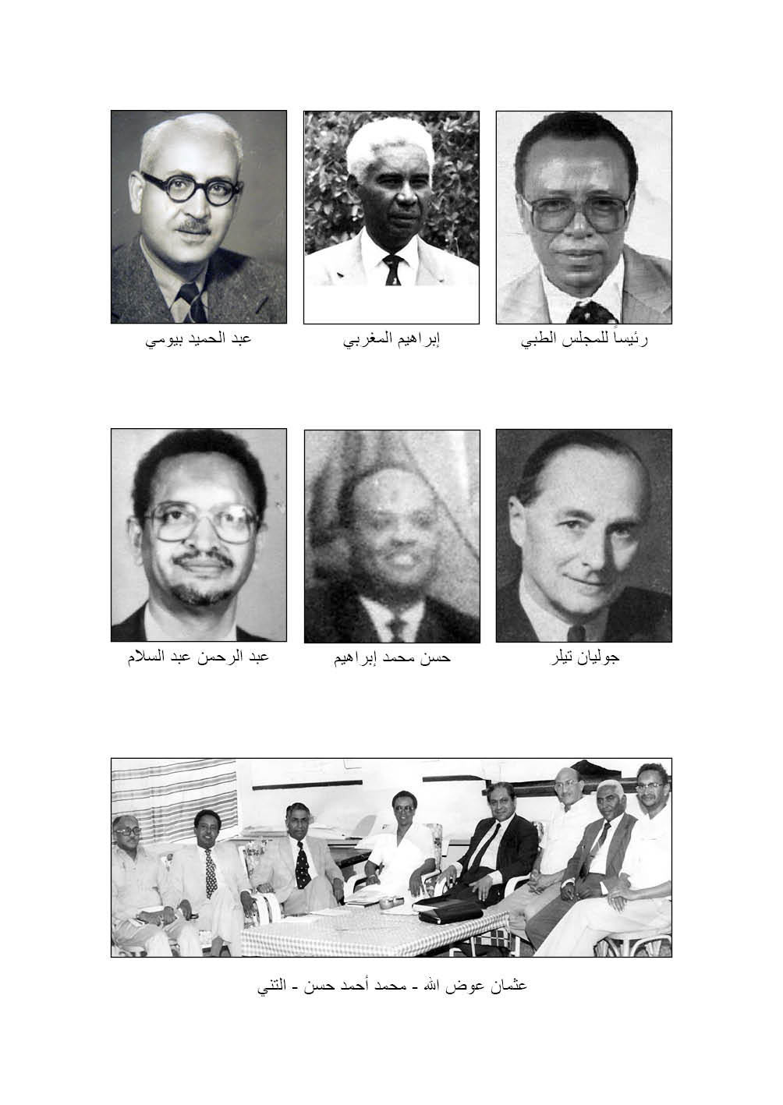
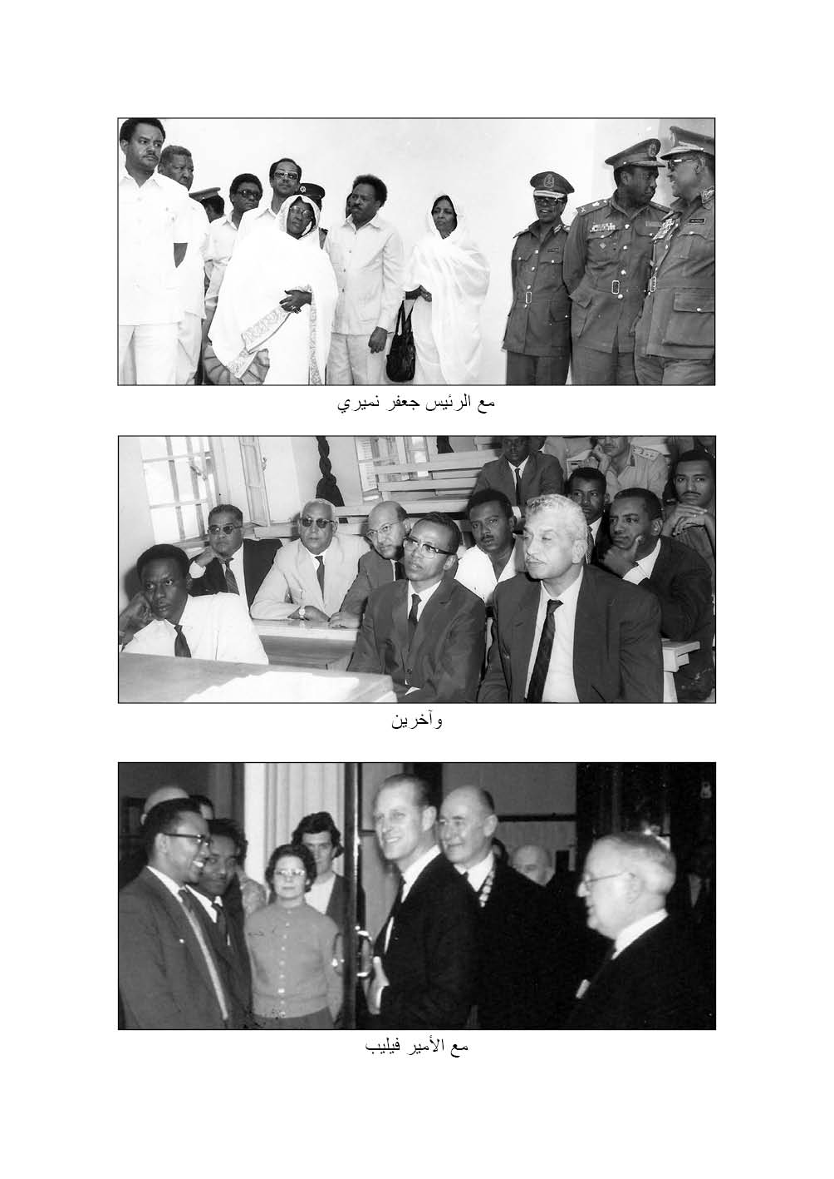
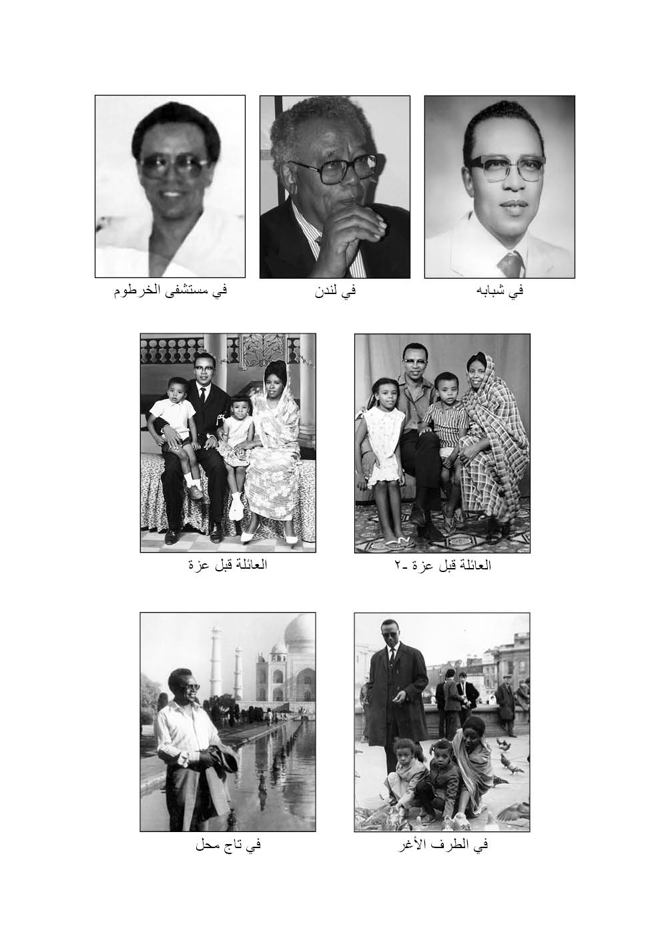
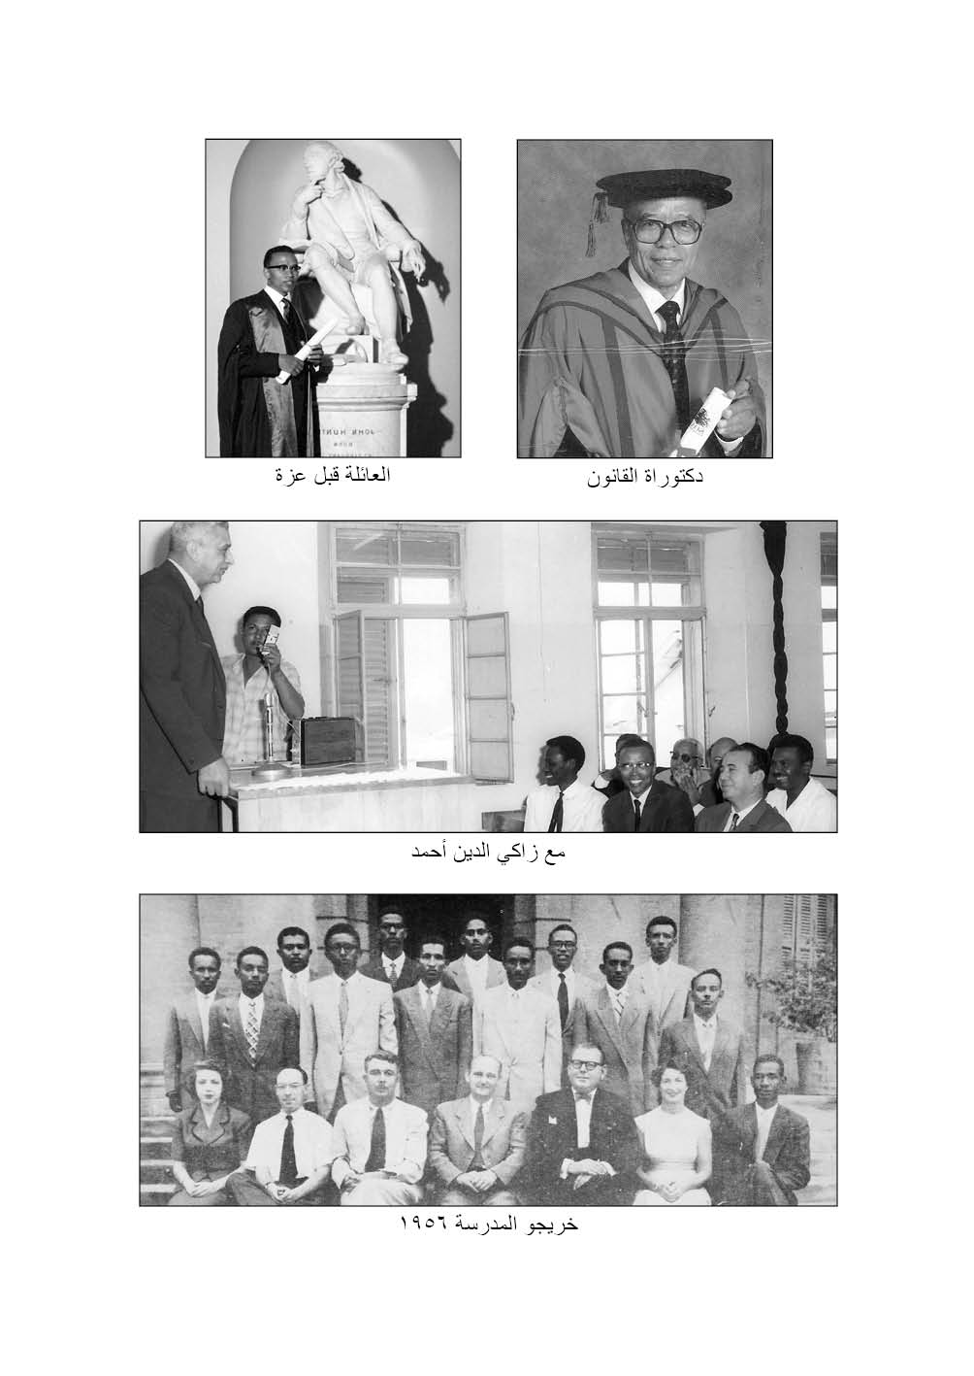
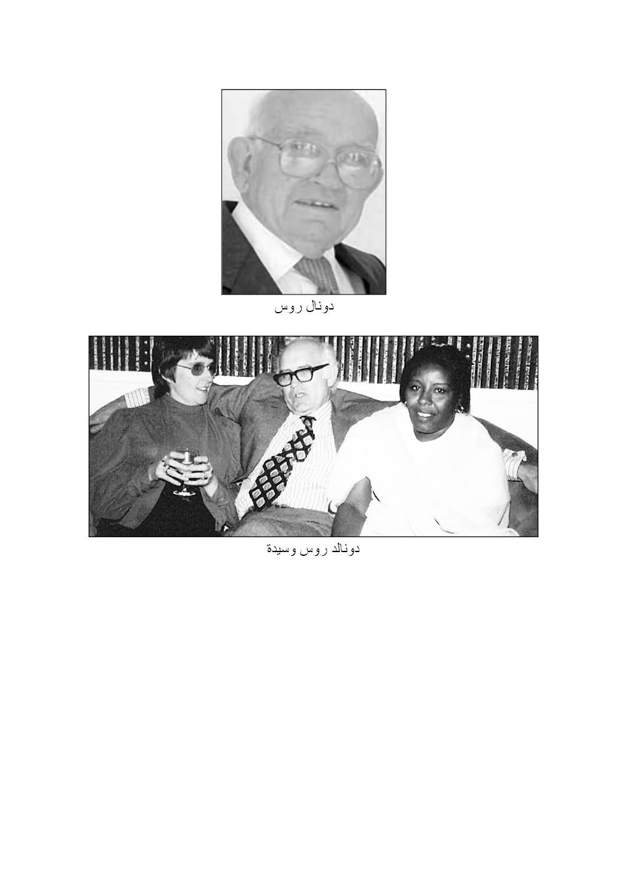

Biographer’s Profile
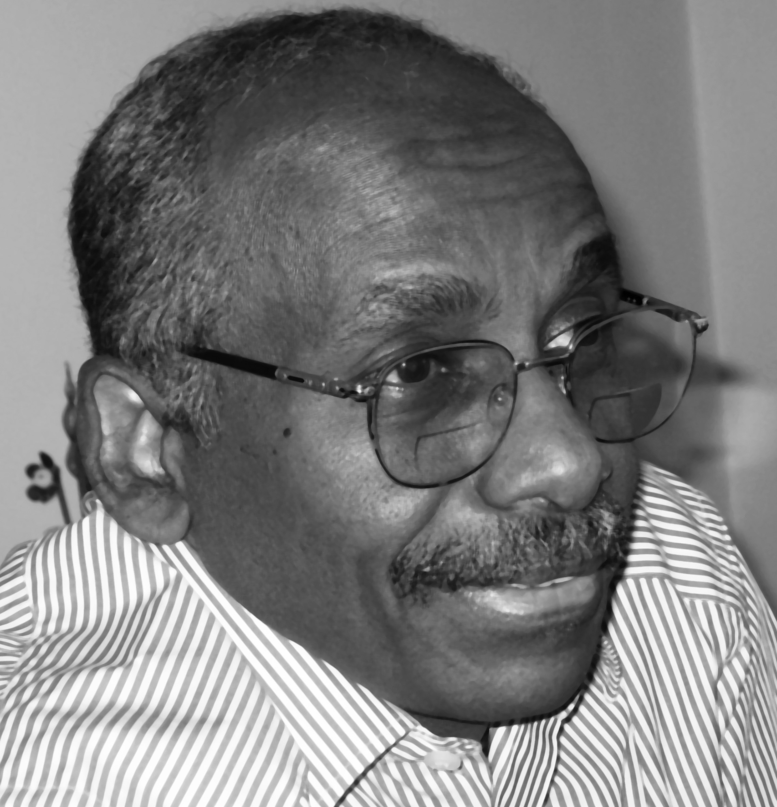
Professor Ahmad Al Safi
MB BS, DA FFARCS, FRCA
Ahmad Al Safi is a Sudanese anesthesiologist, researcher, administrator, and writer. He is known in the medical field as a medical biographer, and noted for his role as founder of institutional research in the history of medicine, and health heritage, and that he broke new grounds by establishing unique non-governmental high skills medical training. Ahmad Al Safi has an extensive record of accomplishment of activities in working with and in groups for four decades. He founded or co-founded several organizations – governmental and non-governmental, and held executive offices in many.
Ahmad Al Safi has been honoured by the Sudanese Writers Union (SWU) in December 2013 in recognition of his valuable contributions in studies of the Sudan’s health heritage, and for his scholarly publications in these virgin fields. The Union applauded his remarkable contributions in improving knowledge and enlightenment in academic work in Sudan. In February 2014, Professor Ahmad Al Safi was elected President of SWU.

References and Notes

Ahmad Al-Safi; Taha Baasher, Editors. Tigani Al-Mahi: Selected Essays. Fist ed. (with an introduction by Taha Baasher). Khartoum: Khartoum University Press; 1981; University of Khartoum, Silver Jubilee-1956-1981. 187 pages.
Ahmad Al-Safi; Taha Baasher, Editors. Tigani Al-Mahi: Selected Essays. [Arabic] Fist ed. (with an introduction by Dr. Ahmad Al Safi). Khartoum: Khartoum University Press; 1984; University of Khartoum, pages.
This monograph is based on Ahmed Abdel Aziz resume, list of publications, grey documents, written statements, and personal communications with him and with those who knew him closely.
1956 graduates of the Faculty of Medicine, University of Khartoum were fourteen: Ahmed Abdel Aziz Yacoub, Ahmed Mahmoud Abbas, Ali Mohamed Fadl, Amin Ali Nadim, Al Sayid Daoud Hassan, Al Tahir Fadl Mahmoud, Haddad Omer Karoam, Hassan Hag Ali, Hassan Hussain, Kamal Bushra, Mustafa Mohamed Abdel Magid, Nasr El Din Ahmed Mahmoud, Tag El Din Ahmed, and Widad Grunfuli.
Mohamed El Makki Ahmed and El bagir Ali Elfaki. Tribute to the Late Professor Ahmed Abdel Aziz Yacoub.
Ahmed Abdel Aziz Yacoub. The role of surgery in the treatment of rheumatic heart disease in the Sudan. A thesis submitted to the University of Khartoum at the Faculty of Medicine for the Degree of Master of Surgery, 1972.
A. M. Halim and John E. Jacques. Br Heart J 1961 23: 383-386.
Glover, HP, and Da Villa, JC. Circulation. 15:661. 1957.
Op. Cit. Page 28.
Professor A.L. d’Abreu, OBE, MCh, FRCS (England). Professor of Cardiac Surgery, Queen Elizabeth Hospital, University of Birmingham, England, with whom Mr. Ahmed Abdel Aziz trained between July 1962 and January 1964.
Pilcher
d’Abreu
Mr. Andrew Logan, MCh, FRCS (England), FRCS (Ed.), FRCP (Ed). Reader in thoracic surgery, University of Edinburgh and Director of the Thoracic Surgical Unit, Royal Infirmary, Edinburgh, whom Mr. Ahmed visited for four weeks in January, 1964 on the recommendation of Professor d’Abreu.
Klebs, F. Praag. Med. Wsche., 1, 28: 1876.
Saways. D.W. Lancet, 1898, 1, 927
Ahmed Abdel Aziz Yacoub. Rheumatism and the history of mitral valvotomy. Annals of the Royal College of Surgeons of England, Vol 54: June 1974; 309-312.
Ahmed Abdel Aziz Yacoub. The role of surgery in treatment of rheumatic heart disease in the Sudan. A thesis submitted to the University of Khartoum at the Faculty of Medicine for the Degree of Master of Surgery, 1972.
Acquired FRCSI in February 1976, and did later two years training in the Cardiothoracic Institute in Dublin.
Ahmed Abdel Aziz Yacoub. Figh of Medicine: Responses in Islamic Jurisprudence to Development in Medical Science. Taha Publishers Ltd. London. 2001: 349 pages.
أحمد عبد العزيز يعقوب. فقه الطبابة. استجابة الفقه الإسلامي للمستجدات في العلوم الطبية: إطلاعات في الفقه المقارن والقوانين الوضعية. رسالة دكتوراه في مدرسة الدراسات الشرقية، شعبة القانون، جامعة لندن. 2000 ونشرت في 2004.
Read the excellent foreword for Ahmed Abdel Aziz’ book by Abel Alier, former Judge of the Sudan Judiciary, former Member of the Law Revision Committee, Member of the Permanent Court of Arbitration at the Hague, and Legal Practitioner in Khartoum, Sudan.
Ahmed Abdel Aziz Yacoub. Op. Cit. Page 1.
Dr. Ahmed Al Safi attained his DA (England) in 1976, and FFARCS (England) in 1977. He came back to Sudan in 1978 and was immediately assigned to start anaesthesia for neurosurgery, chest, and heart surgery at the Shaab Hospital. He and other anaesthetists, cardiologists, technicians, nurses and other supporting staff were all enthusiastically involved with Mr. Ibrahim Mostafa in launching an ambitious heart surgery programme. This programme was unfortunately brought to a complete halt due to the premature death of Mr. Mostafa in 1984. Dr Safi also helped in anaesthesia and intensive care work for the cases done by Mr. Magdi Yacoub. Anaesthetists including Dr. Laila Abdalla and later Dr. Mamoun Hanafi Obeid, and Dr. Batoul Ibrahim Ishag covered neurosurgery in the same complex. This is the prime time of work of Mr. Hussain Sulaiman Abu Salih and the new comers in neurosurgery: Mohsin Mohamed Hussain, Ali Mohamed Abdel Rahman and Mohamed Mohi Eldin Abusaif.
The paediatric cardiologist, Dr. Abdel Monem El Seed, went to UK in 1969. His first post was an SHO at the Royal Hoso for Sick Children, Bristol with Professor Nevil Butler. After obtaining his DCH, he left to Newcastle upon Tyne in March 1970 & worked in the Royal Victoria Infirmary with David Kerr until he obtained his MRCP in September 1971. In February 1972, he was appointed as a registrar in paediatric cardiology at Royal Brompton hospital, a post that he held until 1974. There he was trained by some of the best doctors & in one of the best centres. It was a hands-on training on the devious aspects of paediatric cardiology including clinical, echo-Doppler, cardiac catheterization & research. The years 1972-74 were important. He published a number of papers that appeared in quite respectable medical journals. Some of the published research formed the basis on which some of the most important therapeutic interventions in pediatric cardiology were subsequently based on how surgical closure of the ductus arteriosus can unmask hidden coarctation of the aorta & this formed the basis on which prostaglandins were later used to maintain ductal patency. Similarly, the publications on Doppler were important & came when Doppler was in its infancy. He had training in the best centers in the USA, and was in contact with the masters of paediatric cardiac anatomy & physiology. For training in paediatric cardiac anatomy, he went to Harvard & worked with Professor Richard Van Prague who was the world’s leading cardiac anatomist. Then, he went to the University of California, San Fransisco where he spent another month with Professor Abe Rudolph one of the finest cardiac physiologists & a superb paediatrician.
Abdel Monem El Seed. Letter to Tarik Elhadd and passed to me (2008).
I am deeply indebted to Mr. Magdi Bayoumi (son) and Abdel Aziz Bayoumi (brother) of the late Mr. Abdel Hamid Bayoumi for providing most of the information on Mr. Bayoumi in this section.
Mr. F. Bartholomew, joined SMS in 1932. He got his Edinburgh FRCS while working in Merawi. He worked in Omdurman Hospital (1937-49) as surgeon and director. He died in UK in 1952.
Abd Al-Al A. Osman. Milestones in the History of Surgical Practices in the Sudan. Sudan Notes and Records. 1973; 54139-152
FS Mayne obtained his medical degrees at Queens University, Belfast, and FRCSE. He was posted to Sennar in place of O’Shaughnessy on his retirement in 1929. He had had considerable surgical experience when he succeeded Grantham-Hill in Khartoum in 1933. He continued as Senior Surgeon and Lecturer in Surgery until 1944 when he was forced to retire due to illness. (Squires, Herbert Chavasse. The Sudan Medical Service: An Experiment in Social Medicine. London: Heinemann Medical Books, 1958: page 53.
Obituary by AHMS. In memoriam of Marriott Faulkner Nicholls. K.B.E., M.Ch., F.R.C.S. (1898-1969)
British Medical Journal, Vol. 3, No. 5670 (Sep. 6, 1969), p. 600
Squires, Herbert Chavasse. The Sudan Medical Service: An Experiment in Social Medicine. London: Heinemann Medical Books, 1958: pages 53, 54, 55.

