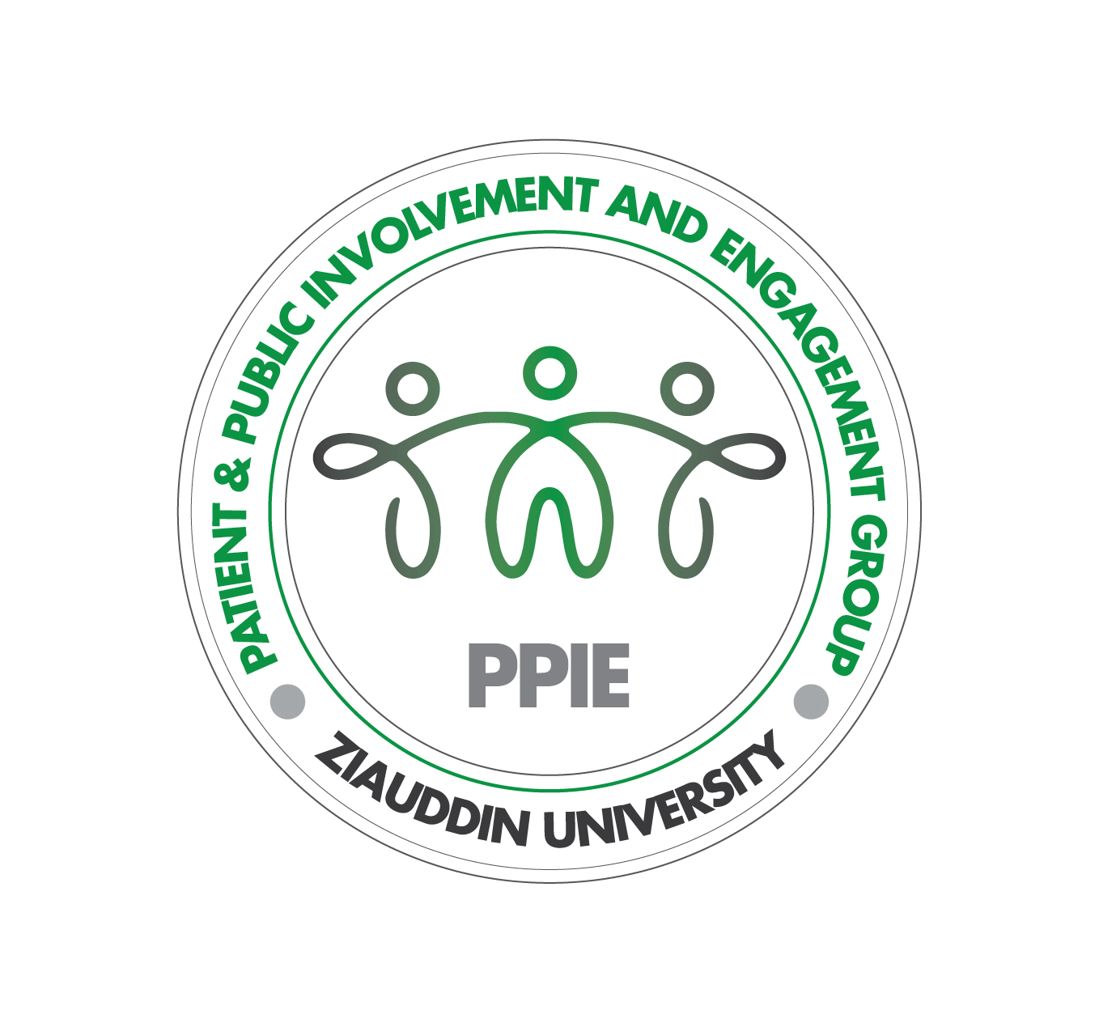
Honoraria & Expenses Policy
Patient & Public Involvement and Engagement (PPIE) Group
version 1.0 - 20/10/2024

About this policy
The ‘Honoraria & Expenses Policy’ details the payment of patient and public members of the Patient & Public Involvement and Engagement (PPIE) Group of the Critical Care Medicine Research Group at Ziauddin University Group of Hospitals. All members of the PPIE group and coordinators provided input and approved the final version of this policy. The policy has also been reviewed and approved by the Director of Office of Research, Innovation and Commercialization (ORIC) and Director of Finance at Ziauddin University. As there is no national guidance on payments for PPIE initiatives in Pakistan, this policy is based on the principles outlined in the National Institute for Health and Care Research (NIHR) payment guidance, and the lived experiences of our PPIE group members. This policy will be shared with all new PPIE group members prior to onboarding.

Honoraria
Honorarium payments are made to patient and public members of the PPIE group to acknowledge their contribution to the work conducted by the group. Members will receive payment for any time spent preparing or attending PPIE-related activities, including those taking place online, at a rate of 1000 PKR/hour. If the PPIE-related activity is canceled by the organizers less than 48 hours before it is due to take place, the full honorarium amount will be given.

Rights
Members have the right to decline payment or ask for payment of a lower value at any time by informing the PPIE coordinator. The honorarium payments do not create an employment relationship between the members and Ziauddin University, and no taxes are deducted prior to payment.

Expenses

Travel in Karachi
Travel to regular in-person PPIE meetings and activities taking place in Karachi will be reimbursed at a flat rate of 1500 PKR. If the amount is not sufficient to cover travel costs for a member, the amount will be increased for that member based on the average cost of their travel.

Travel & Accommodation Outside Karachi
Travel and accommodation for in-person activities outside of Karachi will be planned together with members and booked by Ziauddin University. Decisions regarding travel and accommodation will be made based on member needs and best value for money.

Meals
Refreshments provided at PPIE-related activities will be arranged and paid by Ziauddin University. A flat rate of 5000 PKR/day will be provided for meals at in-person activities taking place in Pakistan, accounting for 1000 PKR for breakfast, 1500 PKR for lunch and 2500 PKR for dinner. The daily amount for meals during international travel will depend on the destination of travel. Below are indicative rates for travel to the United Kingdom:

- Breakfast: £10/meal
- Lunch: £15/meal
- Dinner: £30/meal

Additional expenses
All additional expenses resulting from PPIE-related activities (e.g. childcare) will be covered. For any expenses not mentioned above, members will have to discuss the expense with the coordinator before it is incurred in order to ensure timely and appropriate reimbursement.

Payment
Members will be asked to provide their bank details (i.e. name of bank, name of account, account number, Computerised National Identity Card (CNIC) number) when they join the PPIE group. This information will be kept confidential and stored in a password-protected Google Drive. Payments to members will be made within a week of the PPIE-related activity either as an electronic bank transfer or a cheque according to preference. Patients and public members do not need to submit claims, receipts or evidence.

Review & Ratification
This policy will be reviewed and ratified annually by the PPIE group, Director of ORIC and Finance Director at Ziauddin University, or at any time in the case of proposed amendments based on feedback from PPIE members, coordinators or staff at Ziauddin University.

© 2024, Ziauddin University Patient & Public Involvement and Engagement Group
Licensed under CC BY-NC-SA 4.0. To view a copy of this license: https://creativecommons.org/licenses/by-nc-sa/4.0/

NIHR (2024): ‘Payment guidance for researchers and professionals’
HDR UK. 2024. Honoraria and Expenses Policy – Patient and Public Involvement and Engagement Activities version 3.0

