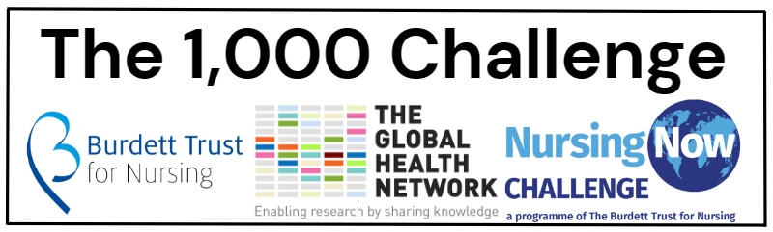

[Date]
[Recipient's Name]
[Recipient's Title]
[Medical Institution's Name]
[Medical Institution's Address]
Dear [Recipient's Name],

Subject: Request for Institutional Support for Participation in The 1,000 Challenge

I trust this letter finds you well. We are writing to seek the support of [Medical Institution's Name] for an innovative initiative that has the potential to significantly impact healthcare outcomes. The initiative in question is The 1,000 Challenge, a unique opportunity for nurses and midwives to contribute to advancements in patient care and healthcare practices.

What is it?
Nursing Now Challenge and The Global Health Network have come together to enable nurses, midwives, and community health workers in low-resource settings to lead research studies that address priority issues in their practice. It’s a powerful opportunity for leadership and career development, delivered through workplace learning whilst generating vital evidence to improve health outcomes in their communities.

Working through the powerful global communities of nurses that exist within Nursing Now Challenge and The Global Health Network we can reach nurses, midwives and community health workers across the globe who are working in low-resource settings, managing diseases of poverty to engage with this comprehensive programme. This will then translate on the ground and online to enable nurses to design and complete a pragmatic and achievable study within their care setting, supporting them in every step of the process; from setting the question, running the study right through to taking the findings up into practice and sharing their recommendations.

Studies accepted could be observational, social science (behavioural or practice), diagnostic or clinical trials involving non-pharmaceutical interventions that are known to be safe. These will ask locally important questions to generate evidence that can be taken up to change practice and management to improve patient management, care, or treatment.

Help, support, training, tools, and resources will be provided to each research team to ensure successful completion of each study. Student nurses and midwives can join this challenge through research education and leadership development and be linked to a research team to gain experience and new competences.

Where we fit in
Our nurses and midwives at [Medical Institution's Name] have demonstrated a strong commitment to excellence in patient care and have consistently exhibited a spirit of innovation. We believe that their active participation in The 1,000 Challenge can not only showcase the exceptional talent within our institution but also contribute to the broader healthcare community by sharing best practices and successful strategies.

To ensure the success of our nurses and midwives in The 1,000 Challenge, we are seeking your support in the following ways:

- Endorsement: Provide an official endorsement from [Medical Institution's Name] to strengthen the credibility of the projects submitted by our nurses and midwives.
- Promotion: Support the promotion of our nurses' and midwives' participation in The 1,000 Challenge through internal communication channels and collaboration with the institution's public relations team.
- Recognition: Acknowledge the achievements of our nurses and midwives who successfully contribute to The 1,000 Challenge, highlighting their accomplishments within the institution and in relevant publications.

We firmly believe that by supporting our nurses and midwives in this endeavour, [Medical Institution's Name] can play a pivotal role in fostering a culture of innovation and continuous improvement in healthcare.

Thank you for considering our request. We are confident that your support will not only benefit our institution but also contribute to the advancement of healthcare practices on a broader scale.

Should you have any questions or require additional information, please do not hesitate to contact [Your Contact Information].

Sincerely,
[Your Name]
[Your Title]
[Medical Institution's Name]
[Contact Information]

