[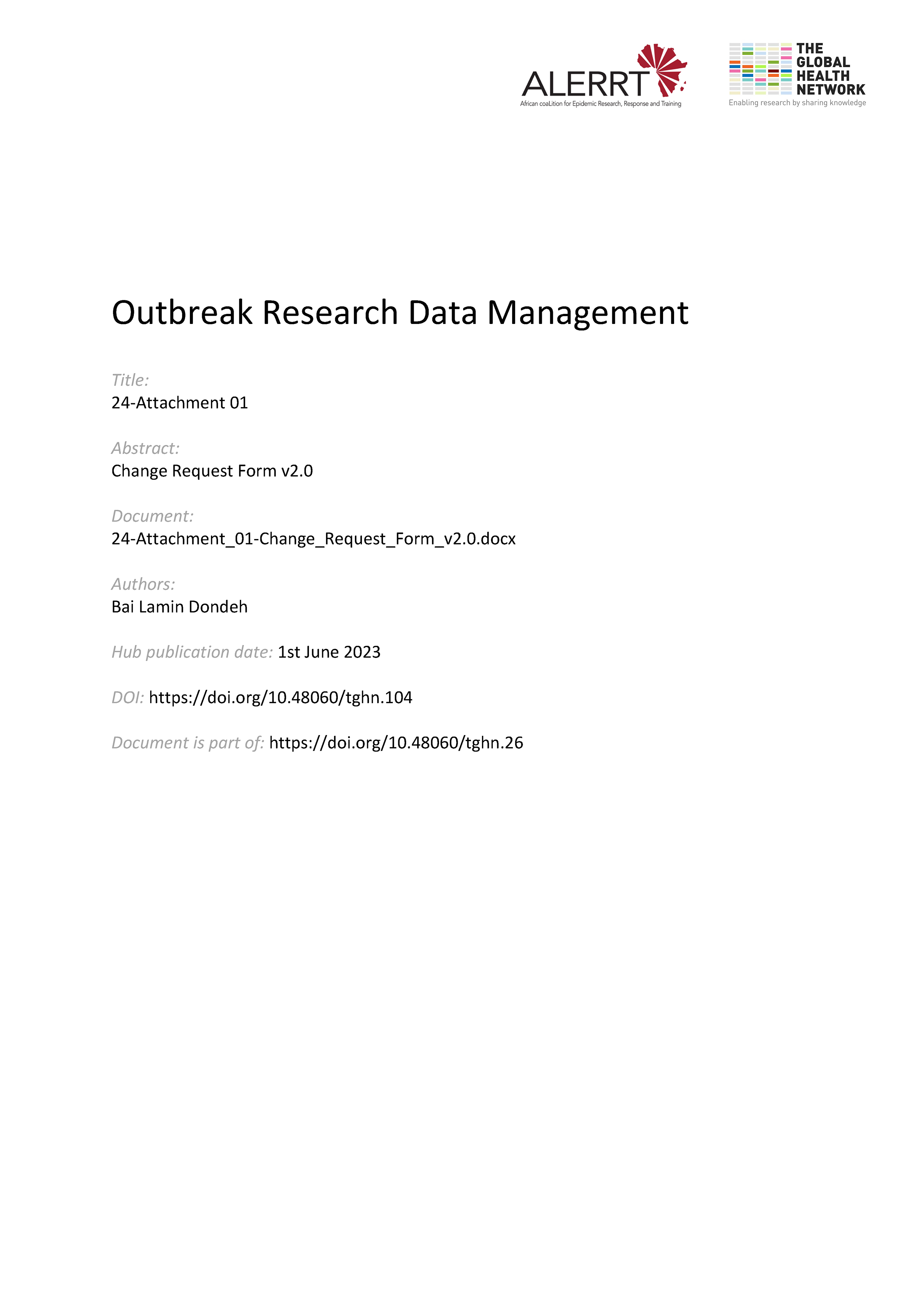](https://doi.org/10.48060/tghn.104)

|  |  |
| --- | --- |
|  | **Title:** Change Request Form |
| **Study title:** *Give study title to which this applies* |
| **System name:** *Give system name to which this applies*  *(e.g. Application/Database, Server, Network, etc.)* |

**Section A – Request Details** (completed by Change Requester)

|  |
| --- |
| Requester name: ___________________________________________________  Email address: _____________________________________________________  Description of the change  Reasons for the change - *(Attach additional sheets if required)*  **Signature** (Change Requester) : _________________________ Date : __ __ - __ __ __ - __ __ __ __ |

**Section B – Approval, Priority Assessment, & Planning** (completed by Change Manager)

|  |  |  |  |  |  |  |  |  |  |  |  |  |  |  |  |  |  |  |  |  |  |  |  |  |  |  |  |  |  |  |  |  |  |  |  |  |  |  |  |  |
| --- | --- | --- | --- | --- | --- | --- | --- | --- | --- | --- | --- | --- | --- | --- | --- | --- | --- | --- | --- | --- | --- | --- | --- | --- | --- | --- | --- | --- | --- | --- | --- | --- | --- | --- | --- | --- | --- | --- | --- | --- |
| Type of Change  Emergency  Maintenance  Retroactive  Standard  **Approved:**   Yes (complete Priority Assessment)  No (provide reason below and close)  If rejected, reason for rejecting the request:  Priority Assessment     |  |  | | --- | --- | | ***Urgency*** | ***Impact*** | | Core Business Services (High) | Network-wide / Group of VIPs (High) | | Support Services (Medium) | Lab or Single VIP (Medium) | | Non-urgent Services (Low) | Single User (Low) |   ☐   |  | | --- | | ***Resolution time*** | | **P1** = 4 hours  **P2** = 24 hours  **P3** = 3 days  **P4** = 5 days |   Planning   |  |  | | --- | --- | | **Communication** | **Comments** | | Determined those to be notified |  | | User notification message drafted |  | |  |  | | **Rollout Plan** |  | | Step-by-step outline of the process developed |  | |  |  | | **Back out Plan** |  | | Back out plan already in place |  | |  |  | | **Change Completion Checklist** |  | | Checklist developed and ready for use |  | |  |  | | **Downtime** |  | | Outage time determined and communicated |  |   **Name** (Change Manager)**:** _______________________________________  **Signature** (Change Manager) : ________________________ Date : __ __ - __ __ __ - __ __ __ __ |

**Section C – Implementation** (completed by Change Implementer)

|  |
| --- |
| Changes made (describe specific details):  Testing carried out (attach evidence if appropriate):  Downtime scheduling:  Review  Was the change successful?  Yes  No  If No, why was the change unsuccessful?  Was the change completed according to plan?  Yes  No  If No, why was the change not according to plan?  **Name** (Change Implementer)**:** _______________________________________  **Signature**: ________________________ Date : __ __ - __ __ __ - __ __ __ __ |

**Section D – Review & Close-out** (completed by Change Manager)

|  |
| --- |
| Have all changes been completed satisfactorily?  Yes  No  If No, what further actions are required?  **Name** (Change Manager)**:** _______________________________________  **Signature**: ________________________ Date : __ __ - __ __ __ - __ __ __ __ |