[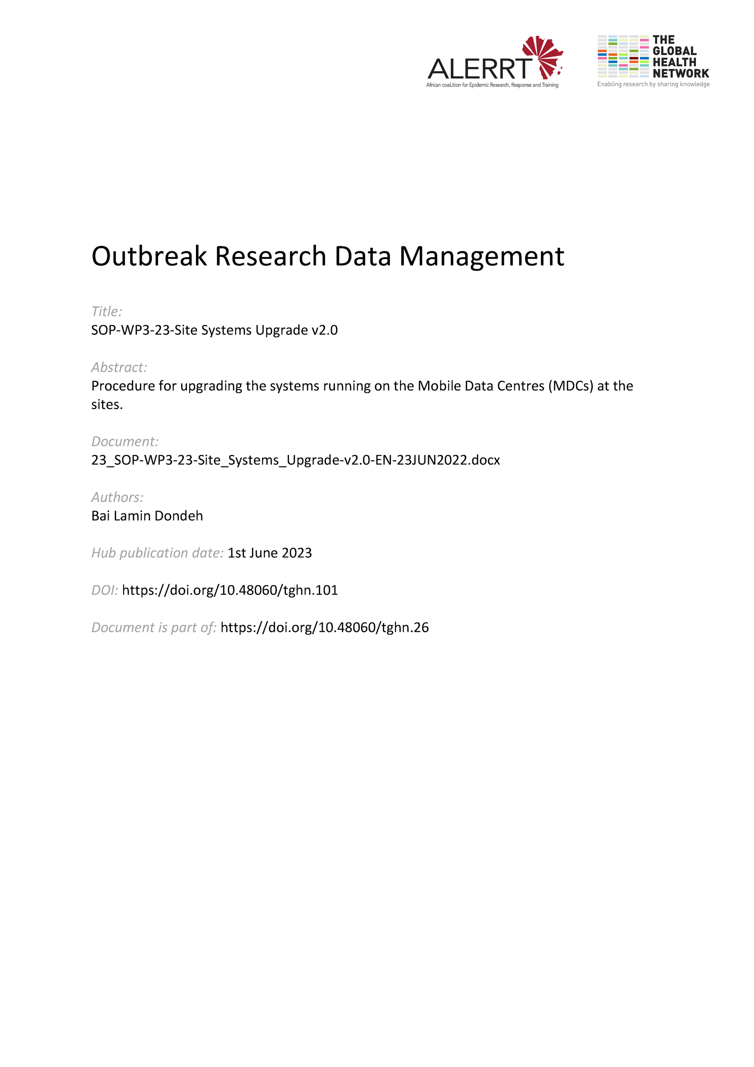](https://doi.org/10.48060/tghn.101)

|  |  |
| --- | --- |
|  | **SOP Title:** Site Systems Upgrade |
| **Study title:** *Give study title to which this SOP applies* |

1. **Scope and application**

|  |
| --- |
| The purpose of this Standard Operating Procedure (SOP) is to define the steps required to upgrade any of the systems running on the Mobile Data Centers (MDCs) at the sites. An upgrade includes any change to the system by the systems developers/manufacturers that causes a version change. These might include upgrades of the clinical data management software (e.g. REDCap), tabulations software (e.g. MySQL) and of any other MDC supporting software. These might include also an update of the eCRF (new version of the eCRF).  The procedure applies to any site that is using the MDC or a similar design. |

1. **Responsibilities**

|  |  |
| --- | --- |
| **Function** | **Activities** |
| Systems Developer | Responsible for:   * Performing and overseeing the entire systems upgrade process. * Notifying the Central Data Manager whenever there is a new version of any of the systems running on the MDC. |
| Central Data Manager | * Responsible for notifying the Site Data/IT Managers whenever there is a new version of any of the systems running on the MDC. |
| Site Data/IT Manager | * Responsible for notifying the active users of the system(s) through communication channels (email, phone call, online meetings, etc.) |
| Head of Data/IT | * Review and approval of Change Requests |

1. **Definitions**

**CDM**: Central Data Manager

**eCRF**: electronic Case Report Form

**MDC**: Mobile Data Centre

**PI**: Principal Investigator

**SD**: Systems Developer

**SDM**: Site Data/IT Manager

# Procedures

* 1. **Pre-upgrade Communication & Planning**

Prior to an upgrade of any of the systems running on the MDC, the following must be carried out:

* The SD notifies the CDM of the planned upgrade and the two of them discuss and agree on a date and time for the upgrade to take place.
* The CDM notifies the SDMs of the planned upgrade including the agreed date and time for it to take place, and the specific system(s) to be upgraded.
* The SD submits a “Change Request” (see SOP-WP3-25) to the Head of Data/IT for review and approval.
* The SDMs notify all active users via email and any other communication channels available on the details of the planned upgrade and any expected downtime.
* All notifications must happen at least a week before the agreed date with a reminder sent 3 days before as well as on the morning of the day.
  1. **Data synchronization & Backup**

The CDM works with the SDMs to ensure that there are no data pending synchronization and that the system(s) is backed up fully prior to the upgrade.

* The SDM performs final synchronization of all systems where synchronization is required to ensure that no new data is pending on the MDC.
* The SDM performs a full backup of all systems and data using the backup procedures outlined in SOP-WP3-19 Data Backup & Disaster Recovery.
  1. **Upgrade**
* The SD performs the upgrade process with the CDM (and members of the IT team where necessary) on the scheduled date and time.
* During the upgrade, the system is taken offline and a message with upgrade information would have been sent to the potential users already.
* The upgrade is carried out following the guidelines laid out for the upgrade of the specific system(s).
* Following successful upgrade, configuration and core functionality are tested and validated to confirm that various functions are working as expected.
* The system(s) is brought back online and all upgrade documentation and results are filed.
  1. **Post-upgrade Communication**
* The CDM informs the SDMs after successful completion of the upgrade.
* The SDM informs all end users on the successful completion of the upgrade and that the system(s) are available again.

# Attachments

|  |  |
| --- | --- |
| **Attachments** | |
| **Number** | **Title** |
|  |  |

# Document History & References

|  |  |  |  |
| --- | --- | --- | --- |
| **Revision** | | | |
| **Version number** | **Author** | **Date** | **Description/reason for modification** |
| 1.0 | Bai Lamin Dondeh | 23/03/2020 | Initial version – based on BCCH Research DM SOP 516 REDCap Software Upgrade.  Review by Pa Modou Cham.  Approval by Bai Lamin Dondeh and Harry van Loen. |
| 2.0 | Bai Lamin Dondeh | 23/06/2022 | Review to ensure that the SOP is appropriate within ALERRT and with current clinical research best practices. |

# Approval

|  |  |  |
| --- | --- | --- |
| **Name and function** | **Date (dd/mm/yyyy)** | **Signature** |
| ***Author*** | | |
| *Indicate who wrote the SOP* |  |  |
| ***Review*** | | |
| *Indicate WP team members who reviewed (if applicable)* | *Date of review* |  |
| ***Approval*** | | |
| *Indicate WP Lead/Co-lead(s) who approved* | *Date of approval* |  |