[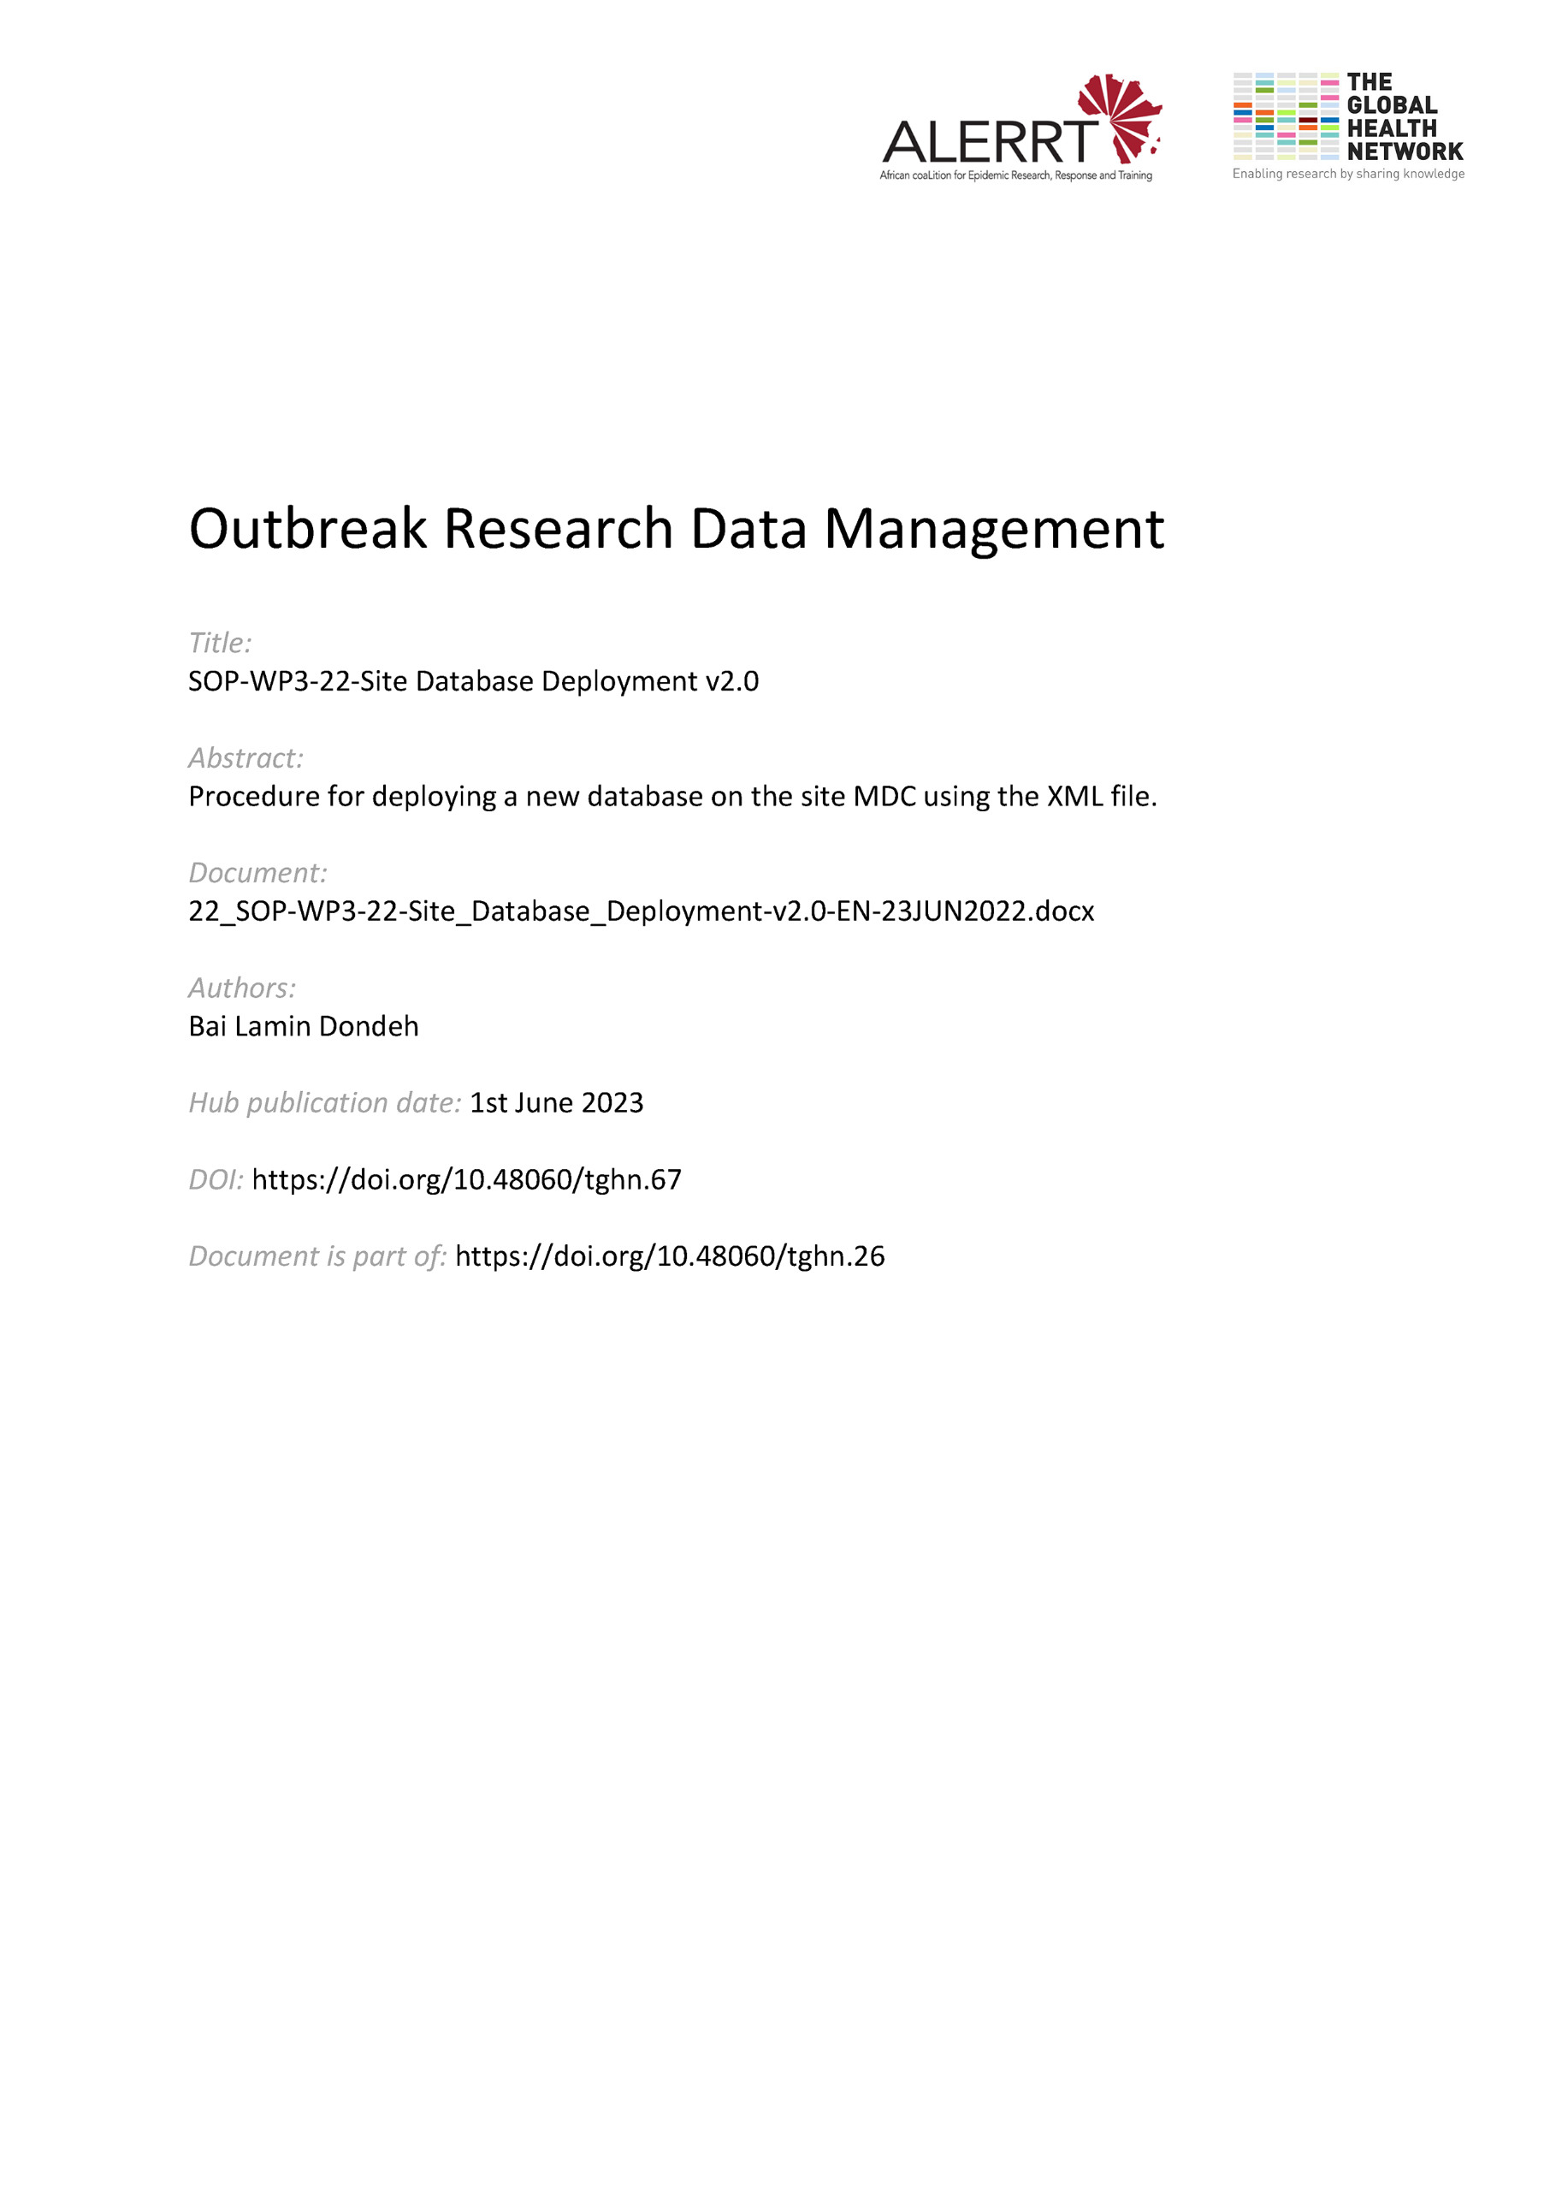](https://doi.org/10.48060/tghn.67)

|  |  |
| --- | --- |
|  | **SOP Title:** Site Database Deployment |
| **Study title:** *Give study title to which this SOP applies* |

1. **Scope and application**

|  |
| --- |
| The purpose of this Standard Operating Procedure (SOP) is to define the steps required to deploy a REDCap database already developed on the central server, to the Mobile Data Centers (MDCs) at the sites.  The procedure applies to all REDCap database deployments, whether the platform originally hosting the data is maintained by the ALERRT DM team or an external entity. |

1. **Responsibilities**

|  |  |
| --- | --- |
| **Function** | **Activities** |
| Central Data Manager | * Responsible for initiating the deployment process from the REDCap Central server to the sites’ Mobile Data centers as well as overseeing the entire process from start to completion. |
| Site Data Manager | * Responsible for completing the deployment process at site level and carrying out preliminary tests to ensure the deployment was successful. |

1. **Definitions**

**CDM**: Central Data Manager

**MDC**: Mobile Data Centre

**PI**: Principal Investigator

**SDM**: Site Data Manager

# Procedures

* 1. **Database File Transfer**

A replica of the database to be deployed needs to be sent to all sites conducting the study. Following testing and validation of the study database, the CDM needs to perform the following steps prior to any data collection in order to transfer the necessary files over to the sites for deployment.

* Login to REDCap Central Server and open the study database.
* Under “Data Exports, Reports, and Stats” -> “Other Export Options”, download the REDCap XML file (containing metadata & data).
* Using email, send the XML file as an attachment to all SDMs.
  1. **Database File Receipt and Deployment Planning**

The SDMs should carry out the following:

* Using the laptop connected to the MDC, download the XML file sent via email and save on the MDC file server.
* Respond to the email from the CDM to arrange a date and time for the deployment to take place.
* Await confirmation from the CDM and ensure that the MDC is connected to internet on the agreed date and time.
  1. **Database Deployment**
* The CDM logs into the MDC using the remote connection mechanism outlined on Appendix 1 of SOP-WP3-20 IT & Data Management Support.
* Log into REDCap on the MDC as an administrator using the “alerrt_admin” user.
* Add a “New Project” and in the “Create a new REDCap Project” page, on the “Start project from scratch or begin with a new template?” question, select the “Upload a REDCap project XML file (CDISC ODM format)” option.
* Select the XML file saved on the MDC file server and click on “Create Project”.
  1. **Deployment Confirmation**
* Under “Project Setup” -> “Online Designer” – check that all the instruments (eCRFs) have been successfully transferred and are in the database.
* Under “Project Setup” -> “Define My Events” – check and confirm that all events have been successfully transferred as set up on the central database
* Under “Project Setup” -> “Designate Instruments for My Events” – and confirm that the instrument assignment to events are as set up on the central server.
  1. **Initial Configuration & Testing**
* The CDM ensures that the SDM has completed the necessary Access Request forms and has been authorized for access to the study database by the PI. This should be ensured ONLY by viewing the signed Access Request form.
* Under “User Rights”, the CDM create a “Data Manager” role and add the SDM’s account to the role to enable him/her to access and manage the database.
* Under “Control Center” -> “Administrators & Acct Managers” - the CDM adds the SDM user to the list of " Current Account Managers”.
* The CDM creates a project mapping file (pmf) containing the site id and the API token for the “alerrt_admin” user account. Under “Applications” -> “File Repository” -> “Upload New File” – uploads the pmf file.
* Under “Project Setup” -> “Add or edit bookmarks” – the CDM adds “http://192.168.0.4/redcap/plugins/Export_data.php” as the “Link URL / Destination” for the Data Export Plugin. Ticks the “Append project ID to URL” checkbox and enters a label for the link under “Link Label”.
* The CDM logs out of REDCap and allows the SDM to log in with his/her new username and password to confirm that access to the study database has been granted.
* The SDM then carries out a complete User Acceptance Testing (UAT) as required as part of the database validation process outlined in SOP-WP3-17 on Systems Validation.

# Attachments

|  |  |
| --- | --- |
| **Attachments** | |
| **Number** | **Title** |
|  |  |

# Document History & References

|  |  |  |  |
| --- | --- | --- | --- |
| **Revision** | | | |
| **Version number** | **Author** | **Date** | **Description/reason for modification** |
| 1.0 | Bai Lamin Dondeh | 17/03/2020 | Initial version  Review by Pa Modou Cham.  Approval by Bai Lamin Dondeh and Harry van Loen. |
| 2.0 | Bai Lamin Dondeh | 23/06/2022 | Review to ensure that the SOP is appropriate within ALERRT and with current clinical research best practices. |

# Approval

|  |  |  |
| --- | --- | --- |
| **Name and function** | **Date (dd/mm/yyyy)** | **Signature** |
| ***Author*** | | |
| *Indicate who wrote the SOP* |  |  |
| ***Review*** | | |
| *Indicate WP team members who reviewed (if applicable)* | *Date of review* |  |
| ***Approval*** | | |
| *Indicate WP Lead/Co-lead(s) who approved* | *Date of approval* |  |