[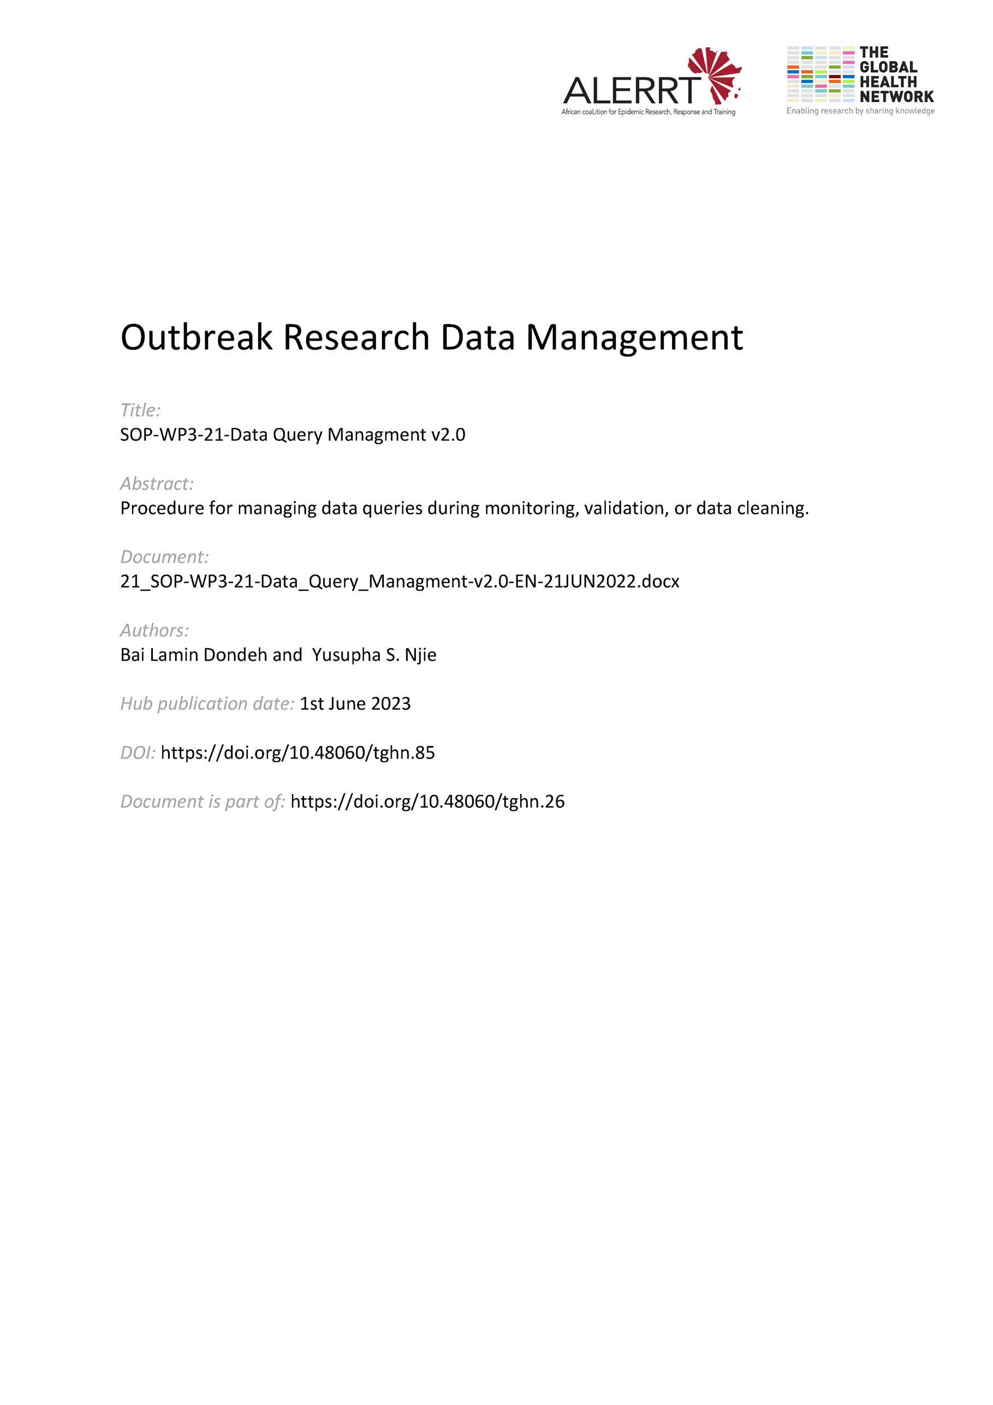](https://doi.org/10.48060/tghn.85)

|  |  |
| --- | --- |
|  | **SOP Title:** Data Query Management |
| **Study title**: *Give study title to which this SOP applies* |

# Scope and application

|  |
| --- |
| This SOP describes the process involved in the resolution of raised data queries.  Data queries are raised to request/provide clarification on data in the database that is missing, inconsistent with other data, indicates a protocol violation, or is unusual (e.g. outside a specified range for a particular parameter). Data queries may lead to changes to the data in the database if missing data is obtained or an error is discovered as a result of the query.  This SOP applies to all aspects of querying on data for a clinical research project/study. |

# Responsibilities

|  |  |
| --- | --- |
| **Function** | **Activities** |
| Data Manager  Monitor | * (re-)Raise, tracks and verifies all raised queries are responded * Ensures no edits are made to the database without a supporting authorized Data Query Form (DQF) * Closing queries after resolution |
| Project Lead or Project Lead delegate  Site staff (including data entry staff) | * Ensures the necessary data are complete and accurate on the electronic case record form (eCRF) * Respond to the data queries (either through DQF or through a database in-built data resolution workflow) and update the data where needed. |

# Definitions

**CRF**: Case Report Form

**pCRF**: Paper Case Report Form

**eCRF**: electronic Case Report Form

**DQF**: Data Query Form

**DQL**: Data Query Log

# Procedures

A flowchart of the Data Query process is provided in Appendix 2.

There are 5 basic components in the query management process

1. Identifying a (possible) inconsistency or uncertainty
2. Raising a query
3. Responding to the query
4. Updating the data (if applicable)
5. Closing or re-raising a query
   1. **Identifying a (possible) inconsistency**

* An error or discrepancy can be identified by a member of the study team through the team’s own adopted quality control.
* An error or discrepancy can be identified by the data manager or monitor through on-going review and data cleaning checks in the trial database (SOP-WP3-07-Data Validation & Review)
* Clarification on any participant information or variable that needs further evaluating.
  1. **Raising a query**

In case an error is found, or clarification is needed a query can be raised. This query describes the question being posed about an issue with a particular data point. The raised queries should be logged, describing who raised them and when.

When raising queries:

* Keep the question as short but as clear as possible.
* Questions should not be leading (e.g. write ‘Please recheck this value on the source and confirm’ rather than to ask ‘Is the value 5’)
* Keep consistency between similar questions. Templates can be useful for recurring queries.

**4.2.1. Projects using electronic CRFs**

Most electronic clinical data management systems have an internal system to raise, log and track queries. Please refer to the help files of the specific software for how to handle queries. Terminology might deviate from the one used in this SOP.

Whenthe software used is not capable of providing all the necessary query tracking, additional tracking mechanisms might need to be applied.

**4.2.2. Projects using paper CRFs - Data Query Forms (DQF)**

* When paper CRFs are used, a paper DQF (see Attachment 01) should be used to write the query. This document should contain the query, the name and function of the person raising the query, the date of the query and the section of data it describes. This document is then sent to the site.
* Prior to sending DQFs to the site, each must be logged in the Data Query Log (DQL) (see Attachment 02). The DQL should be updated throughout the query process, starting with raising the query and ending with the closing of the query.  
  1. **Responding to a query**

The site (data collection) staff should respond to any queries raised. Any questions raised in the query should be responded to, and where needed extra clarification should be given. If anything is unclear, the site can ask for further clarification in their response.

In electronic systems the query can be responded to in the system itself. Where paper versions are used, or the system does not have a query management tool, the responses should be registered on the DQF and sent back to the Data Manager/Monitor.

* 1. **Updating the data (if applicable)**

After responding to the query, the data can be updated where needed. Data updates should be done by data entry/collection staff. Self-evident queries may be updated by the Data Manager but should still be documented. Updates in the data should be logged either in the electronic audit trail, or another logging system (e.g. On paper documents, the change should be signed and dated)

* 1. **Closing or re-raising a query**

**4.5.1. Closing a query**

Queries can be closed by the Data Manager or Monitor (depending on who raised the query) after a final check. The response should be satisfactory that all applicable updates should have been done.

**4.5.2. Re-raising the query**

In cases where the site response is not satisfactory the query can be re-raised by the Data Manager or Monitor. Additional questions might be raised, or the original question might need to be re-worded if it was not clear.

# Attachments

|  |  |
| --- | --- |
| **Attachments** | |
| **Number** | **Title** |
| 01 | Data Query Form (DQF) |
| 02 | Data Query Log (DQL) |
|  |  |

1. **Document History and References**

|  |  |  |  |
| --- | --- | --- | --- |
| **Revision** | | | |
| **Version number** | **Author** | **Date** | **Description/reason for modification** |
| 1.0 | Yusupha Njie | 08/10/2019 | Initial version  Review by Hanne Landuyt.  Approval by Bai Lamin Dondeh and Harry van Loen. |
| 2.0 | Bai Lamin Dondeh | 21/06/2022 | Review to ensure that the SOP is appropriate within ALERRT and with current clinical research best practices. |

1. **Approval**

|  |  |  |
| --- | --- | --- |
| **Name and function** | **Date (dd/mm/yyyy)** | **Signature** |
| ***Author*** | | |
| *Indicate who wrote the SOP* |  |  |
| ***Review*** | | |
| *Indicate WP team members who reviewed (if applicable)* | *Date of review* |  |
| ***Approval*** | | |
| *Indicate WP Lead/Co-lead(s) who approved* | *Date of approval* |  |