[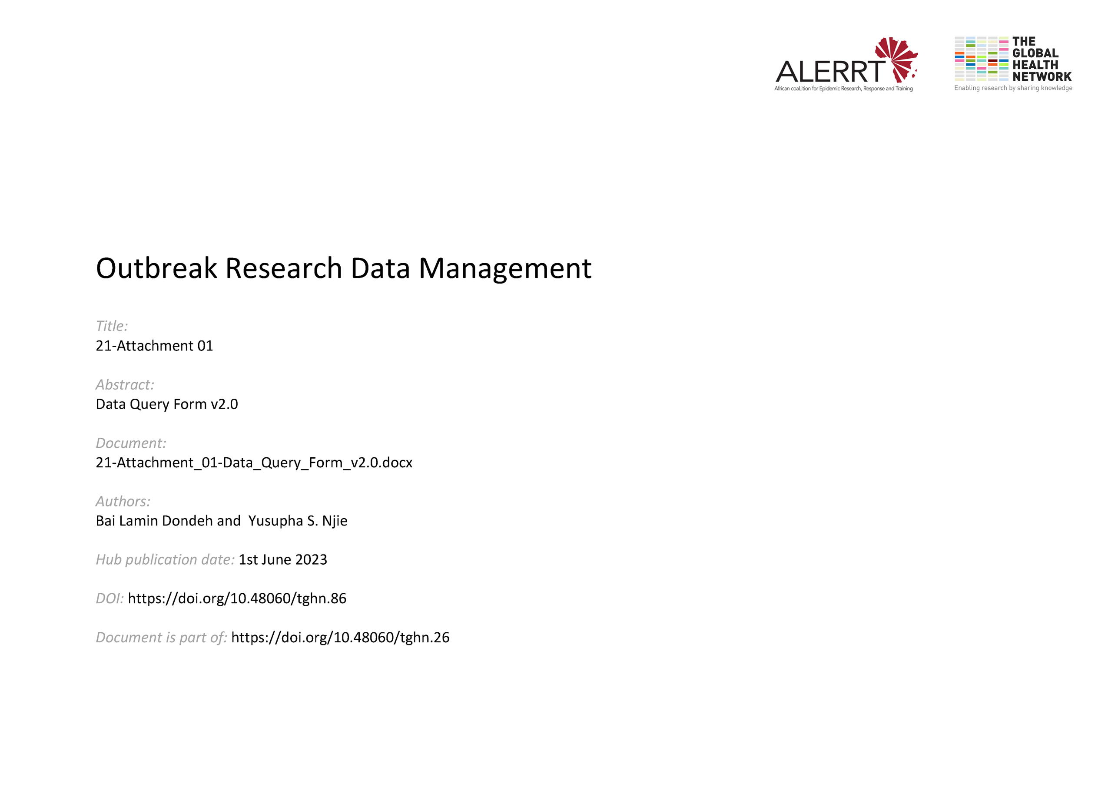](https://doi.org/10.48060/tghn.86)

|  |  |
| --- | --- |
|  | **Title:** Data Query Form |
| **Study title:** *Give study title to which this applies* |

|  |  |  |  |  |  |  |  |  |  |
| --- | --- | --- | --- | --- | --- | --- | --- | --- | --- |
|  |  | | |  | | | | **Query Form #:** |  |
|  |  | | |
|  | | | |  | | | |  | |
| **Participant ID** __________________ | | | | **Secondary participant ID**: _________________ | | | | **Participant initials**: |__|__|__| | |
|  | | |  | | | |  | | |
| **Form name:** ________________ | | **Form Date:** |__|__|-|__|__|__|-|__|__|__|__| | | | | **Form ID:** ______________________ | | | |
| **Visit:** ______________________ | | **Form Time:** |__|__|:|__|__| | | | | **Field number(s):** ______________________ | | | |
|  | | | | | | | | | |
| **Problem/Nature of Query:** | | | | | **Response:** | | | | |
|  | | | | |  | | | | |
| **Person raising query:** ____________________ | | | | | **Person responding to query:** ____________________ | | | | |
| **Date:** |__|__|-|__|__|__|-|__|__|__|__| **Time:** |__|__|:|__|__| | | | | | **Date:** |__|__|-|__|__|__|-|__|__|__|__| **Time:** |__|__|:|__|__| | | | | |
|  | | | | |  | | | | |
| **DM closing query:** ____________________ | | | | | **Date:** |__|__|-|__|__|__|-|__|__|__|__| **Time:** |__|__|:|__|__| | | | | |