[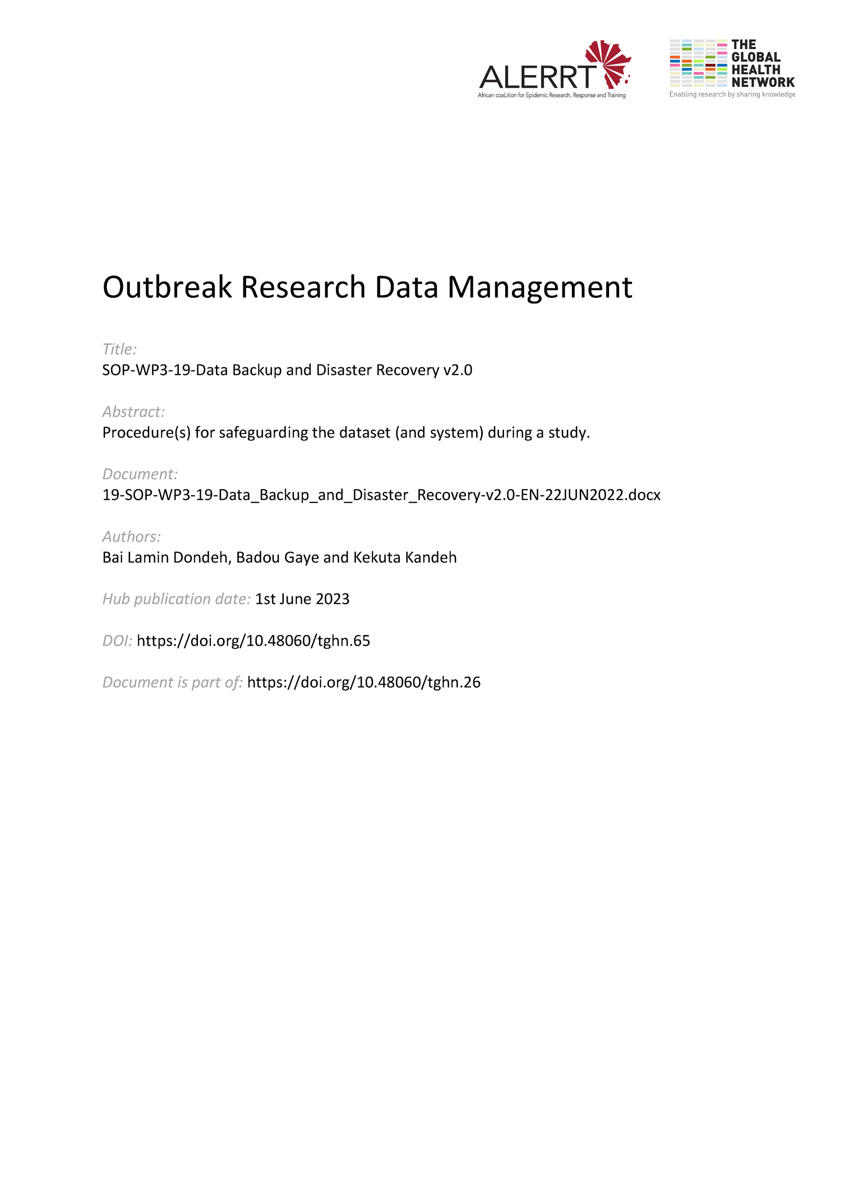](https://doi.org/10.48060/tghn.65)

|  |  |
| --- | --- |
|  | **SOP Title: Data Backup & Disaster Recovery** |
| **Study title**: *Give study title to which this SOP applies* |

# 1. Scope and application

|  |
| --- |
| This standard operating procedure (SOP) describes the process for backing up all data and meta data of a project/study. This backup procedure includes The backup procedure includes backup at the study sites and the data centre and their final copies to an offline storage.  In Information Technology (IT) a back-up of data refers to making copies of data so that these additional copies may be used to restore the original after a data loss event. Back-ups of data are an important part of disaster recovery and business continuity planning.  This SOP applies to all data types in the datacentre including files, databases, applications and the entire servers in general. |

# 2. Responsibilities

|  |  |
| --- | --- |
| **Function** | **Activities** |
| Data Manager | * Performing Systems Administration tasks such as running the schedule of backups, ensuring that backup is successful and copying the backups to an offline storage. |
| IT Application Manager (AM) | * Collecting weekly backup logs and notifications and storing these logs on a repository as evidence of backups * Review and approve the backup plan * Provide overall support for backup and recovery |

# 3. Definitions

* DM: Data Manager
* AM: Application Manager
* SOP: Standard Operating Procedure

# 4. Procedures

* 1. **Backup software and Server**
* Use a software to backup the entire infrastructure including servers and to the granular level including files and databases. An example of such a software for Backup is Veeam Backup and Replication Community Edition which is a free Edition and can backup up to a combination of 10 nodes including virtual machines, physical servers and cloud instances including granular files, databases, SharePoint repositories, email and Active Directory. This software can be installed on Windows, Mac and Linux.

Install this software on a computer or server dedicated as the Backup Media Server from which backup schedules and selections are run targeting all locations within the infrastructure to backup, when to run the backups, and what types of backups to run as well as the frequency of the backups

* 1. **Backup Schedule and Selection**
* AM will plan the backup job and indicate all the locations (targets) to back-up on a backup job
* AM will also set a schedule on when the backup job(s) will be running either manually or automated
  1. **Backup Types and Rotation**

The AM can decide to run two types of backups which are:

1. Full Backups – backups everything irrespective of whether they have been backed up before or not
2. Incremental backups – only backups data that have changed from the last full or incremental backup

* AM will run an initial Full backup and would run weekly Full backups at the end of each week on Friday evening
* AM will run incremental backups on every other day that data is captured at end of day
* AM will run monthly full backups
  1. **Backup File Naming Formats and Repository**

Backups can be labelled using the standard naming conventions. Example are shown below:

* Day’s Full Backup – “dd-mm-yyyy-Full ” where ‘dd’ represents two digits of the day, ‘mm’ represents the two digits of the month and ‘yyyy’ represents the 4 digits of the year. A Full backup taken on 12th December 2019 would thus be 12-12-2019-Full
* Incremental Backup - “dd-mm-yyyy-Incremental ” where ‘dd’ represents two digits of the day, ‘mm’ represents the two digits of the month and ‘yyyy’ represents the 4 digits of the year. An incremental backup taken on 15th December 2019 would thus be 15-12-2019-Incremental
* Weekly Backup – Weekx of MM-YYYY- Full where ‘x’ is a number representing 1st, 2nd, 3rd or 4th week of a month. A weekly backup taken on 13th December 2019 would thus be Week2 of 12-2019-Full
* Monthly Backup – MM-YYYY-Full where ‘mm’ represents the two digits of the month and ‘yyyy’ represents the 4 digits of the year. A Full backup taken at the end of month for December 2019 would thus be 12-2019-Full
  1. **Backup Job Notifications**

DM will check outcome of the job in the events log or notifications of the application to check if the job was fully successful, partially successful or failed altogether and where it failed, would address the reason for failure and run job again or notify the IT Application Manager for needed help.

* 1. **Restoration Tests**

AM will run monthly restore tests of monthly backups to ensure that the backups are restoring data as intended.

# 5. Attachments

|  |  |
| --- | --- |
| **Appendices & Attachments** | |
| **Number** | **Title** |
| Appendix 01 | Document Version History |

**6. Document History and References**

|  |  |  |  |
| --- | --- | --- | --- |
| **Revision** | | | |
| **Version number** | **Author** | **Date** | **Description/reason for modification** |
| 1.0 | Badou Gaye  Kekuta Kandeh | 08/10/2019 | Initial draft – based on SOP ADMIT-004-00 System Validation  Review by Hanne Landuyt.  Approval by Bai Lamin Dondeh. |
| 2.0 | Bai Lamin Dondeh | 22/06/2022 | Review to ensure that the SOP is appropriate within ALERRT and with current clinical research best practices. |

**7. Approval**

|  |  |  |
| --- | --- | --- |
| **Name and function** | **Date (dd/mm/yyyy)** | **Signature** |
| ***Author*** | | |
| *Indicate who wrote the SOP* |  |  |
| ***Review*** | | |
| *Indicate WP team members who reviewed (if applicable)* | *Date of review* |  |
| ***Approval*** | | |
| *Indicate WP Lead/Co-lead(s) who approved* | *Date of approval* |  |