[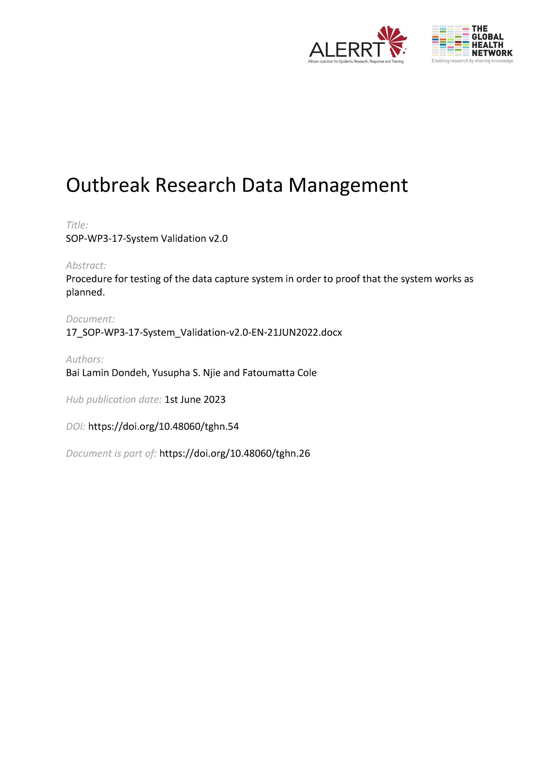](https://doi.org/10.48060/tghn.54)

|  |  |
| --- | --- |
|  | **SOP Title:** System Validation |
| **Study title**: *Give study title to which this SOP applies* |

# Scope and application

|  |
| --- |
| The SOP describes the process by which the a computer system used for clinical data management, is validated. Computerized system validation helps to demonstrate that the system is fit for purpose in acquisition, processing, recording, reporting, storing or retrieving of participant data in a study or trial.  This SOP outlines the process of system testing and reporting that must be conducted to maintain the integrity and quality of clinical trial data.  The SOP applies to all computerized systems used in clinical research, in particular clinical trials. |

# Responsibilities

|  |  |
| --- | --- |
| **Function** | **Activities** |
| Data Manager | * Ensuring that all data management systems that require validation are validated as per this procedure. * Approving the validation documentation for all systems undergoing validation. * Ensuring that system(s) under their responsibility are validated (if necessary) and maintained in a validated state, according to this SOP. * Managing the validation of the system whilst in production use. |
| System Developer | * Managing the validation of the functional aspects of the system such as installation, database connection, etc. * Handing over the system to the Data Manager once the system is developed, validated and deployed into production. * Drafting the documentation for system validation * Supervising and approving testing done by a system reviewer/tester * Ensuring reprogramming and retesting in case of deviations * Ensuring the system goes live only after all System Validation Documents are signed |
| Quality Assurance  ( Manager or Officer) | * Reviewing the validation documentation pack. * Approving the Validation Report. |

# Definitions

**FS:** Functional Specification

**IQ:** Installation Qualification

**OQ:** Operation Qualification

**PQ:** Performance Qualification

**QA:** Quality Assurance

**SD:** Systems Developer

**ST:** Systems Testing

**URS:** User Requirement Specification

**VP:** Validation Plan

**VR:** Validation Report

# Procedures

* 1. **Validation Plan (VP)**

This gives an overview of the entire validation process for a particular system, describing the scope of work to be performed and processes and test procedures to be employed. The plan also describes responsibilities of different members of the validation team, which will typically consist of members of the end users, Data Management and Quality Assurance.

* Ensure that the VP is created using the template (see Attachment 01).
* Submits the VP for approval and sign-off. The VP will be approved and at the end of the validation process it will be reviewed. The full approval and review list of all validation documentation will be defined in the VP.
  1. **User Requirements Specification (URS)**

The URS document is a high-level description of the system explaining why it is required and what is required of it. It includes the background, key objectives and benefits, main functions and interfaces, applicable GCP requirements, and other applicable regulations as basis to choose a proper system or software.

* Create the URS (see Attachment 02) based on the study protocol. Instances where the study protocol is not detailed enough the required information can be obtained actively via email, meetings, or teleconference, and validated as stated on the URS document.
* Ensure that the URS is created prior to the system or software being chosen.
* Submit the URS for review and approval.
  1. **Functional Specification (FS)**

The FS document defines the required system design, functions, and operation. This is the technical implementation of the requirements in the URS.

* Ensure the FS is created using the template (see Attachment 03) before commencing any programming/development.
* Submit the FS for review, approval, and sign-off.
* The FS will be approved and the approval and review list will be defined in the VP.
  1. **Systems Testing (ST)**

ST determines that the system operates according to URS, and to record all relevant information and data to demonstrate it functions as expected.

* + Use the System Test Plan and Report (STP) Template (see Attachment 04) to develop a system test plan defining all the test events that are planned to test all items in the URS from a functional perspective i.e. technically. If a test event requires a more detailed description of steps, then write a test script as a separate document and reference in the STP.
  + Submit the STP for review and approval by the prior to execution.
  + Carry out testing as defined on the STP and document the outcome and any deviations.
  + Carry out retesting if there are deviations, or completed STP for filing if testing was successful.
  + Upon successful ST, move to the next stage of testing i.e. User Acceptance Testing (UAT).
  1. **User Acceptance Testing (UAT)**

The UAT determines that the system performs as documented in the URS, with data and tests intended to demonstrate satisfactory performance over the full range of expected operating conditions. These tests are preferably done by the end user(s) of the system if possible.

* + Use the UAT Template (see Attachment 05) to develop a UAT Plan defining the required test events to be performed (e.g. number of test CRFs / forms to be entered in the system). If a test event requires a more detailed description of steps, then write a test script as a separate document and reference in the UAT Plan.
  + Submit the UAT for review and approval by prior to execution.
  + Carry out testing as defined on the UAT plan. Document the outcome and any deviations by updating the plan.
  + Submit the completed UAT for further action if there are deviations, or for filing if testing was successful.
  + Get the system ready for final sign off and production use following the completion of the Validation Report.
  1. **Installation Qualification (IQ)**

The IQ describes the installation procedure and provides documentary evidence that the system has been installed and set up correctly and that all required supporting services are available and working correctly.

* + Use the IQ Template (see Attachment 06) to record the information on installation of each module/component, add-ons, supporting files and utilities, and compare to expected outcome in the developer’s/manufacturer’s specifications. Include expectations for documenting the installation process including checking and retention of log files.
  + Submit the IQ for review, approval, and sign-off.
  1. **Validation Report**

The Validation Report (VR) summarizes the outcome of all the validation steps described in the VP, documents any deviations and concludes the outcome of the entire process.

* Ensure the VR is created using the attached template (Attachment 07).
* Submit the VR for review, approval, and sign-off. The VR will be approved and reviewed - the full approval and review list will be defined in the VP.
* Once the VR is signed the system is considered validated and is ready for production use.
  1. **Change Control**

All changes post production must be requested via a clearly defined and documented procedure – see SOP-WP3-24 on Change Management. Following approval of all change requests, all affected modules of the system must be re-validated by going through steps 4.1 – 4.7 above.

* 1. **Periodic Review**

Review the system periodically to confirm that it is still validated for the purpose for which it is being used. Periodic reviews must look at the current use of the system, its history since it was validated or last reviewed, and the current validation process and policy. A judgement must be made as to whether the system has been, and is being, maintained in a validated state.

* Once the system enters production, set a date for the first Periodic Review, together with a planned frequency of future Periodic Reviews. At each Periodic Review the date of the next review will be planned, and the planned frequency can be confirmed or changed.
* Document each Periodic Review and send for signature and approval – QA should be involved in this process.
* Include the following in the Periodic Review document:
  + Description of current use of the system
  + List of documents reviewed
  + Number of change requests and risk category since implementation or the last review
  + Any deficiencies found
  + Outcome of the Periodic Review
* If any deficiencies are found during the review, raise an action for each item, assign a person to ensure that the action is addressed and agree a target completion date. This information should be included in the Periodic Review document.
* If any of the deficiencies are considered serious enough that they jeopardize the validation status of the system, then the Project Management should be informed immediately.
* If serious deficiencies were found, then a follow up report must be prepared that shows how the actions were successfully completed and that the deficiency(s) have been resolved. This report should be completed within 6 months of the approval date of the Periodic Review document.
* If the deficiencies are minor, then the outcome of the actions will be assessed at the next Periodic Review.
  1. **Training**

All staff involved in the validation of a computer system must be competent to carry out their role. This should be ensured through appropriate training

* All training must be documented in the individual's training records
  1. **Business Continuity**

Includes processes both for dealing with temporary loss of access to the system and Disaster Recovery scenarios

* Ensure that there is an existing disaster recovery plan (see SOP-WP3-19 on Data Backup and Disaster Recovery) which should be referenced in the Validation Report (Attachment 07).
  1. **Archiving**

Ensure all data or output created by the system is retained and archived. This should be referenced in the Validation Report.

* 1. **Security**

Physical and user access to any validated system must be restricted to trained and authorized users.

* For physically hosted servers, ensure that the servers where the system(s) are hosted are physically secure with restricted access to IT staff and escorted guests.
* Ensure all user access to the system is controlled by a defined access request and approval procedure.

# Attachments

|  |  |
| --- | --- |
| **Attachments** | |
| **Number** | **Title** |
| 01 | Validation Plan (VP) |
| 02 | User Requirements Specification (URS) |
| 03 | Functional Specification (FS) |
| 04 | Systems Testing Plan (STP) |
| 05 | User Acceptance Testing (UAT) |
| 06 | Installation Qualification (IQ) |
| 07 | Validation Report (VR) |

1. **Document History & References**

|  |  |  |  |
| --- | --- | --- | --- |
| **Revision** | | | |
| **Version number** | **Author** | **Date** | **Description/reason for modification** |
| 1.0 | Yusupha Njie  Fatoumatta Cole | 07/10/2019 | Initial draft – based on SOP ADMIT-004-00 System Validation  Review by Hanne Landuyt.  Approval by Bai Lamin Dondeh. |
| 2.0 | Bai Lamin Dondeh | 21/06/2022 | Review to ensure that the SOP is appropriate within ALERRT and with current clinical research best practices. |

1. **Approval**

|  |  |  |
| --- | --- | --- |
| **Name and function** | **Date (dd/mm/yyyy)** | **Signature** |
| ***Author*** | | |
| *Indicate who wrote the SOP* |  |  |
| ***Review*** | | |
| *Indicate WP team members who reviewed (if applicable)* | *Date of review* |  |
| ***Approval*** | | |
| *Indicate WP Lead/Co-lead(s) who approved* | *Date of approval* |  |