[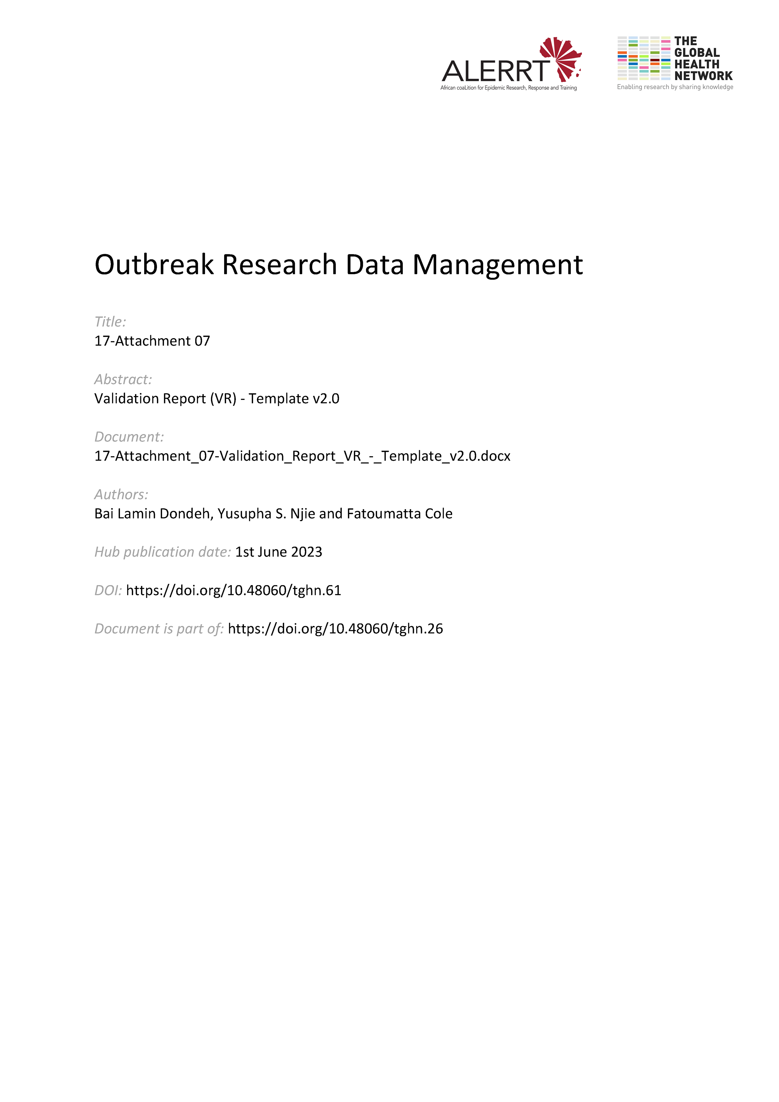](https://doi.org/10.48060/tghn.61)

|  |  |
| --- | --- |
|  | **Title:** Validation Report (VR) |
| **Study title:** *Give study title to which this applies* |
| **System name:** *Give system name to which this applies* |

1. **Documents produced during the validation process**

|  |  |  |  |
| --- | --- | --- | --- |
| **Validation Plan (VP)** | [ ] Okay | [ ] Not Okay | [ ] N/A |
| If not okay, why: |
| **User Requirements Specification (URS)** | [ ] Okay | [ ] Not Okay | [ ] N/A |
| If not okay, why: |
| **Functional Specification (FS)** | [ ] Okay | [ ] Not Okay | [ ] N/A |
| If not okay, why: |
| **Systems Testing Plan and Report (STP)** | [ ] Okay | [ ] Not Okay | [ ] N/A |
| If not okay, why: |
| **User Acceptance Test Plan and Report (UAT)** | [ ] Okay | [ ] Not Okay | [ ] N/A |
| If not okay, why: |
| **Installation Qualification (IQ)** | [ ] Okay | [ ] Not Okay | [ ] N/A |
| If not okay, why: |

1. **Outcome of the validation process**

|  |
| --- |
|  |

1. **Approvals**

|  |  |  |  |  |
| --- | --- | --- | --- | --- |
|  | **Name** | **Role** | **Signature** | **Date** |
| **Author** |  |  |  |  |
| **Reviewed By** |  |  |  |  |
| **Approved By** |  |  |  |  |