[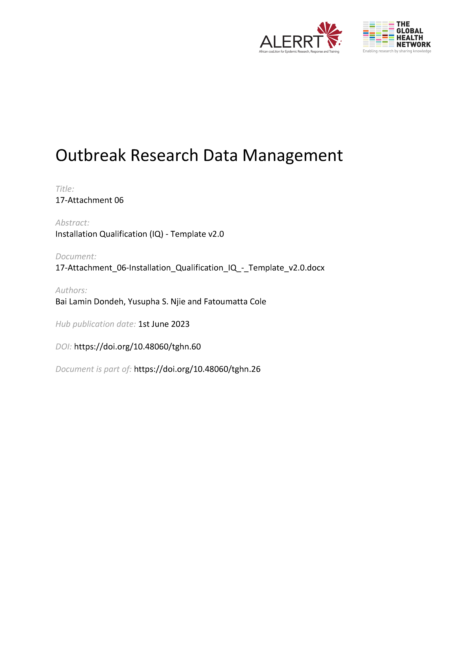](https://doi.org/10.48060/tghn.60)

|  |  |
| --- | --- |
|  | **Title:** Installation Qualification (IQ) |
| **Study title:** *Give study title to which this applies* |
| **System name:** *Give system name to which this applies* |

|  |  |  |
| --- | --- | --- |
| 1. **Software identification** | | |
| *Name and version:* |  | |
| 1. **Software location (*Where is it installed?)*** | | |
| *On local system (PC/Laptop*) ☐ | | *Device id:* |
| *Linked to the network*  ☐ | | *Comment:* |
| *Hosted on the server* ☐ | | *Server name:* |
| 1. **Data storage *(Where will the data generated by this software be stored?)*** | | |
| *On local system (PC/Laptop*) ☐ | | *Location path:* |
| *Linked to the network*  ☐ | | *Location path:* |
| *Hosted on the server* ☐ | | *Server name:* |
| 1. **Documentation** | | |
| *Is there a user manual for this software available?* | | *Yes* ☐ *No* ☐  *Comment:* |
| *Where the user manual is stored?* | | *Location path:* |
| 1. **Software installation *(Instructions followed for installation of the software)*** | | |
| *Steps:* | | *Appendix attached:*☐  *Comments:* |
| 1. **Installation verification *(Tests performed to verify installation was done correctly)*** | | |
| *Steps:* | | *Appendix attached:*☐  *Comments:* |
| 1. **Configuration settings** | | |
|  | | |
| 1. **Other remarks** | | |
|  | | |

1. **Approvals**

|  |  |  |  |  |
| --- | --- | --- | --- | --- |
|  | **Name** | **Role** | **Signature** | **Date** |
| **Author** |  |  |  |  |
| **Reviewed By** |  |  |  |  |
| **Approved By** |  |  |  |  |