[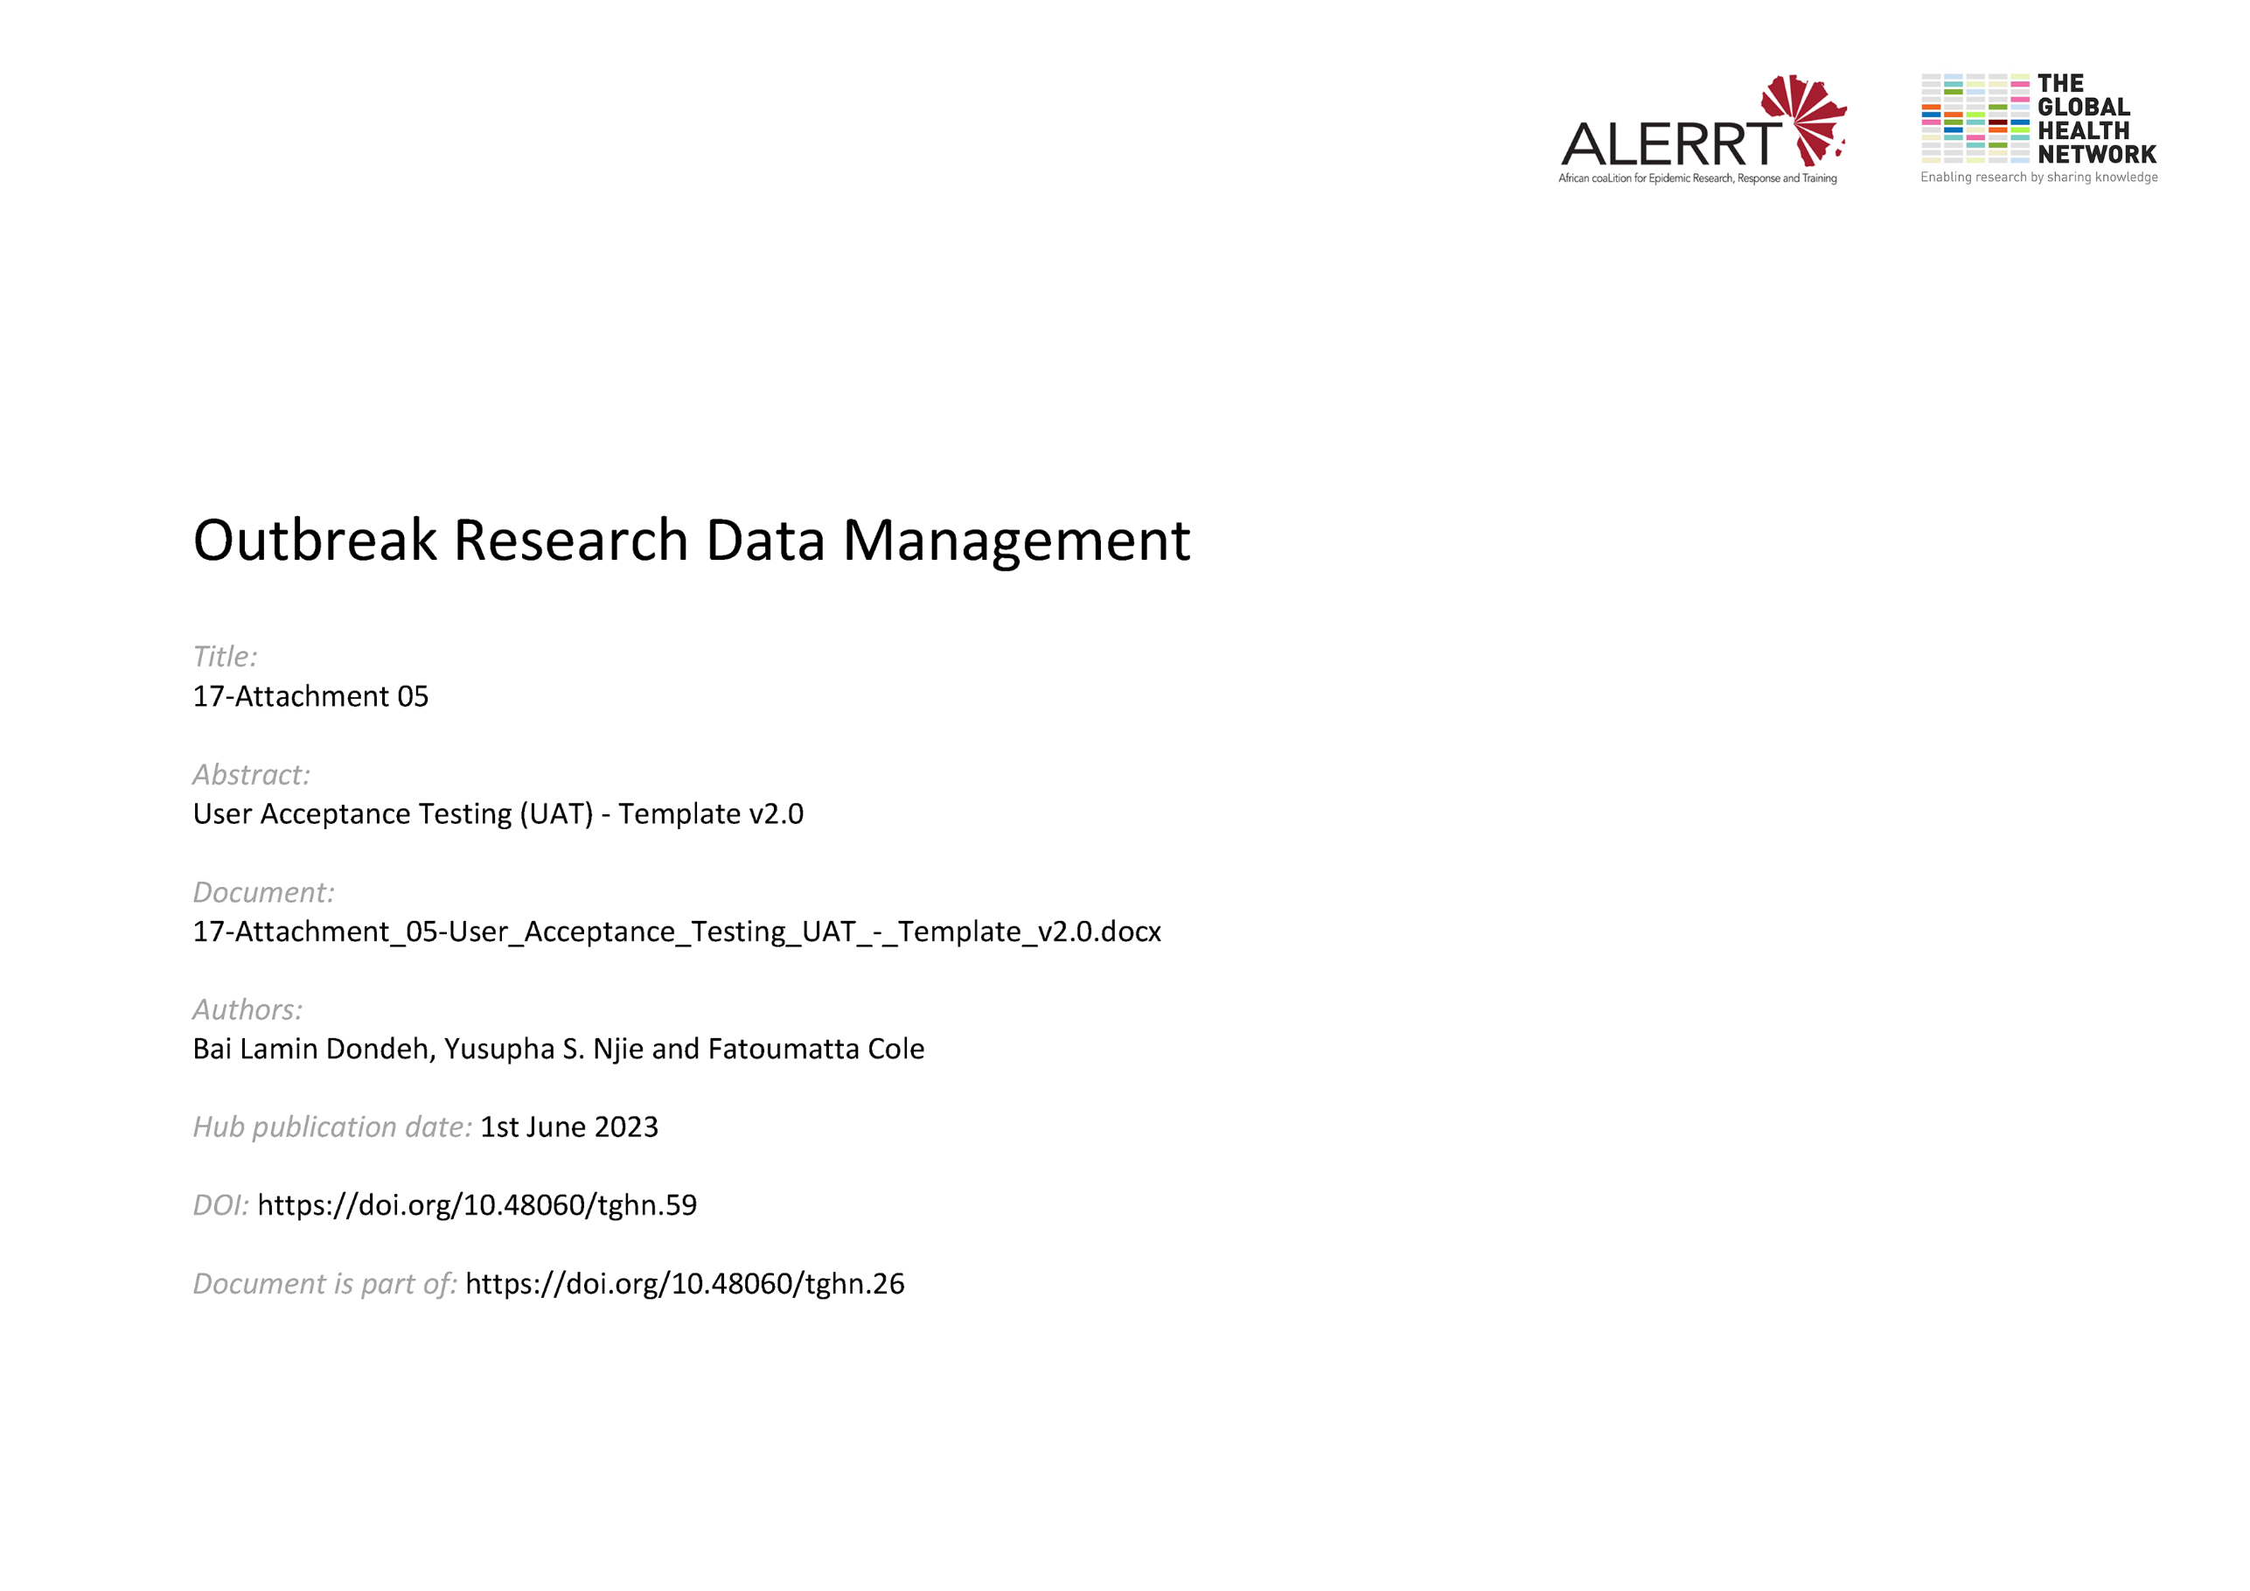](https://doi.org/10.48060/tghn.59)

|  |  |
| --- | --- |
|  | **Title:** User Acceptance Testing (UAT) |
| **Study title:** *Give study title to which this applies* |
| **System name:** *Give system name to which this applies* |

1. **Test Plan**

|  |  |  |  |  |  |  |
| --- | --- | --- | --- | --- | --- | --- |
| **No** | **Date** | **Description** | **Expected Result** | **Actual Result** | **Pass/Fail** | **Proof** |
| **1** | *10/04/14* | *Enter username and password, click “log in” to log into the database* | *User logged in successfully* | *User logged in successfully* | **Pass**  **Fail ☐** | *screenshot – login.jpg* |
| **2** |  |  |  |  |  |  |
| **3** |  |  |  |  |  |  |
|  |  |  |  |  |  |  |
|  |  |  |  |  |  |  |
|  |  |  |  |  |  |  |
|  |  |  |  |  |  |  |
|  |  |  |  |  |  |  |

1. **Approvals (Plan)**

|  |  |  |  |  |
| --- | --- | --- | --- | --- |
|  | **Name** | **Role** | **Signature** | **Date** |
| **Author** |  |  |  |  |
| **Plan Approved By** |  |  |  |  |

1. **Outcome of Testing**

|  |
| --- |
| **Conclusion of User Acceptance Testing – (*to be completed by the end-user, including future releases, bug fixes, etc.)*** |
| The items specified on the attached test plan have tested in accordance with the URS. All items have been validated successfully (including retesting following any issues identified during a previous test).  The end-user is satisfied that the specified items (above) have passed testing and are fit for purpose as specified. |
| The end-user has tested successfully with deviations to the URS – *please list deviations below* |

## **Approvals (Testing)**

|  |  |  |  |  |
| --- | --- | --- | --- | --- |
|  | **Name** | **Role** | **Signature** | **Date** |
| **Tested By** |  |  |  |  |
| **Testing Reviewed By** |  |  |  |  |
| **Approved By** |  |  |  |  |