[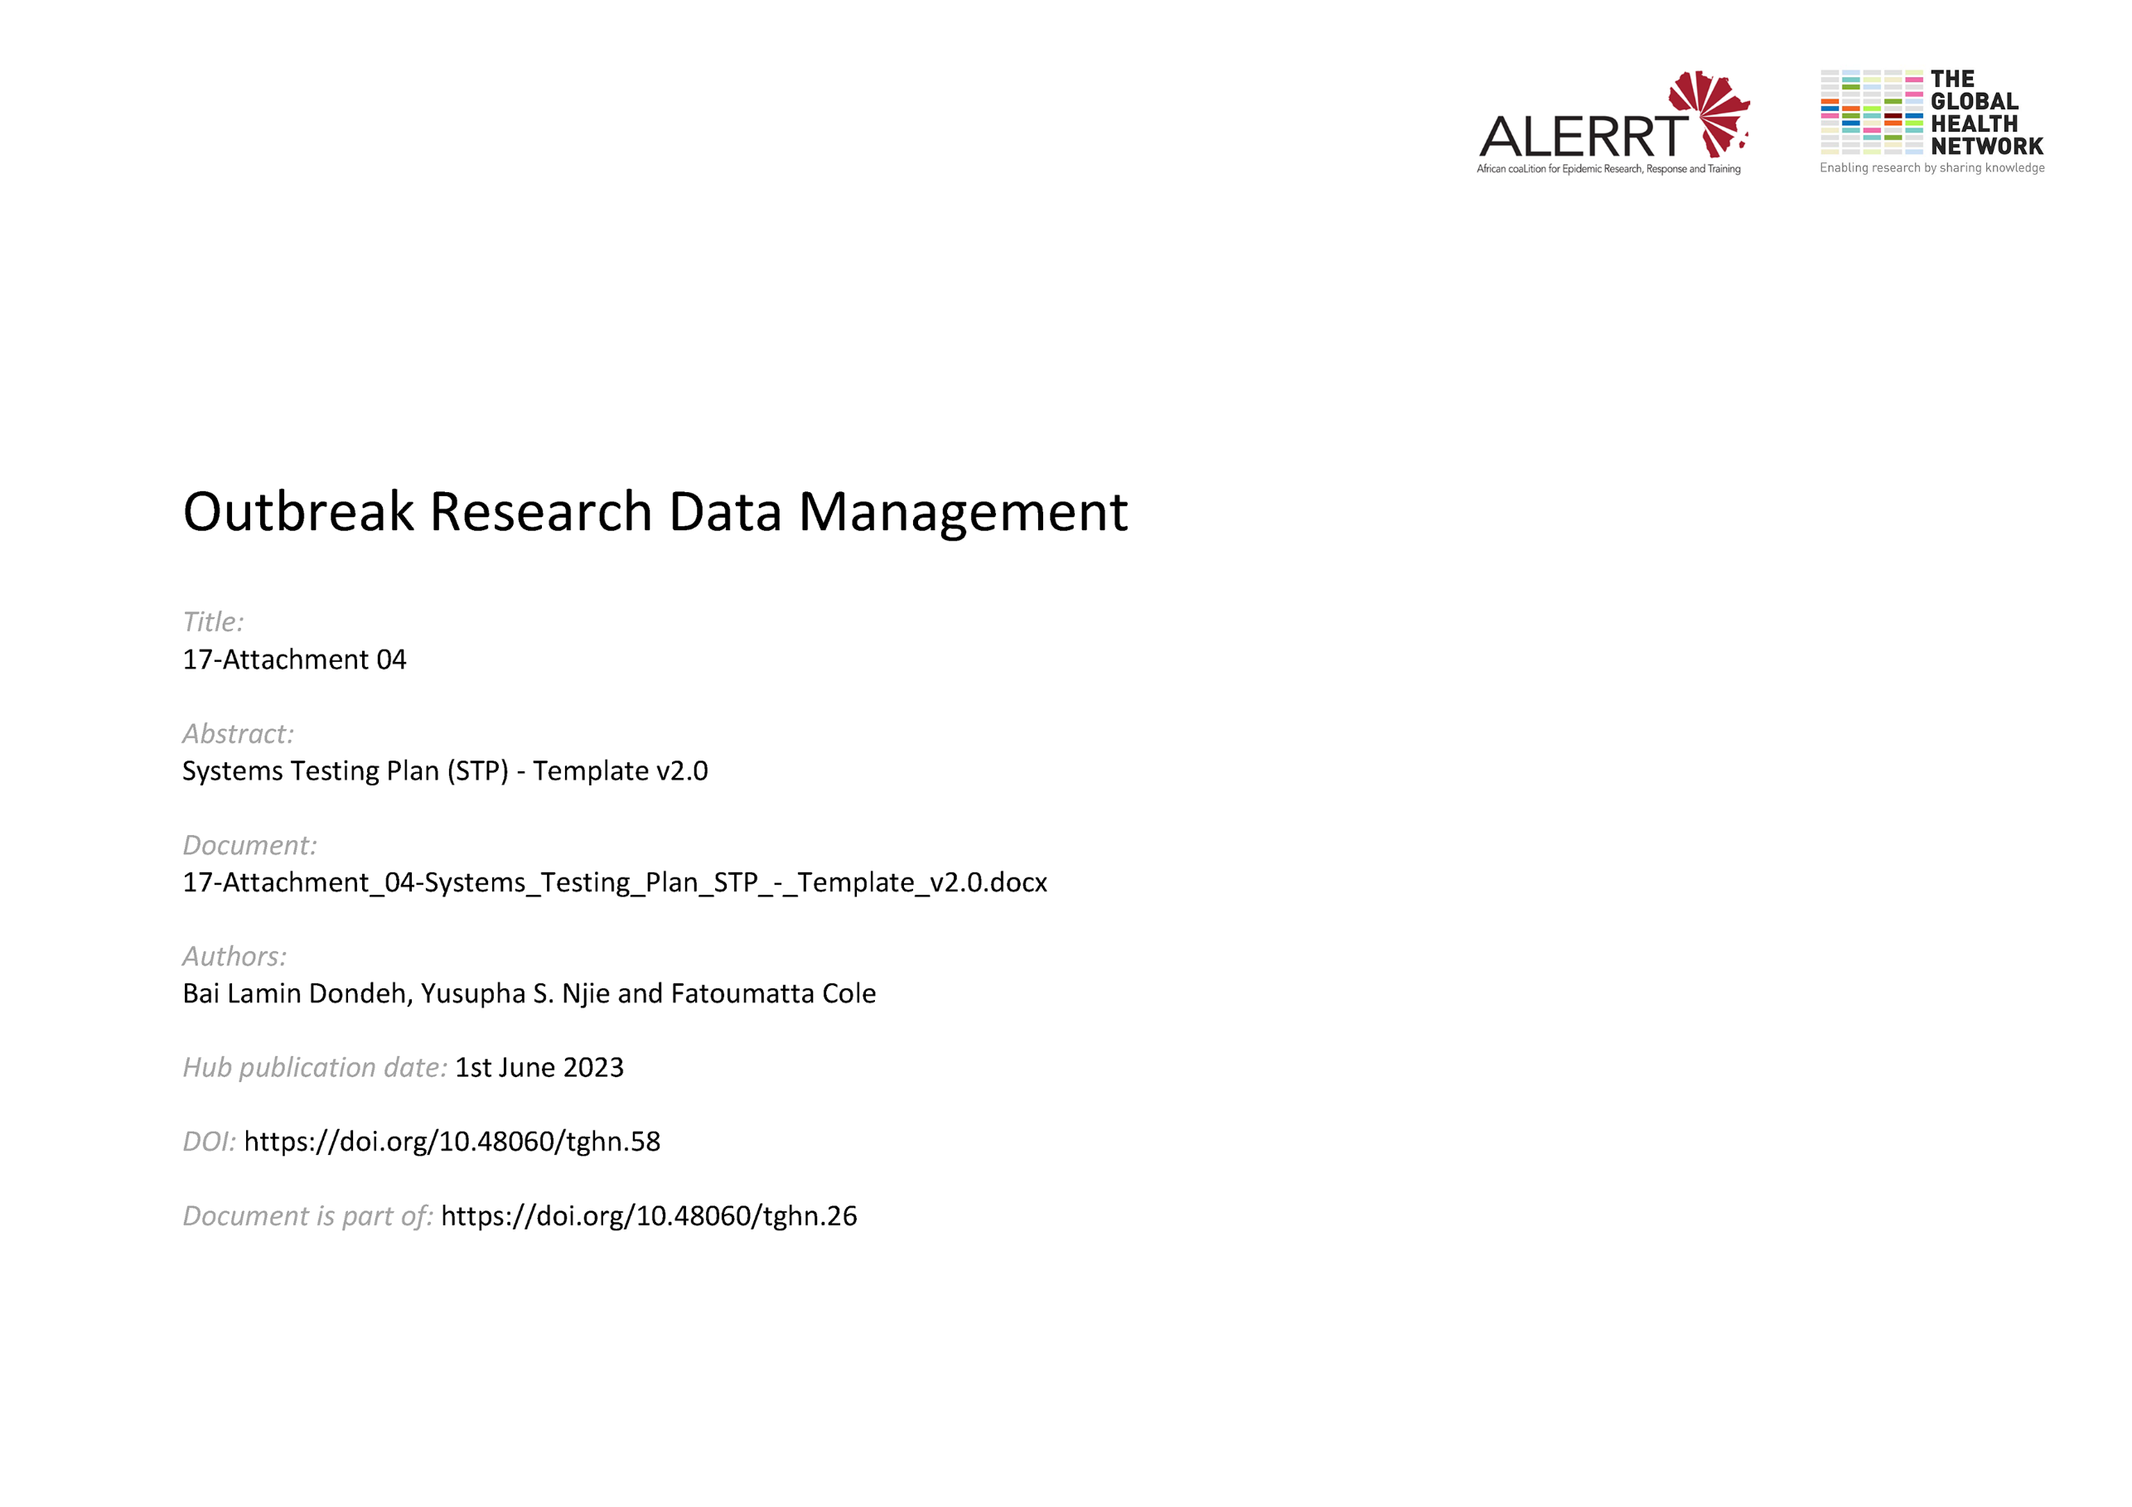](https://doi.org/10.48060/tghn.58)

|  |  |
| --- | --- |
|  | **Title:** Systems Testing Plan (STP) |
| **Study title:** *Give study title to which this applies* |
| **System name:** *Give system name to which this applies* |

1. **Test Plan**

|  |  |  |  |  |  |  |  |
| --- | --- | --- | --- | --- | --- | --- | --- |
| **No** | **Date** | **Description** | **Expected Result** | **Actual Result** | **Pass/Fail** | **Proof** | **Action Required** |
| **1** | *10/04/14* | *Run configuration check* | *All configurations passed* | *All configurations passed* | **Pass**  **Fail ☐** | *Print screen of affected database tables* | *None* |
| **2** |  |  |  |  |  |  |  |
| **3** |  |  |  |  |  |  |  |
|  |  |  |  |  |  |  |  |
|  |  |  |  |  |  |  |  |
|  |  |  |  |  |  |  |  |

1. **Approvals (Plan)**

|  |  |  |  |  |
| --- | --- | --- | --- | --- |
|  | **Name** | **Role** | **Signature** | **Date** |
| **Author** |  |  |  |  |
| **Plan Approved By** |  |  |  |  |

1. **Outcome of Testing**

|  |
| --- |
| **Conclusion of System Testing – *please select one outcome*** |
| System testing (including retests if applicable) performed successfully |
| System testing performed successfully with deviations to the URS – *please list deviations below* |

1. **Approvals (Testing)**

|  |  |  |  |  |
| --- | --- | --- | --- | --- |
|  | **Name** | **Role** | **Signature** | **Date** |
| **Tested By** |  |  |  |  |
| **Testing Reviewed By** |  |  |  |  |
| **Approved By** |  |  |  |  |