[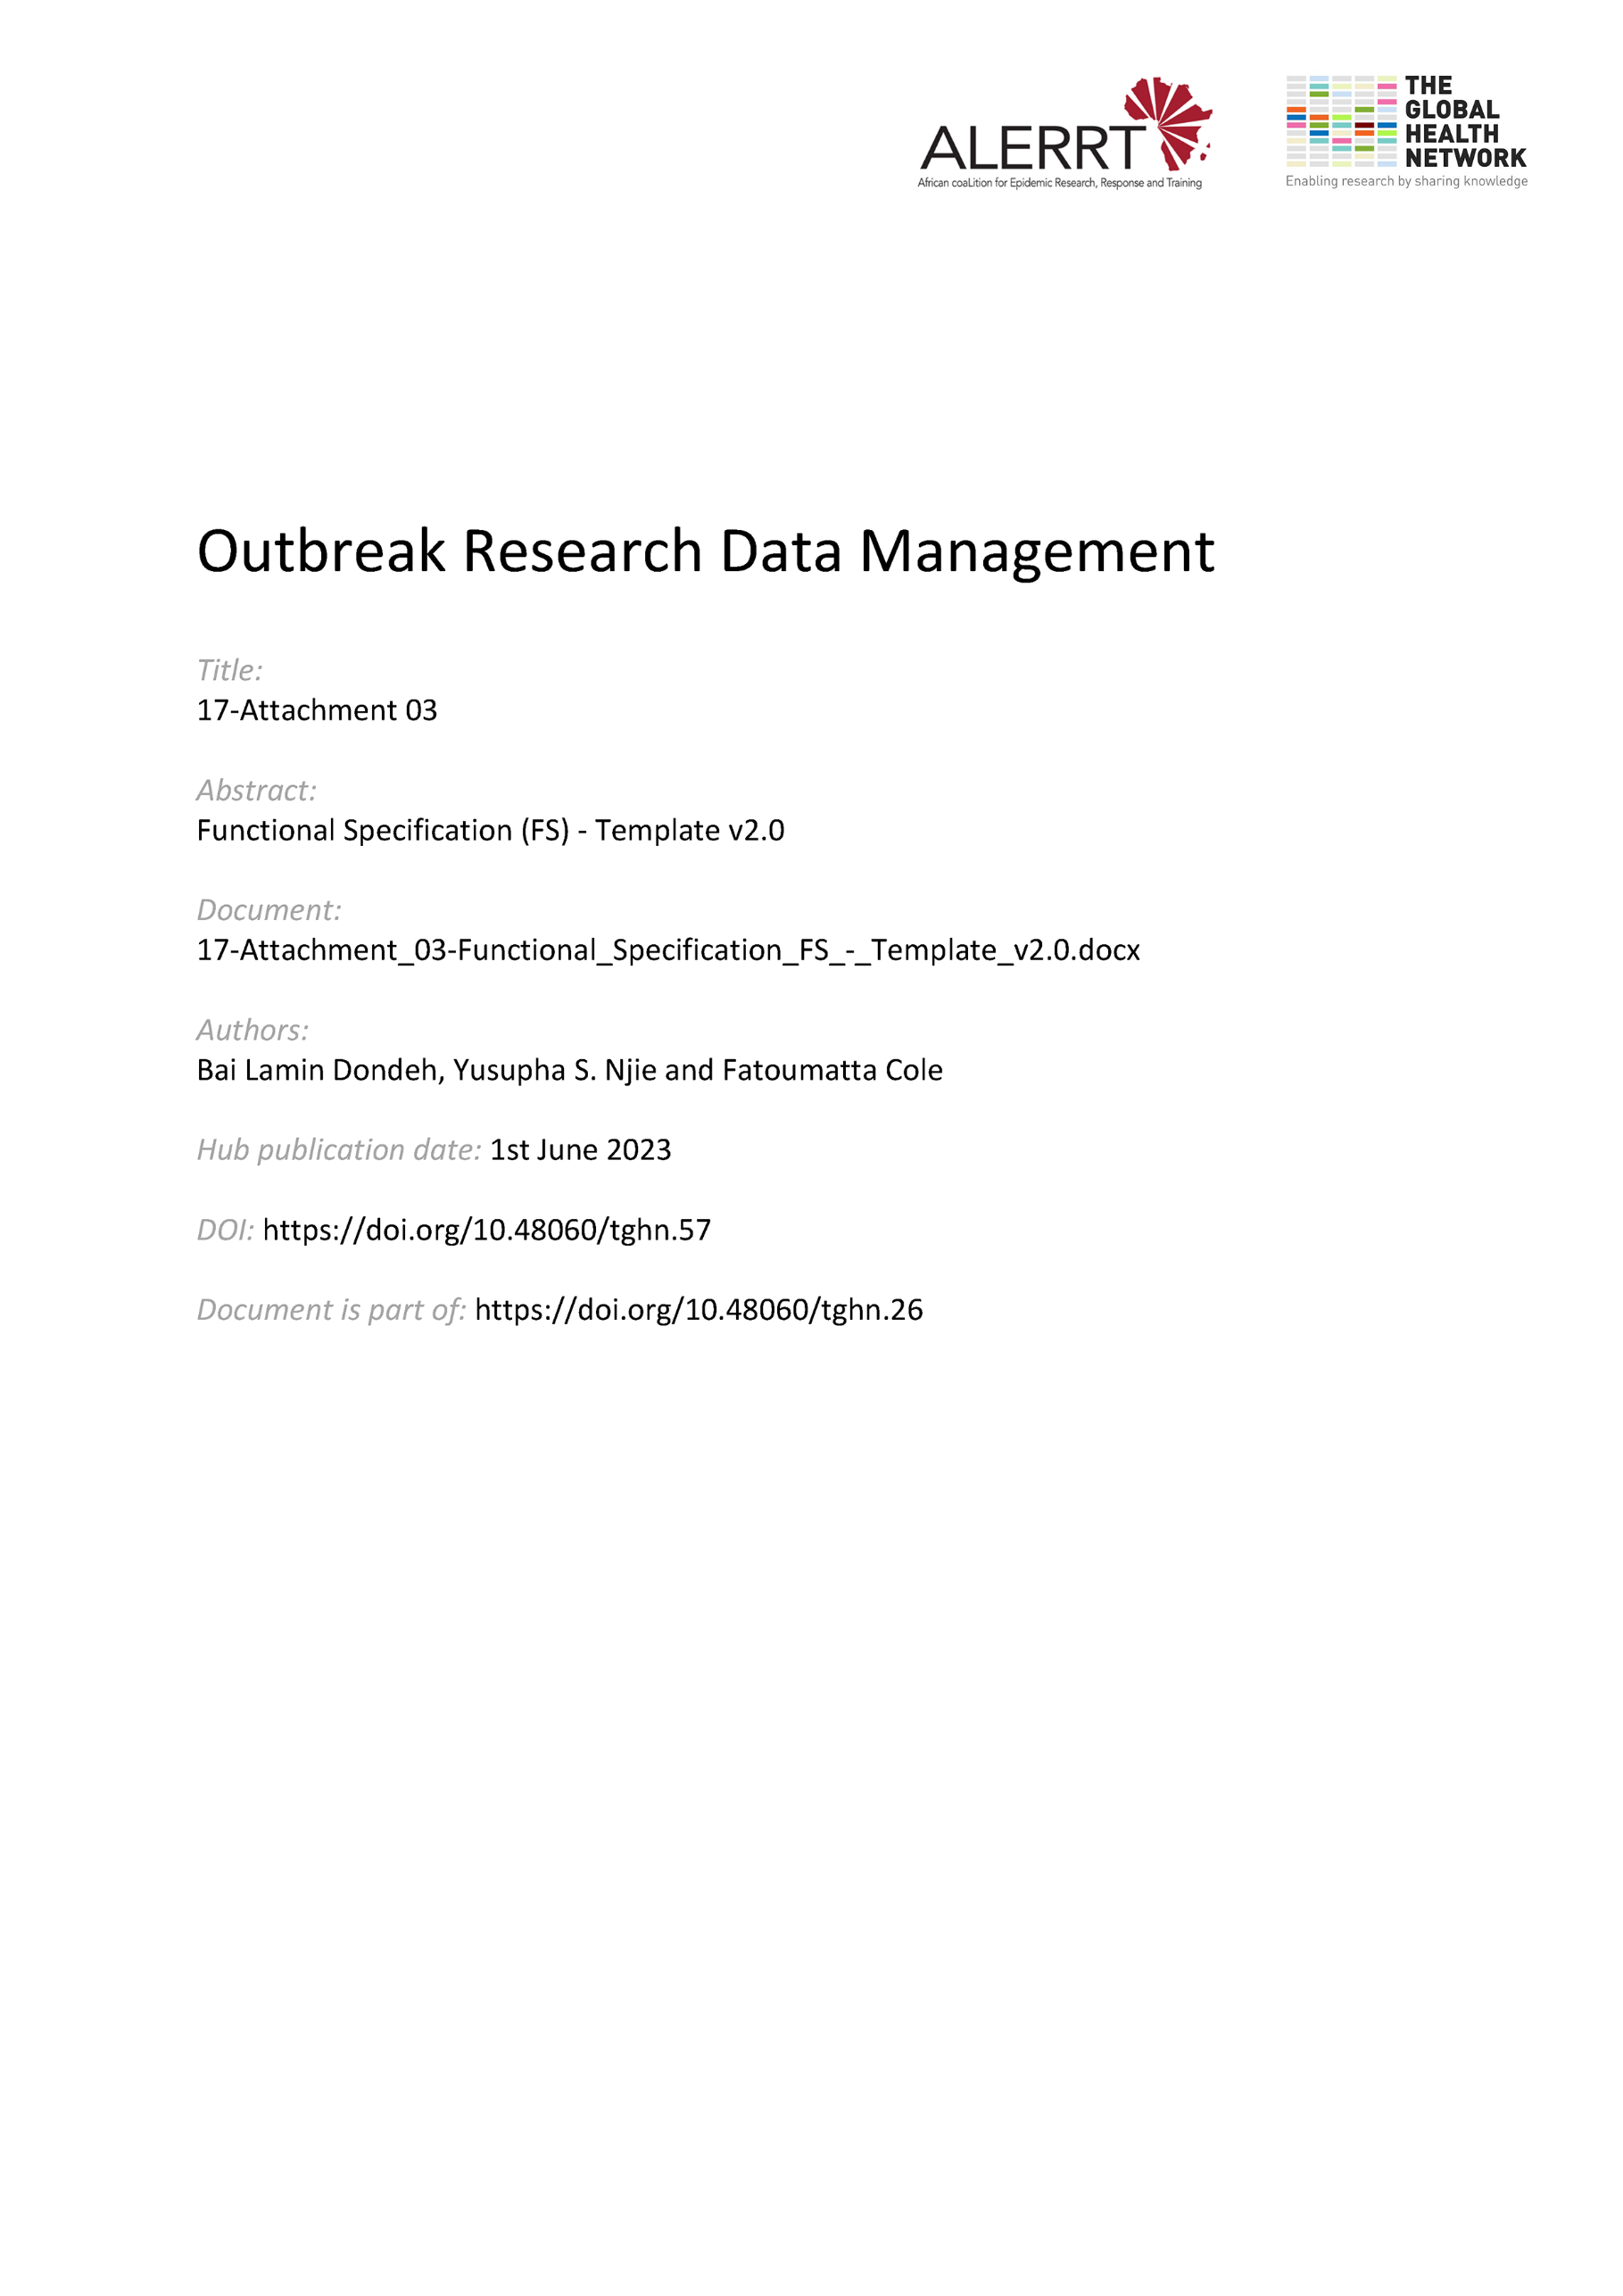](https://doi.org/10.48060/tghn.57)

|  |  |
| --- | --- |
|  | **Title:** Functional Specification (FS) |
| **Study title:** *Give study title to which this applies* |
| **System name:** *Give system name to which this applies* |

|  |
| --- |
| 1. **Introduction** |
| *Overview of system design and how the main user requirements are being addressed.* |
| 1. **Functional Description** |
| *Detailed description of functions in the system and how they address each of the user requirements.* |

1. **Approvals**

|  |  |  |  |  |
| --- | --- | --- | --- | --- |
|  | **Name** | **Role** | **Signature** | **Date** |
| **Author** |  |  |  |  |
| **Reviewed By** |  |  |  |  |
| **Approved By** |  |  |  |  |