[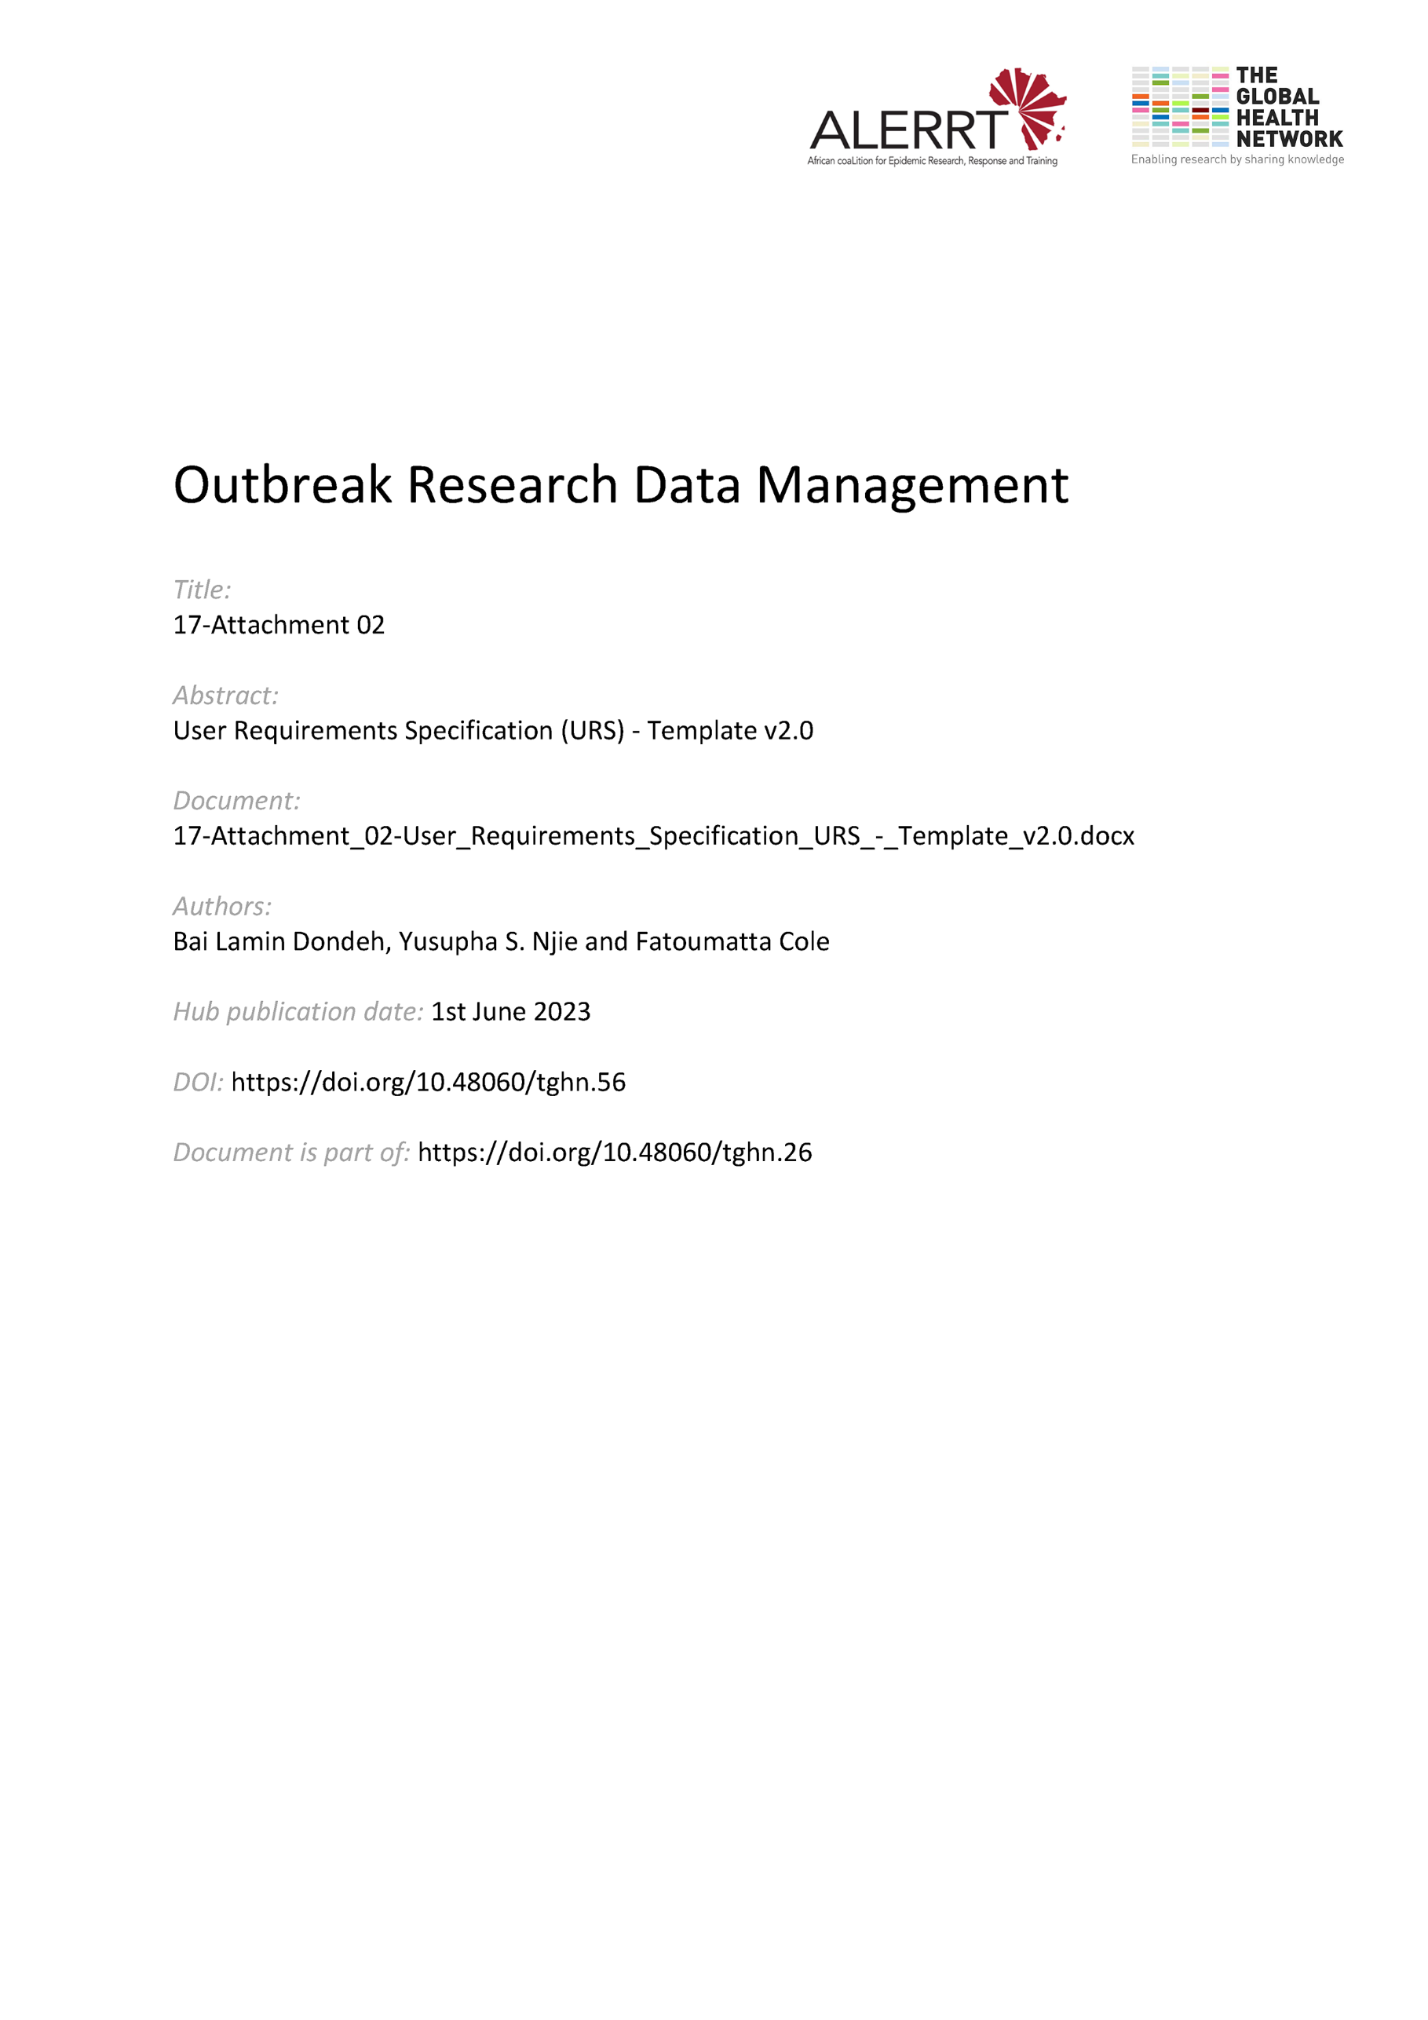](https://doi.org/10.48060/tghn.56)

|  |  |
| --- | --- |
|  | **Title:** User Requirements Specification (URS) |
| **Study title:** *Give study title to which this applies* |
| **System name:** *Give system name to which this applies* |

|  |
| --- |
| 1. **Operational Requirements** |
| 1. **Data**   *Description of data (refer to Data Dictionary if available)*  *Capacity requirements*  *Archive Requirements*   1. **Interfaces**   *Data Entry Screen - I/O interface*  *Back-end accessibility*  *Reporting and selective data view*  *Interface with other systems e.g. statistical software, excel, data import/export, etc.*  *Interface with equipment e.g. handheld GPS, diagnostic equipment, etc.*   1. **Environment**   *Is there a supported and validated Unit application or equipment that will meet the above requirement? (e.g. SPSS, OpenClinica)*  *Is there an off-the-shelf pre-validated computer system that will meet the above requirement?*  *Operating System - MS Windows, Linux, Web-based or Desktop, Networked, etc.*  *Compatibility - with any existing systems or hardware, and any laboratory strategy.*  *Constraints – Limited bandwidth, slow internet connection, etc.* |
| 1. **Training and Support** |
| 1. **Documentation**   *Functional Specification, Testing Plans, Design Specifications, etc.*   1. **Training Materials**   *User Manuals and General Guidelines, etc.*  *Practical training to staff*   1. **Support**   *On-line and off-line support – regular support system and maintenance requirements* |
| 1. **Delivery** |
| 1. **Installation**   *On turnkey basis, with setup media (CDs, DVDs), dongles, etc.*   1. **Timelines and milestones**   *What to provide and by when* |

## 

## **Approvals**

|  |  |  |  |  |
| --- | --- | --- | --- | --- |
|  | **Name** | **Role** | **Signature** | **Date** |
| **Author** |  |  |  |  |
| **Reviewed By** |  |  |  |  |
| **Approved By** |  |  |  |  |