[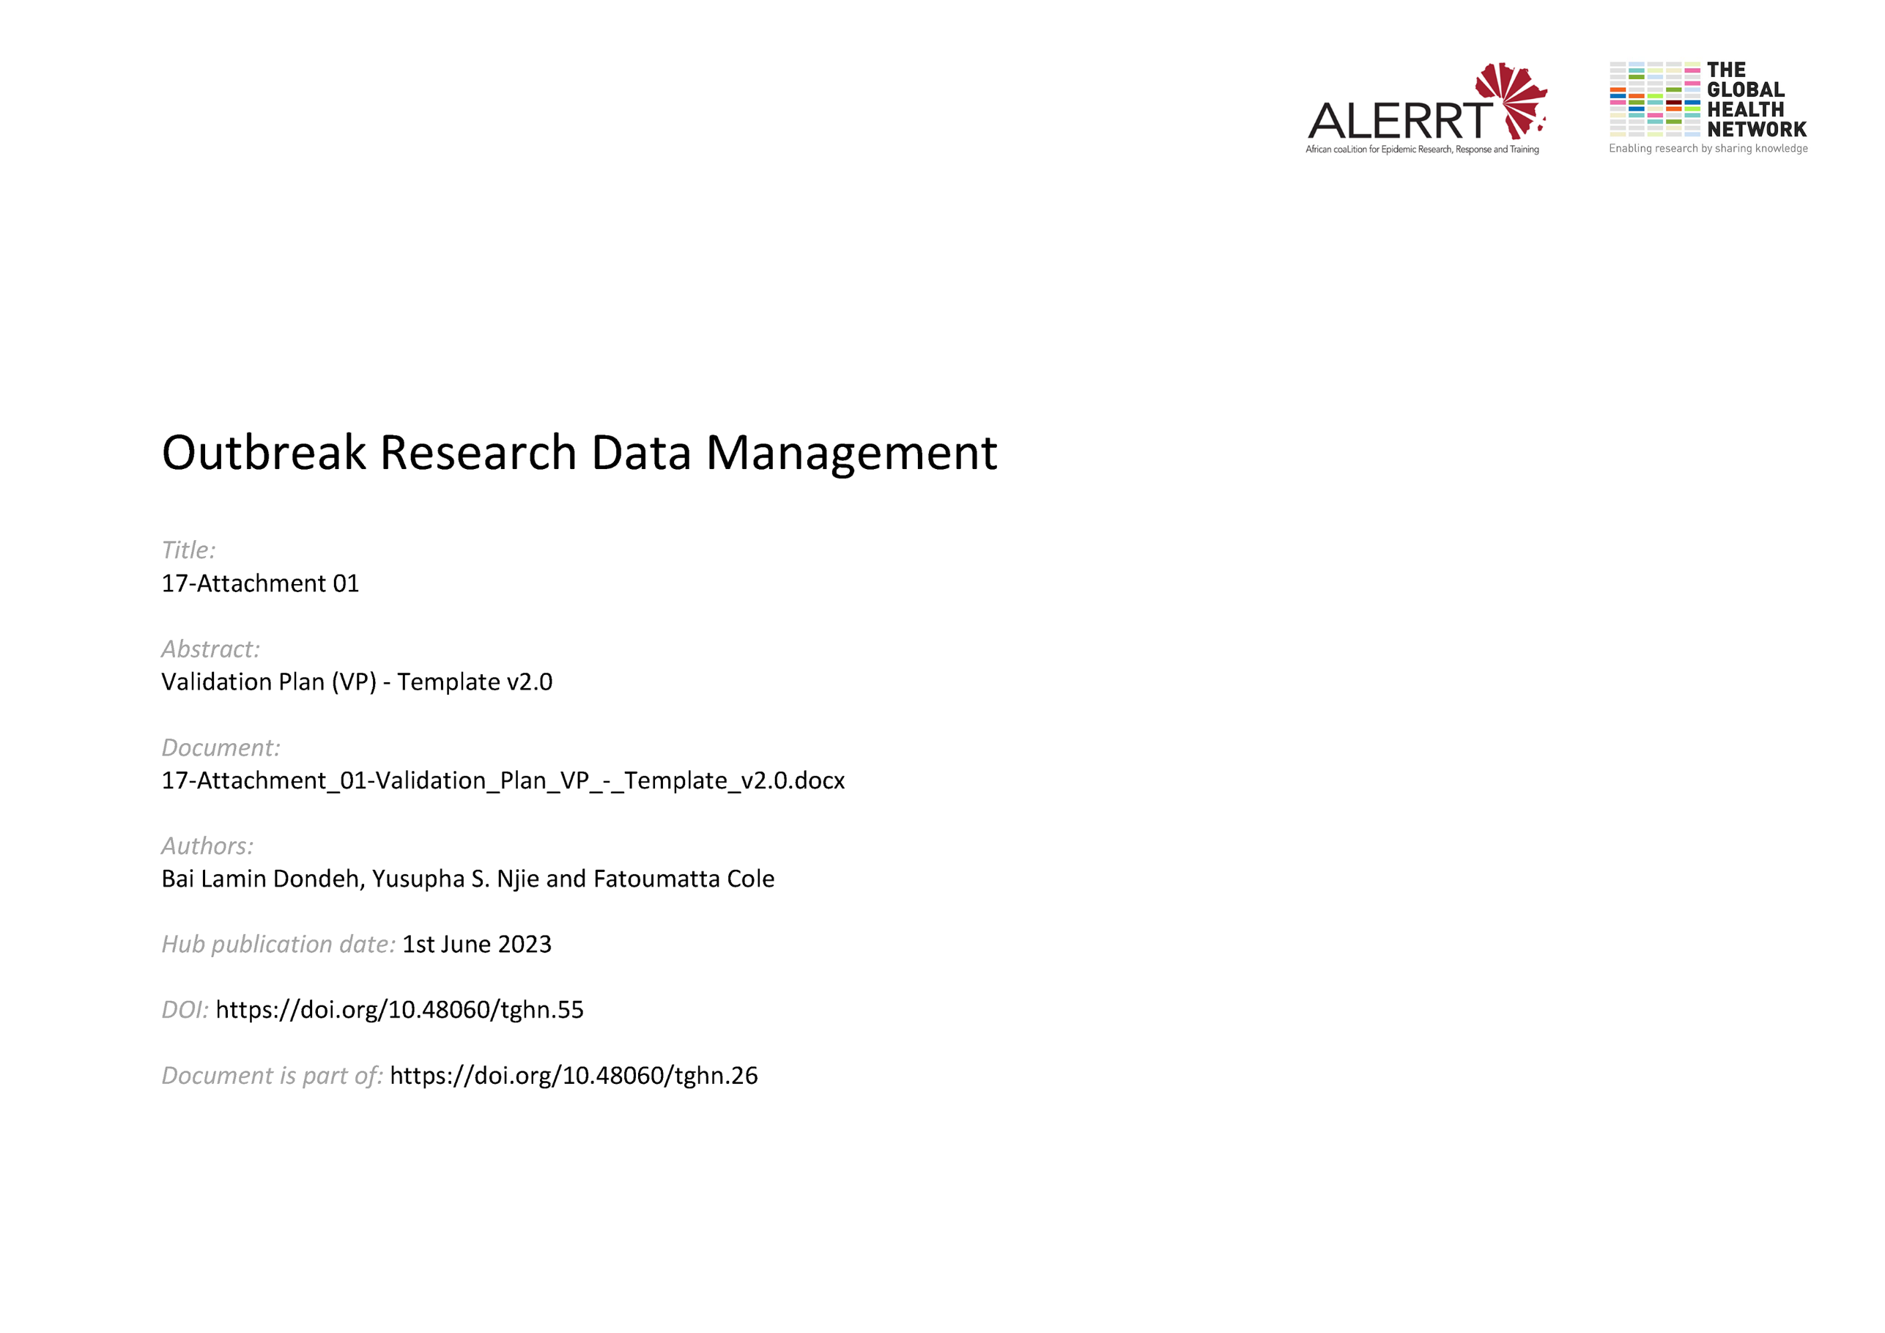](https://doi.org/10.48060/tghn.55)

|  |  |
| --- | --- |
|  | **Title:** Validation Plan (VP) |
| **Study title:** *Give study title to which this applies* |
| **System name:** *Give system name to which this applies* |

## Deliverables

List below the documents that will be created, the author, the approvers, the reviewers and any dependencies on previous steps.

Specify any requirements of each document below the document title.

| **Validation Documentation** | **Author** | **Approvers** | **Reviewers** | **Dependencies** | **Estimated duration(weeks)** | **Date completed** |
| --- | --- | --- | --- | --- | --- | --- |
| User Requirements Specification (URS) |  |  |  |  |  |  |
| Functional Specification (FS) |  |  |  |  |  |  |
| Systems Testing Plan and Report (STP) |  |  |  |  |  |  |
| User Acceptance Testing (UAT) Plan and Report |  |  |  |  |  |  |
| Installation Qualification (IQ) |  |  |  |  |  |  |
| User Manuals / Training Material |  |  |  |  |  |  |
| Disaster Recovery |  |  |  |  |  |  |
| *(Add other items as required)* |  |  |  |  |  |  |

## Other Considerations

Document below any other requirements of the validation procedure.

Specify any actions in relation to the requirements, who is responsible and dependencies.

| **Requirement** | **Responsible** | **Dependencies** |
| --- | --- | --- |
| Change Control |  |  |
| Access Control |  |  |
| Physical security of the computer hardware |  |  |
| Periodic Review |  |  |
| *(Add other items as required)* |  |  |

## 

## Approvals

|  |  |  |  |  |
| --- | --- | --- | --- | --- |
|  | **Name** | **Role** | **Signature** | **Date** |
| **Author** |  |  |  |  |
| **Reviewed By** |  |  |  |  |
| **Approved By** |  |  |  |  |