[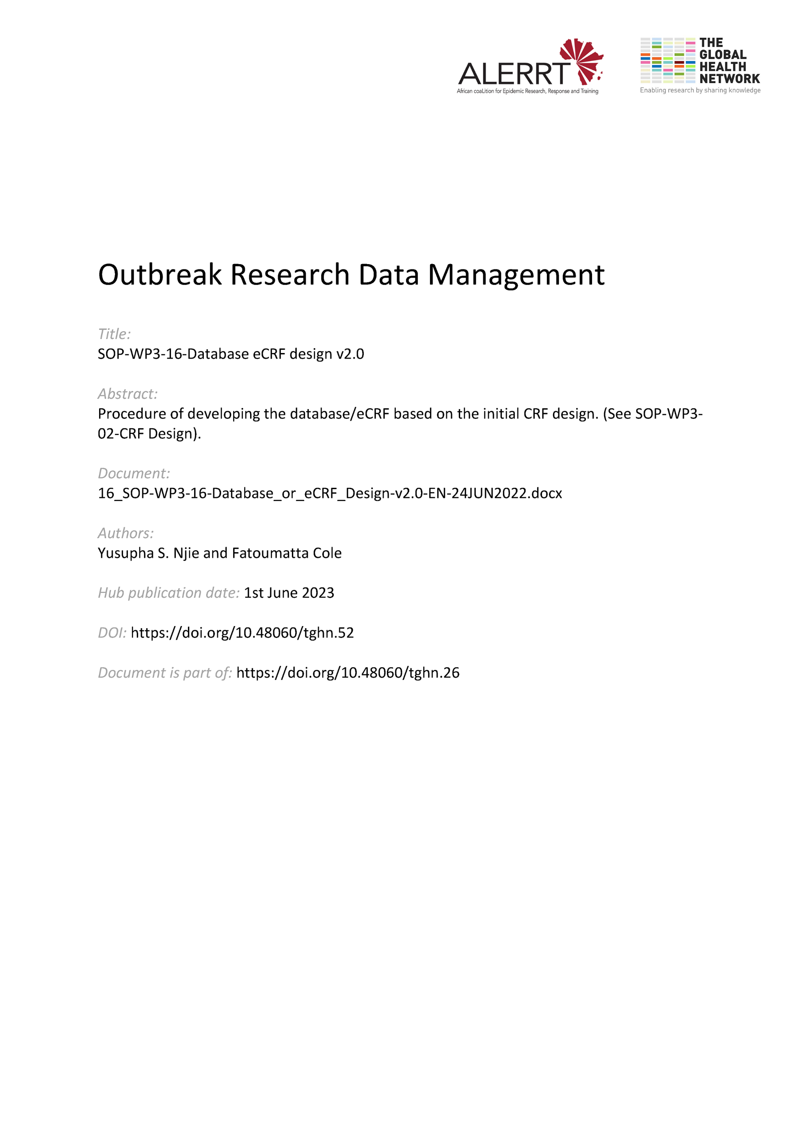](https://doi.org/10.48060/tghn.52)

|  |  |
| --- | --- |
|  | **SOP Title:** Database / eCRF Design |
| **Study title**: *Give study title to which this SOP applies* |

# Scope and application

|  |
| --- |
| This procedure describes the process of developing the database/eCRF based on the initial CRF design. This SOP should be read in particular with the procedure SOP-WP3-02-CRF Design.  This SOP applies to all clinical research and clinical trials for which a database and the electronic case report form is used to capture, store and manage participants information. |

# Responsibilities

|  |  |
| --- | --- |
| **Function** | **Activities** |
| Database Developer  (System Developer) | * Agrees and set a timeline for the development work. * Programs and develops a database/eCRF for data capture * Maximizes a quality and user friendliness approach |
| Data Manager | * Coordinates the design process and other data management * Assists the Database Developer in the delivery of database training. * Drafts all the relevant necessary documentation including training documentation on the database. |
| Project Lead or Project Lead delegate | * Provides the necessary documents (e.g. protocol, draft data dictionary/CRF, amendments, etc.) and information needed * Keeps the Data Manager and Database Developer informed on the status of the project * Approves the final paper CRF, eCRF interface and validation of the database |
| Statistician | * Supports and advises on data structure design |

# Definitions

**CRF**: Case Report Form

**DB**: Database

**DBMS**: Database Management System

**eCRF**: electronic Case Report Form

**PL**: Project Lead

**URS**: User Requirement Specification

# Procedures

#### **Planning** Before starting DB/eCRF design and development, everyone involved must individually or collectively carry out the following tasks:

* Initiate a Project Plan
* Review the proposed work and the paper CRF (as described SOP-WP3-02-CRF Design)
* Complete a User Requirements Specifications document (URS) detailing the end-user’s requirements as well as some functional requirements as outlined by SOP-WP3-17-System Validation.

#### **Requirements Analysis & Software Selection**

This stage allows you to think about data structure, relationship schema, user-interface and software selection that will best fit the project/study needs.

* Select the software which best fits all requirements.
* Review the URS and all available project documentation such as the Data Management Plan (DMP), CRFs, Study Protocol, etc. to identify all user requirements.
* Draft a data dictionary for documentation of your DB/eCRF structure.
  1. **Development and programming**

At this stage, the documents produced at the requirements analysis stage will be used to create the database, in accordance with the project plan created during the planning stage.

* Develop a user-friendly interface for end-users.
* Apply programming and coding as deemed suitable and applicable (see SOP-WP3-08-Data Coding and Medical Coding)
* Ensure to use versioning for the DB/eCRF system to ensure everyone is working on the same version.
  1. **Database Validation & Testing**

Testing and validation will be carried out before the DB/eCRF system is released for LIVE data entry. This process is described in SOP-WP3-17-System Validation.

* 1. **Implementation and training**

Implementation and training will be carried out before the DB/eCRF system is released for LIVE data entry. This process is described in SOP-WP3-03-Training & Capacity Building.

Organize the training and see to it that all study staff are trained before using the study database.

* 1. **Deployment**
* Create a new clean production database on the production server ready for data collection.
* Grant the Data Manager full access to the production database so that he/she can control access to the database.
* Ensure all access requests are documented as per the agreed procedure.
* Create the requested user accounts and notify all users indicating the location of the database.
  1. **Updates in Database Design**
* In events where there is a need to capture data from additional CRFs that were not part of the initial database service the database can be updated.
* The database developer updates the data dictionary versioning to reflect the changes and communicates to the end users when the changes have taken place. SOP-WP3-17-System Validation describes the process of re-testing after updates.
  1. **Maintenance and Evaluation**
* The DB/eCRF should be continuously monitored by the Data Manager using a process to capture user feedback about the system to identify system errors, missing functionality or increased functionality.
* The database is backed up according to the SOP-WP3-19-Data Backup and Disaster Recovery.

# Attachments

|  |  |
| --- | --- |
| **Attachments** | |
| **Number** | **Title** |
| *NA* | *NA* |
|  |  |
|  |  |

1. **Document History & References**

|  |  |  |  |
| --- | --- | --- | --- |
| **Revision** | | | |
| **Version number** | **Author** | **Date** | **Description/reason for modification** |
| 1.0 | Fatoumatta Cole, Yusupha Njie | 07/10/2019 | Initial version  Review by Hanne Landuyt  Approval by Bai Lamin Dondeh and Harry Van Loen |
| 2.0 | Fatoumatta Cole | 24/06/2022 | Review to ensure that the SOP is appropriate within ALERRT and with current clinical research best practices. |

1. **Approval**

|  |  |  |
| --- | --- | --- |
| **Name and function** | **Date (dd/mm/yyyy)** | **Signature** |
| ***Author*** | | |
| *Indicate who wrote the SOP* |  |  |
| ***Review*** | | |
| *Indicate WP team members who reviewed (if applicable)* | *Date of review* |  |
| ***Approval*** | | |
| *Indicate WP Lead/Co-lead(s) who approved* | *Date of approval* |  |