**[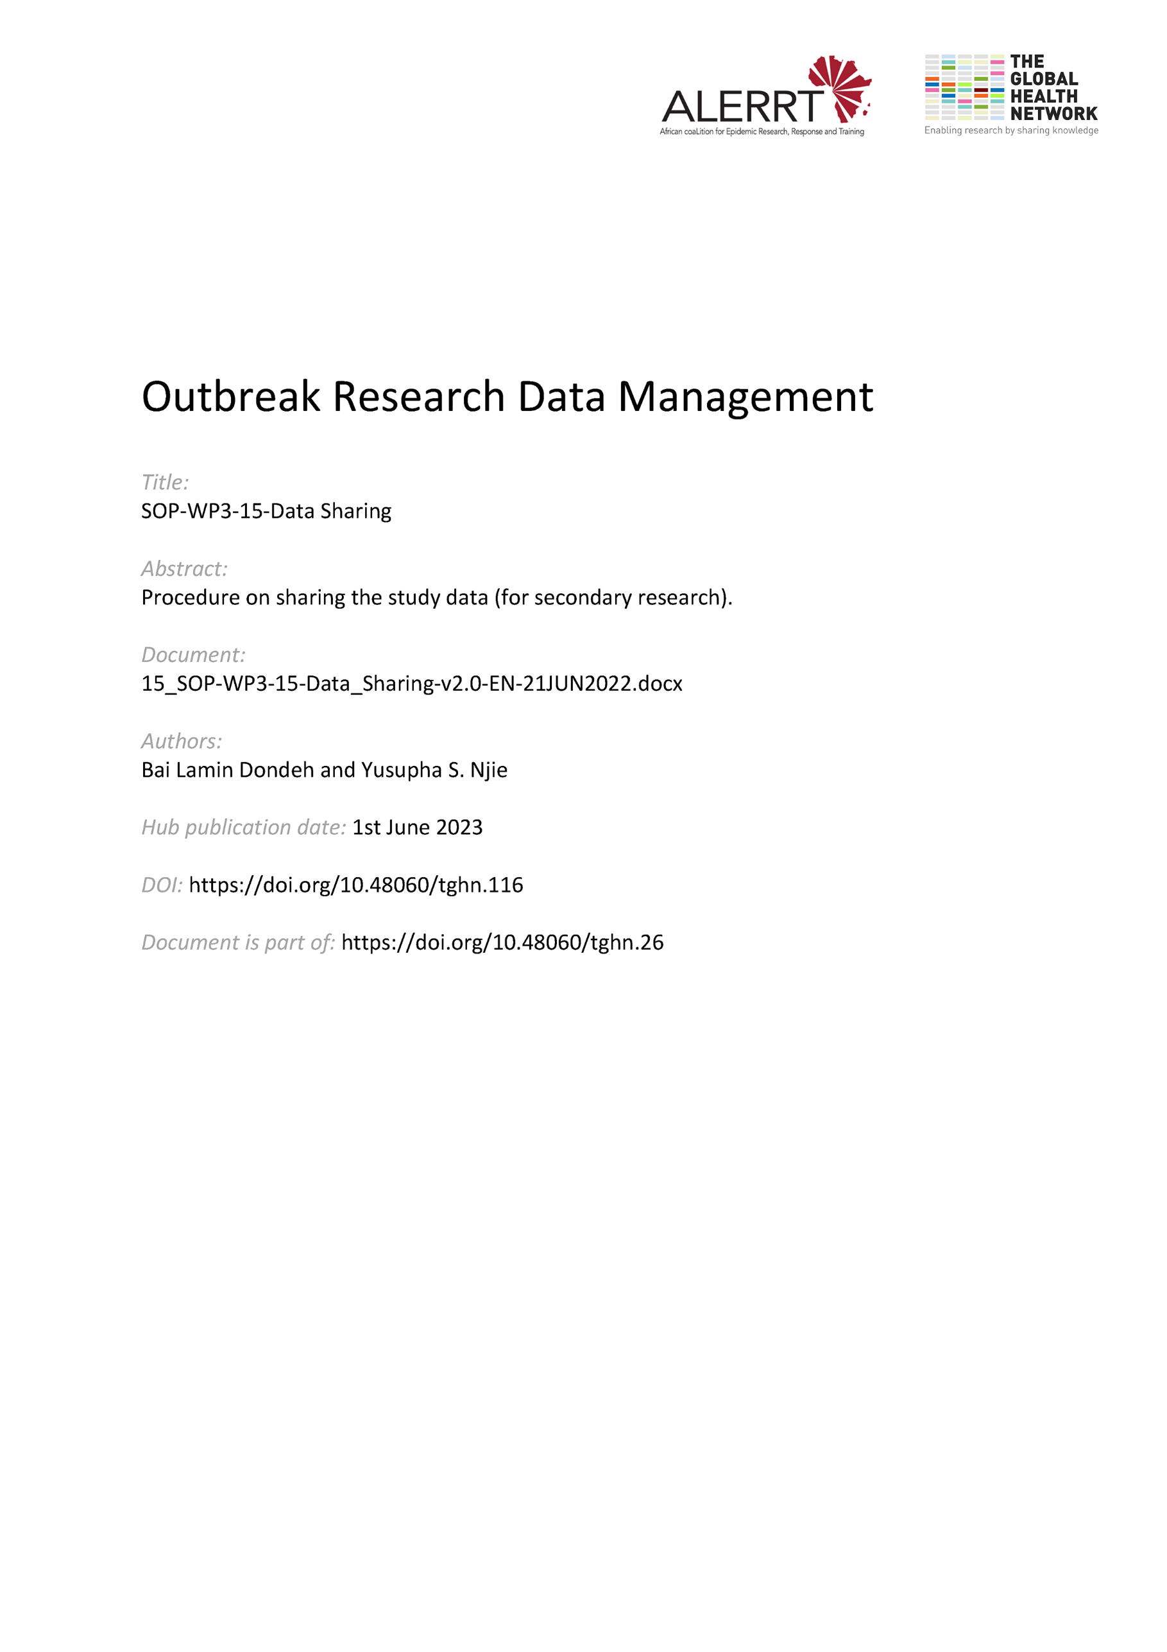](https://doi.org/10.48060/tghn.116)**

|  |  |
| --- | --- |
|  | **SOP Title:** Data Sharing |
| **Study title**: *Give study title to which this SOP applies* |

# Scope and application

|  |
| --- |
| This SOP sets out the framework for making data from clinical research studies available to others, while adhering to good research practice, the relevant ethical, contractual, and legal obligations, whilst not forgetting the regulatory requirements and confidentiality.  The SOP is aimed at any study staff who is asked to share information as part of their role. Data can be shared either routinely or in a pre-determined agreement during or at the final stage of a clinical research study. |

# Responsibilities

|  |  |
| --- | --- |
| **Function** | **Activities** |
| Principal Investigator or Project Lead | * Has a very good understanding of regulations and requirements at the local, national, and international levels that apply to their research and data * Ensures data management practices on the project fulfills all the necessary data sharing requirements |
| Data Manager | * Prepares data for onward data sharing whilst ensuring that all requirements are fulfilled e.g. anonymization. * Ensures to adopt standards and formats that support re-use |

# Definitions

**CRF**: Case Report Form

**GDPR**: General Data Protection Regulation

**FAIR**: Findable, Accessible, Interoperable, and Reusable

**SAP**: Statistical Analysis Plan

**Sharing**: refers to the act of making data available through an approved governance process to an authorized party.

# Procedures

## Data sharing principles or requirements

* Adhere as much to existing data sharing principles (e.g. the FAIR Data Principles; the PANDORA-ALERRT Data Sharing Principles)
* Follow requirements from stakeholders such as Funding agencies, Publishers, Academia (Institutional policies or Consortia agreements) … (e.g. European funded projects under Horizon 2020 require to develop a Data Management Plan and adhering to the FAIR data principles).
* Make use of a Data Management Plan (see SOP-WP3-04-Data Management Plan), with particular details on data sharing.

## Who to share

* Identify the purpose and rules to adhere to when sharing data.
* Provide a list of individuals/partners/stakeholders/study specific repositories to share with.

## What to share

* Provide a comprehensive data summary (type, format, size, origin).
* Convert data into an anonymized form before sharing (amongst others by replacing the study subject identification code with a new code; by generalizing and randomizing specific variables).
* Provide essential metadata which clarify your study data. These metadata might include the study protocol, SAP, CRF, data dictionary etc.

## Where to share

* Preferably, deposit data in a research data repository. Alternatively, data may be shared as per an agreed suitable medium (see SOP-WP3-11-Data Transfer).
* See to it that data are accessible where possible at no monetary cost.

## How to share

* The data should be made available through a governed data access process which includes a transparent, accountability and decision-making process
  + Completion of data request form
  + Evaluation by a data access committee
  + Data sharing Agreement
  + Secure transfer of data
* Provide data ‘As open as possible, as closed as necessary’.
* Ensure that you have obtained consent of study participants for sharing study data.
* See to it that you have permission of the ethical bodies involved in the study.
* Agree on the process with all study investigators.
* Ensure that data are clean, fully anonymized and consistently labelled.
* All variable labels, codes and acronyms should be either self-explanatory or explained in order to make the data fully decipherable by others (e.g. data dictionary).

## When to share

* Make data and metadata available according to stakeholder requirements regarding timelines.
* Data must be made available timely upon end of study or publication of manuscripts.
* In the context of an active public health emergency, data should be made available as soon as possible, but without jeopardizing the scientific integrity.

# Attachments

|  |  |
| --- | --- |
| **Attachments** | |
| **Number** | **Title** |
|  |  |
|  |  |

# Document History & References

|  |  |  |  |
| --- | --- | --- | --- |
| **Revision** | | | |
| **Version number** | **Author** | **Date** | **Description/reason for modification** |
| 1.0 | Yusupha Njie | 07/10/2019 | Initial version – based on LSHTM Research Data Management Policy  Review by Fatoumatta and Laura Merson.  Approval by Bai Lamin Dondeh and Harry van Loen. |
| 2.0 | Bai Lamin Dondeh | 21/06/2022 | Review to ensure that the SOP is appropriate within ALERRT and with current clinical research best practices. |

# Approval

|  |  |  |
| --- | --- | --- |
| **Name and function** | **Date (dd/mm/yyyy)** | **Signature** |
| ***Author*** | | |
| *Indicate who wrote the SOP* |  |  |
| ***Review*** | | |
| *Indicate WP team members who reviewed (if applicable)* | *Date of review* |  |
| ***Approval*** | | |
| *Indicate WP Lead/Co-lead(s) who approved* | *Date of approval* |  |