[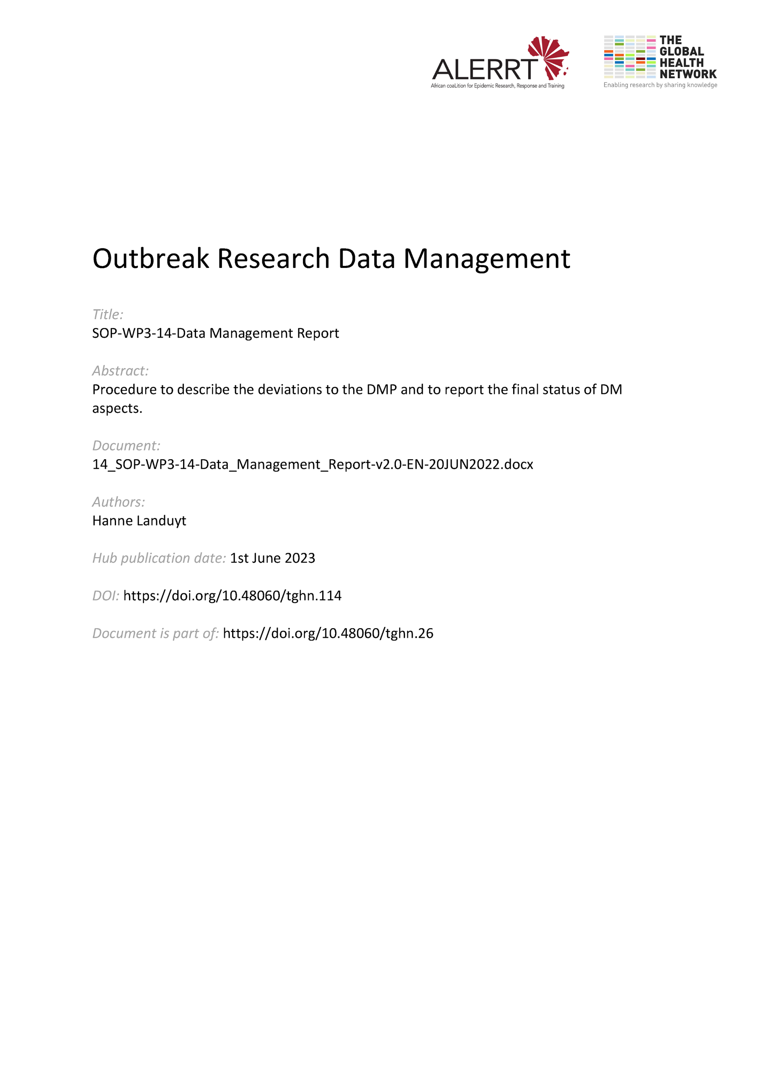](https://doi.org/10.48060/tghn.114)

|  |  |
| --- | --- |
|  | **SOP Title:** Data Management Report |
| **Study title**: *Give study title to which this SOP applies* |

# Scope and application

|  |
| --- |
| This SOP describes the procedure of reporting on the data management activities at the end of a clinical research study. The Data Management Report (DMR) should be written after all data management tasks have been completed.  The DMR is based on the Data Management Plan (DMP) (SOP-WP3-04-Data Management Plan) and is initiated by the Data Manager.  The DMP(s) and DMR together give a complete image of the data management processes and changes during the study. |

# Responsibilities

|  |  |
| --- | --- |
| **Function** | **Activities** |
| Data Manager | * Follow up on the Data Management Plan during the study * Initiate the Data Management Report |
| Coordinating Investigator Or Project Lead | * Approval of the DMR |

# Definitions

**DM:** Data Management

**DMP**: Data Management Plan

**DMR**: Data Management Report

# Procedures

The report is based on the DMP that has been kept up to date throughout the study.

* 1. **General Data Management Report Information**

This section should describe the goal of the report and on which DMP (list version and date) it is based.

It should also describe how changes, updates or additions to the DMP will be listed throughout the document. For example, as red text at the end of every section.

* 1. **Update(s)with regards to the Data Management Plan**

In each section of the DMP additions should be made to a final update. This includes timelines (keeping the estimated date and adding the actual date), additional staff, small changes in procedures, etc.

This can be done throughout the text, or at the end of every section.

An example could be:

**Update(s) with regards to the Data Management Plan:**   
**Data Management Plan followed as planned, with the addition of:**

All relevant changes (e.g. Lost to follow up numbers) , technological problems and quality issues (e.g unresolved queries) should be listed. Deviations to the DMP which have impact on the analysis of the study/project should be timely communicated and documented to the Coordinating Investigator, Project coordinator and Statistician before analysis.

Or, if no updates are needed.

**Update(s) with regards to the Data Management Plan:**   
**Data Management Plan followed as planned.**

If extensive updates or re-writes of the text are needed the following can be written instead:

**Update(s) with regards to the Data Management Plan:**   
**The following procedure was followed:**

* 1. **Additional information**

In some sections additional information should be added.

Data such as:

* number of participants included
* number of DCRs raised
* number of SAEs
* number notes/comments
* Percentage of source data verification done (including error rate)
* etc

can be added.

On the technical side the report should also list the (number of) CRF updates, software updates, (interim) database locks, etc.

Sections can be added to discuss issues that arose during the study. These sections should also include what steps were made to resolve the issue and how they will be avoided in the future.

* 1. **Review and approval**

The Data Manager will distribute a draft of the DMR to relevant study DM staff for review and possible input. The final DMR should be approved by the Coordinating Investigator.

# Attachments

|  |  |
| --- | --- |
| **Attachments** | |
| **Number** | **Title** |
| *NA* | *NA* |

1. **Document History and References**

|  |  |  |  |
| --- | --- | --- | --- |
| **Revision** | | | |
| **Version number** | **Author** | **Date** | **Description/reason for modification** |
| 1.0 | Hanne Landuyt | 07/10/2019 | Initial version  Review by Fatoumatta Cole and  Yusupha Njie  Approval by Bai Lamin Dondeh and Harry van Loen |
| 2.0 | Hanne Landuyt | 20/06/2022 | Review to ensure that the SOP is appropriate within ALERRT and with current clinical research best practices. |

1. **Approval**

|  |  |  |
| --- | --- | --- |
| **Name and function** | **Date (dd/mm/yyyy)** | **Signature** |
| ***Author*** | | |
| *Indicate who wrote the SOP* |  |  |
| ***Review*** | | |
| *Indicate WP team members who reviewed (if applicable)* | *Date of review* |  |
| ***Approval*** | | |
| *Indicate WP Lead/Co-lead(s) who approved* | *Date of approval* |  |