[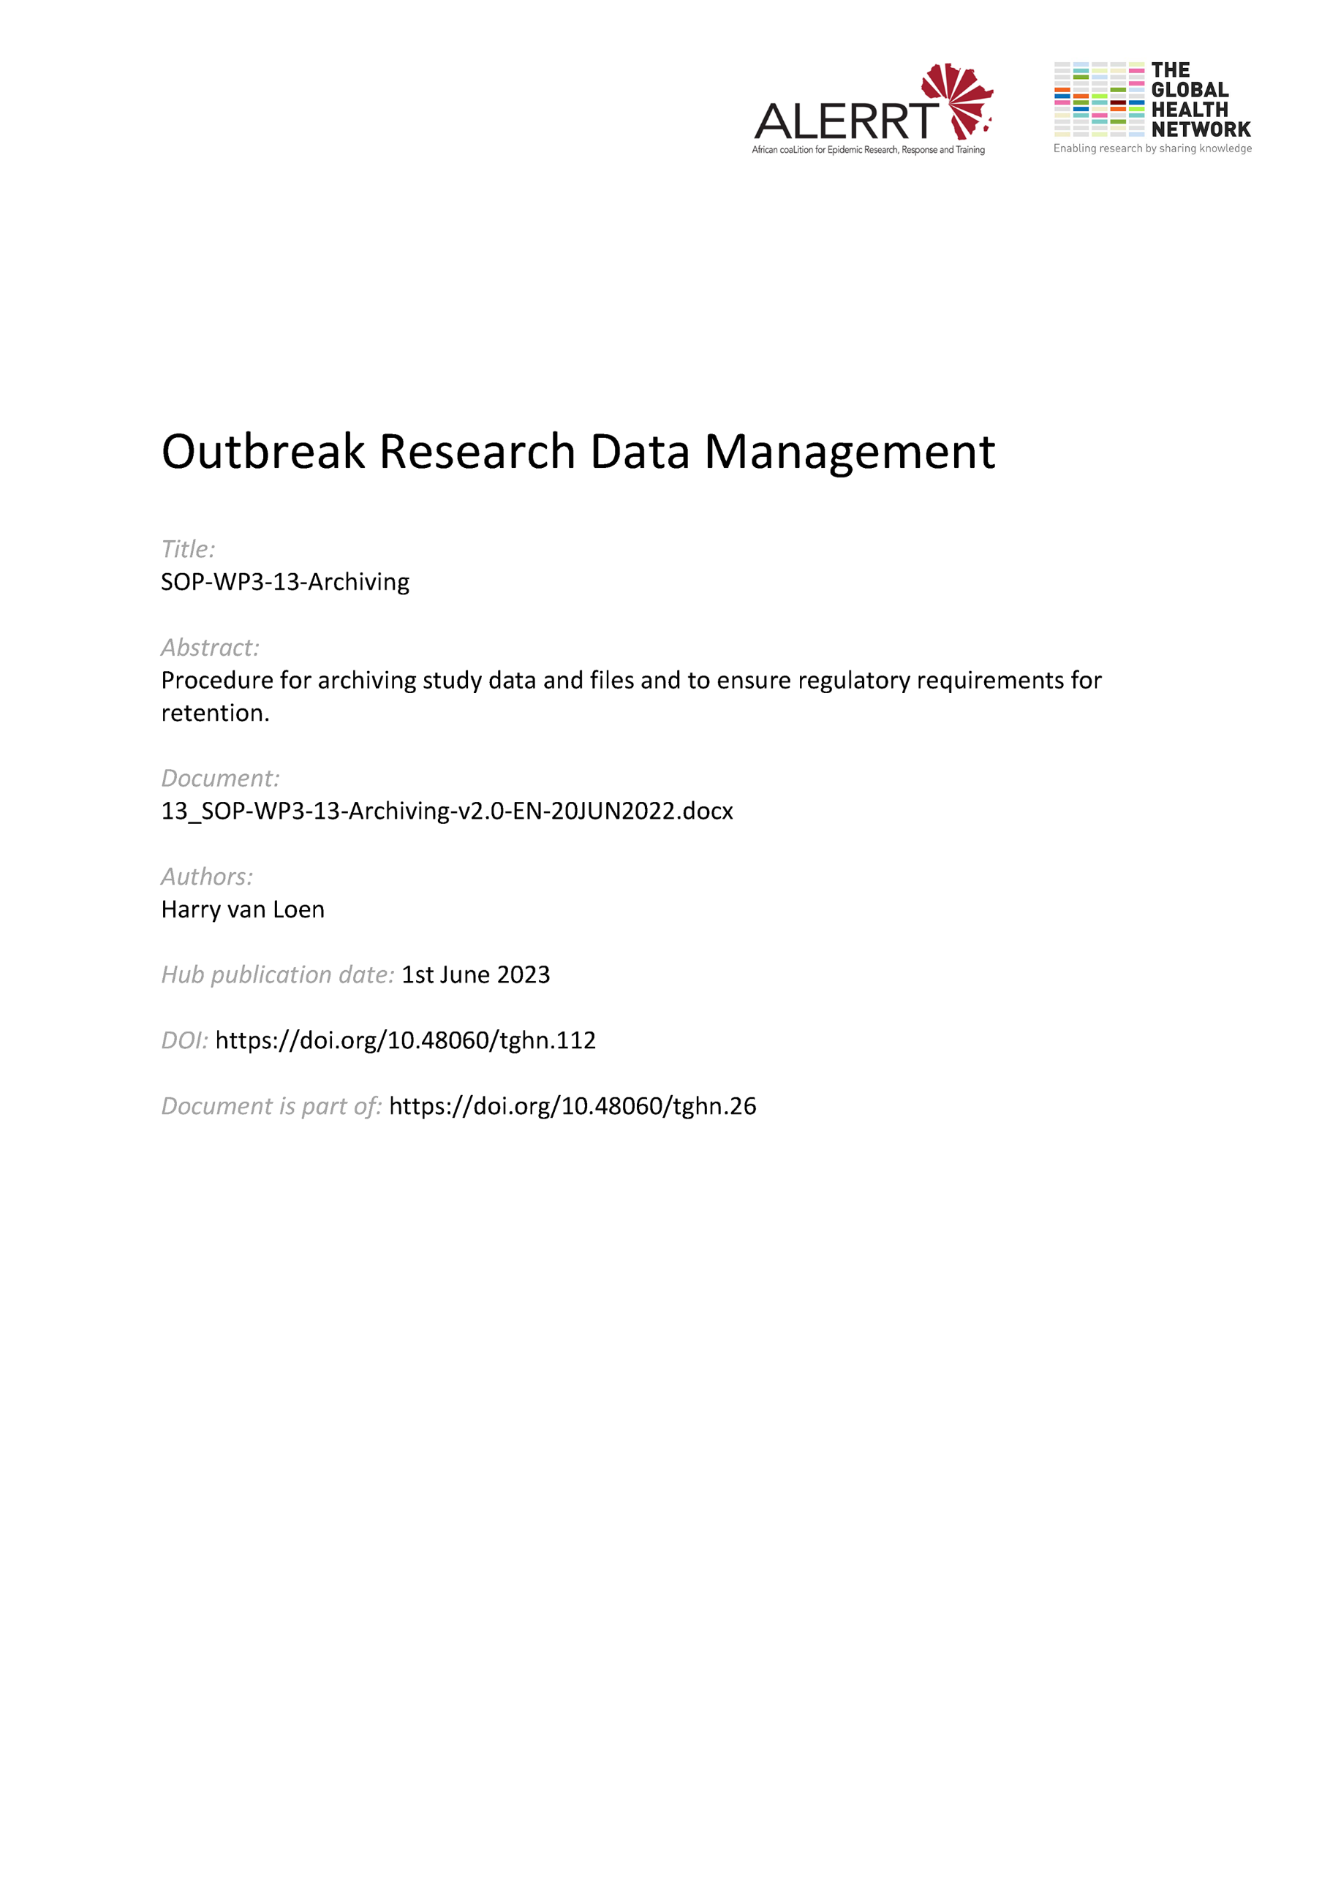](https://doi.org/10.48060/tghn.112)

|  |  |
| --- | --- |
|  | **SOP Title:** Archiving |
| **Study title**: *Give study title to which this SOP applies* |

# Scope and application

|  |
| --- |
| Clinical research generates numerous data sets, files and documentation, in paper and electronic format. After completion of the project/study all of these materials have to be stored in safe and appropriate long-term storage facilities, enabling access for follow up on the project/study, to comply to regulatory requirements and/or to facilitate data sharing (if applicable).  This SOP applies to all key aspects and staff involved in the archiving of these study materials.  This SOP should best be read with SOP-WP3-15-Data Sharing. |

# Responsibilities

|  |  |
| --- | --- |
| **Function** | **Activities** |
| Coordinating Investigator or Project Lead | * Organizes and coordinates archiving at the Sponsor and at each site (although this might also be delegated to the PI of each site) |
| Principal Investigator  Subinvestigator | * Organizes and coordinates archiving at each site |
| Data Manager (if any) | * Supports archiving at the Sponsor * Supports archiving at the site(s) |
| Archivist (if any) | * Provides access to archives * Arranges archives for long term and structured retention of materials |

# Definitions

**Audit trail:** Documentation that allows reconstruction of the course of events.

**Clinical trial/study:** Any investigation in human subjects intended to discover or verify the clinical, pharmacological and/or other pharmacodynamic effects of an investigational product(s), and/or to identify any adverse reactions to an investigational product(s), and/or to study absorption, distribution, metabolism, and excretion of an investigational product(s) with the object of ascertaining its safety and/or efficacy. In Good Clinical Practice, the terms clinical trial and clinical study are defined synonymous.

**Coordinating Investigator**: An investigator assigned the responsibility for the coordination of investigators at different centres participating in a multicentre trial.

**CRF**: A printed, optical, or electronic document designed to record all of the protocol required information to be reported to the sponsor on each trial subject.

**(e)CRF**: (electronic)Case Report Form

**Essential Documents**: Electronic and/or paper documents which individually and collectively permit evaluation of the conduct of a study and the quality of the data produced. Amongst others, these include Study Protocol, Informed Consents signed by PI and study participants, Case Report Forms signed and dated by the PI, etc. Essential documents should be kept in a secure and accessible manner.

**Good Clinical Practice (GCP):** A standard for the design, conduct, performance, monitoring, auditing, recording, analyses, and reporting of clinical trials that provides assurance that the data and reported results are credible and accurate, and that the rights, integrity, and confidentiality of trial subjects are protected.

**Informed Consent Form**: A process by which a subject voluntarily confirms his or her willingness to participate in a particular trial, after having been informed of all aspects of the trial that are relevant to the subject's decision to participate. Informed consent is documented by means of a written, signed and dated informed consent form.

**Principal Investigator (PI)**: A person responsible for the conduct of the clinical trial at a trial site. If a trial is conducted by a team of individuals at a trial site, the investigator is the responsible leader of the team and may be called the principal investigator. See also Subinvestigator.

**SOP**: Standard Operating Procedure. Detailed, written instructions to achieve uniformity of the performance of a specific function.

**Source Data**: All information in original records and certified copies of original records of clinical findings, observations, or other activities in a clinical trial necessary for the reconstruction and evaluation of the trial. Source data are contained in source documents (original records or certified copies).

**Source Documents:** Original documents, data, and records (e.g., hospital records, clinical and office charts, laboratory notes, memoranda, subjects' diaries or evaluation checklists, pharmacy dispensing records, recorded data from automated instruments, copies or transcriptions certified after verification as being accurate copies, microfiches, photographic negatives, microfilm or magnetic media, x-rays, subject files, and records kept at the pharmacy, at the laboratories and at medico-technical departments involved in the clinical trial).

**Sponsor**: An individual, company, institution, or organization which takes responsibility for the initiation, management, and/or financing of a clinical trial

**Study materials:** Defined here as all project/ study relevant paper and electronic files, documentation and data sets. These include amongst others essential documents, study database (clinical & laboratory data), safety database (if applicable), relevant correspondence…

**Subinvestigator:** Any individual member of the clinical trial team designated and supervised by the investigator at a trial site to perform critical trial-related procedures and/or to make important trial-related decisions

**Trial Master File (TMF)**: Binder(s) or Folder(s) which keeps at large the project/study paper or electronic essential documents (See Essential Documents). The TMF should be set up at the beginning of a trial. The TMF is usually composed of a sponsor TMF, held by the sponsor organization, and an investigator TMF held by the investigator(s) at the site(s). The investigator TMF is often referred to as the Investigator Site File (ISF) or Site Master File (SMF).

# Procedures

#### **Before the project/study**

* Assess the particularities and responsibilities to what/when/how/where study materials are to be archived.
* See to it that the Coordinating Investigator (or delegate) prepares a Trial Master File Index, which lists the essential documents before, during and after the study.
* Document the archiving process in the Study Protocol and Data Management Plan.

#### **After the completion of the project/study**

**4.2.1 What to archive?**

* Ensure archiving of the Trial Master File and all essential paper and electronic documents (before/during/after study). For Clinical trials/studies see Guideline for Good Clinical Practice E6(R1), in particular section 8 “Essential documents for the conduct of a clinical trial”.
* Ensure archiving of paper and electronic study data (source data, (e)CRF data , safety data (if applicable), statistical analysis and other study data sets) and its metadata (information on how to reconstruct the data sets: database design, coding dictionaries, data collection and entry guidelines, statistical study specific analysis and randomization codes ). For clinical trials, the audit trail should also be archived. This audit trail might include all corrections to the data and notebooks.
* Ensure that the original CRFs (with data) and a copy of these CRFs is kept for archival. When the original CRFs are sent to the Sponsor, then the site(s) should hold a copied of the CRFs. When the original CRFs are kept at the site(s), then the copied CRFs should be sent to the Sponsor.
* Ensure archiving of essential data management and statistical documentation, such as the data management plan and report, data review plan, study specific data management SOPs, system validation documents, training records, statistical analytical plan and report.
* Ensure archiving of relevant communication (e-mails, meeting minutes), trial reports and publications.

**4.2.2 When to archive?**

* Proceed for archival once the trial is completed.
* Define well when a project/study is set as ‘ended or completed”. Take into account that this may vary among studies. The end of a clinical trial means usual the last visit of the last subject in the trial. However take notice that the trial then still needs a final closeout visit and a written database lock approval, monitoring closeout report and final trial report. See thus to it that archiving is done at least with considering still these deliverables, but also within reasonable timelines after the end of the project/study.
* Document the end of the project/study and archiving in the study protocol or in the meeting minutes.

**4.2.3 How to archive?**

* Organize and document the archiving at Sponsor location and at site(s) location(s).
* Ensure availability and accessibility for study materials for study purpose or regulatory requirements.
* Assure that the study materials are held complete, legible and accurate. Avoid loss, alteration or corruption of data and documents.
* Ensure that all study materials are clearly named, labeled, versioned and ordered.
* Separate study materials identified by a study subject code from that with direct identifiable study subject data. See to it that direct identifying information is stored and archived at the sites only. This includes Participant Information Sheets (including locater information with names, addresses, phone numbers, email addresses) & subject signed Informed Consent Forms.
* Restrict access to storage facilities and study materials to appropriate and authorized individuals only (e.g. biometric or badge control; keys for locked cupboards and rooms; personal usernames and passwords)
* Document any transfer of data or documents (paper or electronic).

**4.2.4 Where to archive?**

* Provide a clear organization in binders, shelving and closets (for paper documentation) and a folder structure at electronic media, such as server(s), USB-drive(s), magnetic tapes etc; (for electronic data and files).
* Provide storage facilities that got appropriate size, allow for authorized access only and ensure secure long-term storage, considering risks such as impact from water, fire, extensive temperature, humidity, sunlight and pests originating from rodents or insects.

**4.2.5 How long should study materials be archived?**

* Retain study materials for at least 5 years after the end of the project/study or for a longer period when so required by the study protocol or regulatory requirements.
* The sponsor should notify the principal investigators in writing when their trial records can be destroyed.

**4.2.6 Archiving and Data Sharing**

* Take into account that some Funders or Editors require data sharing after the project/study ends. This might be expected according specific conditions and might interfere your way of archiving. For example, the FAIR principles <https://www.force11.org/group/fairgroup/fairprinciples> are a set of principles to make data and its metadata ‘Findable, Accessible, Interoperable and Re-usable’. See also SOP-WP3-15-Data Sharing

# Attachments

|  |  |
| --- | --- |
| **Appendices & Attachments** | |
| **Number** | **Title** |
|  |  |

1. **Document History & References**

|  |  |  |  |
| --- | --- | --- | --- |
| **Revision** | | | |
| **Version number** | **Author** | **Date** | **Description/reason for modification** |
| 1.0 | Harry van Loen | 07/10/2019 | Initial version based on the SOP-010 from the Association for Data Management in the Tropics (ADMIT).  Review by Fatoumatta Cole, Hanne Landuyt and Yusupha Njie.  Approval by Bai Lamin Dondeh. |
| 2.0 | Harry van Loen | 20/06/2022 | Review to ensure that the SOP is appropriate within ALERRT and with current clinical research best pratices. |

1. **Approval**

|  |  |  |
| --- | --- | --- |
| **Name and function** | **Date (dd/mm/yyyy)** | **Signature** |
| ***Author*** | | |
| *Indicate who wrote the SOP* |  |  |
| ***Review*** | | |
| *Indicate WP team members who reviewed (if applicable)* |  |  |
| ***Approval*** | | |
| *Indicate WP Lead/Co-lead(s) who approved* |  |  |