[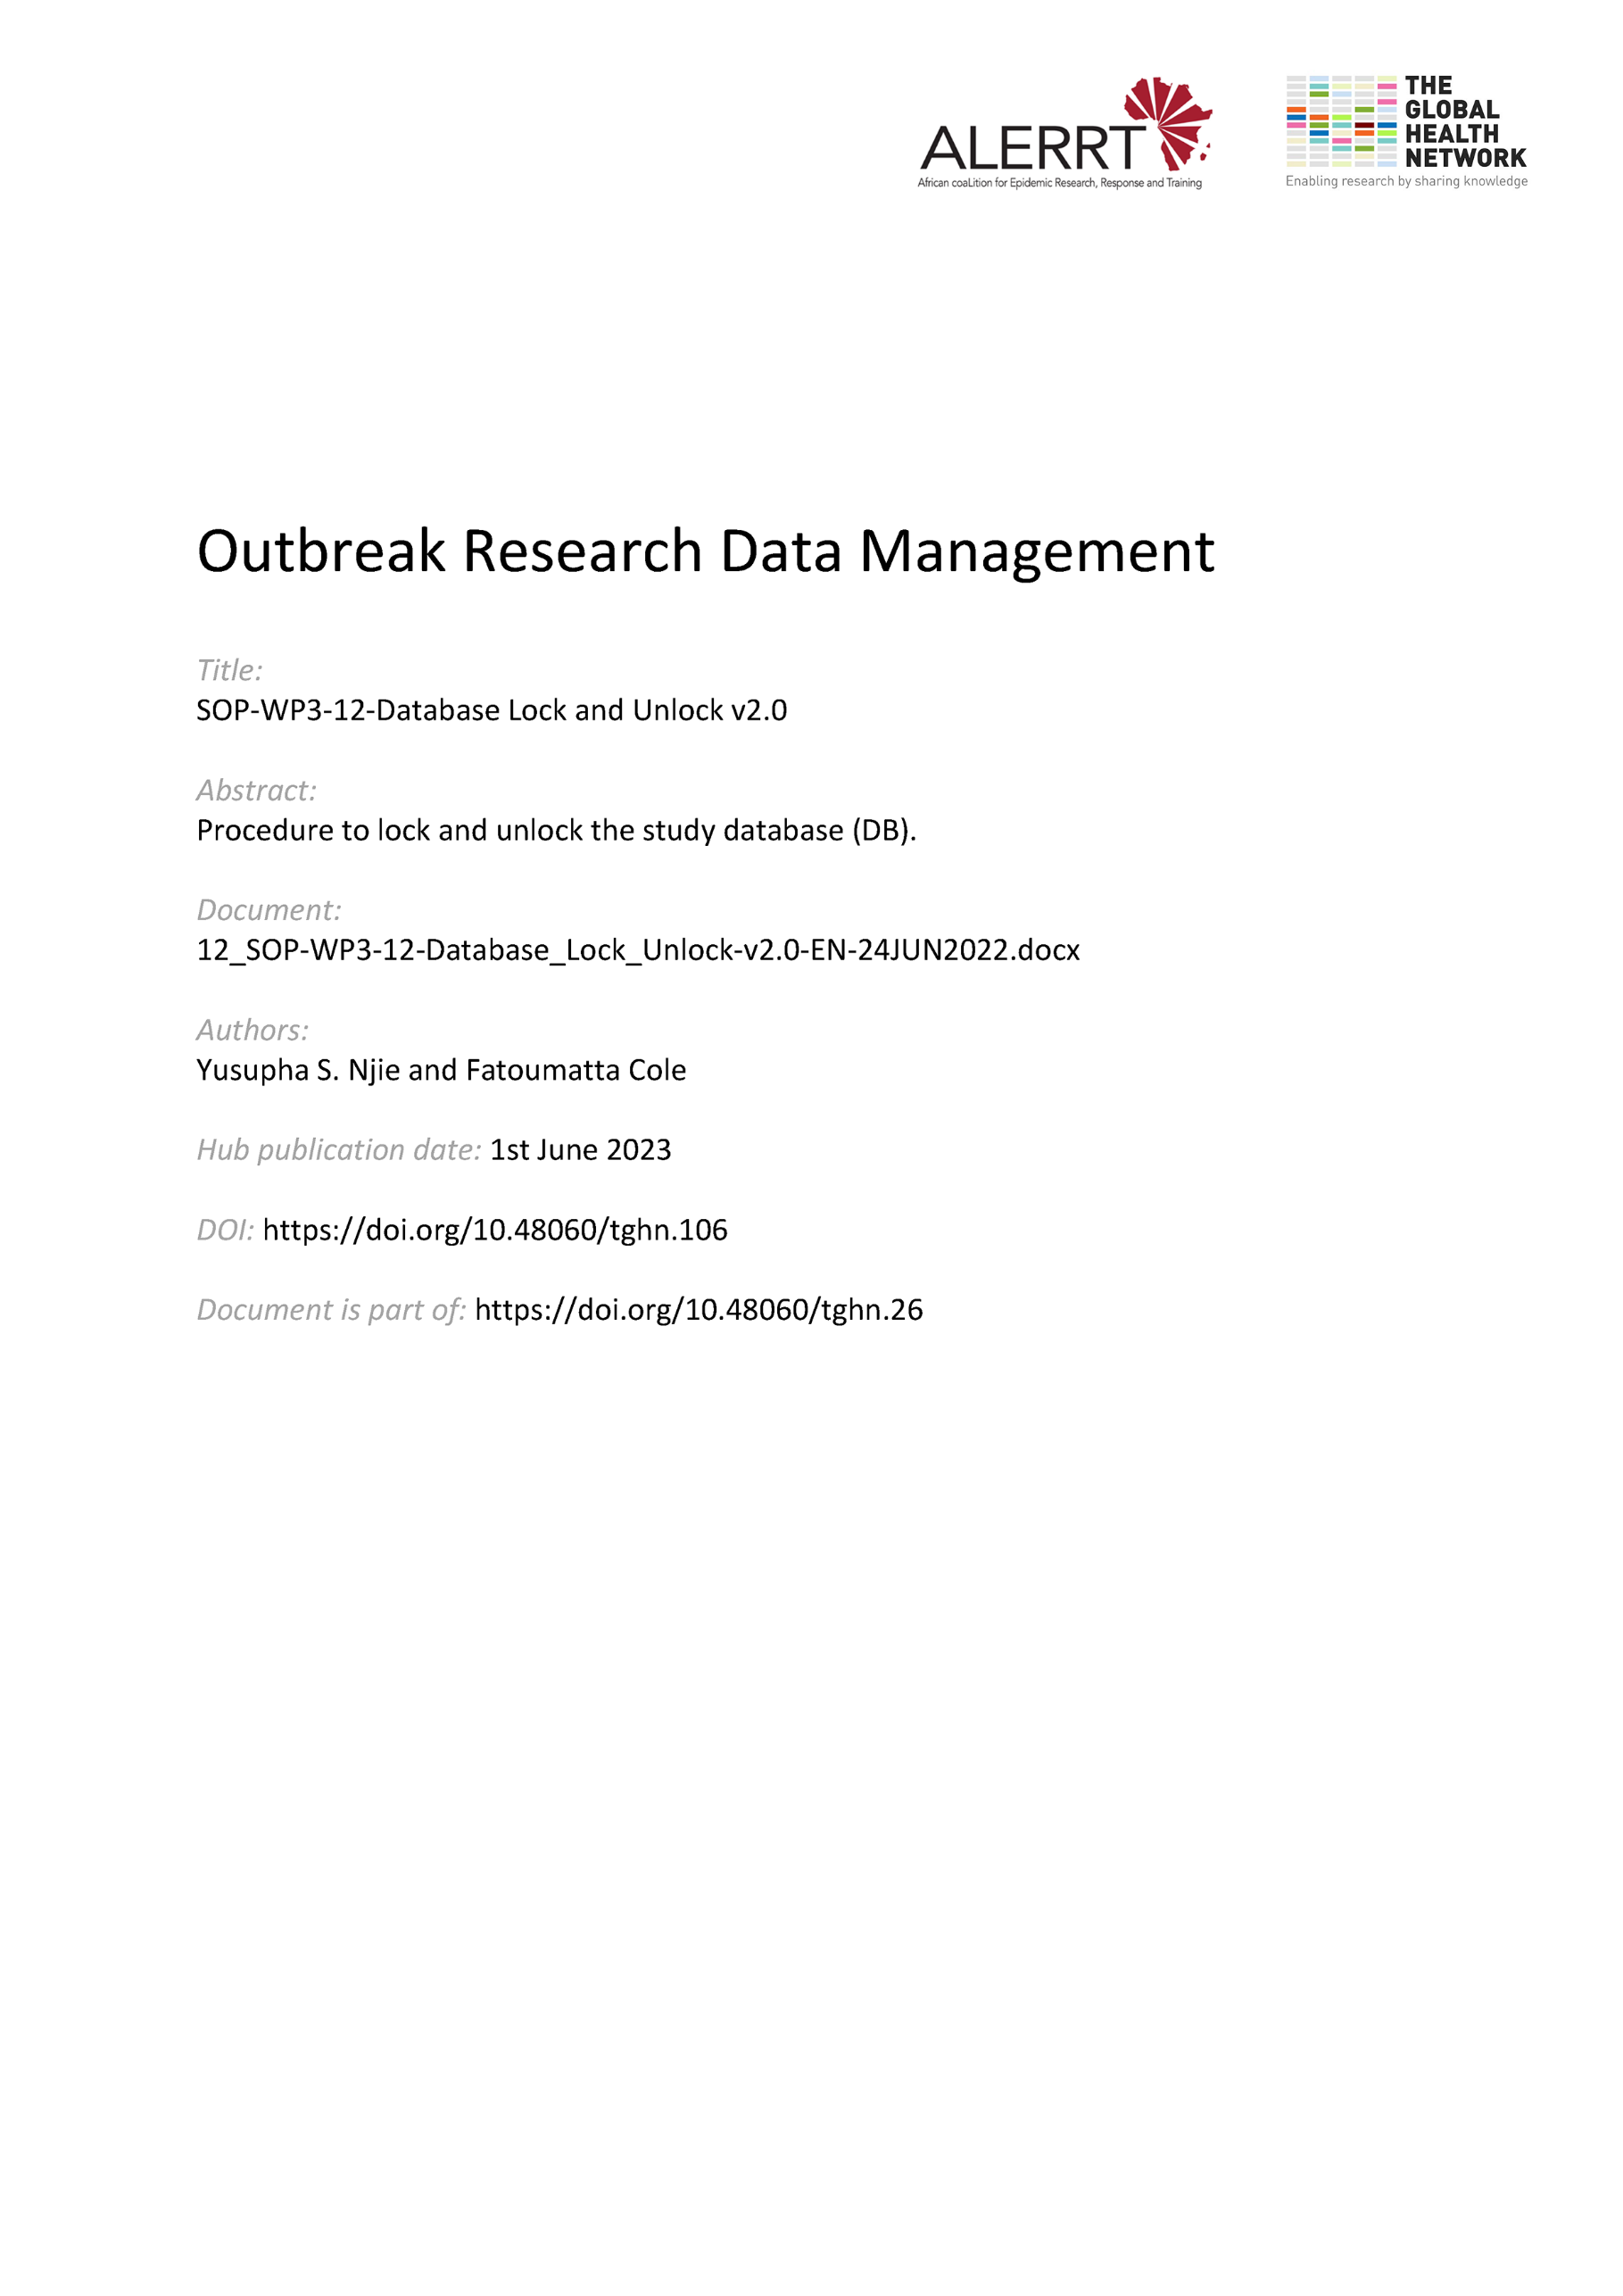](https://doi.org/10.48060/tghn.106)

|  |  |
| --- | --- |
|  | **SOP Title:** Database Lock / Unlock |
| **Study title:** *Give study title to which this SOP applies* |

# Scope and application

|  |
| --- |
| The purpose of this standard operating procedure (SOP) is to document how to undertake a project database lock once all data has been collected and cleaned at the end of the project. Alternatively, the process for locking data during the study (in case data needs to be analysed during the study) is described (Interim lock). This SOP applies to clinical research.  The SOP also covers the procedures required should a locked database need to be unlocked. A database should only be unlocked if changes are required. |

# Responsibilities

|  |  |
| --- | --- |
| **Function** | **Activities** |
| Data Manager | * Coordinating database lock/unlock procedures * Performing checks prior to database lock/unlock * Performing database lock/unlock * Confirming database unlock |
| Project Lead / Project Lead delegate | * Approving database lock/unlock |
| Statistician | * Approving database lock/unlock |

# Definitions

**eCRF:** AnElectronic Case Report Form is an electronic document designed to collect the data that is described in the protocol for each trial subject.

**Database Lock**: The process whereby, at the end of a study, a dataset is readied for analysis (i.e. cleaned and validated) and then its state is kept constant –i.e. locked so that the data cannot be subsequently amended.

**Interim Database Lock:** The process whereby part of a dataset is readied for analysis (i.e. cleaned and validated) and then its state is kept constant –i.e. locked so that the data cannot be subsequently amended

**Standard Operating Procedures (SOPs)**: Detailed, written instructions to achieve uniformity of the performance of a specific function.

# Procedures

# Preparing for Interim/Database Lock

* All responsible parties, in this case the data manager, project lead and statistician will agree a predefined closure point according to the project’s timeline, when all data must be entered, reviewed and cleaned. In case of an Interim Database lock the locked sections (visits, participants, etc) need to be defined in the protocol and the Database Lock Form (see Attachment 1). If needed, a Database lock meeting can be held.
* The project lead makes the request for a (interim) database lock.
* The data manager ensures that all applicable data is entered and reviewed. This is documented on the Database Lock Form.
* The data manager sends a final copy of the data set to the statistician prior to locking for reviewing.
* The data manager circulates the Database Lock Form for approval signature to the project lead.
  1. **Locking the Database**
* Upon receipt of a lock request, the data manager will begin the process of locking the database
* The data manager will document the status of the database on the Database Lock Form.
* The data manager will remove all user access to the database, apart from necessary administrative access, so that no changes can be made to the data.
* The data manager will lock part of the database (for interim database lock), or the complete database (at the end of the study). This is documented in the Database Lock Form. The process of locking data depends on the Clinical Data Management Software used. Please refer to the help files of your software.
  1. **Unlocking of a Locked Database**
* In a rare occasion that changes are required to the data after a database has been locked then authorization is sought by completing a Database Unlock Form (see Attachment 2) stating who needs access, which section needs updating and reasons for the need to unlock the database.
* The Unlock Form must be approved and signed by the data manager, project lead and statistician.
* Once the Unlock Form is approved, the data manager grants access to the limited users defined on the form and unlocks the pre-defined data sections.
* The data manager will perform a final check to ensure that only the approved updating of the database was performed.
* The data manager re-locks the database by following section 4.1 and 4.2 above.
  1. **Re-locking the database**
* Prior to re-locking, the data manager must review the audit trail for the database to confirm that only the approved changes were made. Any files, data etc. created to support this process should be retained.
* Only once all queries or issues have been resolved the re-locking process should be undertaken again as soon as reasonably appropriate.

1. **Attachments**

|  |  |
| --- | --- |
| **Attachments** | |
| **Number** | **Title** |
| 01 | Database Lock Form |
| 02 | Database Unlock Form |

1. **Document History and References**

|  |  |  |  |
| --- | --- | --- | --- |
| **Revision** | | | |
| **Version number** | **Author** | **Date** | **Description/reason for modification** |
| 1.0 | Yusupha Njie  Fatoumatta Cole | 07/10/2019 | Initial version  Review by Hanne Landuyt  Approval by Bai Lamin Dondeh and Harry Van Loen |
| 2.0 | Fatoumatta Cole | 24/06/2022 | Review to ensure that the SOP is appropriate within ALERRT and with current clinical research best practices. |

1. **Approval**

|  |  |  |
| --- | --- | --- |
| **Name and function** | **Date (dd/mm/yyyy)** | **Signature** |
| ***Author*** | | |
| *Indicate who wrote the SOP* |  |  |
| ***Review*** | | |
| *Indicate WP team members who reviewed (if applicable)* | *Date of review* |  |
| ***Approval*** | | |
| *Indicate WP Lead/Co-lead(s) who approved* | *Date of approval* |  |