[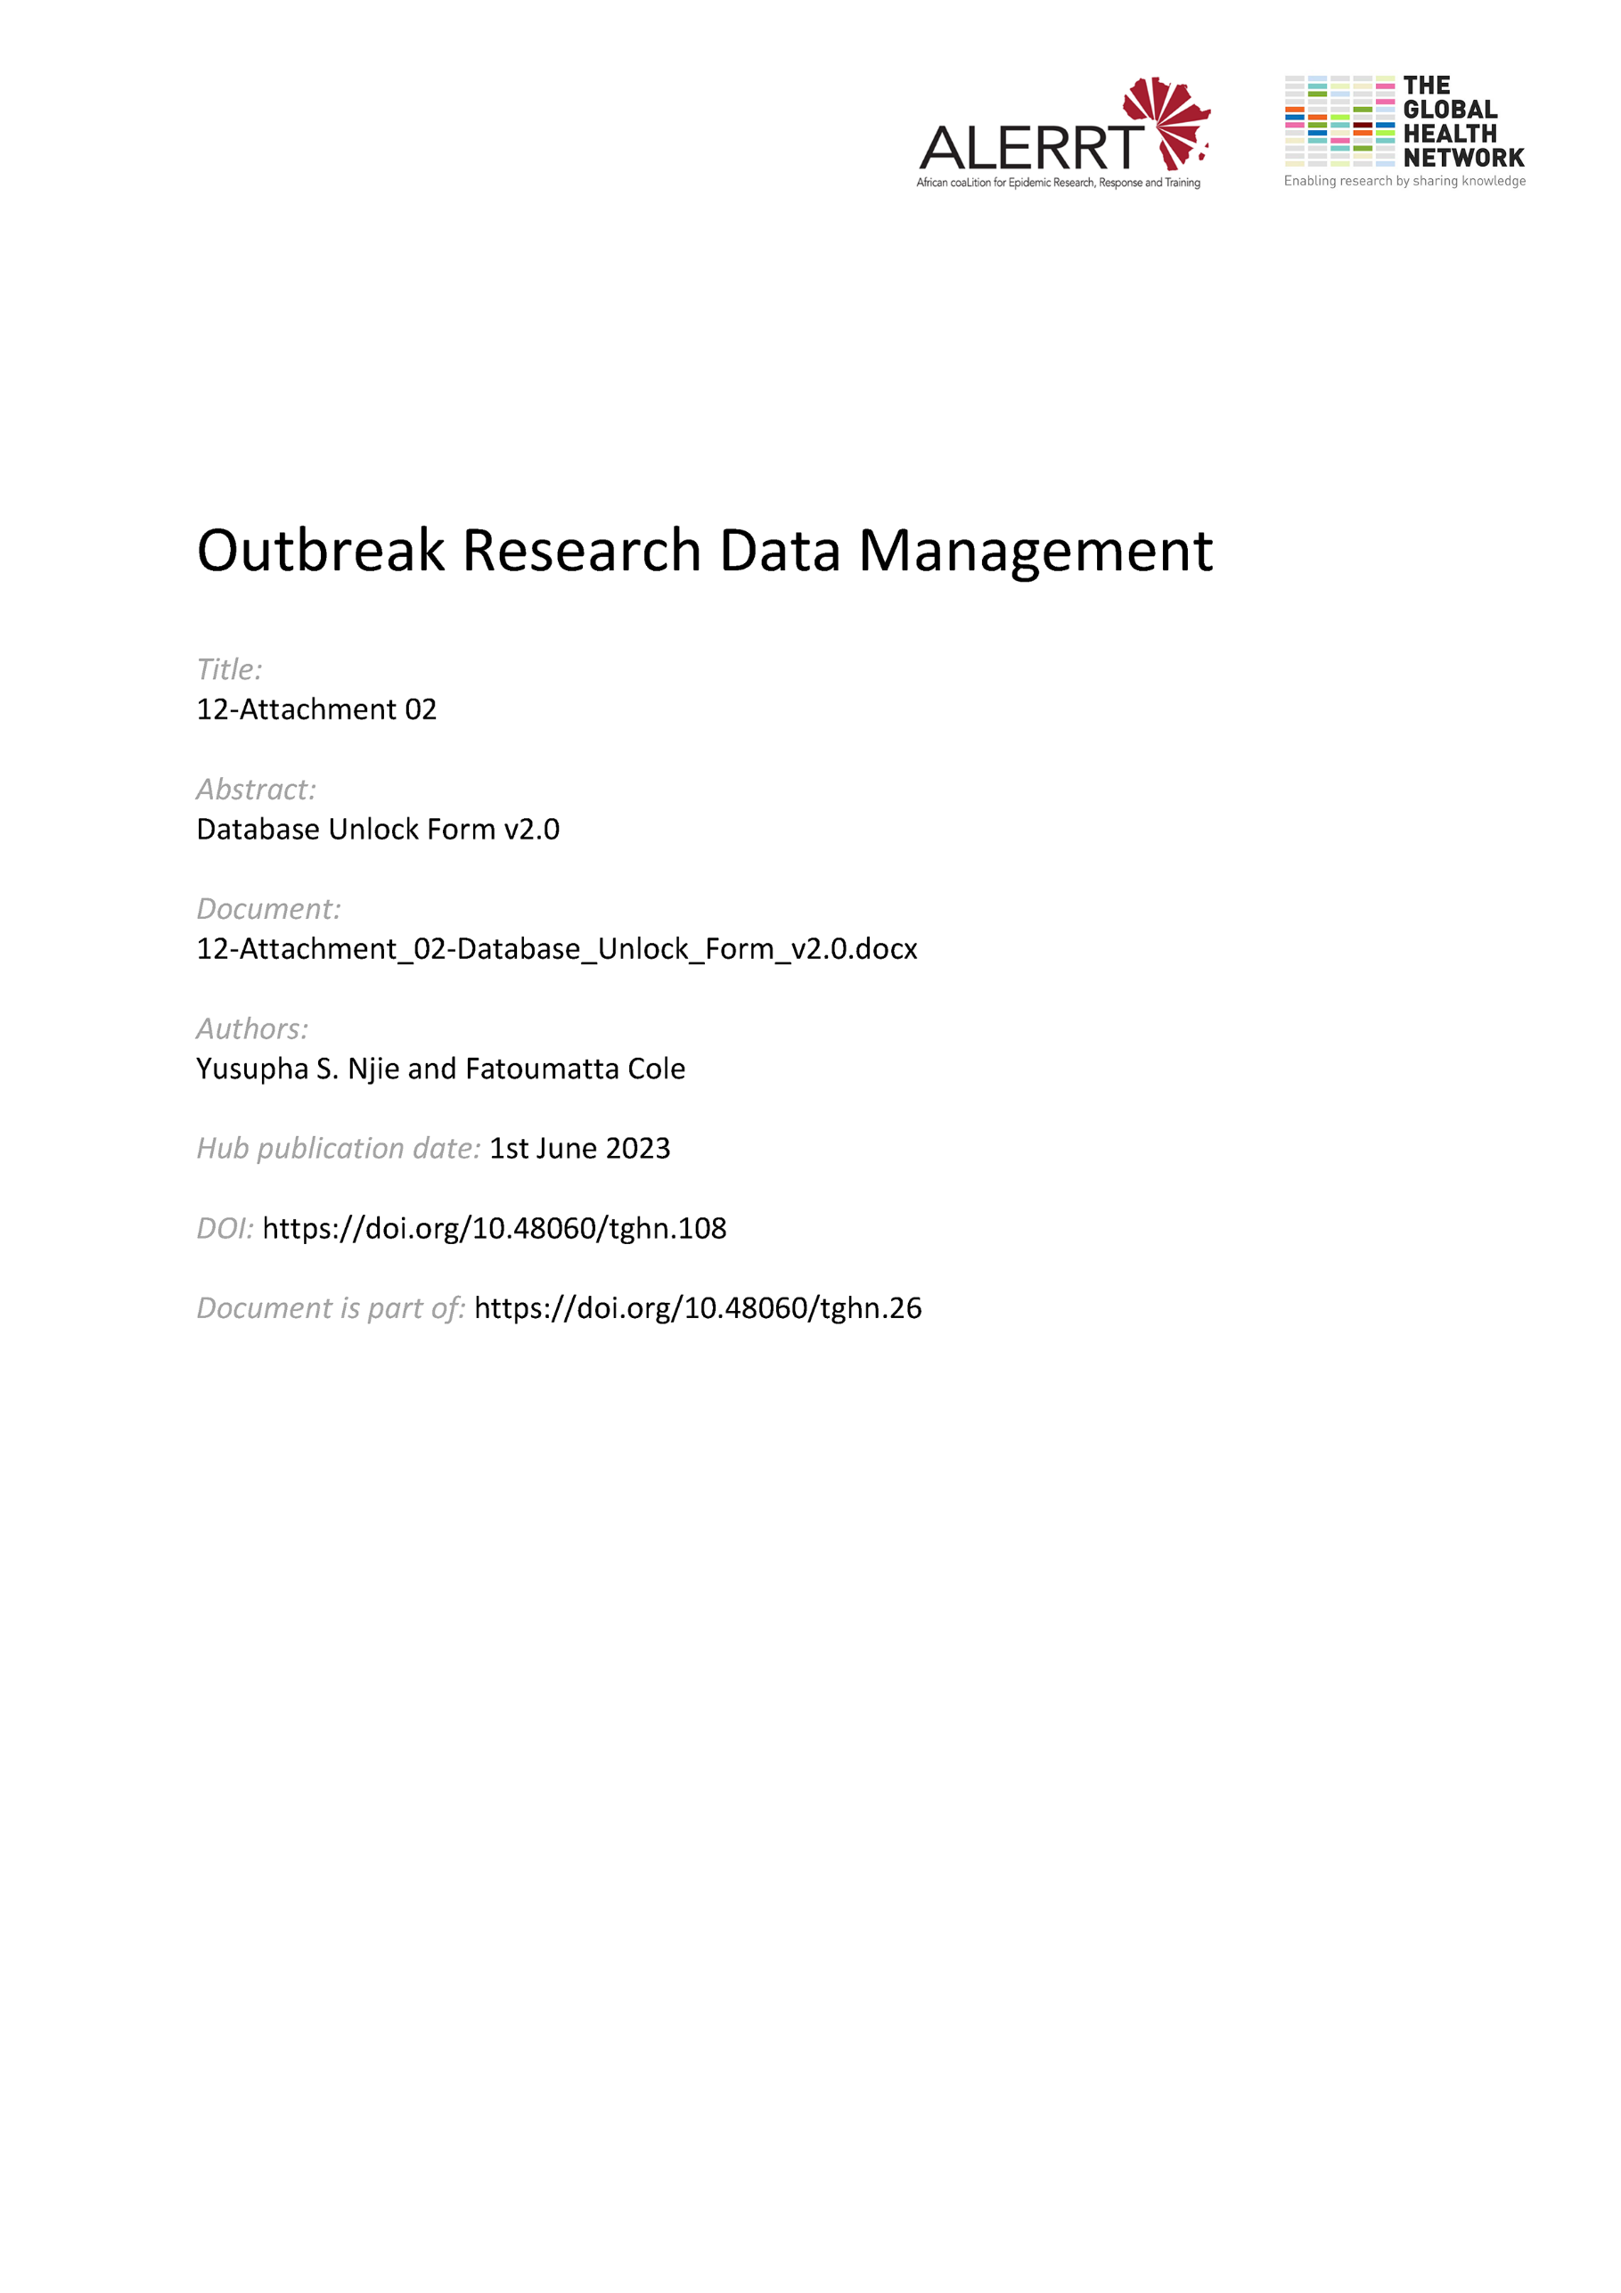](https://doi.org/10.48060/tghn.108)

|  |  |
| --- | --- |
|  | **Title: Database Unlock Form** |
| **Study title:** *Give study title to which this applies* |

**Unlock Occurrence: *_______***

(number each occurrence from 1)

1. **Justification for unlocking**

Specify the reasons for the need to unlock and who needs access and what changes are required – attach additional sheet(s) if required:

|  |
| --- |
|  |

1. **Approvals**

The following persons give their approval for the unlocking of the database of the above study.

|  |  |  |  |  |
| --- | --- | --- | --- | --- |
|  | **Name** | **Role** | **Signature** | **Date** |
| **Approved By**  **(Data Manager)** |  |  |  |  |
| **Approved By**  **(Statistician)** |  |  |  |  |
| **Approved By**  **(Project Lead)** |  |  |  |  |

(Document unlocking process overleaf)

1. **Database Unlock Confirmation**

|  |  |  |
| --- | --- | --- |
| **Database access restored** | ** Yes**  ** No** | **Specify user accounts enabled:** |

|  |  |  |  |  |
| --- | --- | --- | --- | --- |
|  | **Name** | **Role** | **Signature** | **Date** |
| Confirmation carried out by: |  |  |  |  |