[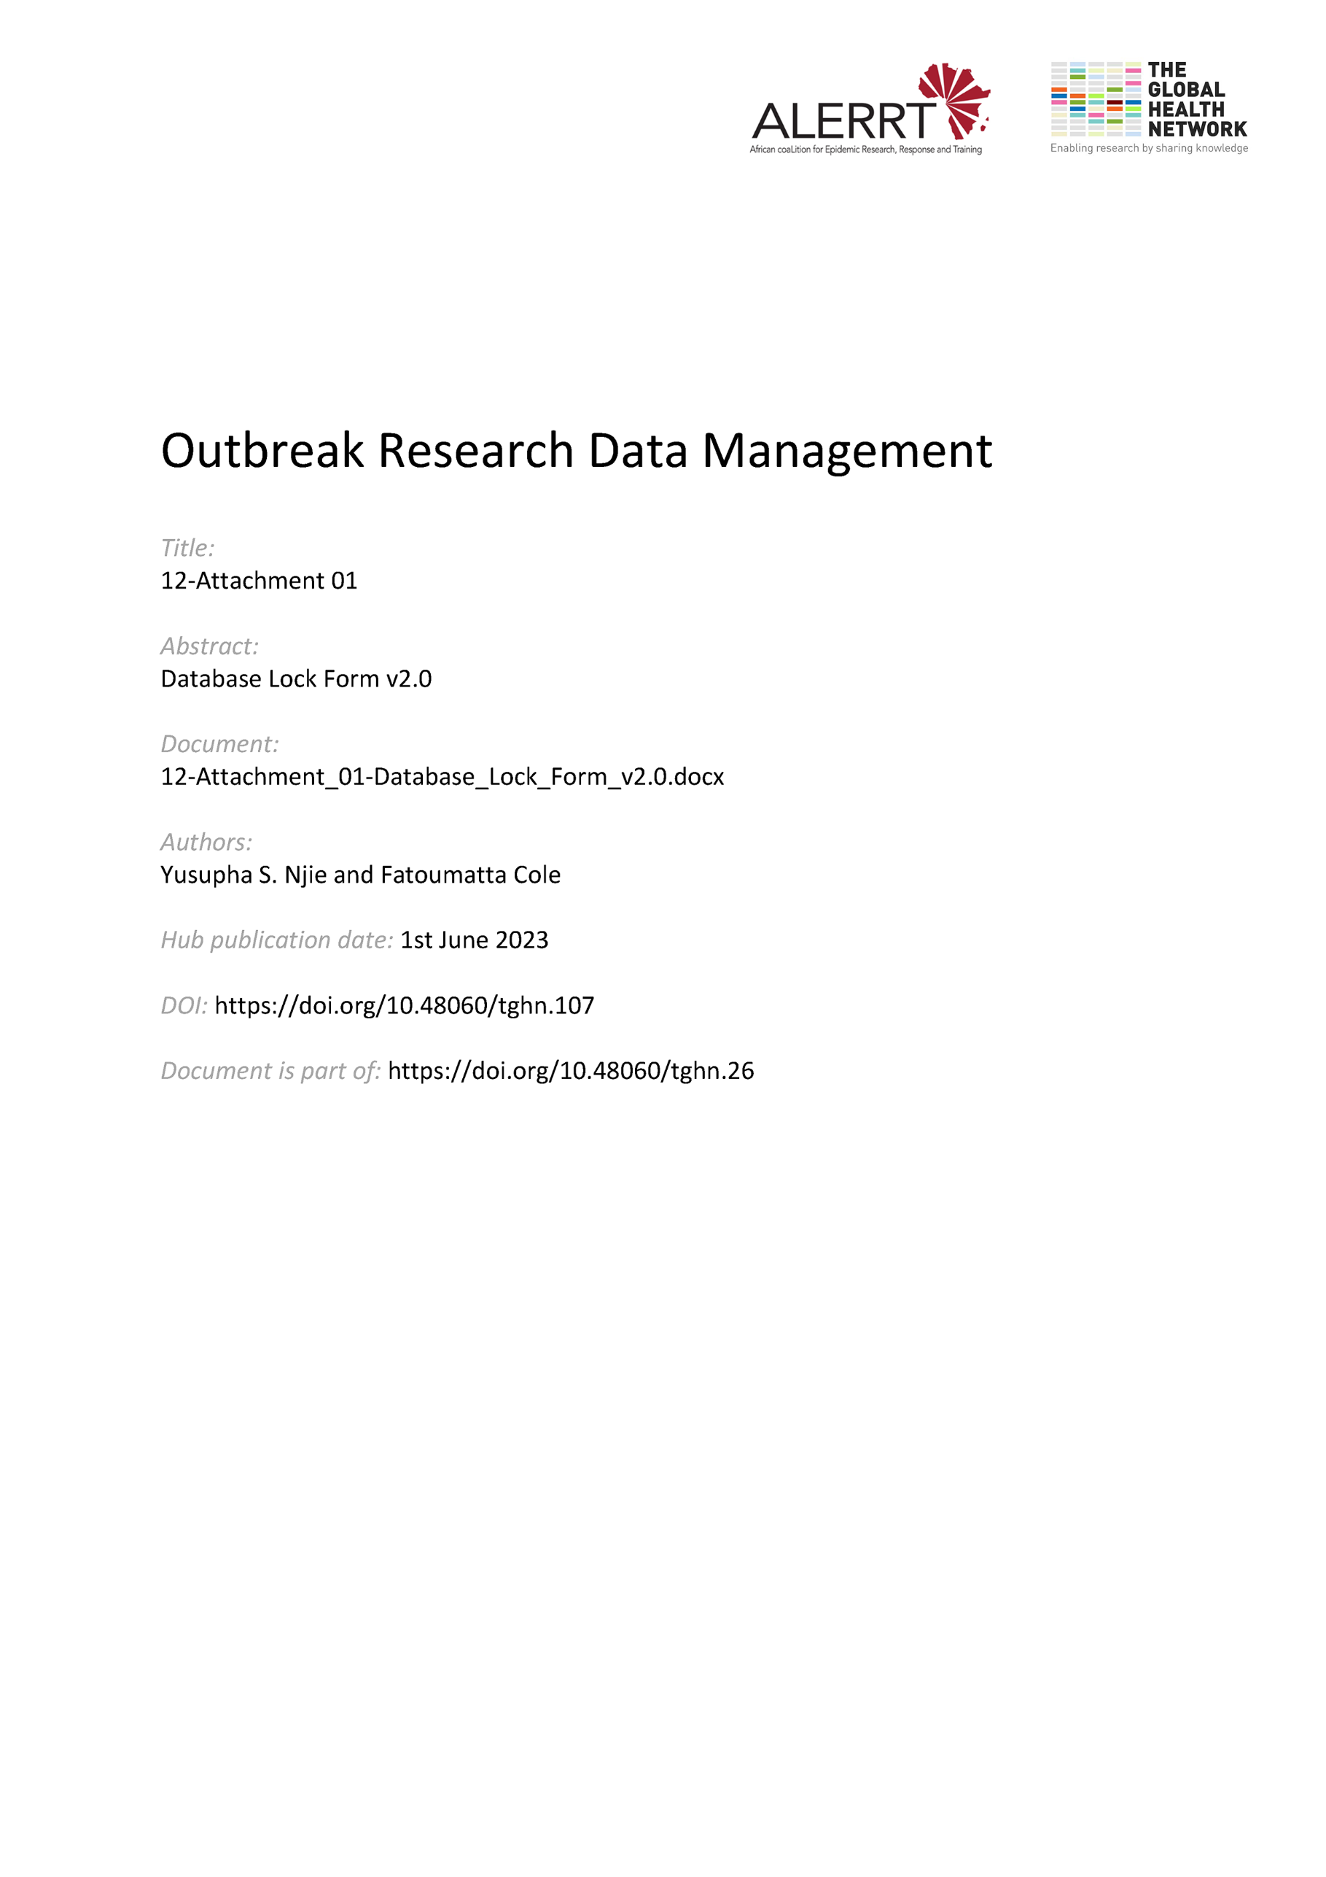](https://doi.org/10.48060/tghn.107)

|  |  |
| --- | --- |
|  | **Title:** Database Lock Form |
| **Study title:** *Give study title to which this applies* |

**Lock Occurrence: *_______***

(number each occurrence from 1)

1. **Pre-Lock Database Checklist**

The Following tasks are to be performed and checked for database lock of the above-mentioned study the first time the database is locked:

|  |  |  |
| --- | --- | --- |
| **All queries closed**  (Attach screenshot as evidence) | r Yes  r No | Comment: |
| **A final run of the Data Cleaning checks has been carried out and all issues have been followed up**  (Attach signed final data cleaning checklist) | r Yes  r No |  |
| **SAE reconciliation has been completed**  (for Clinical Trials Only)  (Attach signed SAE Reconciliation Sheet) | r Yes  r No  r N/A |  |
| **All expected participants and their associated CRFs in the final database confirmed present / absent with reason**  (Provide signed report) | r Yes  r No |  |

Or, if re-Locking an Unlocked database then…

|  |  |  |
| --- | --- | --- |
| **Confirm only the data changes specified on the Database Unlock Form have been done.** | r Yes  r No | Comment: |

|  |  |  |  |  |
| --- | --- | --- | --- | --- |
|  | **Name** | **Role** | **Signature** | **Date** |
| Checks carried out by: |  |  |  |  |

1. **Approvals**

|  |  |  |  |  |
| --- | --- | --- | --- | --- |
|  | **Name** | **Role** | **Signature** | **Date** |
| **Approved By**  **(Data Manager)** |  |  |  |  |
| **Approved By**  **(Statistician)** |  |  |  |  |
| **Approved By**  **(Project Lead)** |  |  |  |  |

1. **Database Lock Confirmation**

|  |  |  |
| --- | --- | --- |
| **All user access removed**  **(apart from Data Manager)** | r Yes  r No | Comments: |
| **Read-only database snapshot created** | r Yes  r No | (Enter filename) |

|  |  |  |  |  |
| --- | --- | --- | --- | --- |
|  | **Name** | **Role** | **Signature** | **Date** |
| Confirmation carried out by: |  |  |  |  |