[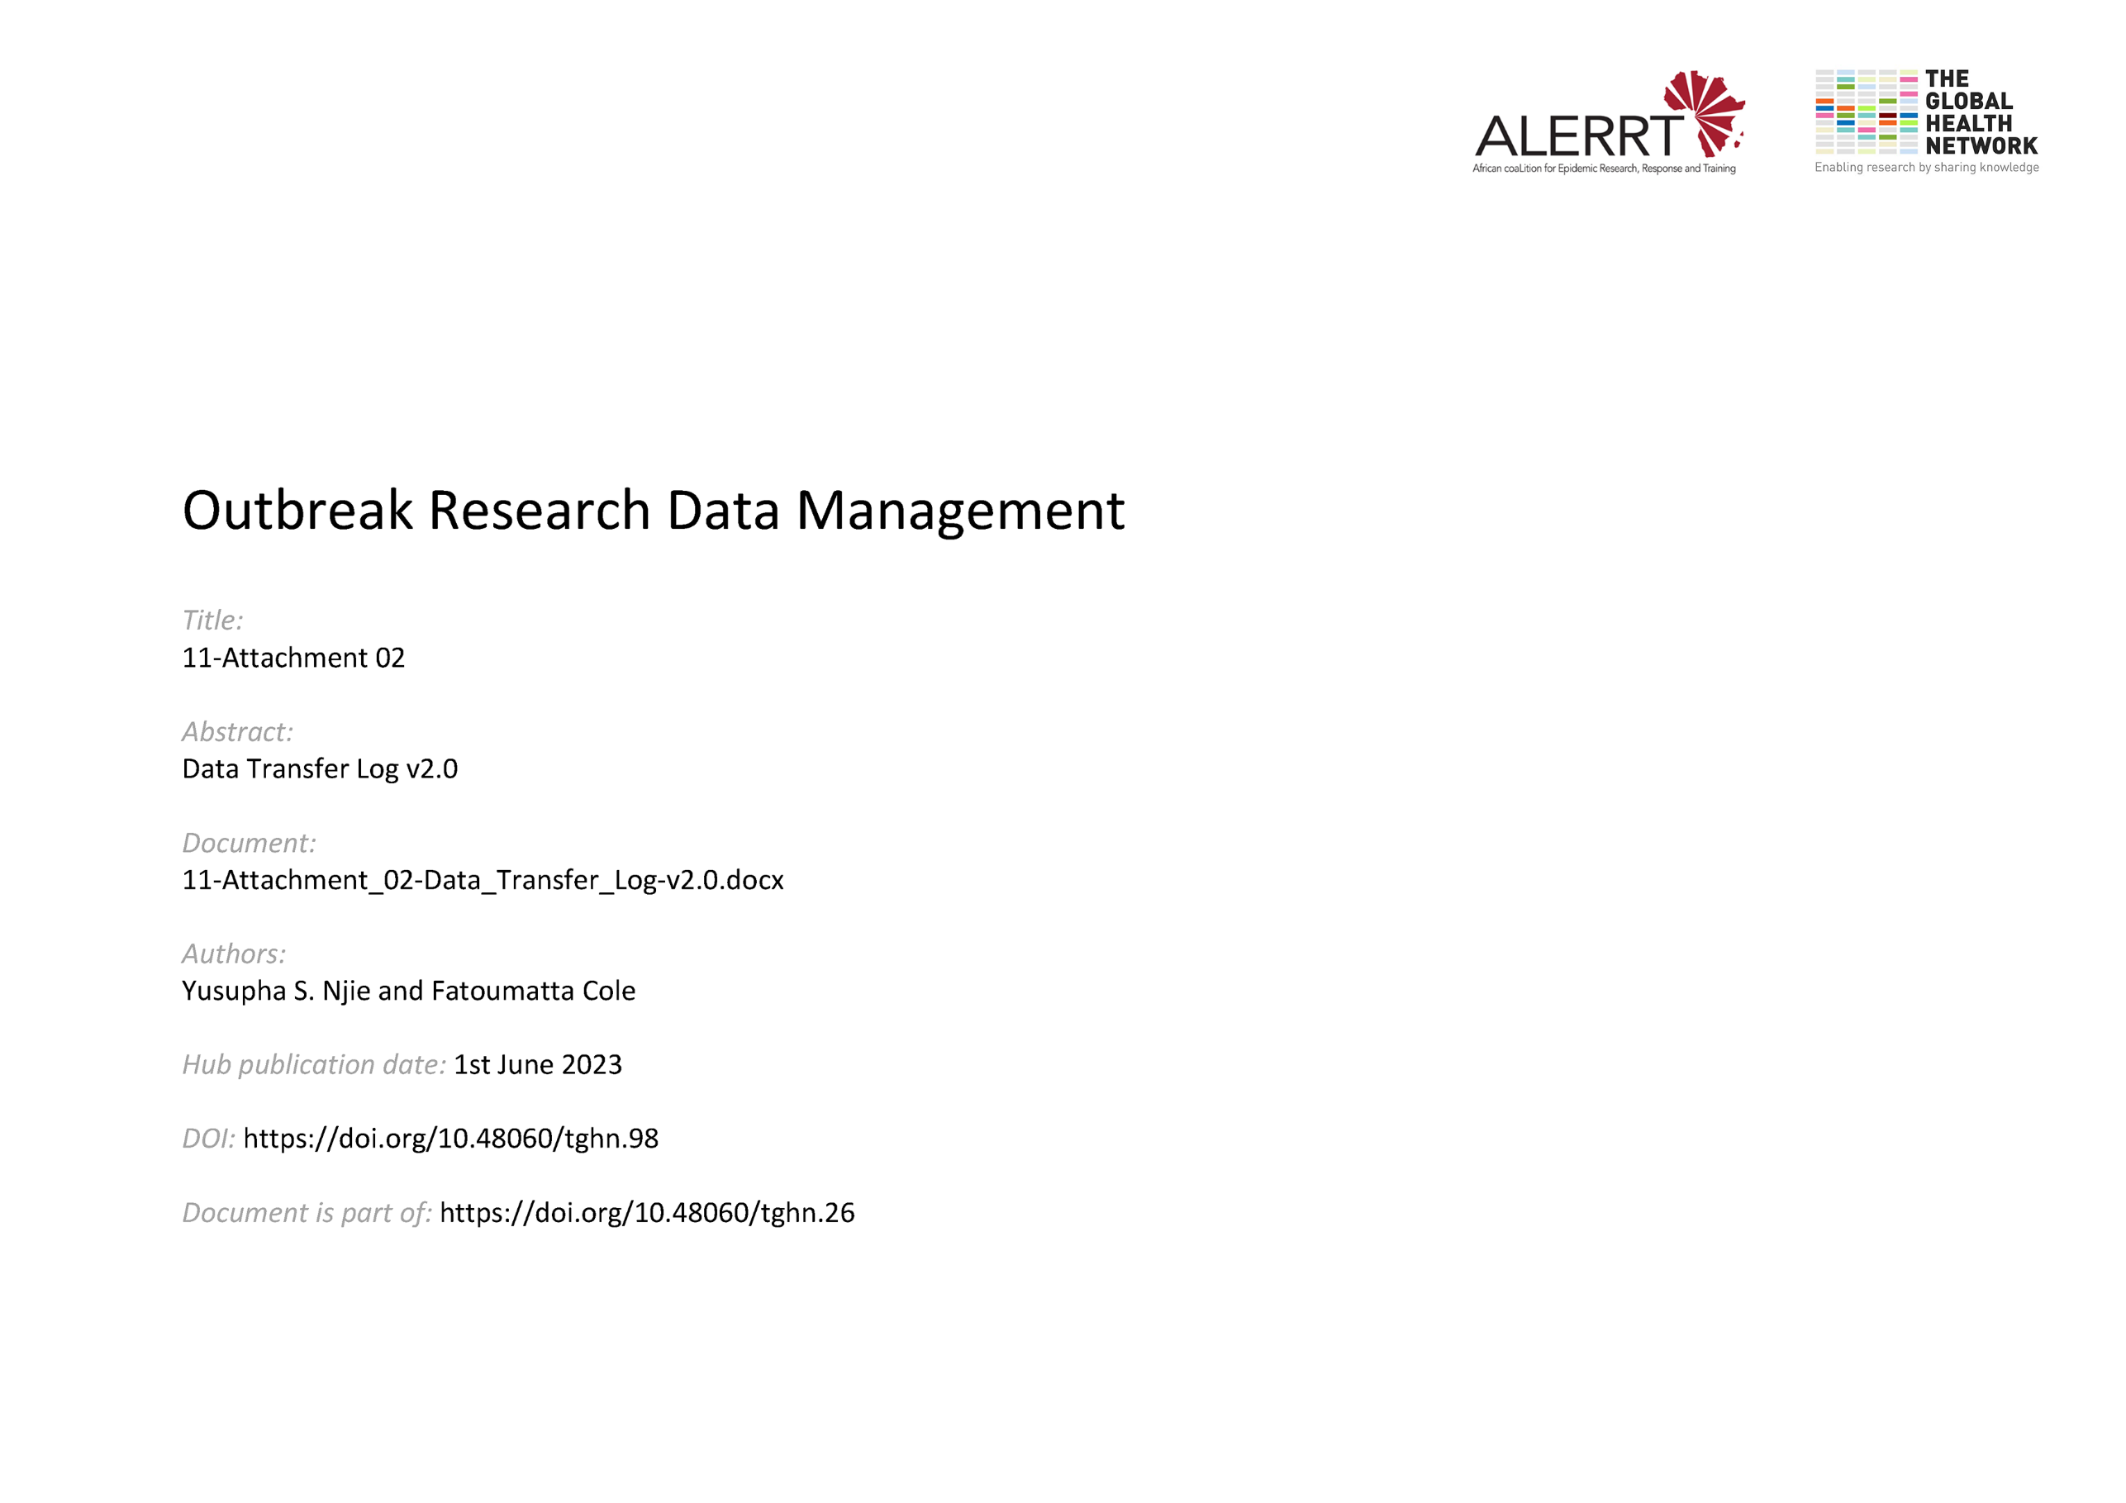](https://doi.org/10.48060/tghn.98)

|  |  |
| --- | --- |
|  | **Title: Data Transfer Log (DTL)** |
| **Study title:** *Give study title to which this applies* |
| **System name:** *Give system name to which this applies* |

|  |  |  |  |  |  |
| --- | --- | --- | --- | --- | --- |
| **Transfer No.** | **Transfer Date** | **List of Files** | | | |
| ***Filename*** | ***File size*** | ***Description*** | |
| **2** | __­_/___/_______ |  |  |  | |
|  |  |  | |
|  |  |  | |
|  |  |  | |
|  |  |  | |
| **Sender:** | | *Name* | *Role* | *Signature* | *Date* |
| **Receiver:** | | *Name* | *Role* | *Signature* | *Date* |

|  |  |  |  |  |  |
| --- | --- | --- | --- | --- | --- |
| **Transfer No.** | **Transfer Date** | **List of Files** | | | |
| ***Filename*** | ***File size*** | ***Description*** | |
| **3** | __­_/___/_______ |  |  |  | |
|  |  |  | |
|  |  |  | |
|  |  |  | |
|  |  |  | |
| **Sender:** | | *Name* | *Role* | *Signature* | *Date* |
| **Receiver:** | | *Name* | *Role* | *Signature* | *Date* |