[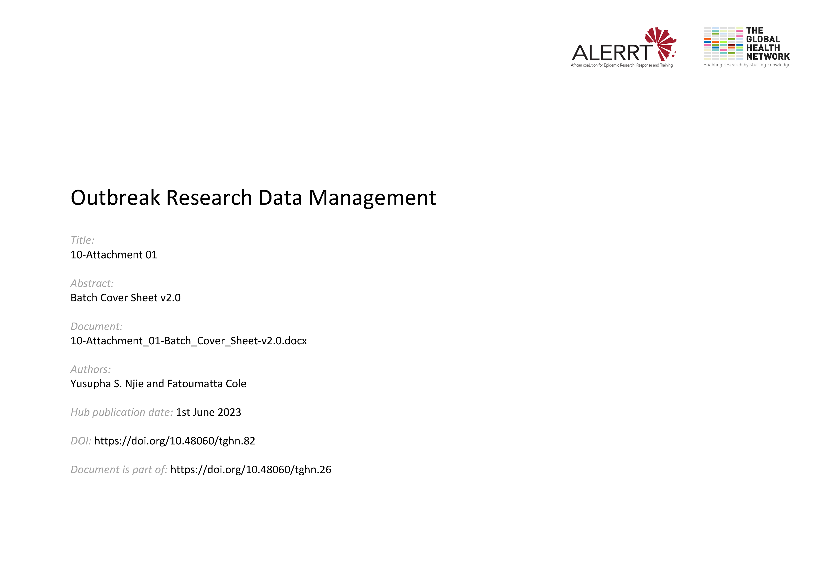](https://doi.org/10.48060/tghn.82)

|  |  |  |
| --- | --- | --- |
|  | **Title:** Batch Cover Sheet (BCS) | |
| **Study title:** *Give study title to which this applies* | |
| **Batch number:** | **Date:** |

|  |
| --- |
| **Batch Contents:** |

|  |  |  |  |  |  |
| --- | --- | --- | --- | --- | --- |
| **Activity** | **Start Date and Time** | **End Date and Time** | **Operator**  (Name and signature) | **Attachments?** | **Notes** |
| Data Entry 1 |  |  |  |  |  |
| Data Entry 2 |  |  |  |  |  |
| Verification |  |  |  |  | (Record number of errors found in each entry in the rows above) |
| Data Correction |  |  |  |  |  |
| Verification 2 |  |  |  |  |  |
| Filing |  |  |  |  |  |

|  |
| --- |
| **Notes:** |