[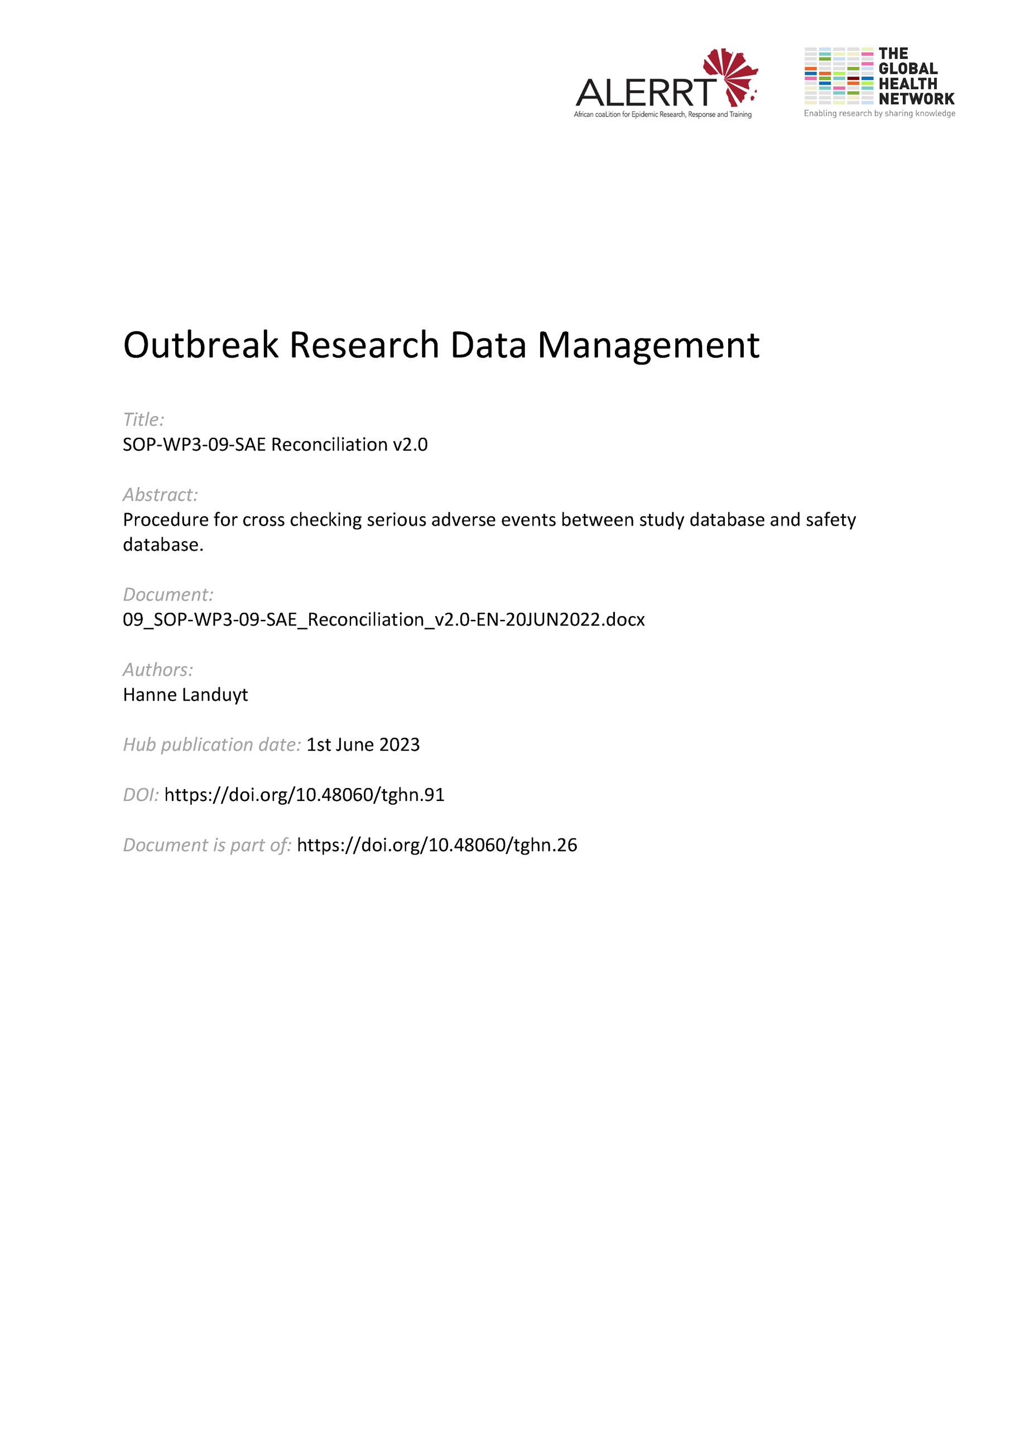](https://doi.org/10.48060/tghn.91)

|  |  |
| --- | --- |
|  | **SOP Title:** SAE Reconciliation |
| **Study title**: *Give study title to which this SOP applies* |

# Scope and application

|  |
| --- |
| In clinical research, serious adverse events (SAE) reconciliation is part of data review and an important aspect of pharmacovigilance and collecting safety data. It is the process of comparing the different data flows of SAE data.  GCP requires that SAEs are reported to the sponsor immediately. However, routinely entered study data has other timelines. SAEs are also part of the study data, which means they are also entered in the study database. This means there are two versions of the same safety data. Both versions of the safety data need to be compared and reconciled.  This SOP will only apply to studies where SAEs are reported. This procedure does not describe the procedures for reporting (serious) adverse events, only the process of reconciling the SAE collected data from all applicable sources.  Pharmacovigilance can be organized in different ways. This SOP describes the SAE reconciliation procedure for the situation where received reports are stored in a secure electronic filing system with the addition of a line listing system for tracking. |

# Responsibilities

|  |  |
| --- | --- |
| **Function** | **Activities** |
| Data Manager and/or Data Reviewer | * Liaise with the study clinician to finalize the SAE Reconciliation form * To finalize the context of how variables contained in the SAE CRF should be compared, for example as exact matches or as consistent matches. * Provide the detail to the SAE Reconciliation form (see attachment 1) * Work with the <study clinician> to reconcile SAEs captured in the study database with SAEs reported outside the study database |
| Investigator or Study clinician | * Respond to queries and discrepancies raised during the reconciliation process * Provide necessary interpretation for clinical information contained in the SAE |
| Project Lead or Project Lead delegate | * Determine frequency of SAE reconciliation |

# Definitions

**AE: Adverse Event**. Any untoward medical occurrence in a patient or clinical investigation subject administered a pharmaceutical product and which does not necessarily have a causal relationship with this treatment.

**GCP**: Good Clinical Practice. A standard for the design, conduct, performance, monitoring, auditing, recording, analyses, and reporting of clinical trials that provides assurance that the data and reported results are credible and accurate, and that the rights, integrity, and confidentiality of trial subjects are protected.

**PV: Pharmacovigilance:** The collection, proper documentation and reporting of side effects, adverse effects and any untoward health reaction to the subject of a clinical trial.

**SAE: Serious Adverse Event**. A serious adverse event (SAE) in clinical trials is an adverse event which can be categorized in one (or more) of the following categories

* + results in death
  + life-threatening
  + requires inpatient hospitalization or prolongation of existing hospitalization
  + results in persistent or significant disability/incapacity
  + is a congenital anomaly/birth defect
  + requires intervention to prevent permanent impairment or damage

**Safety database.** A database where all SAE reports, safety data and information (mails, death reports…) received by pharmacovigilance are stored. This can be a secure electronic filing system for reports, or a specialized database.

**Secure electronic filing system**: a system consisting of access controlled electronic folders.

**Study database.** A database where all study data, including some safety data are stored.

# Procedures

AllSAE data should be followed up during the study. Reconciliation should be part of the data review. The reports received at PV will often be the most updated safety data during the study. However, efforts should be made to have the study database reflect the PV data as closely as possible during the study.

Reconciliation for a specific SAE can only be finalized once the SAE is closed or resolved.

* 1. **Define dataflows**

1. The SAE reports received at pharmacovigilance
2. The SAE data entered in the study database

The reports received at PV are tracked in a line listing system. This line listing contains the essential information needed for identification and follow up of the SAE (Participant ID, diagnosis, start/stop date, outcome, …) and should also be reviewed for accuracy.

As described above this SOP details the procedure in which the SAEs are stored and tracked electronically. If SAE reports received at PV are manually entered in full in a separate safety database system, this dataflow should be added as it is a separate version of the data.

This also means that an additional check should be performed to compare the reports received with the separate safety database system.

* 1. **Identify SAEs**
* Create a list of SAEs in the study database
* Create a list of SAEs in the pharmacovigilance system

Compare the two lists and query:

- SAE’s that exist in the study database but not in the PV system

- SAE’s that exist in the PV system but not in the study database

The number of SAEs should be the same in the two systems.

* 1. **Compare variables**

Based on the SAE report, make a list of key variables which need to be validated

* Define the match criteria for these variables
  + An exact match for outcomes, dates, etc.
  + Consistent matches for free text, etc.
  + All drugs on the SAE report should be in the study database but not the other way around.
* Cross check the variables between the reports and the study database
  + Checks should be done in a systematic and transparent way
  + Use a SAE Reconciliation Checklist (see attachment 01) to document and standardize the checks
  + Any inconsistencies should be queried to the site or investigator
  1. **Finalizing the SAE reconciliation**

Once the SAE is closed the final reconciliation check should be done. This should be clearly documented on the checklist .

If possible, the reconciled data should be ‘frozen’ to avoid changes to the data (some data management software allows to set data as ‘frozen’),

# Attachments

|  |  |
| --- | --- |
| **Attachments** | |
| **Number** | **Title** |
| 01 | SAE Reconciliation Checklist Template |

1. **Document History** **and References**

|  |  |  |  |
| --- | --- | --- | --- |
| **Revision** | | | |
| **Version number** | **Author** | **Date** | **Description/reason for modification** |
| 1.0 | Hanne Landuyt | 04/10/2019 | Initial version  Review by Fatoumatta Cole and Yusupha Njie,  Approval by Bai Lamin Dondeh and Harry van Loen |
| 2.0 | Hanne Landuyt | 20/06/2022 | Review to ensure that the SOP is appropriate within ALERRT and with current clinical research best practices. |

1. **Approval**

|  |  |  |
| --- | --- | --- |
| **Name and function** | **Date (dd/mm/yyyy)** | **Signature** |
| ***Author*** | | |
| *Indicate who wrote the SOP* |  |  |
| ***Review*** | | |
| *Indicate WP team members who reviewed (if applicable)* | *Date of review* |  |
| ***Approval*** | | |
| *Indicate WP Lead/Co-lead(s) who approved* | *Date of approval* |  |