[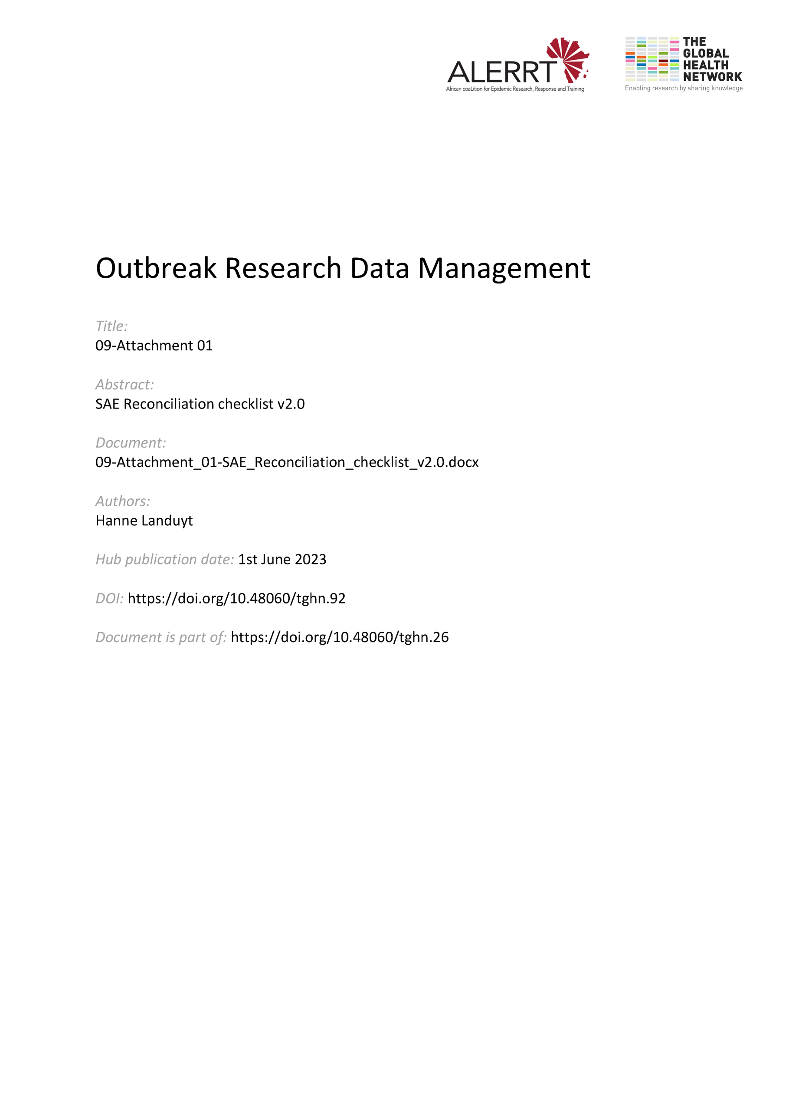](https://doi.org/10.48060/tghn.92)

|  |  |
| --- | --- |
|  | **Title:** SAE Reconciliation Checklist |
| **Study title:** *Give study title to which this applies* |

**Patient number: __ __ __ __ SAE No: __ __**

|  |  |  |  |  |  |
| --- | --- | --- | --- | --- | --- |
| **eCRF data** | **SAE Report** | **Match** | **Check** | | **Follow up Query** |
| OK | Query | **OK** |
| **Description SAE** | SAE diagnosis | Consistent |  |  |  |
| **Patient number** | Patient number | Exact |  |  |  |
| **Date of birth or Age** | Age | Consistent |  |  |  |
| **Onset Date** | Date of event onset | Exact |  |  |  |
| **Stop Date** | Date Event Recovered | Exact |  |  |  |
| **Severity** | Severity | Exact |  |  |  |
| **Relation to the study drug** | Relationship to study drug | Exact |  |  |  |
| **Outcome** | Outcome of the event | Consistent |  |  |  |
| **Action taken** | Action taken by Investigator | Consistent |  |  |  |
| **Treatment assigned** | Study Drug Information | Exact |  |  |  |
| **Date of Study Med intake** | Date of Study Drug intake | Exact |  |  |  |
| **Concomitant Medication** | Concomitant Drug Information | All drugs present on the SAE Report form should be present in the eCRF but not vice versa. |  |  |  |
| **….** | **….** | **….** |  |  |  |

SAE Reconciled and all discrepancies closed? ⬜ Yes ⬜ No

Signature:

Date: __ __ / __ __ __ / __ __ __ __  
 DD / MMM / YYYY