[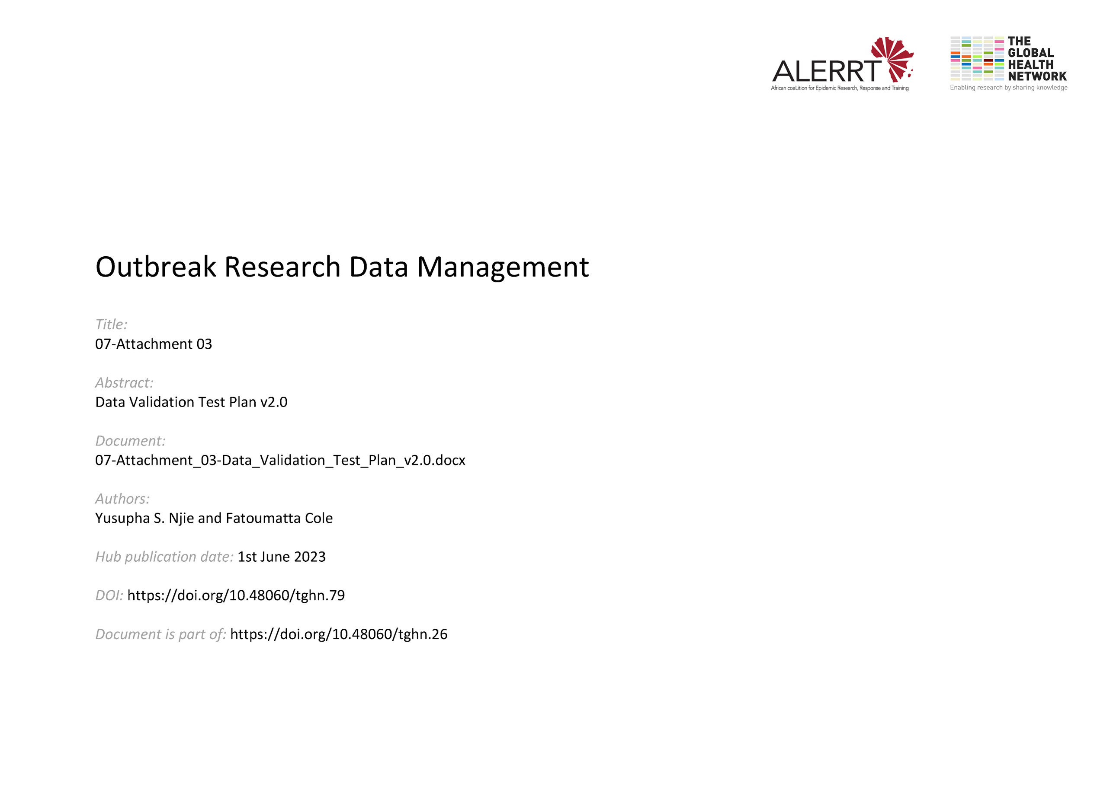](https://doi.org/10.48060/tghn.79)

|  |  |
| --- | --- |
|  | **Title: Data Validation Test Plan** |
| **Study title:** *Give study title to which this applies* |

***Note: List all Post-Entry checks from the DVP***

|  |  |  |  |  |  |
| --- | --- | --- | --- | --- | --- |
| **No** | **CRF name** | **Variable name(s)** | **Check description** | **Violated** | **Not violated** |
| **1** |  |  |  |  |  |
| **2** |  |  |  |  |  |
| **3** |  |  |  |  |  |
|  |  |  |  |  |  |
|  |  |  |  |  |  |

|  |  |  |  |  |
| --- | --- | --- | --- | --- |
|  | **Name** | **Role** | **Signature** | **Date** |
| **Tested by:** |  |  |  |  |