[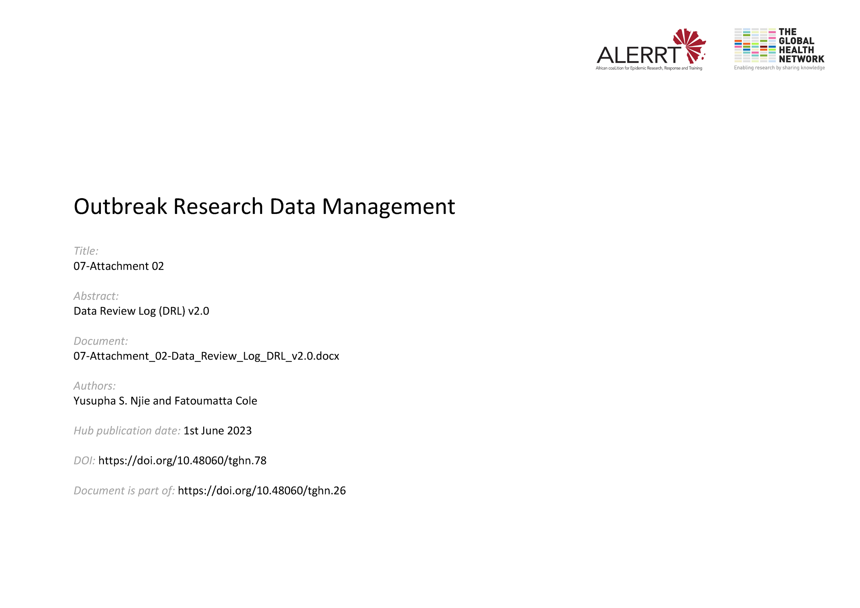](https://doi.org/10.48060/tghn.78)

|  |  |
| --- | --- |
|  | **Title: Data Review Log (DRL)** |
| **Study title:** *Give study title to which this applies* |

|  |  |
| --- | --- |
| **Data Scope:** |  |

***Note: List all Post-Entry checks within the specified data scope from the DVP and add an additional column for outcome***

|  |  |  |  |  |
| --- | --- | --- | --- | --- |
| **No** | **CRF name** | **Variable name** | **Check description** | **Outcome\*** |
|  |  |  |  |  |
|  |  |  |  |  |
|  |  |  |  |  |
|  |  |  |  |  |
|  |  |  |  |  |

**\*\* Record outcome of check. Attach printed output if necessary and reference here. Sign and date the form when all checks have been carried out.**

|  |  |  |  |  |
| --- | --- | --- | --- | --- |
|  | **Name** | **Role** | **Signature** | **Date** |
| **Carried out by:** |  |  |  |  |