[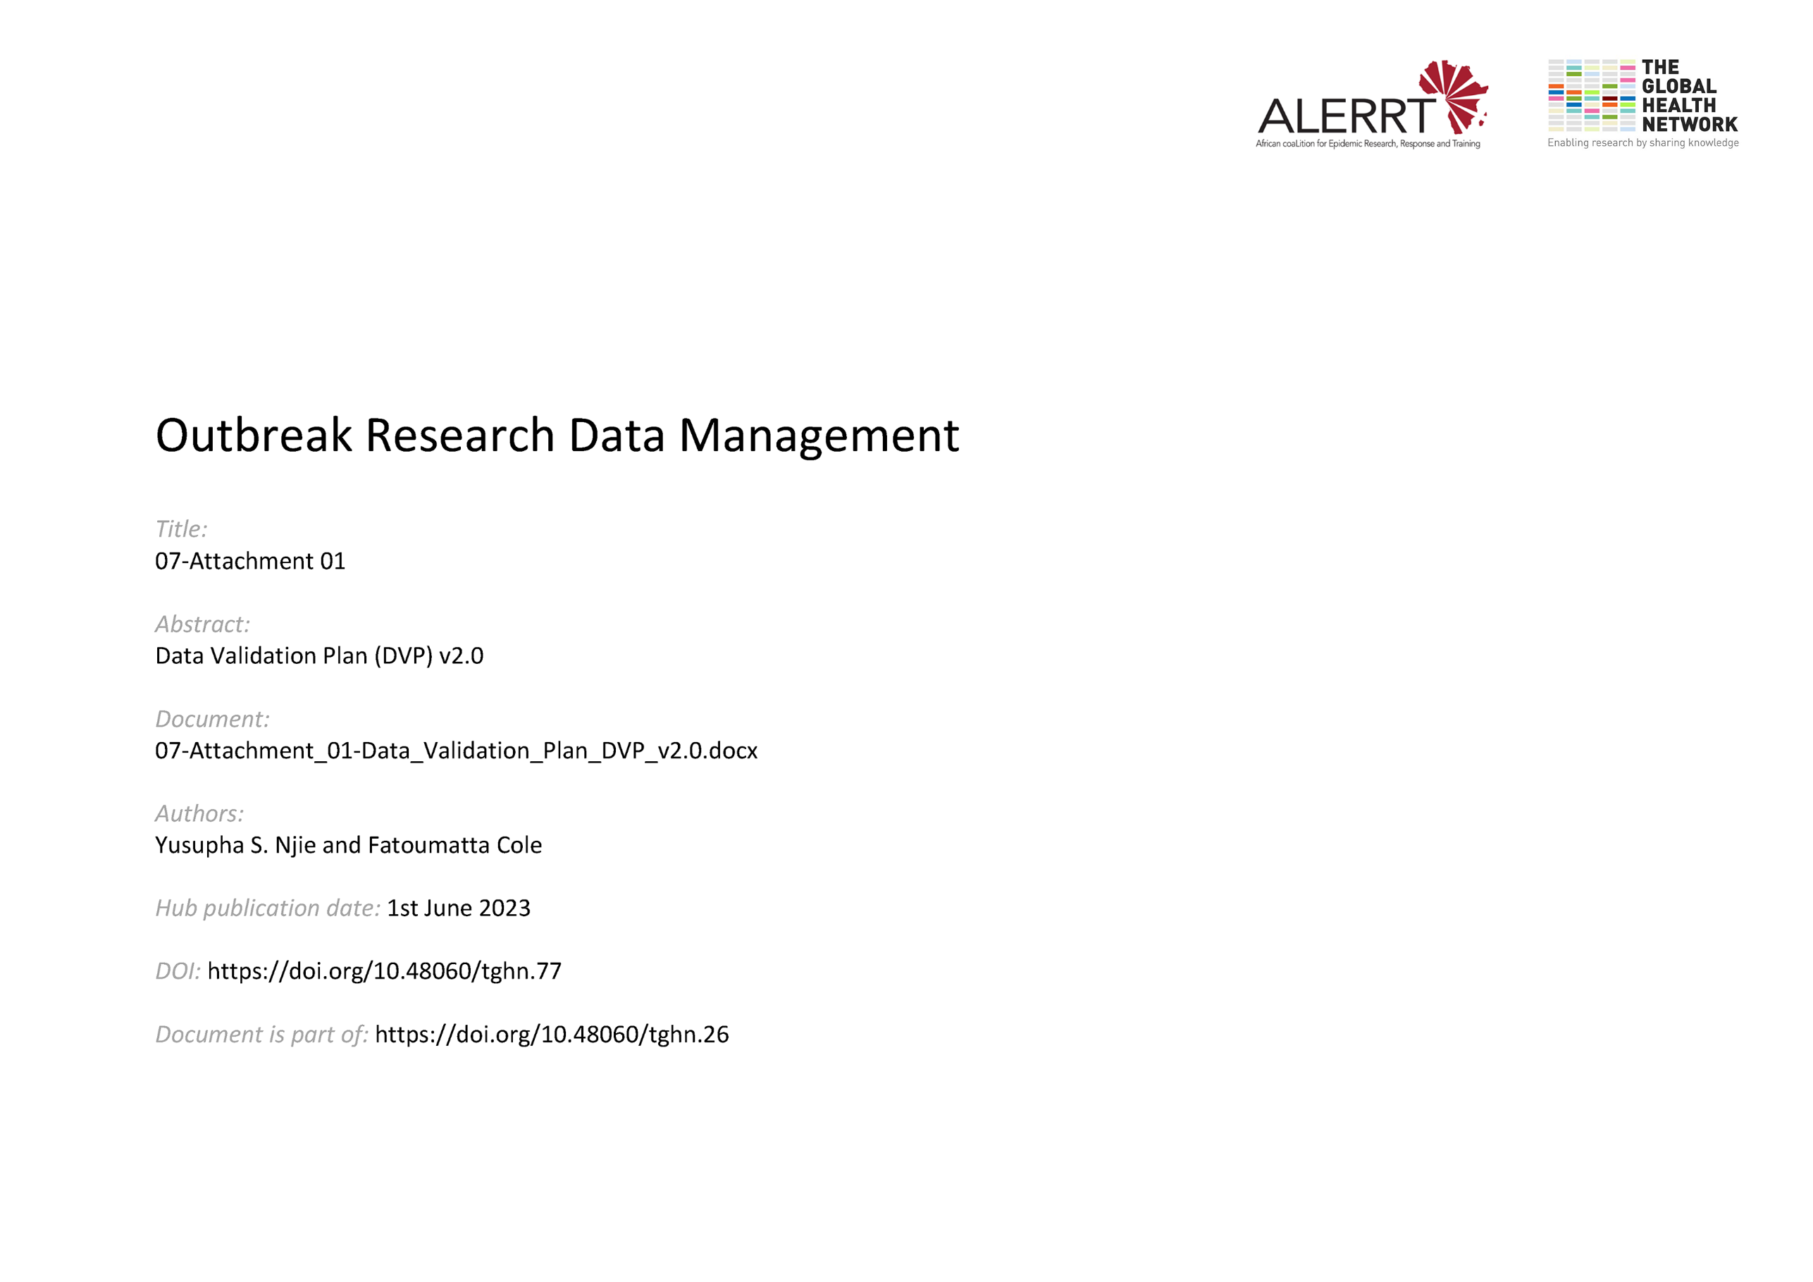](https://doi.org/10.48060/tghn.77)

|  |  |
| --- | --- |
|  | **Title: Data Validation Plan (DVP)** |
| **Study title:** *Give study title to which this applies* |

1. **Data Entry Checks – Edit Check Specification (programmed into the study database)**

|  |  |  |  |  |
| --- | --- | --- | --- | --- |
| **No** | **CRF name** | **Variable name** | **Check description** | **How check will be performed** |
| **1** | *Demography* | *DOB* | *Check subject is within inclusion criteria age range* | *(Visit 1 date – DOB) / 365 is greater than 18 and less than 55* |
| **2** | *Adverse Events* | *AECode* | *Check AE code is a valid code* | *Check if AE code is within the list of AE codes* |
| **3** |  |  |  |  |
|  |  |  |  |  |
|  |  |  |  |  |

1. **Post-Entry Checks**

|  |  |  |  |  |
| --- | --- | --- | --- | --- |
| **No** | **CRF name** | **Variable name** | **Check description** | **How check will be performed**  **(indicate whether programmed into the study database or external to it)** |
|  |  |  |  |  |
|  |  |  |  |  |
|  |  |  |  |  |
|  |  |  |  |  |
|  |  |  |  |  |

1. **Source Data Verification (SDV)**

* What approach will be taken for SDV:  Full SDV (100%)  Partial SDV
* If “Partial SDV”, what percentage of data will SDV be carried out on? _____ %
* Categories of data for SDV

*e.g. Informed Consent, Primary efficacy end points, Recording and reporting of SAEs, Conformance to patient inclusion/exclusion criteria, Visit dates as per window period specified in the study protocol, etc.*

* How will this percentage be selected?

1. **Quality Control (QC) and Quality Assurance (QA)**
2. List out which data is to be quality controlled
3. For each data point, what is the acceptable level of error

|  |  |  |  |
| --- | --- | --- | --- |
| **No** | **Data to be QC’d** | **Sample percentage (%)** | **Acceptable level of error (%)** |
| **1** | *Adverse Events* | *100* | *0* |
| **2** |  |  |  |
| **3** |  |  |  |

## **Approvals**

|  |  |  |  |  |
| --- | --- | --- | --- | --- |
|  | **Name** | **Role** | **Signature** | **Date** |
| **Author** |  |  |  |  |
| **Approved By** |  |  |  |  |