[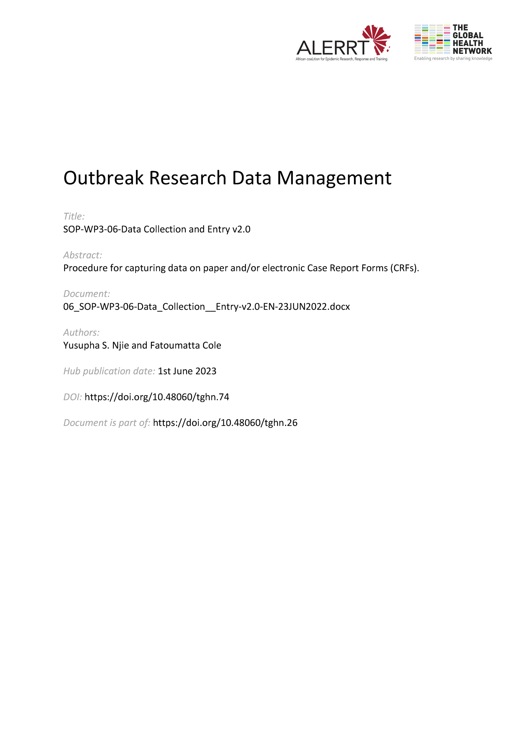](https://doi.org/10.48060/tghn.74)

|  |  |
| --- | --- |
|  | **SOP Title:** Data Collection & Entry |
| **Study title**: *Give study title to which this SOP applies* |

1. Scope and application

|  |
| --- |
| The SOP describes the process of Data collection and Entry on Case Report Forms (CRFs) or Electronic Data Capture (EDC) for the study database.  This SOP applies to study staff who will carry out data collection and entry of study data in clinical research. It aims to highlight data collection methods for both paper and electronic data. |

1. Responsibilities

|  |  |
| --- | --- |
| **Function** | **Activities** |
| Site staff (PI, Clinicians, Labstaff etc**.**) | **Paper CRFs**   * Collect the data as described in the protocol (i.e. survey, interviews or observation) * Write legibly and correct using black ink * Complete all fields in the CRFs according to the training specification and take note of skip patterns on the CRFs. |
| Site staff and data entry staff | **eCRFs**   * Enter data in the eCRF * To be attentive to validation, skip logic and check prompts on the eCRF screen * In case of Offline collection: Collect data offline and later synchronize to the central server * In case of Online collection: Enter data directly online to the central server |
| Data Manager | * Train Data Entry staff for the data entry in the Data Entry System * Generate reports on number of records received and overall recruitment * Coordinate data entry |
| Project Lead / Project Lead Delegate | * Final responsibility for timely collection and entry of data |

1. Definitions

**CRF**: Case Report Form

**eCRF**: electronic Case Report Form

**EDC**: Electronic Data Capture

**PL**: Project Lead

**Source** **data**: All information in original records and certified copies of original records of clinical findings, observations, or other activities in a clinical trial necessary for the reconstruction and evaluation of the trial. Source data are contained in source documents (original records or certified copies).

**Data** **Collection**: is the process of gathering and measuring data, information or any variables of interest in a standardized and established manner that enables the collector to answer or test hypothesis and evaluate outcomes of the particular collection. This is an integral, usually initial, component of any research done in any field of study such as the physical and social sciences, business, humanities and others.

**Data** **Entry**: is the process of transcribing information into an electronic medium such as a computer or other electronic device. It can either be performed manually or automatically by using a machine or computer. Most data entry tasks are time consuming in nature, however data entry is considered a basic, necessary task for most organizations.

1. Procedures

**4.1 Data Collection**

Any Research is only as good as the data that drives it, so choosing the right technique of data collection can make all the difference*.*

Data caneither be

* Transcribed from a source document to a paper CRF
* Transcribed from source document into an electronic CRF
* Directly into a paper CRF
* Directly on an electronic CRF
* Scanned from paper CRF to an OCR software that digitize data automatically - Optical character recognition is the mechanical or electronic translation of scanned images of handwritten, typewritten or printed text into machine-encoded text.

#### **4.2 Data Entry**

Data entry describes the process of transcribing data from the paper CRFs into the eCRF/EDC.

**4.2.1. Double data entry**

* The same data is entered twice by two data entry staff, each working independently of the other
* Data from first and second entry are compared and discrepancies are identified and reconciled. The comparison and reconciling might be done by involving a third person (data manager or supervisor).

**4.2.2. Single data entry**

* Data is entered by one Data Entry staff

**Note**: As a good practice a random selection of entries is manually reviewed against the source documents (if present).

1. Attachments

|  |  |
| --- | --- |
| **Attachments** | |
| **Number** | **Title** |
| *NA* | *NA* |
|  |  |

1. Document History & References

|  |  |  |  |
| --- | --- | --- | --- |
| **Revision** | | | |
| **Version number** | **Author** | **Date** | **Description/reason for modification** |
| 1.0 | Yusupha Njie,  Fatoumatta Cole | 03/10/2019 | Initial version  Review by Hanne Landuyt  Approval by Bai Lamin Dondeh. |
| 2.0 | Fatoumatta Cole | 23/06/2022 | Review to ensure that the SOP is appropriate within ALERRT and with current clinical research best practices. |

1. Approval

|  |  |  |
| --- | --- | --- |
| **Name and function** | **Date (dd/mm/yyyy)** | **Signature** |
| ***Author*** | | |
| *Indicate who wrote the SOP* |  |  |
| ***Review*** | | |
| *Indicate WP team members who reviewed (if applicable)* | *Date of review* |  |
| ***Approval*** | | |
| *Indicate WP Lead/Co-lead(s) who approved* | *Date of approval* |  |