[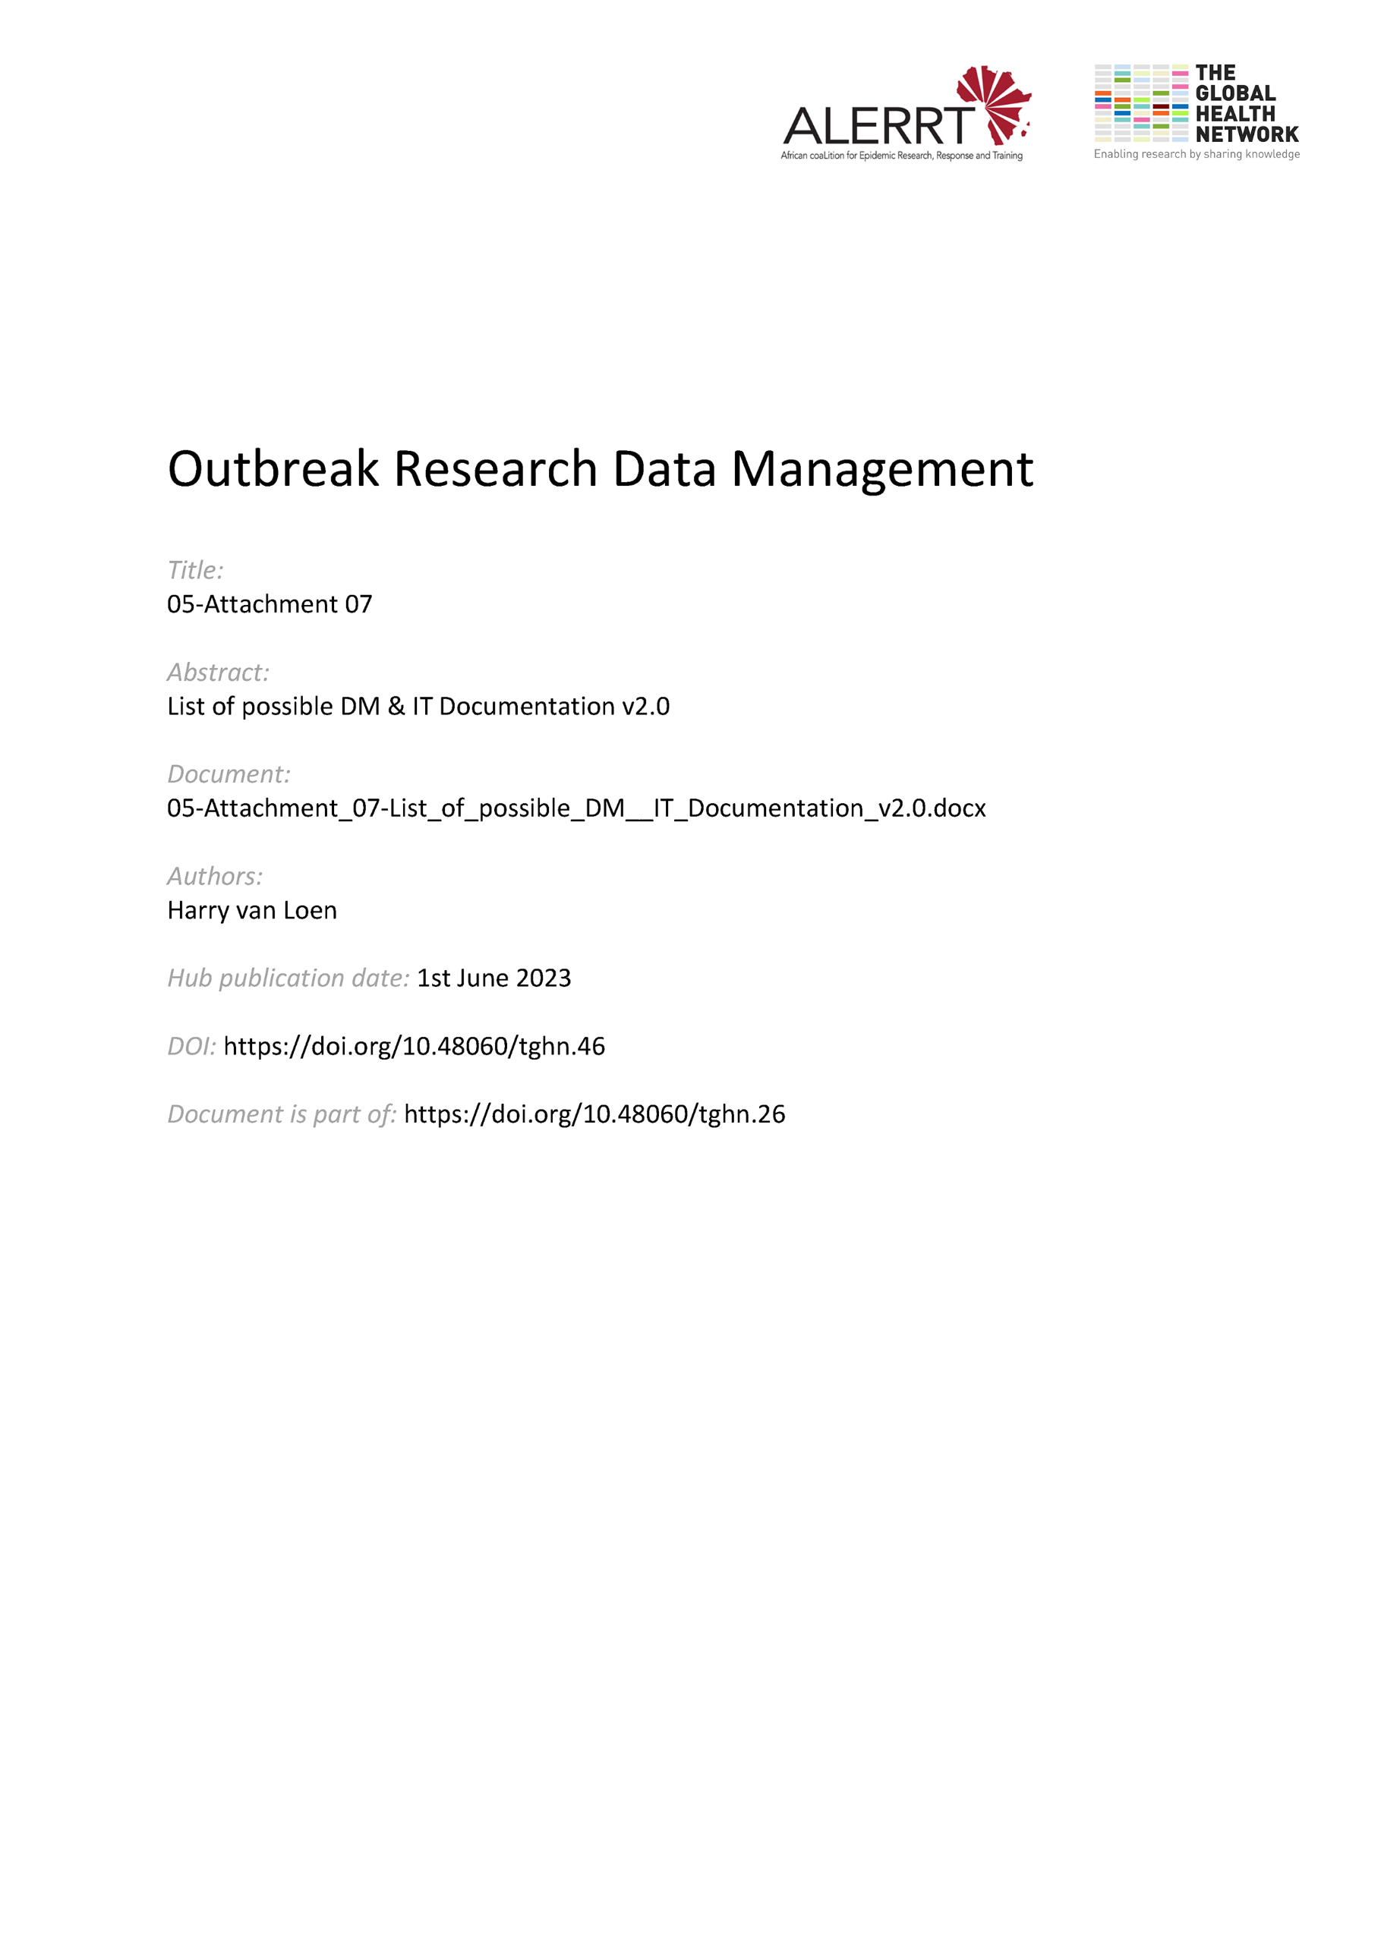](https://doi.org/10.48060/tghn.46)

|  |  |
| --- | --- |
|  | **Essential DM/IT documentation** |
| **Study title**: *Give study title to which this applies* |

|  |
| --- |
| **Templates: blank documentation with preference prepared at project initiation** |
| * Subject identification code list (1) * Subject screening log (1) * Subject enrolment log (1) * (Annotated) Case Report Form (CRF) (1) * CRF and eCRF approval form * (DM) Training Log (1) * TMG / DM meeting minutes template * Protocol violation form * Data Clarification Form (paper query form, if applicable) * CRF tracking log * SAE report (inital/follow up) form * SAE reconciliation form * DB Lock checklist * DB (Un) Lock Approval form |

|  |
| --- |
| **Documents: with preference prepared at project initiation** |
| * DM/ICT SOPs (1) * Normal value / ranges Laboratory tests (1) * Data Management Plan (2) * Data Review Plan (= Data Validation Plan) * DM section in Study protocol * User list for database/eCRF (with user role & access rights) (1) * Software contract & license agreement * IT specifications (software & hardware) * Randomization list, enveloppes + allocation sheet * System Validation documentation (1) * DM training pack (data collection/entry/medical coding guidelines…) (1) |

|  |
| --- |
| **Documents: other** |
| * Data Management Report (2) * Data sharing Agreement |

(1)= Required by GCP (2) = Required by some funders, editors