[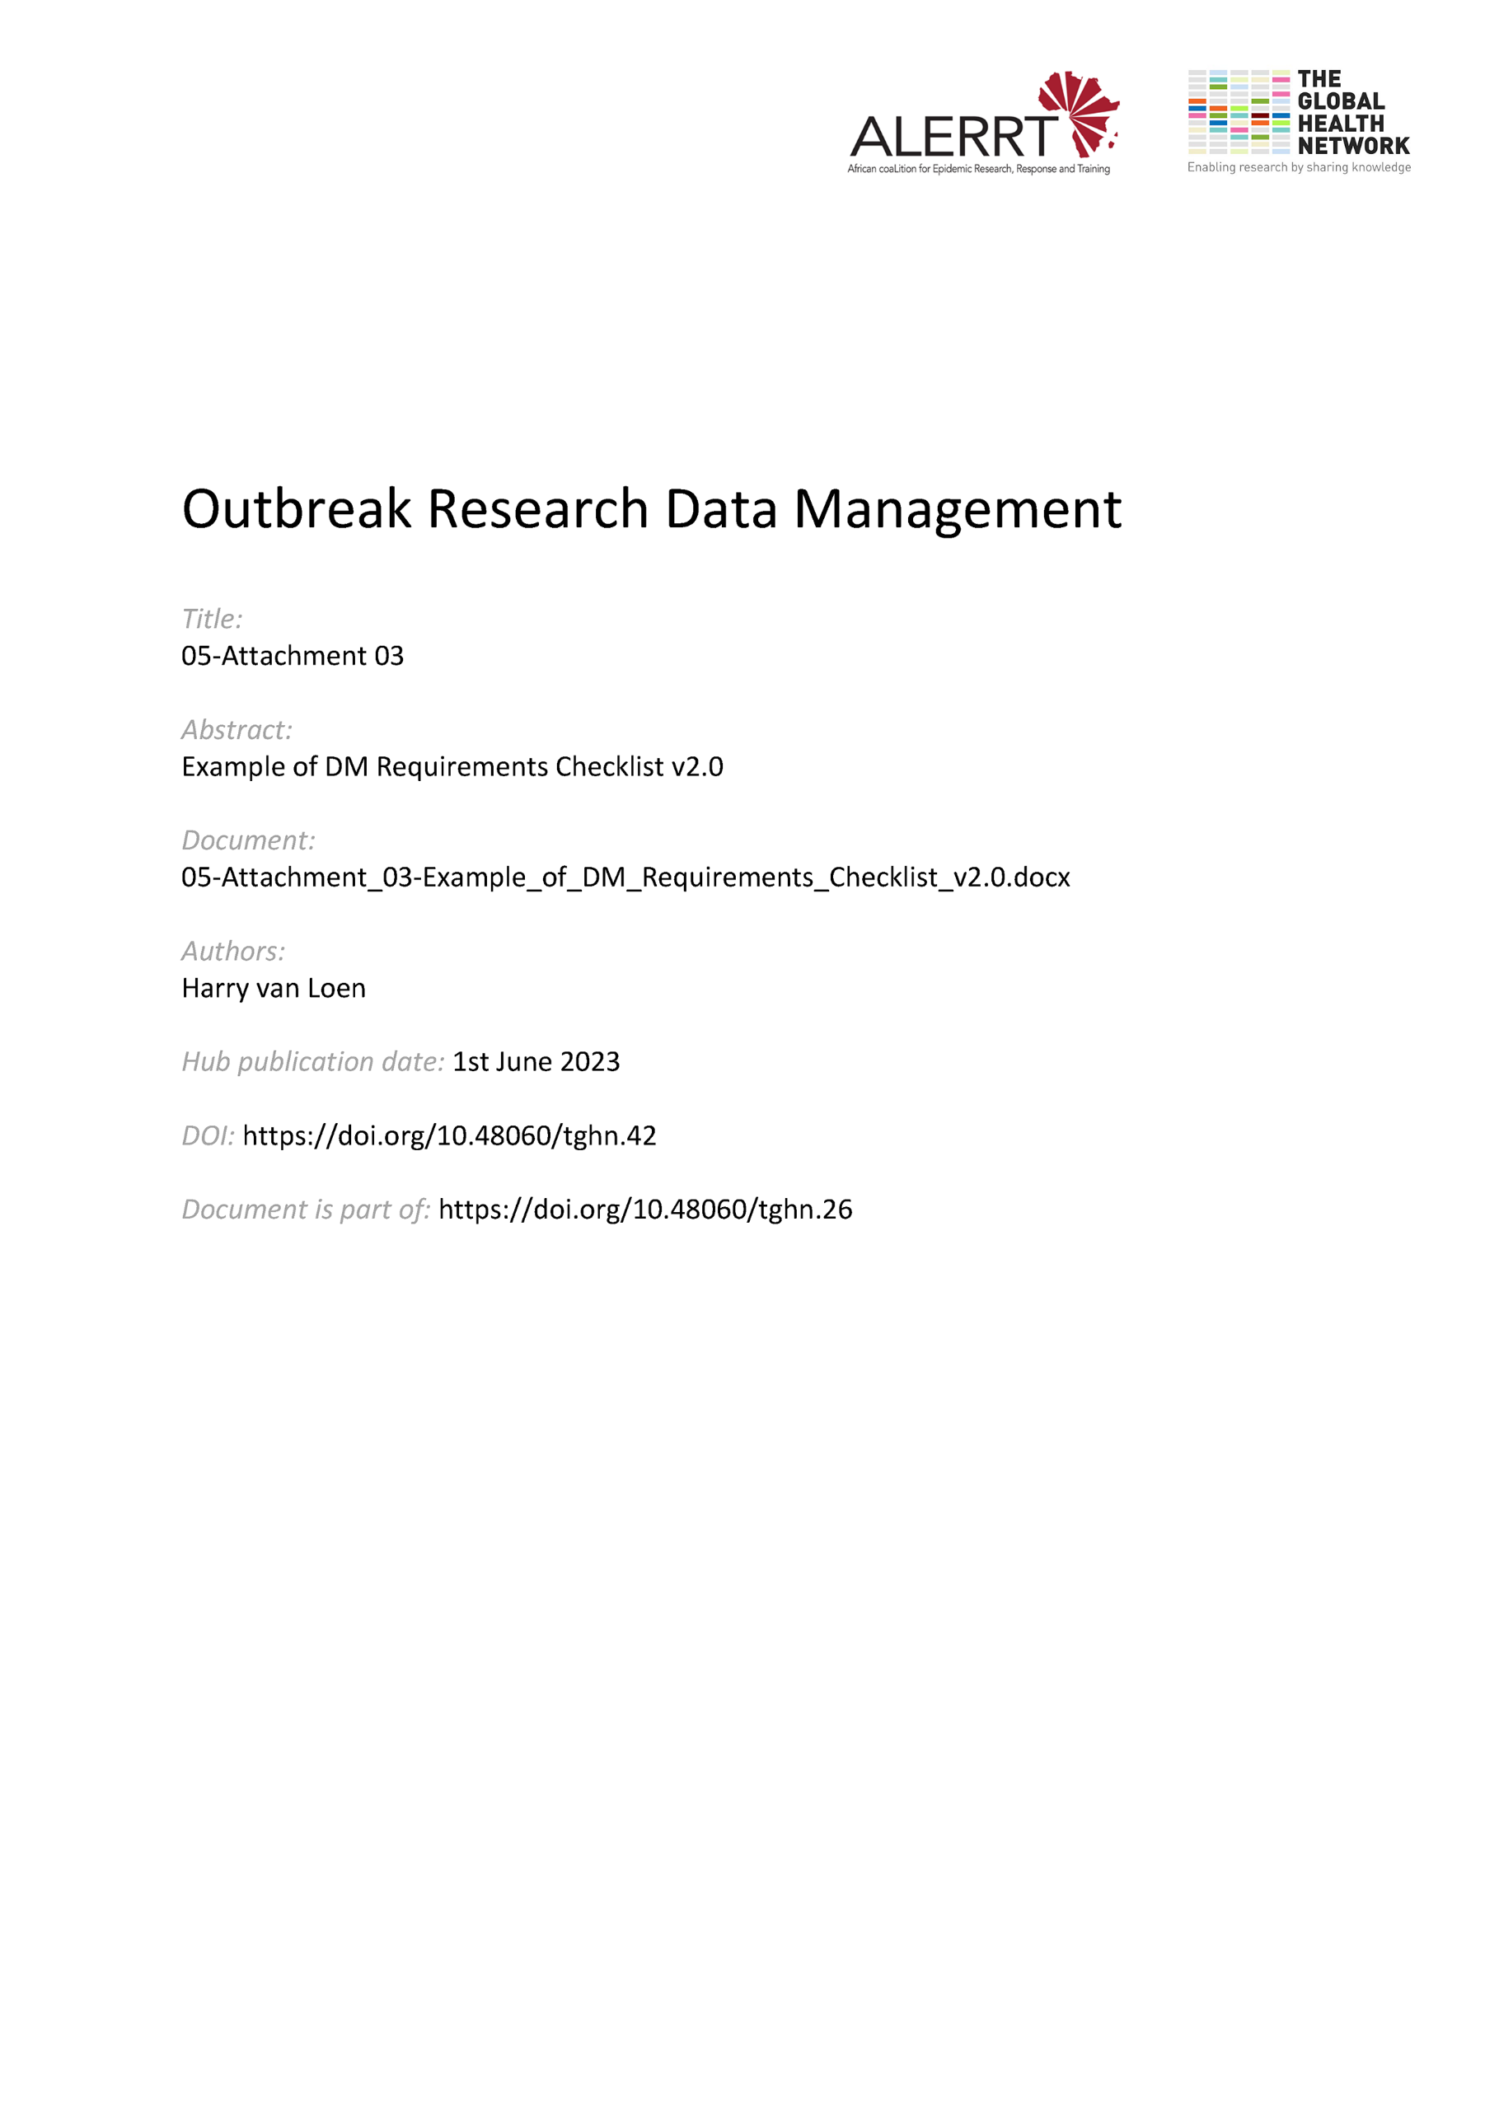](https://doi.org/10.48060/tghn.42)

|  |  |
| --- | --- |
|  | **Data Management Requirements Checklist** |
| **Study title:**  *Give study title to which this SOP applies* |

|  |  |
| --- | --- |
| **General Project/Study Information** | |
| **Project /Study acronym or Registration code** |  |
| **Sponsor** |  |
| **Principal Investigator** |  |
| **Type of Project/study**  (Select all that apply) | 0 Clinical trial (specify phase …)  0 Observational study  0 Epidemological study  0 Diagnostic study  0 Qualitative study  0 Other, specify: |
| **Study protocol** | 0 Final version available or due for _ _/_ _/_ _ _ _ (DD/MM/YYYY) |
| **Expected Study Start**  **(First participant first visit)** | _ _ / _ _ / _ _ _ _ (DD/MM/YYYY) |
| **Expected Study End**  **(Last participant last visit)** | _ _ / _ _ / _ _ _ _ (DD/MM/YYYY) |
| **# subjects (estimated)** |  |
| **# visits/subject** |  |
| **# data points/subject** |  |

|  |  |  |
| --- | --- | --- |
| **DM / ICT Information – User Requirement Specifications** | | |
| **Adherence to regulations, standards & Funder needs**  (Select all that apply) | 0 GDPR or other privacy regulation  0 Good Clinical Practice  0 Good Clinical Laboratory Practice  0 ISO 9001  0 ISO 27001  0 FDA 21 CFR part 11  0 Local regulation, specify:  0 CDISC , specify 0 CDASH 0 SDTM 0 ADaM 0 XML  0 MedDRA  0 WHO drug  0 FAIR data sharing principles  0 Other, specify: | |
| **Type of data**  (Select all that apply) | 0 Demographic data  0 Clinical/medical data  0 Laboratory data  0 Epidemological survey data  0 GPS data  0 Qualitative data (e.g. social, anthroplogical etc.)  0 Other, specify: | |
| **Type of data collection** (Select all that apply) | 0 Paper  0 Electronic  0 Other, specify: | |
| **Type of data entry**  (Select all that apply) | 0 Single data entry  0 Double data entry  0 Offline entry  0 Online entry  0 Other, specify: | |
| **Type of data collection tools**  (Select all that apply) | 0 Laptop, specify number: _ _  0 PC, specify number: _ _  0 Tablets, specify number: _ _  0 Smart phone, specify number: _ _  0 Barcode reader, specify number: _ _  0 Other, specify: | |
| **Type of data backup**  (Select all that apply) | 0 On server, specify where (institution, country):  0 On data collection tools, specify:  0 On external memory  0 Other, specify: | |
| **Specifications Software**  **(Front end; back end; Operating system etc.)** | **Name(s):** | |
| **Specifications Hardware** | **Name(s):** | |
| **Specific DM/ICT documentation** | 0 DM / ICT SOPs  0 Data Management Plan (DMP), specify format or template:   * 0 ALERRT DMP template * 0 DMP tool * 0 DMP online * 0 Horizon 2020 * 0 Other, specify:   0 DM/ ICT reports, specify ……………………………….  …………………………………………………………………...  0 Other, specify: | |
| **Estimated HR needed** | 0 Data Entry Clerk(s) : ☐1 ☐ 2-5 ☐ more than 5  0 Data Reviewer : ☐1 ☐ 2-5 ☐ more than 5  0 Data Manager : ☐1 ☐ 2-5 ☐ more than 5  0 Monitor : ☐1 ☐ 2-5 ☐ more than 5  0 Medical Coder : ☐1 ☐ 2-5 ☐ more than 5  0 Database administrator: : ☐1 ☐ 2-5 ☐ more than 5  0 Help Desk : ☐1 ☐ 2-5 ☐ more than 5  0 Other, specify: | |
| **Estimated Timelines** | Activities  CRF finalization  Database/eCRF testing  First participant first visit  Last participant last visit  Database lock  Data sharing | Estimated date (dd/mm/yyyy): |
| **Estimated DM & ICT Costs** | **Human resources:**  **Software:**  **Hardware:**  **Other:** | |
| **Notes:** | | |

|  |  |  |
| --- | --- | --- |
| **Read & Approved** | | |
| Project coordinator | Other, if applicable | Central Data Manager |
| Name, Signature & Date | Name, Signature & Date | Name, Signature & Date |