[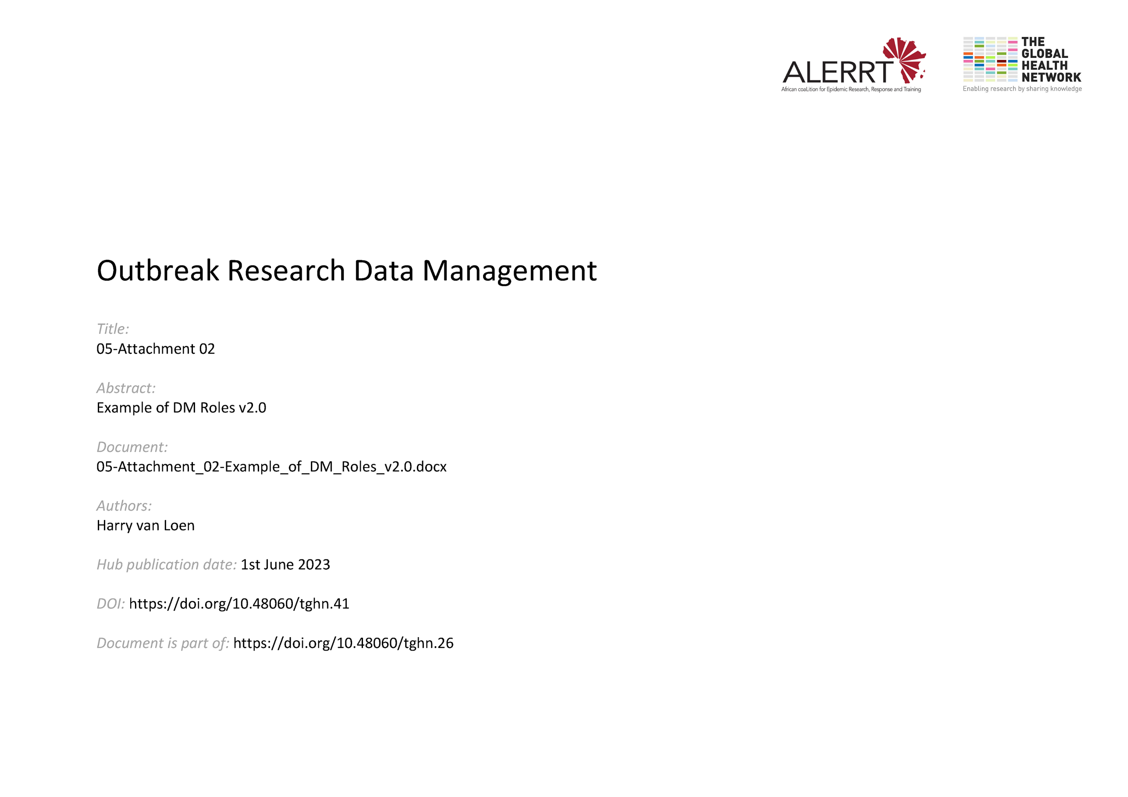](https://doi.org/10.48060/tghn.41)

|  |  |
| --- | --- |
|  | **Example of a Project Management Structure , in particular with DM roles** |
| **Study title**: *Give study title to which this applies* |

Funder

Sponsor

Contract

Database administrator

Programmer

IT Helpdesk

Medical coder

**Central data manager**

**Trial Management Group:**

**Data reviewers**

QA manager ; LAB manager ;Statistician, Monitor, Other…….

**Data entry clerks**

IT Helpdesk

**Site data manager**

Principal Investigator

SITE

Project coordinator

Coordinating Investigator

CENTRAL (SPONSOR)

Data and Safety Monitoring Board

Trial Steering Committee