[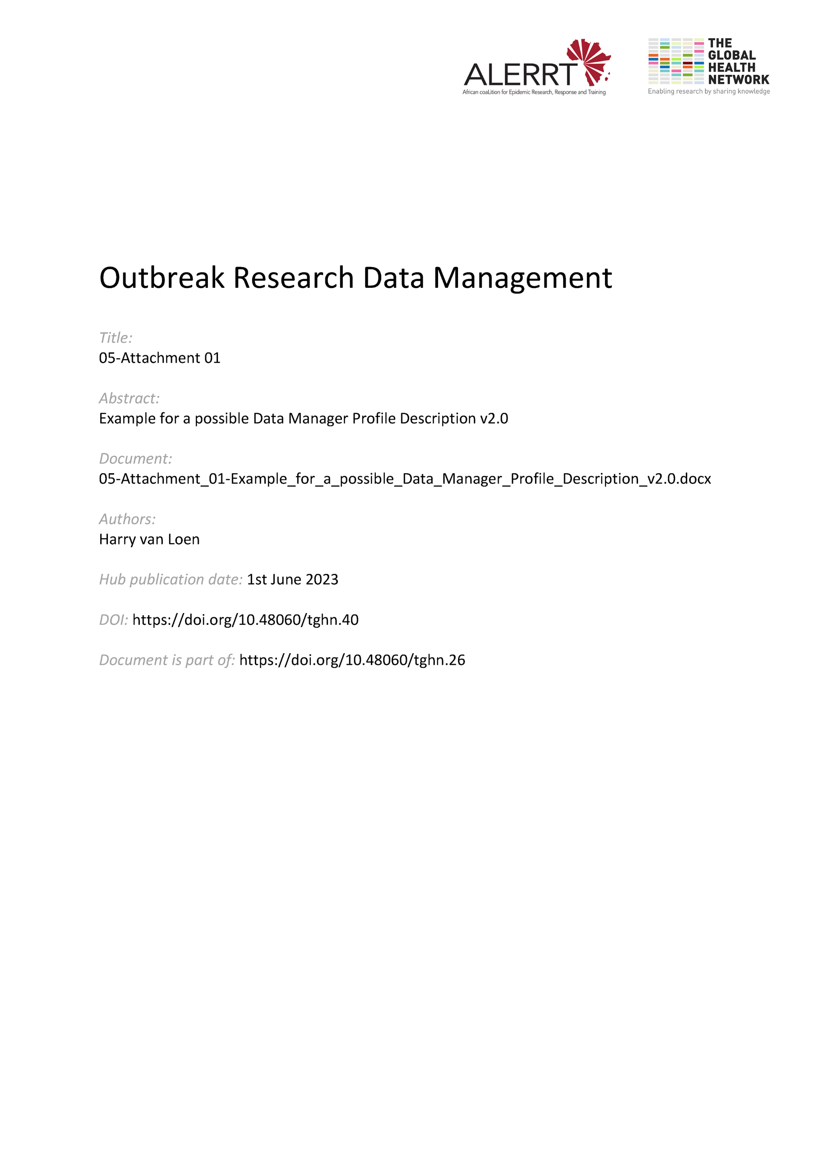](https://doi.org/10.48060/tghn.40)

|  |  |
| --- | --- |
|  | **Job description Clinical Data Manager** |
| **Study title**: *Give study title to which this applies* |

|  |
| --- |
| **Your assignment/functions** |
| * You act as the data management focal point within projects (clinical trials, epidemiological studies…). * You plan, coordinate and supervise data management of projects. More specific activities include:   + participating in the development of protocols   + developing paper and/or electronic questionnaires, Case Report Forms and databases   + involvement in testing of eCRFs/databases   + coordination of data collection and entry   + organization of data validation and cleaning; generate queries with reference to missing, inconsistent or inaccurate data   + preparing of data base lock   + archiving   + data sharing * You ensure high quality data within strict timelines. * You ensure privacy and security of project data. * You develop, write and update the essential documents related to clinical data management, such as a data management plan, SOPs, guidelines (e.g. data entry). * You interact with researchers, project coordinators and statisticians in Project Management Groups. * You are responsible for training personnel in data management at your centre, at sites and possible partner institutions (if applicable). * You contribute to writing project reports, presentations and publications (if applicable). * You participate in training programmes and conferences to improve your skills/experience. |

|  |
| --- |
| **Qualifications** |
| **Required skills/experience**   * You hold at least a Bachelor degree in Life sciences, Biomedical sciences, IT or equivalent by experience. * You are a team player. * You are a problem solver and able to prioritize when confronted with high workload. * You have good verbal and writing skills of English. * You have working knowledge of Excel, Access and databases.   **Desired skills/experience**   * You have experience in clinical data management . * You have working knowledge of a clinical trial process, Good Clinical Practice, regulatory requirements (e.g. 21CFR part 11; GDPR). * Team/Project coordination |