[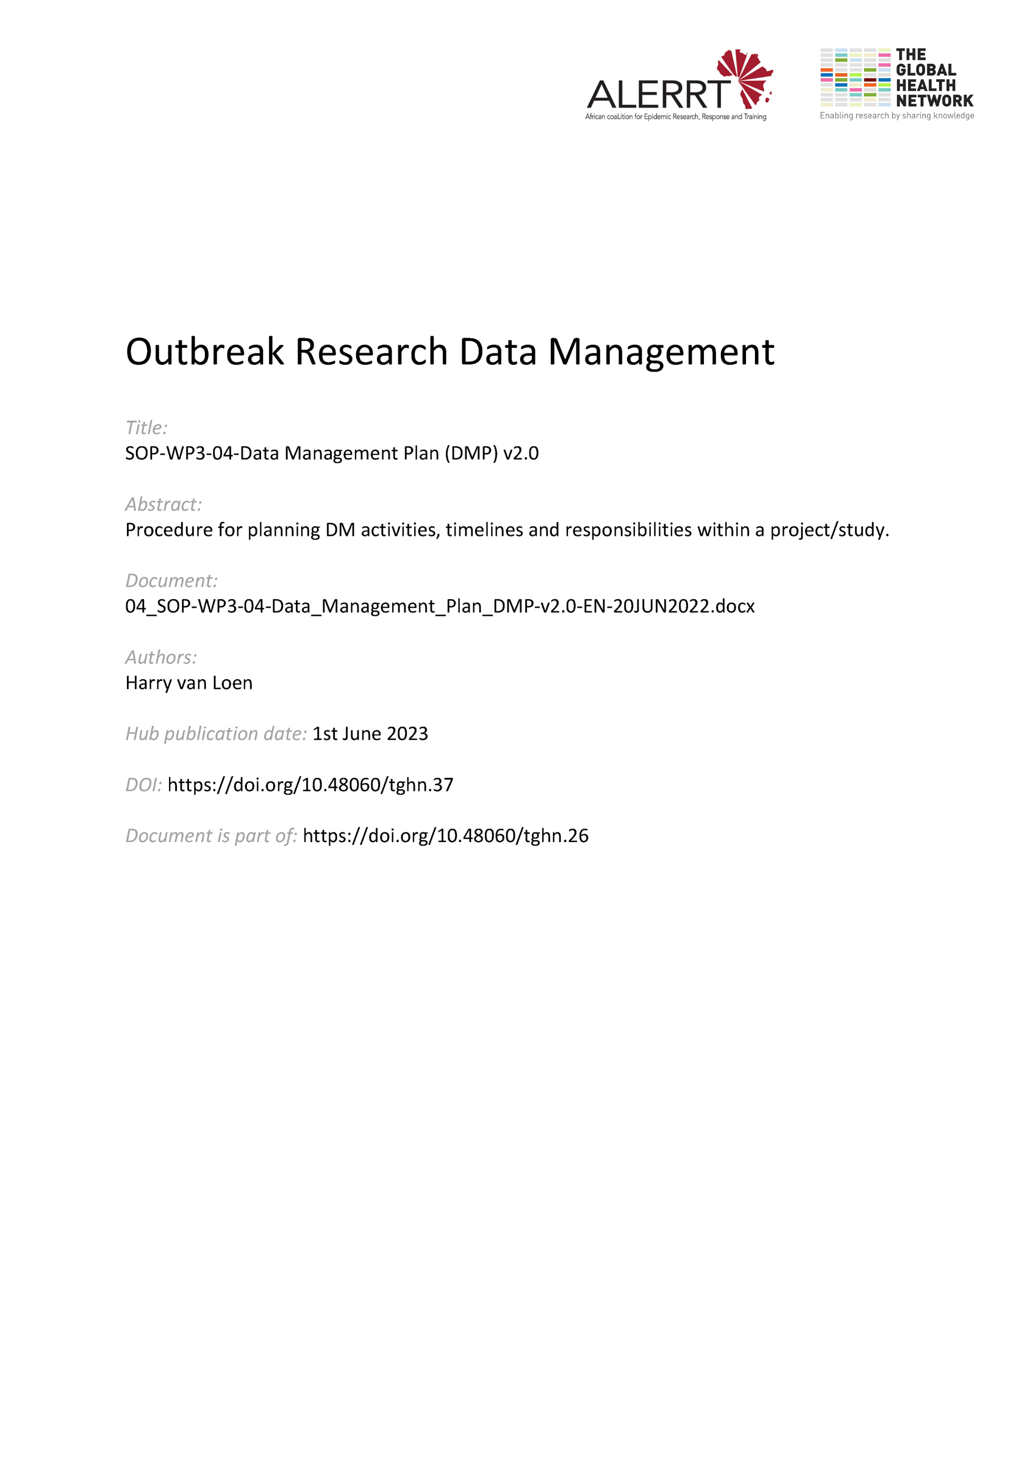](https://doi.org/10.48060/tghn.37)

|  |  |
| --- | --- |
|  | **SOP Title:** Data Management Plan (DMP) |
| **Study title**: *Give study title to which this SOP applies* |

1. Scope and application

|  |
| --- |
| A Data Management Plan (DMP) plays a central role in making explicit to all stakeholders, specific information regarding the data management practices for a project/study. It provides information on what and how data will be collected, processed, retained, shared, on roles and responsibilities of those involved, on deliverables and timelines and on the measures to ensure data integrity, quality, confidentiality and security.  A DMP is a key document that guides the data management procedures similar to how a study protocol guides the study procedures.  This SOP applies to all key aspects of a clinical trial/study and to staff involved in preparing, reviewing, approving and updating a Data Management Plan. |

1. Responsibilities

|  |  |
| --- | --- |
| **Function** | **Activities** |
| Coordinating Investigator or  Project Lead | * Provides the information and resources required for all DM activities * Approves the DMP |
| Principal Investigator | * Approves the DMP (if deemed necessary) |
| Data Manager | * Prepares, implements and updates the DMP * Responsible representative for DM at the TMG meetings * Informs the Coordinating Investigator/Study team on timelines, deliverables and possible delays of DM |
| Data Reviewer  Statistician  Monitor | * Gives input to the DMP where necessary |
| QA Manager (if applicable) | * Approves the DMP |

1. Definitions

**Clinical trial/study:** Any investigation in human subjects intended to discover or verify the clinical, pharmacological and/or other pharmacodynamic effects of an investigational product(s), and/or to identify any adverse reactions to an investigational product(s), and/or to study absorption, distribution, metabolism, and excretion of an investigational product(s) with the object of ascertaining its safety and/or efficacy. In Good Clinical Practice, the terms clinical trial and clinical study are defined synonymous.

**Coordinating Investigator:** An investigator assigned the responsibility for the coordination of investigators at different centres participating in a multicentre trial.

**DB**: database

**DM**: Data Management

**DMP**: Data Management Plan

**DMR**: Data Management Report

**Good Clinical Practice (GCP):** A standard for the design, conduct, performance, monitoring, auditing, recording, analyses, and reporting of clinical trials that provides assurance that the data and reported results are credible and accurate, and that the rights, integrity, and confidentiality of trial subjects are protected.

**Monitor:** A person overseeing the progress of a clinical trial, and of ensuring that it is conducted, recorded, and reported in accordance with the protocol, Standard Operating Procedures (SOPs), Good Clinical Practice (GCP), and the applicable regulatory requirement(s).

**Principal Investigator (PI)**: A person responsible for the conduct of the clinical trial at a trial site. If a trial is conducted by a team of individuals at a trial site, the investigator is the responsible leader of the team and may be called the principal investigator. See also Sub investigator.

**Quality Assurance (QA):** All those planned and systematic actions that are established to ensure that the trial is performed, and the data are generated, documented (recorded), and reported in compliance with Good Clinical Practice (GCP) and the applicable regulatory requirement(s).

**Serious Adverse Event (SAE)**: Any untoward medical occurrence that at any dose: results 1. in death, 2. is life-threatening, 3. requires inpatient hospitalization or prolongation of existing hospitalization, 4. results in persistent or significant disability/incapacity, or 5. is a congenital anomaly/birth defect.

**SOP**: Standard Operating Procedure. Detailed, written instructions to achieve uniformity of the performance of a specific function.

**Source Data**: All information in original records and certified copies of original records of clinical findings, observations, or other activities in a clinical trial necessary for the reconstruction and evaluation of the trial. Source data are contained in source documents (original records or certified copies).

**Source Documents (SD):** Original documents, data, and records (e.g., hospital records, clinical and office charts, laboratory notes, memoranda, subjects' diaries or evaluation checklists, pharmacy dispensing records, recorded data from automated instruments, copies or transcriptions certified after verification as being accurate copies, microfiches, photographic negatives, microfilm or magnetic media, x-rays, subject files, and records kept at the pharmacy, at the laboratories and at medico-technical departments involved in the clinical trial).

**Sponsor**: An individual, company, institution, or organization which takes responsibility for the initiation, management, and/or financing of a clinical trial.

**Sub investigator:** Any individual member of the clinical trial team designated and supervised by the investigator at a trial site to perform critical trial-related procedures and/or to make important trial-related decisions.

**TMG**: Trial Management Meeting

1. Procedures
   1. Preparing the Data Management Plan (DMP)

* A DMP will be prepared by the Data Manager to meet the requirements of the study/project and with reference to applicable legislation and standards (e.g. compliance to GCP for clinical trials/studies)
* The DMP should be based on the template attached to this SOP, unless it is requested otherwise (e.g. by specific funder requirements).
* The initial page will list information on the sponsor conducting the project/study, the coordinating investigator and the author preparing the DMP.  
  1. Reviewing and approving of the DMP
* A 1st draft of the DMP is reviewed within the project/study team, by the Data Reviewer(s). the statistician(s), the monitor(s) and/or possibly other team members, where applicable. That draft will be assigned as v0.1.
* Reviewing and approving of the DMP will be done applying following version numbering principles:
  + During initial drafting, each successive draft of the document is numbered sequentially:
  + Version 0.1 (or v0.1) >> Version 0.2 (or v0.2) >> Version 0.3 (or v0.3) >>…
  + Once the review is defined final, then a Version 1.0 is assigned and approved: (for example draft Version 0.3 becomes thus Version 1.0).
* A section “Revision History” will list information on the different versions of the DMP.
* A section “Approved by” will list information and signatures of the Coordinating Investigator/Project Leader. It can be decided that other study personnel should be reviewing/approving the DMP (e.g. QA Manager).
* The DMP has to be completed and approved before any data handling starts.  
  1. Updating the DMP
* Any relevant changes in DM of the study/project will be documented, at least in the TMG meeting minutes, and may lead to updates of the DMP.
* Updates of the DMP will be done applying following version numbering principles:
  + If Version1.0 should be updated, each successive draft of the document is numbered sequentially:
  + Version 1.1 (or v1.1) >> Version 1.2 (or v1.2) >> Version 1.3 (or v1.3) >>…
  + Once the review is defined final, then a Version 2.0 is assigned and approved: Draft Version 1.3 becomes thus Version 2.0.
  + This process is repeated for any subsequent revision.
  + The version number and version date (being the date the changes were made or a version was finalized), should be mentioned at least in the header or the footer of each page in the document.
* Updates of the DMP template or other appendices to the DMP can be treated separate to the versioning of the DMP.
* After the project/study, all relevant changes may be listed in a Data Management Report (DMR). Deviations which have impact on the analysis of the study/project should be communicated and documented to the Coordinating Investigator/Project leader and Statistician before analysis.
  1. DMP: flow of data management activities and deliverables (see template DMP)

**POST STUDY PHASE**

**STUDY PHASE**

**PRE-STUDY PHASE**

**Final Dataset**

**Analysis**

**Database**

**Case Report Form**

**Protocol**

**Data Collection/Entry**

**DB Backup**

**SD / CRF design**

**DB Validation**

**Study setup**

**DB/ eCRF design**

**Archiving**

**Data Review**

**DM Report**

**Data Tracking**

**DB/Data Security**

**Data Sharing**

**Data/Medical Coding**

**SAE Reconciliation**

**DM Training**

**DB Lock / Unlock**

**IT Support**

**Data Storage**

**Data Transfer**

UPDATING

REVIEWING

REPORTING

**DMR**

**DMP**

PREPARING

1. Attachments

|  |  |
| --- | --- |
| **Attachments** | |
| **Number** | **Title** |
| 01 | DMP-Template |

1. Document History and References

|  |  |  |  |
| --- | --- | --- | --- |
| **Revision** | | | |
| **Version number** | **Author** | **Date** | **Description/reason for modification** |
| 1.0 | Harry van Loen | 03/10/2019 | Initial version  Review by Fatoumatta Cole, Hanne Landuyt and Yusupha Njie.  Approval by Bai Lamin Dondeh. |
| 2.0 | Harry van Loen | 20/06/2022 | Review to ensure that the SOP is appropriate within ALERRT and with current clinical research best pratices. |

1. Approval

|  |  |  |
| --- | --- | --- |
| **Name and function** | **Date (dd/mm/yyyy)** | **Signature** |
| ***Author*** | | |
| *Indicate who wrote the SOP* |  |  |
| ***Review*** | | |
| *Indicate WP team members who reviewed (if applicable)* | *Date of review* |  |
| ***Approval*** | | |
| *Indicate WP Lead/Co-lead(s) who approved* | *Date of approval* |  |