[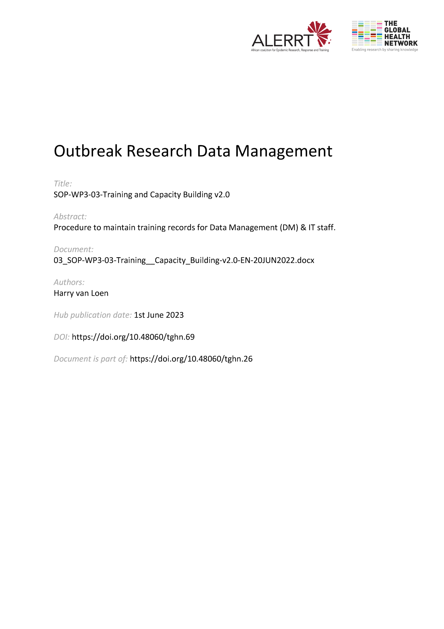](https://doi.org/10.48060/tghn.69)

|  |  |
| --- | --- |
|  | **SOP Title:** Training and Capacity Building |
| **Study title**: *Give study title to which this SOP applies* |

# Scope and application

|  |
| --- |
| The aim of this procedure is to define the key aspects of training and capacity building, in particular on DM and IT.  ‘Training’ and ‘capacity building’ are sometimes confused or used interchangeably. Training can be seen as one element of capacity building which is focusing on skills of individuals, whereas capacity building is targeting both individuals and institutions (sites) to obtain and improve skills, knowledge, tools, equipment and other resources needed to perform the required tasks.  This SOP is applicable for any process on improving skills and knowledge of DM and IT in clinical research. |

# Responsibilities

|  |  |
| --- | --- |
| **Function** | **Activities** |
| Project Lead  or delegate | * Overall responsibility that training or capacity building is performed and documented. * Ensure that all site/project members are adequately ‘trained’ in the tasks carried out to perform their role. * Ensure that a training log is maintained in the trial master file or keep track of capacity building at site |
| Data Manager or  IT Manager  or DM/IT Trainer | * Make the adequate documentation (e.g. data entry user guidelines...) * Give training sessions |

# Definitions

**DM**: Data Management

**IT**: Information Technology

**SOP**: Standard Operating Procedure

**SDV**: Source Data Verification

# Procedures

# Training

* Before the start of the project, the needs on training, in particular for IT and DM, of the personnel assigned to a clinical project or study should be identified. Experienced users may have less intensive ‘refresher’ training needs.
* Initiate or maintain a Training Plan on acquiring skills for IT/DM on individual level.
* Draft a programme or schedule to help identify who will be leading each training package, resources needed, list of attendees (which should be all involved in the study or project) and a potential timeline.
* The training should be given, preferably by an experienced member of the team and if that's not available, then by an external trainer. Training needs should be broken down to the tasks involved in each different role within the project. Amongst others:
  + For all:
    - Protocol training specific to their role
    - Any regulatory required training such as GCP for clinical trials
    - SOP training specific to their role
  + Data entry clerk/Data Collector:
    - Login/Logout
    - Enter data
    - System interface navigation
    - Saving procedure
    - Tracking logs
    - Backup procedure
    - Responding to queries
  + Data managers:
    - All of the tasks of the data entry clerk
    - Handling of discrepancies
    - Data Management System use
    - Production of data output (lists, files etc)
  + Trial Monitors:
    - All of the tasks of the data entry clerk
    - Responding to discrepancies
    - SDV specifications
    - Flag data as source data verified
  + IT collaborators:
    - Handling of IT questions and technical problems
    - Data Management System specifications and support
    - Backup procedure
* A training record should be created and maintained (See Training Confirmation Form Template).
* Training records should be stored in the trial master file.

# Capacity building

* Assess the needs for capacity building on IT and DM at institutes/sites.
* Initiate or maintain a Capacity Building Plan on acquiring skills and knowledge for IT/DM on institute level.
* Draft a programme or schedule to help identify who will be leading each capacity building session, resources needed, who will fit most as attendees and a potential timeline.
* Capacity building should be given, preferably by an experienced member of the team and if that's not available, then by an external trainer.
* Following Capacity Building needs might be considered:
  + Good Data Management practices
  + Databases and IT
  + Regulations, guidelines & standards with reference to DM and IT
  + Project Management with reference to DM and IT
* Keep track of the ‘Training’ records on Capacity Building: individuals should keep their list. This will build up to the individuals CV, personal and career development. Sites should best keep an overview of the sessions and contents covered.
* Take a video and/or audio recording of the training sessions where possible so that the impact can reach a wider group who may have not had the opportunity to attend in person.

# Attachments

|  |  |
| --- | --- |
| **Attachments** | |
| **Number** | **Title** |
| 01 | Training Confirmation Form Template |
|  |  |
|  |  |

1. **Document History and References**

|  |  |  |  |
| --- | --- | --- | --- |
| **Revision** | | | |
| **Version number** | **Author** | **Date** | **Description/reason for modification** |
| 1.0 | Harry van Loen | 02/10/2019 | Initial version - based on SOP-006 from the Association for Data Management in the Tropics.  Review by Fatoumatta Cole, Hanne Landuyt and Yusupha Njie.  Approval by Bai Lamin Dondeh. |
| 2.0 | Harry van Loen | 20/06/2022 | Review to ensure that the SOP is appropriate within ALERRT and with current clinical research best pratices. |

1. **Approval**

|  |  |  |
| --- | --- | --- |
| **Name and function** | **Date (dd/mm/yyyy)** | **Signature** |
| ***Author*** | | |
| *Indicate who wrote the SOP* |  |  |
| ***Review*** | | |
| *Indicate WP team members who reviewed (if applicable)* | *Date of review* |  |
| ***Approval*** | | |
| *Indicate WP Lead/Co-lead(s) who approved* | *Date of approval* |  |