[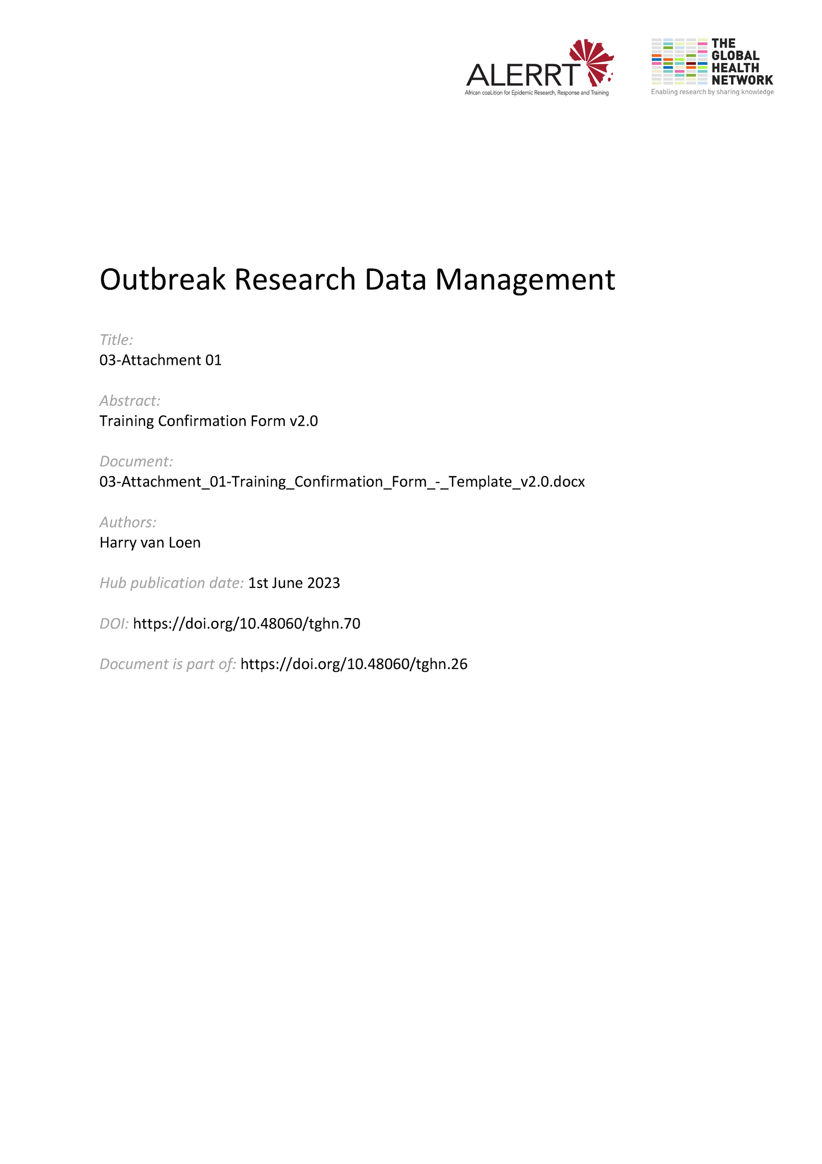](https://doi.org/10.48060/tghn.70)

|  |  |
| --- | --- |
|  | **Title:** Training Confirmation Form |
| **Study title:** *Give study title to which this applies* |

Please complete this form to confirm attending a Training session and/or receipt of the Training Documentation and understanding of the contents.

Contents information (Please provide contents of training given):

|  |
| --- |
|  |
| Contents: |

|  |  |
| --- | --- |
| **Site Information** | |
| **Site/centre name:** |  |
| **City:** |  |
| **Country:** |  |

|  |  |  |  |
| --- | --- | --- | --- |
| **Personnel Information** | | | |
| **Name** | **Role**  e.g. PI, Data Entry, Data Review, Monitor, Study Nurse, etc. | **Signature** | **Date** |
|  |  |  |  |
|  |  |  |  |
|  |  |  |  |
|  |  |  |  |
|  |  |  |  |

|  |  |  |  |  |
| --- | --- | --- | --- | --- |
|  | **Name** | **Role** | **Signature** | **Date** |
| **Training Given By** |  |  |  |  |

|  |
| --- |
| PLEASE FAX/MAIL SIGNED AND COMPLETED FORM TO:  THANK YOU! |