[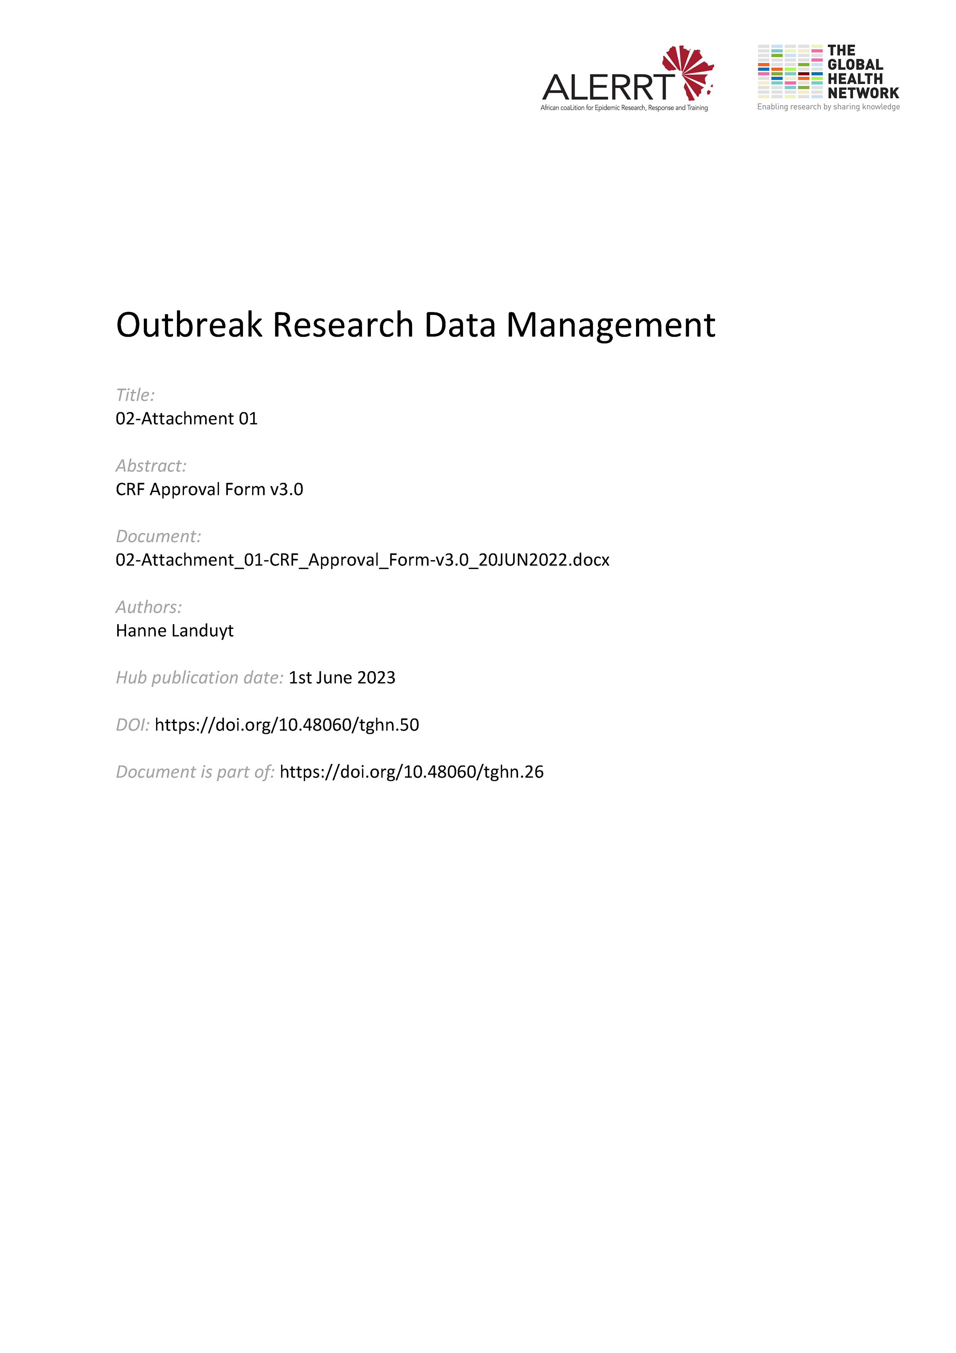](https://doi.org/10.48060/tghn.50)

|  |  |
| --- | --- |
|  | **APPROVAL FORM** |
| **Study title**: *Give study title to which this applies* |

|  |  |
| --- | --- |
| **CRF Approval Form** | |
| **Study CRF version** |  |

|  |  |  |
| --- | --- | --- |
| **Approved by** | **Date** | **Signature** |
| **Name and function** | | |
| *Coordinating investigator* |  |  |
| **Name and function** | | |
| *Principal investigator(s)* |  |  |
| **Name and function** | | |
| *Study statistician* |  |  |
| **Name and function** |  |  |
| *Data manager* |  |  |

*(more names/signatures/dates may be added, as appropriate)*