[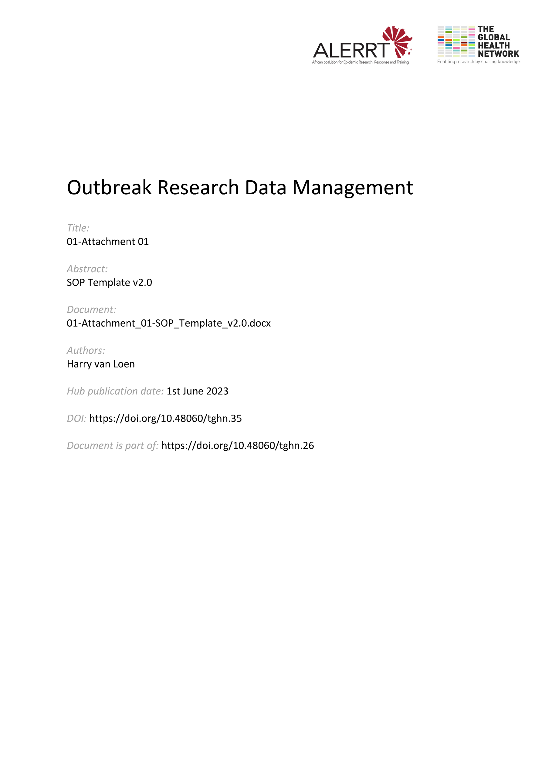](https://doi.org/10.48060/tghn.35)

|  |  |
| --- | --- |
|  | **SOP Title:** *Be concise and precise e.g. Collection of clinical study data* |
| **Study title**: *Give study title to which this SOP applies* |

# Scope and application

|  |
| --- |
| *Indicate when, to whom and to what this SOP applies to. E.g: This SOP applies to all clinical data collected throughout the ALERRT Fever study (WP1). It does not apply to the collection of anthropological data collected through WP6 studies.*  *Give 1-2 sentences of background and indicate why the procedure is being written.* |

# Responsibilities

|  |  |
| --- | --- |
| **Function** | **Activities** |
| *List function of staff* | *List activities for which person is responsible* |
| *e.g. Study Physician* | *Describe what activities the Physician is responsible for, e.g. collecting clinical data, signing CRF etc.* |
| *e.g. Quality manager (QM)* | *Describe what activities the QM is responsible for e.g. Adherence to specific SOPs, Revising data before data transfer, ….* |

# Definitions

*Define technical terms and acronyms used in the SOP e.g. CRF= Case Report Form*

# Procedures

* *Describe in details how the procedure is to be carried out. List the steps in a chronological order and for each indicate the person carrying out the procedure and the timeline.*
* *Use Word styles, or similar, to manage titles at different level.*
* *If the procedure is a lengthy one, then the description can be split up and placed under smaller headings.*  
  *E.g. ‘3.1 Data collection, 3.2 Data entry, 3.2.1 Double data entry, 3.2.2 Single data entry, …’*
* *Use a simple, active language e.g. ‘collect demographic data’ rather than ’demographic are collected’’*
* *If possible add a diagram, flow chart, pictures or table by way of illustration.*

# Attachments

# *Write in this section the attachments to the SOP.*

|  |  |
| --- | --- |
| **Attachments** | |
| **Number** | **Title** |
| *e.g. 01* | *e.g. Attachment 1 with all bibliographic references* |
| *e.g. 02* | *e.g. Attachment 2: scheme of data flow* |
| *Or write ‘NA’ if there are none* | *Write ‘NA’ if there is no attachment* |

1. **Document History and References**

*Indicate previous versions of the SOP and the changes made*

|  |  |  |  |
| --- | --- | --- | --- |
| **Revision** | | | |
| **Version number** | **Author** | **Date** | **Description/reason for modification** |
| *1.0* |  |  | *Initial version*  *When the version is based on a different document, reference should be given: ‘Initial version – based on SOP xxx’* |
| *2.0* |  |  | *Give details of the changes e.g. ‘in paragraph 3.2: ‘Online’ data entry changed to ‘Offline and online’ data entry*  *If many changes, write ‘extensive changes to the whole text’ or ‘complete revision’ (or similar).*  *If it is a new document, write ‘initial version’ or ‘new document.* |

1. **Approval**

|  |  |  |
| --- | --- | --- |
| **Name and function** | **Date (dd/mm/yyyy)** | **Signature** |
| ***Author*** | | |
| *Indicate who wrote the SOP* |  |  |
| ***Review*** | | |
| *Indicate WP team members who reviewed (if applicable)* | *Date of review* |  |
| ***Approval*** | | |
| *Indicate WP Lead/Co-lead(s) who approved* | *Date of approval* |  |