[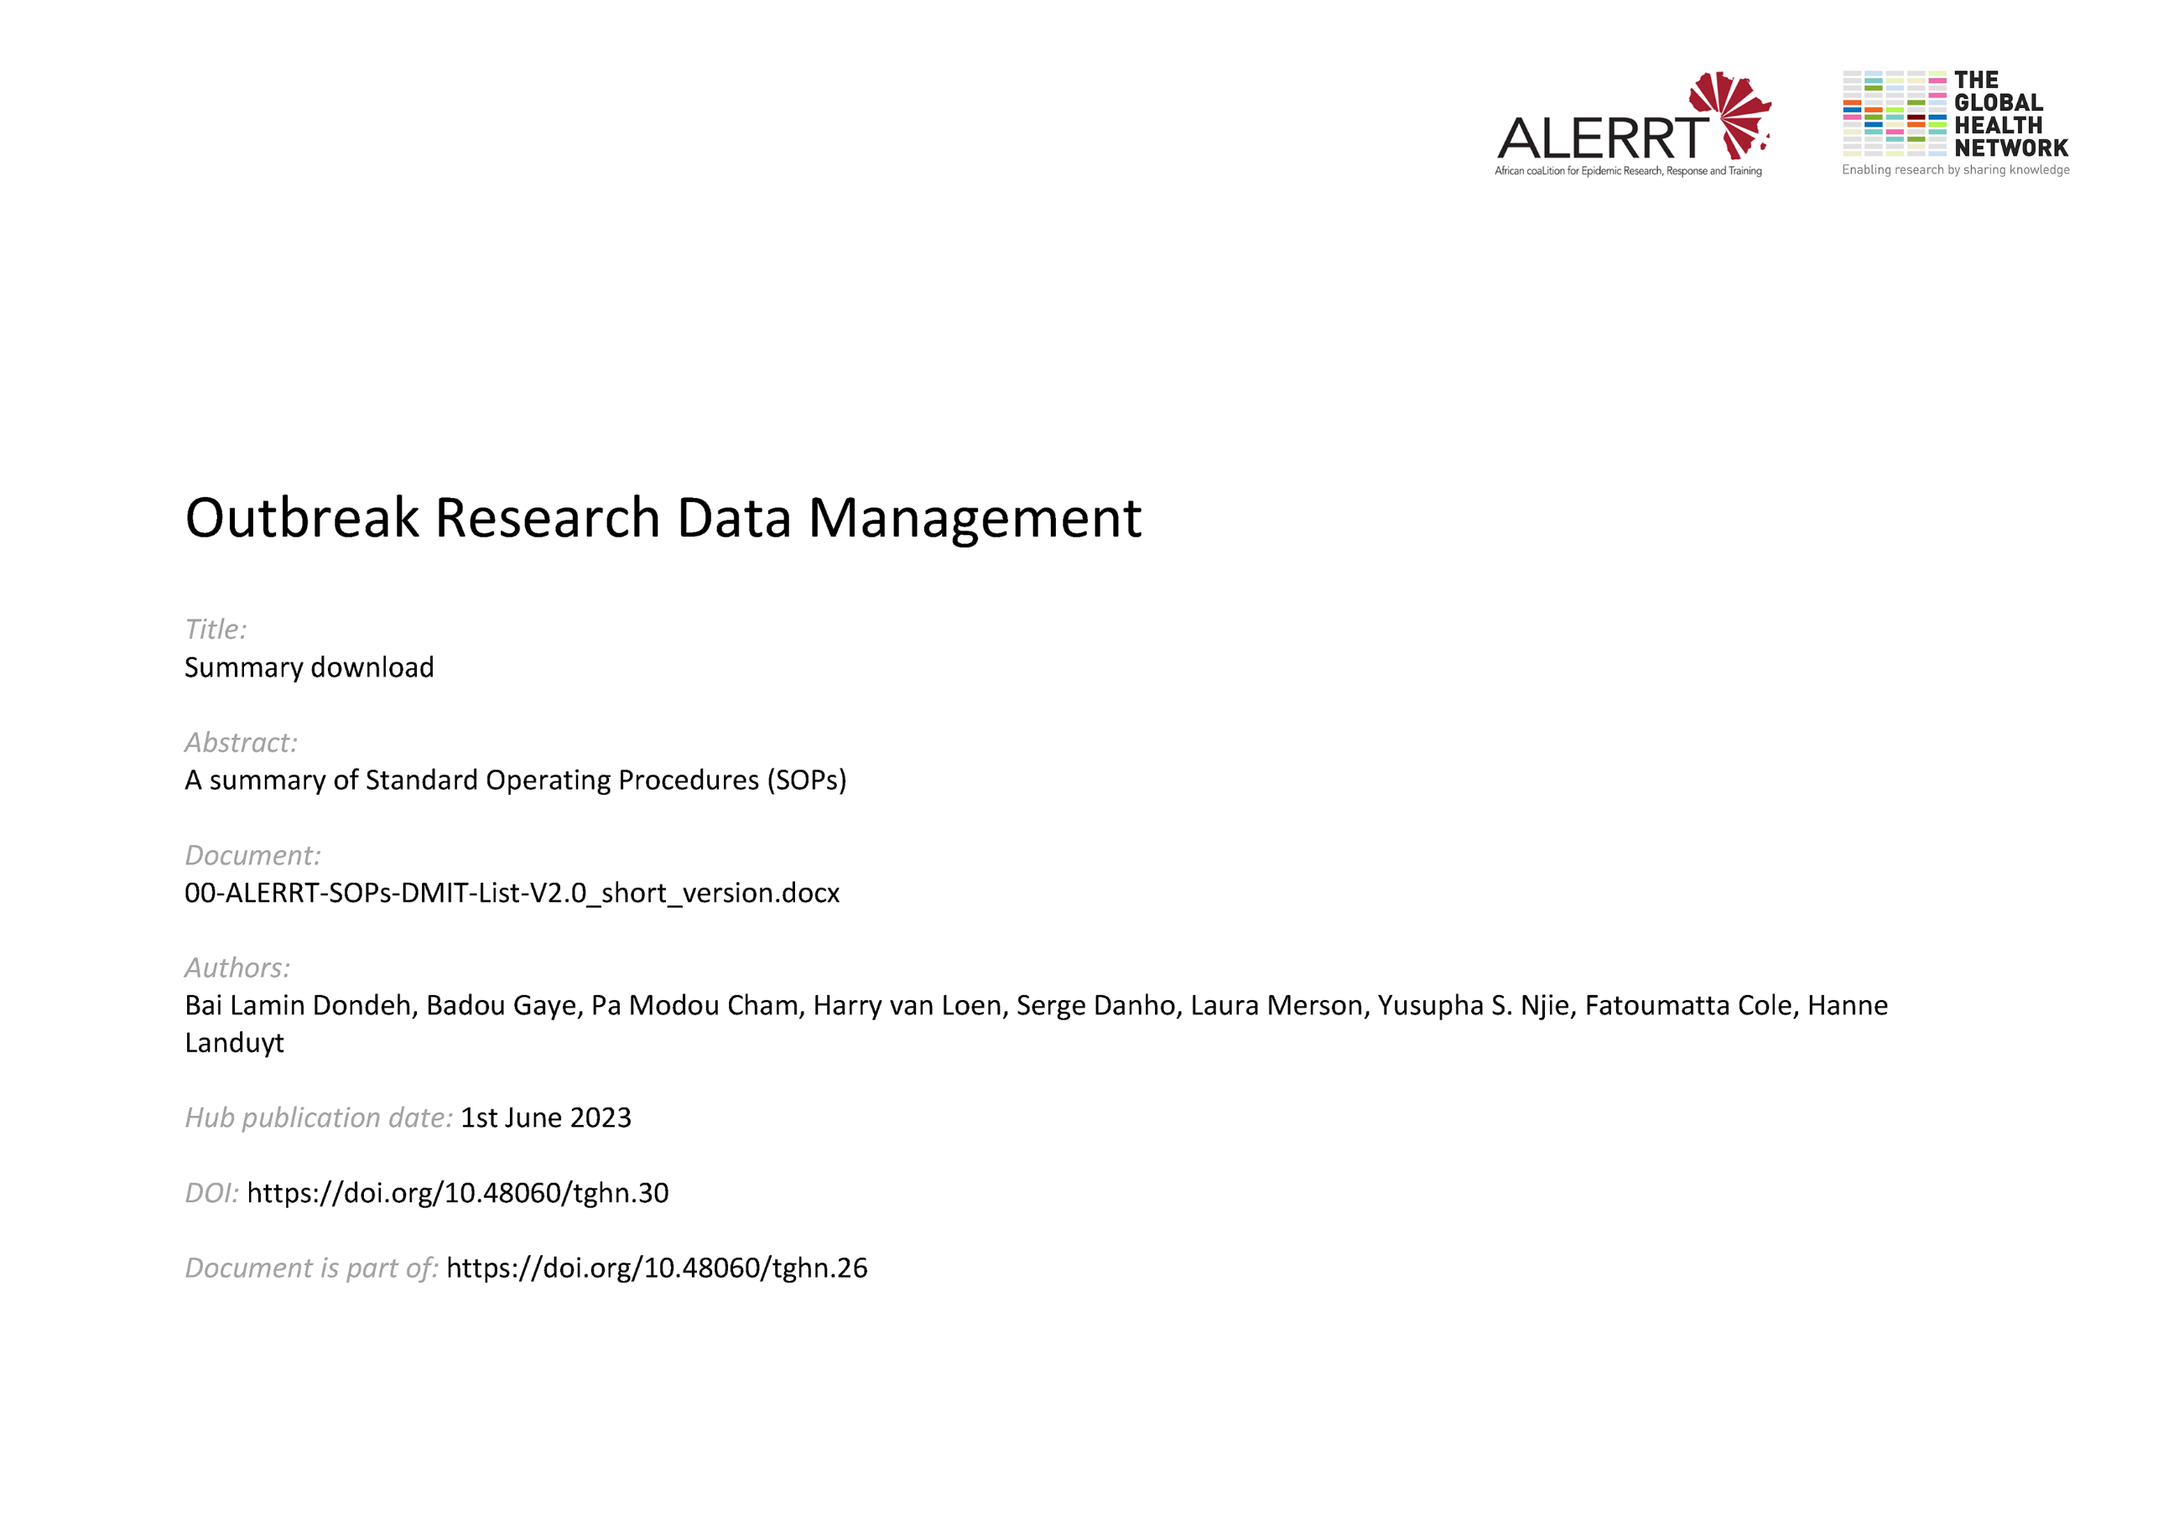](https://doi.org/10.48060/tghn.30)

|  |  |  |
| --- | --- | --- |
| **No.** | **SOP terminology** | **SOP description** |
| 1 | SOP-WP3-01-SOPonSOP | Procedure to write, name and manage SOPs in a standardized way. |
| 2 | SOP-WP3-02-CRF Design | Procedure on key aspects in paper and/or electronic Case Report Form (CRF) design |
| 3 | SOP-WP3-03-Training and Capacity Building | Procedure to maintain training records for Data Management (DM) & IT staff |
| 4 | SOP-WP3-04-Data Management Plan (DMP) | Procedure for planning DM activities, timelines and responsibilities within a project/study. |
| 5 | SOP-WP3-05-GOP for DM | General operating procedure for Data Management and IT (Project Management on DM) |
| 6 | SOP-WP3-06-Data Collection and Entry | Procedure for capturing data on paper and/or electronic Case Report Forms (CRFs) |
| 7 | SOP-WP3-07-Data Validation and Review | Procedure for checking the accurateness, consistency and completeness of clinical study data |
| 8 | SOP-WP3-08-Data Coding and Medical Coding | Procedure for data coding and coding of medical events and medications |
| 9 | SOP-WP3-09-SAE Reconciliation | Procedure for cross checking serious adverse events between study database and safety database |
| 10 | SOP-WP3-10-Data Tracking | Procedure for keeping track of data |
| 11 | SOP-WP3-11-Data Transfer | Procedure for transfer data between internal/external parties or locations (e.g. Lab data). |
| 12 | SOP-WP3-12-Database Lock and Unlock | Procedure to lock and unlock the study database (DB) |
| 13 | SOP-WP3-13-Archiving | Procedure for archiving study data and files and to ensure regulatory requirements for retention. |
| 14 | SOP-WP3-14-Data Management Report | Procedure to describe the deviations to the DMP and to report the final status of DM aspects |
| 15 | SOP-WP3-15-Data Sharing | Procedure on sharing the study data (for secondary research) |
| 16 | SOP-WP3-16-Database eCRF design | Procedure of developing the database/eCRF based on the initial CRF design.(see SOP-WP3-02-CRF Design) |
| 17 | SOP-WP3-17-System Validation | Procedure for testing of the data capture system in order to proof that the system works as planned. |
| 18 | SOP-WP3-18-Information Security Policy | Procedure that defines the security aspects of data capture systems (= IT systems) |
| 19 | SOP-WP3-19-Data Backup and Disaster Recovery | Procedure(s) for safeguarding the dataset (and system) during a study. |
| 20 | SOP-WP3-20-IT and Data Management Support | Procedure for documenting interventions to support  users on all aspects of IT and Data Management. |
| 21 | SOP-WP3-21-Data Query Management | Procedure for managing data queries during monitoring, validation, or data cleaning. |
| 22 | SOP-WP3-22-Site Database Deployment | Procedure for deploying a REDCap database to the Mobile Data Centres (MDCs) at sites |
| 23 | SOP-WP3-23-Site Systems Upgrade | Procedure for upgrading the systems running on the Mobile Data Centres (MDCs) at the sites. |
| 24 | SOP-WP3-24-Change Management | Procedure for changes to network/server infrastructure or changes/updates to software or DB |

Collaborators on the ADMIT SOPs:

|  |  |  |  |
| --- | --- | --- | --- |
| **Full name** | **Role** | **Institution** | **Country** |
| Bai Lamin Dondeh | Head of Data Management & Archives | Medical Research Council at the London School of Hygiene and Tropical Medicine | The Gambia |
| Badou Gaye | Head of IT | Medical Research Council at the London School of Hygiene and Tropical Medicine | The Gambia |
| Pa Modou Cham | Developer | Medical Research Council at the London School of Hygiene and Tropical Medicine | The Gambia |
| Harry van Loen | Scientific Expert in Data Management | Institute of Tropical Medicine Antwerp | Belgium |
| Serge Danho | Data Manager | PAC-CI | Cote D’Ivoire |
| Laura Merson | IDDO Associate Director | University of Oxford | United Kingdom |
| Yusupha S. Njie | Senior Data Manager | Medical Research Council at the London School of Hygiene and Tropical Medicine | The Gambia |
| Fatoumatta Cole | Data Manager | Medical Research Council at the London School of Hygiene and Tropical Medicine | The Gambia |
| Hanne Landuyt | Clinical Data Manager | Institute of Tropical Medicine Antwerp | Belgium |