|  |  |
| --- | --- |
|  | **SOP Title:** Data Tracking |
| **Study title:** *Give study title to which this SOP applies* |

# Scope and application

|  |
| --- |
| This SOP defines all the key aspects involved in Data Tracking. Whilst clinical research data can be collected in different formats throughout a project and be sent between different systems and places, this SOP defines the process for keeping track of data.  This procedure applies to data managers and Project Leads and should best be read with SOP-WP3-11-Data Transfer. |

# Responsibilities

|  |  |
| --- | --- |
| **Function** | **Activities** |
| Data Manager | * Define how data flows within the study * Identify where data tracking is needed and review the data flow process regularly * Responsible to control the data flow |
| Project Lead or Project Lead delegate | * Maintain the data flow and tracking system as defined by Data Management |

# Definitions

**CRF**: Case Report Form

**DE**: Data Entry

**eCRF**: electronic Case Report Form

# Procedures

* 1. **Goal of data tracking**

During and after a study, research data can be sent to different places in which case it is important to know about the whereabouts at all time, to ensure no data is lost during the course of the study, to ensure which data sets have been shared. The goals of data tracking are:

* Register receipt of data by the data management team
* Record, and then be able to track, the type of data received (for example, field data, lab data, etc.).
* To review the data as received and to resolve any problems with it
* To control the data workflow – where are the data carriers physically (who has them?), and as part of the DM process (has the data been submitted or captured in the database?).

This is normally done by entering details into a tracking database, which is then used to manage the rest of the tracking processes. The tracking database may be integrated into the Clinical Data Management System (CDMS), or it could be a log kept in a spreadsheet or a separate database system.

* 1. **Data carriers**

Data can be collected and managed using different tools and formats. Make a list of the different data tools and formats used in your study such as:

* Paper CRFs
* Data Clarification/Query / Discrepancy Forms
* eCRFs
* Lab samples
* Lab Forms
* X Ray results
* Photos
* SAE Reports
  1. **Data deposits**

Data can be stored, permanent or temporarily, in different places. Make a list of all different places where your study research data will be stored or retained, such as:

* Hospital records
* Lab books / databases
* Data Management
* Clinical records e.g. Pharmacy, Ward, etc.
* Field worker - CRFs
* Archives
* Specific study repository
  1. **Data flow**

Make a visual data flow to define the movement of your data. Ensure all data carries and deposits are reflected in the diagram.

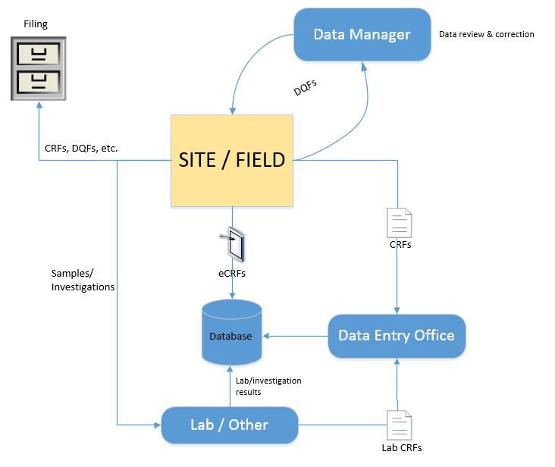

* 1. **Implement Tracking systems**
* Identify for each step in the data flow what tracking method can be implemented based on the location(s) and type of data carrier to allow tracking of lost data and thus ensure completeness of your dataset at the end of the study.
* Possible methods are
  + Batch Covers: A cover paper that travels with a batch of data (e.g. all CRF’s completed in one week) where different locations or activities may be specified (e.g. Single data entry, double data entry, …) - see Attachment 01
  + Tracking Log: A register where in and out status can be tracked e.g. when sending a Data Query Form (DQF) to the Hospital for clarification on CRF, keep a list of all DQFs and update with current status (sent, received, resent, closed) – see Attachment 02

# Attachments

|  |  |
| --- | --- |
| **Attachments** | |
| **Number** | **Title** |
| 01 | Batch Cover Sheet (BCS) |
| 02 | Tracking Log |
|  |  |

# Document History & References

|  |  |  |  |
| --- | --- | --- | --- |
| **Revision** | | | |
| **Version number** | **Author** | **Date** | **Description/reason for modification** |
| 1.0 | Fatoumatta Cole  Yusupha Njie | 04/10/2019 | Initial version – based on SOPs  ADMIT-012-00-SOP-Data Tracking  And LSHTM SOP-037  Review by Hanne Landuyt  Approval by Bai Lamin Dondeh and Harry Van Loen |
| 2.0 | Fatoumatta Cole | 23/06/2022 | Review to ensure that the SOP is appropriate within ALERRT and with current clinical research best practices |

# Approval

|  |  |  |
| --- | --- | --- |
| **Name and function** | **Date (dd/mm/yyyy)** | **Signature** |
| ***Author*** | | |
| *Indicate who wrote the SOP* |  |  |
| ***Review*** | | |
| *Indicate WP team members who reviewed (if applicable)* | *Date of review* |  |
| ***Approval*** | | |
| *Indicate WP Lead/Co-lead(s) who approved* | *Date of approval* |  |