|  |  |
| --- | --- |
|  | **SOP Title:** Change Management |
| **Study title:** *Give study title to which this SOP applies* |

1. **Scope and application**

|  |
| --- |
| The purpose of this Standard Operating Procedure (SOP) is to ensure a standardized approach is followed when changes are implemented on any aspects of the ALERRT Data Management or ICT platform in order to minimize the number and impact of any related incidents upon service.  The SOP will cover all changes – a change constitutes all physical or logical changes to network/server infrastructure or changes/updates to any software or database in production within the environment that may have intended and unintended consequences on service availability, operational effectiveness and security. |

1. **Responsibilities**

|  |  |
| --- | --- |
| **Function** | **Activities** |
| Change Requester | * Responsible for submitting the change request. |
| Change Manager | * The manager of the system impacted by the change. Responsible for reviewing, approving/denying change requests. |
| Change Implementer | * Responsible for carrying out the change – usually the systems developer |

1. **Definitions**

**CI**: Change Implementer

**CM**: Change Manager

**CR**: Change Requester

**MDC**: Mobile Data Centre

**PI**: Principal Investigator

**SDM**: Site Data Manager

# Procedures

* 1. **Types of Changes**

Changes to systems can be of the following types:

* **Emergency** – a change that must take place immediately.
* **Maintenance** – a regularly planned change that has been carried out many times and will be carried out thereafter. This consists of vendor updates and patches.
* **Retroactive** – a change that took place before a change request could be submitted which can be used to record historic changes for department records.
* **Standard** – a change scheduled at least a week in advance and all required approving parties are informed.
  1. **Requesting a Change**
* All changes must be submitted by means of a Change Request Form (see Attachment 01) by the CR.
* Complete all the required fields and as many non-required fields.
* Verify that all fields are correct before submitting the request to the CM.
  1. **Initial Approval & Priority Assessment**
* The CM will review the request and use the priority matrix below to determine which services and users are affected.
* If the request is denied, the CM will discuss request in further detail with the Change Requester. After this discussion, the CM will decide whether to accept the request with the agreed updates or close the denied change.
* Once the request is approved, it will be moved to the planning stage.

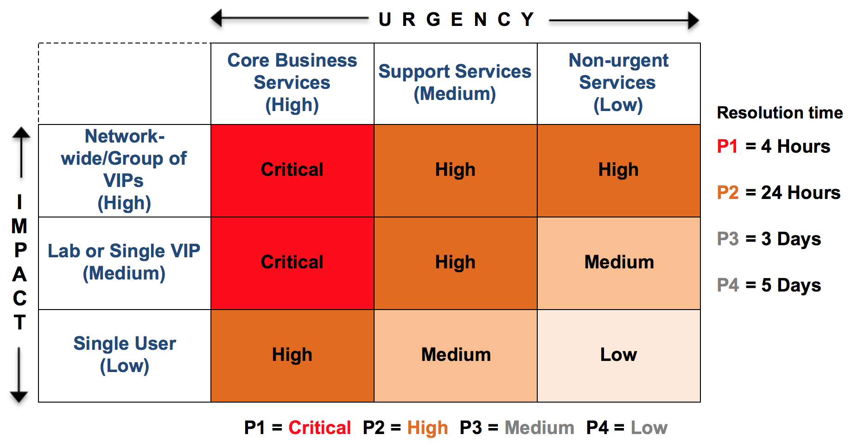

* 1. **Planning**

The CM ensures the following:

* **Communication** – determine who should be notified e.g. a network wide outage alert or user specific communication. Draft a user notification, which will be sent to the management team for approval and circulation.
* **Rollout Plan** – ensure there is a step-by-step outline of the process and the change.
* **Back-out Plan** – determine what steps are required to return to the previous version/state if the change were to fail.
* **Check List** – a list identifying outcomes and states required must be completed before the change can be considered complete.
* **Downtime** – determine the planned outage time of the change.
* Sign off the request and submit to the CI for implementation.
  1. **Implementation & Review**

The CI ensures the following:

* Capture specific details of the change including each task carried out.
* Carry out testing on the changes implement and record all evidence to show successful testing.
* Downtime Scheduling – capture actual vs scheduled times of outages generated by this change. Ensure this field is updated if the outages fall outside of the original plans.
* Completes the review details of the outlining whether the change has been either successfully or unsuccessfully completed.
* Describe in detail if the change was completed according to plan. If the change was not completed according to plan, provide details on why and if further actions is required.
* Notify and submit to the CM.
  1. **Final Review and Close-out**
* The CM will review the change and determine whether it can be closed as a success or whether further action is required.
* Close the change and file accordingly for future reference.
* Communicate the changes to all affected groups.

# Attachments

|  |  |
| --- | --- |
| **Attachments** | |
| **Number** | **Title** |
| Attachment 01 | Change Request Form |

# Document History & References

|  |  |  |  |
| --- | --- | --- | --- |
| **Revision** | | | |
| **Version number** | **Author** | **Date** | **Description/reason for modification** |
| 1.0 | Bai Lamin Dondeh | 02/04/2020 | Initial version - based on BCCHR SOP 203 Change Management, and MRCG@LSHTM SOP-DMA-013 on Change Control  Review by Badou Gaye  Approval by Bai Lamin Dondeh and Harry van Loen |
| 2.0 | Bai Lamin Dondeh | 22/06/2022 | Review to ensure that the SOP is appropriate within ALERRT and with current clinical research best practices |

# Approval

|  |  |  |
| --- | --- | --- |
| **Name and function** | **Date (dd/mm/yyyy)** | **Signature** |
| ***Author*** | | |
| *Indicate who wrote the SOP* |  |  |
| ***Review*** | | |
| *Indicate WP team members who reviewed (if applicable)* | *Date of review* |  |
| ***Approval*** | | |
| *Indicate WP Lead/Co-lead(s) who approved* | *Date of approval* |  |