|  |  |
| --- | --- |
|  | **SOP Title:** IT & Data Management Support |
| **Study title**: *Give study title to which this SOP applies* |

# Scope and application

|  |
| --- |
| This standard operating procedure (SOP) describes the processes of requests for fulfilment, incident management and problem management in order to support users on all aspects of IT and Data Management. This SOP is based on best practices recommended by the Information Technology Infrastructure Library (ITIL) which is a framework designed to standardize the selection, planning, delivery and maintenance of [IT services](https://searchitchannel.techtarget.com/definition/managed-IT-service) within a business with the goal to improve efficiency and achieve predictable service delivery.  Requests for fulfillment are formal requests to provide a product or service. These may include training, account credentials, new hardware, license allocation, and anything else that the IT Helpdesk offers. A request may need approvals before IT fulfills it.   An incident is an unplanned interruption to or quality reduction of an IT/Data Management service. An incident occurs when a service is disrupted or fails to deliver the promised performance during normal service hours, and it is essential to restore the service to normal operation as quickly as possible.  A problem is a condition identified through a series of multiple incidents with the same symptoms. Problem management resolves the root cause of the problem.  This SOP documents the steps needed to deliver or complete specific processes or tasks. It outlines how all requests, incidents or problems should be handled. This allows the Helpdesk to manage all responses in a structured and uniform way from initial contact to successful resolution.  The Helpdesk is the single point of contact for users to submit requests, report incidents and problems. With this, users will contact support staff, and these would be structured and prioritized. |

# Responsibilities

|  |  |
| --- | --- |
| **Function** | **Activities** |
| Data and/or IT Manager (or delegate) | Single point of contact to receive IT and Data Management requests, reports of incidents or problems and pass it over to the Helpdesk. |
| Helpdesk | * Receive requests, reports of incidents or problems, open a ticket and notify IT Manager or Data Manager of the ticket * Assign the ticket to either the Application Manager or Database Systems Administrator * Close tickets |

# Definitions

**SOP**: Standard Operating Procedure

**ITIL**: Information Technology Infrastructure Library

# Procedures

* 1. **Initial Contact**
* Users contact the Data Manager (or delegate) who may submit a request, incident or problem to Helpdesk indicating the state and nature of the submission.
* A ticket is opened by the Helpdesk, and the Data Manager is notified. The status of the ticket is set to “open”.
  1. **Helpdesk Assessment and Prioritization**
* The Helpdesk assesses and assigns the call a priority based on set criteria. Priority labels may include for example, system failure, critical situation, regular scheduled service
* The Helpdesk also provides a timeframe for resolution which could be within 24 hours or 48 hours depending on the criticality of the request, incident or problem.
* The status of the ticket at this stage is set to “In progress”.
  1. **Helpdesk Resolution or Escalation**
* The Helpdesk provides a solution or escalate to more advanced and experienced teams when initial help levels cannot resolve them quickly.
* The status of the ticket is set to “Assigned”.
  1. **Ticket Closure**
* The Helpdesk resolves the user’s service to acceptable service levels. Once this is done, the status of ticket is set to “Closed”. This indicates that the request, incident or problem is resolved and that no further actions will be taken.
* Users expect to be reassured that their problems are being solved, not overlooked. This SOP recommends that users are consulted and that they are happy with the level of service and that their requests are fulfilled satisfactorily before the ticket is closed.
  1. **Receiving Remote Support Assistance**

Quick Assist is an application available with Windows 10 that we are going to use to provide remote assistance to all sites. The process of using Quick Assist is as follows: -

1. IT Support will send a quick assist support code to the remote user. This can be done through e-mail or WhatsApp
2. After logging in to the Windows 10 Desktop, the remote user will Click on Start and search for ‘’Quick Assist’’

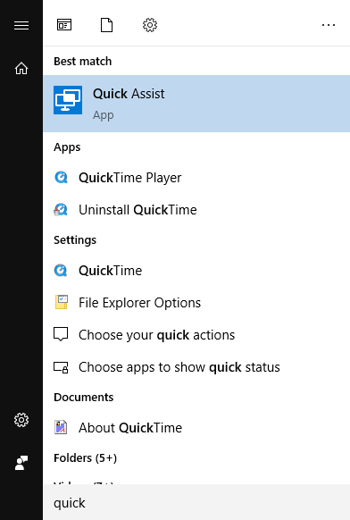

1. Click on the Quick assist to run. Paste the code received on the space below the text ‘’code from assistant’’ and click on share screen.

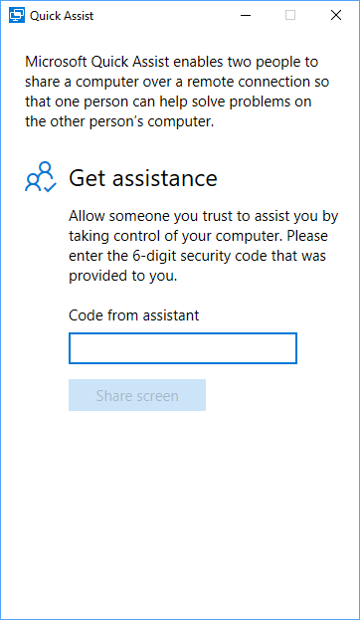

1. It would take some time to connect depending your internet speed. You would also need to grant control to the support assistant when the connection is established for him/her to have full control of your system.

# Attachments

|  |  |
| --- | --- |
| **Attachments** | |
| **Number** | **Title** |
|  |  |

# Appendix – Receiving Remote Support Assistance

|  |  |
| --- | --- |
|  | |
| **Number** | **Title** |
| Appendix 1 | Receiving Remote Support Assistance (See on page 4) |

1. **Document History and References**

|  |  |  |  |
| --- | --- | --- | --- |
| **Revision** | | | |
| **Version number** | **Author** | **Date** | **Description/reason for modification** |
| 1.0 | Badou Gaye,  Kekuta Kandeh | 08/10/2019 | Initial version - Based on SOP_WP3-IT & Data Management Support-V1-08/10/2019  Review by Kekuta Kandeh and Badou Gaye.  Approval by Bai Lamin Dondeh. |
| 2.0 | Badou Gaye,  Kekuta Kandeh | 22/06/2022 | Review to ensure that the SOP is appropriate within ALERRT and with current clinical research best pratices. |

1. **Approval**

|  |  |  |
| --- | --- | --- |
| **Name and function** | **Date (dd/mm/yyyy)** | **Signature** |
| ***Author*** | | |
| *Indicate who wrote the SOP* |  |  |
| ***Review*** | | |
| *Indicate WP team members who reviewed (if applicable)* | *Date of review* |  |
| ***Approval*** | | |
| *Indicate WP Lead/Co-lead(s) who approved* | *Date of approval* |  |